Study of barriers to IPE in the academic setting: Based on survery from Mongolian National University of Medical Sciences (MNUMS) faculties.
Azjargal Baatar, MNUMS, Mongolia
Oyuntsetseg Sandag, PhD, MNUMS, Mongolia
Sumberzul Nyamjav,MD, PhD, MNUMS, Mongolia

Abstract
Background: This study was conducted to determine current attitudes of the faculties who are responsible for the training of future healthcare professionals. This study was conducted to determine current attitudes of the faculties who are responsible for the training of future healthcare professionals. This study differs from the methodology used by the IPE as an online based on the needs of faculties. Methods: A descriptive, cross-sectional design was used to survey participants from a convenience sample of faculty at one large academic located capital city of Mongolia. The modified Attitudes Toward Health Care Teams Scale (ATHCTS) has not been sufficiently analyzed for reliability and validity in measuring attitudes towards health care teams yet, although a high rate of internal consistency, 0.773 of Cronbach’s alpha, with clear factor solution with three subscales was obtained in our previous examination (Hayashi et al. 2012). The scale was subject to exploratory factor analysis to examine the underlying constructs of the survey. The suitability of the correlation matrix was determined by the Kaiser-Meyer-Olkin estimate of sampling adequacy and Bartlett’s Test of Sphericity. Results: The mean score (±SD) for all respondents was 1.26 (±0.64). The barriers identified included problems with problems with schedule/calendar, classroom size, turf battles, lack of received value, lack of administrative support, students acceptance and lack of financial. P Value is calculated with Kruskal wallis tested, P value is considered as significant less than P<0.0001.
Conclusion: Analysis of the perceived barriers to IPE revealed a number of similarities in Mongolia compared to Japan and the need to organize IPE training and to make IPE curriculum.
Keywords: Interdisciplinary education, global health, interprofessional education, barriers.

Image
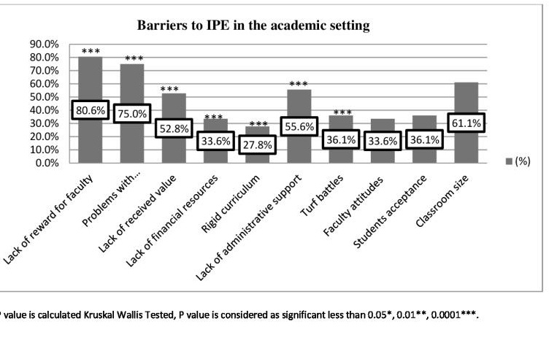
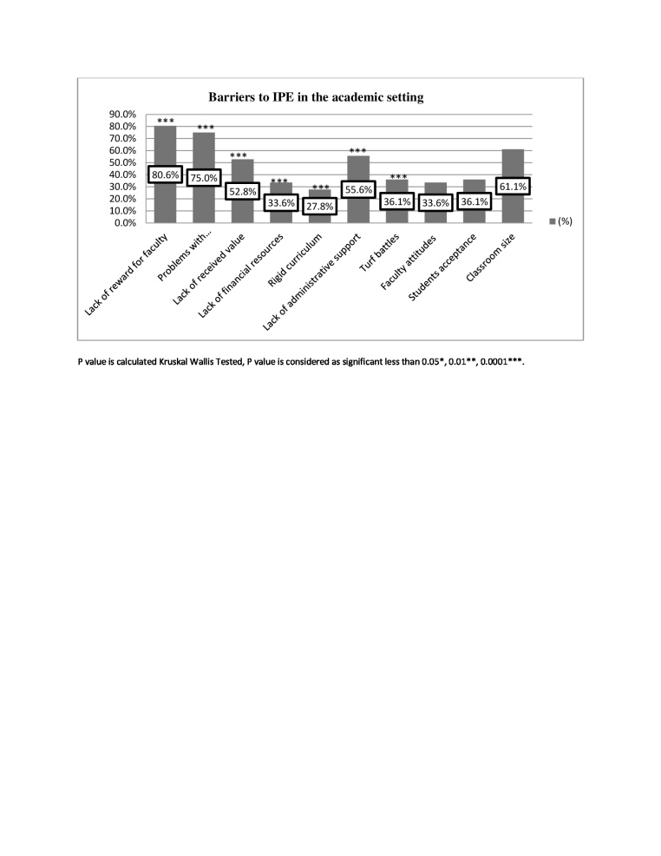
Recent Publications
1. Elizabeth Howkins, Julia Bray, Hugh Barr. Preparing for Interprofessional Teaching. 2008;3.
2. Dawn Forman, Marion Jones, Jill Thistlethwaite. Leading Research and Evaluation in Interprofessional Education and Collaborative Practice. 2016; 46-7.
3. Maree O’Keefe., Helena Ward. Implementing interprofessional learning curriculum: how problems might also be answers. BMC Med Educ. 2018;18:132. http://doi.org/ :10.1186/s12909-018-1231-1 .
4. Curran , V. R.Sharpe, D. Forristall, J. Attitudes of health sciences faculty members toward interprofessional teamwork and education. Medical education, 2007; 41, 892-6.
5. Hayashi T. Shinozaki. H. Makino. T. Ogawara H. Asakawa Y. Iwasaki K. Matsuda T.Abe Y.Tozato F. Koizumi M. Yasukawa T. Lee B. Hayashi K. Watanabe H. Changes in attitudes toward interprofessional health care teams and education in the first- and third-year undergraduate students. J Interprof Care, 2012; 26:100-7.
6. Christine Distefano, Min Zhu, Diana Mindrila. Understanding and Using factor Scores: Considerations for the Applied Researcher. Practical Assessment, Research and Evaluation. 2009; 14:20.

Photograph

 Biography
Azjargal Baatar is currently working as the Lecturer, Maternity Nursing at School of Nursing, Mongolian National University of Medical Sciences. She is also the Medical ethics committee member at the Etugen University. Her graduation thesis is entitled as "Nursing diagnosis and some physiological signs and their changes during the Arterial Hypertension". Her fellowship includes: IPE short training course, Gunma University,Japan,Nursing Management short training course, JICA,Japan,Nursing informatics & Nursing Theory course, Yonsei University, Korea.
Email: azjargal.b@mnums.edu.mn

Notes/Comments:

