Study of the needs of interprofessional education (IPE) in Mongolia
¹Azjargal.B, RN, RM, MScN, MNUMS,Mongolia
¹Sumberzul.N, MD, PhD, MNUMS, Mongolia
²Basbish.Ts, RN, MScN, MNUMS, Mongolia
²Enkhchimeg.H, MScN, MNUMS, Mongolia
³Shinozaki Hiromitsu³, MD, PhD, Gunma University, Japan
³Takatoshi Makino³, RN, PhD, Gunma University,Japan

Abstract (300 word limit)
Objective: The purpose of this study is to describe attitudes toward interprofessional education in Mongolia National University of Medical Sciences. Methods: Cross-sectional study, Heinemann et al (Heinemann, Schmitt, Farrell, & Brallier, 1999)¹ developed the Attitudes Toward Health Care Teams Scale (ATHCTS, 21-item instrument), which has potential for evaluating clinically based team training programs as well as use a pre- and post-test tool for educational interventions with teams. A 14-item instrument in which items containing the word “physician” have been removed from the original instrument is a modified version adapted by Curran et al (Curran, Sharpe, & Forristall, 2007) to measure attitudes towards health care teams. Results:In total, 249 I grade and 243 III grade undergraduate students participated in the study, respectively. Response rates by academic units of the undergraduate students were NS 88.3% (n=223), MD 39.0% (n=193), PT 53.8% (n=29), LS 42.0%(n=47), respectively. As shown in Table II, comparisons using the Mann-Whitney test indicated that in mean scores of seven items, item 1 (3.83±1.169 vs 4.38±0.854, P<0.0001), item 3 (3.97±1.167 vs 4.43±0.702, p<0.05), item 4 (3.99±1.163 vs 4.61±0.62, P<0.0001), item 13 (3.5±1.164 vs 4.11±0.946, P<0.001), 1st year students showed significantly lower scores than 3rd year undergraduate students. Conclusion: The present results showed that students possessed more positive attitudes toward IPE than I years undergraduate students, suggesting that exposure to clinical practice may result in withdrawal of the attitudes toward healthcare teams.
Key words: Interprofessional education, team value, team efficiency.

Image

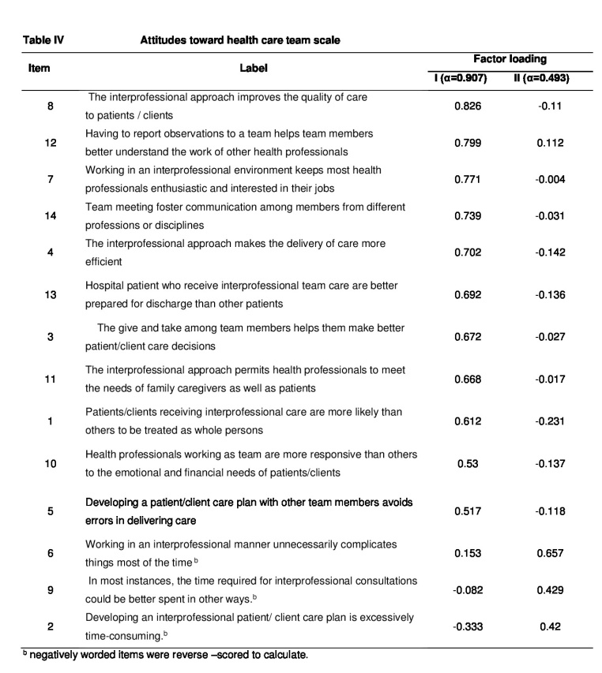
Recent Publications (minimum 5)
¹) Heinemann GD., Schmitt MH., Farrell MP., & Brallier SA. (1999). Development of an Attitudes Toward Health Care Teams Scale. Eval Health Prof, 22(1), 123-142.
²) Curran VR., Sharpe D., & Forristall J. (2007). Attitudes of health sciences faculty members towards interprofessional teamwork and education. Med Educ, 41(9), 892-896.
³) Heinemann GD., Schmitt MH., Farrell MP., &Brallier SA. (1999). Development of an Attitudes Toward Health Care Teams Scale. Eval Health Prof, 22(1), 123-142.
⁴) Curran VR., Sharpe D., &Forristall J. (2007). Attitudes of health sciences faculty members towards interprofessional teamwork and education. Med Educ, 41(9), 892-896.

 Biography (150 word limit)
Azjargal Baatarl works at School ofNursing, MNUMS. Her working experiences are: 2016-09-01 present lecturer of the department midwifery, 2014.09-2016-09-01, Head of Department Maternal & Child Nursing , School of Nursing, MNUMS,2013.01 –2014.09 Head of Department of Fundamental Nursing, School of Nursing, MNUMS, 2012.09 – 2013.01 Head of Department of Specialized Nursing, School of Nursing,2006.08 – 2012.09 Lecturer of Nursing, Etugen University,2004-2006 , "Tugs Yalguun" surgical hospital , an anaesthesiology nurse,1994-2004, Bulgan province, Midwifery & Medical assistant.

Email: azjargal.b@mnums.edu.mn
Phone: 976 – 9910 - 2855

