The relationship of depression risk and gestational diabetes mellitus: A Systematic Review and Meta-Analysis
Yu-Chen Su , PhD Department of Nursing, College of Nursing, National Taipei University of Nursing and Health Sciences, Taiwan
Shu-Fang Chang , Professor Department of Nursing, College of Nursing, National Taipei University of Nursing and Health Sciences, Taiwan

Abstract (300 word limit)

Gestational diabetes mellitus (GDM) refers to the occurrence of any degree of impaired glucose tolerance in pregnant women during pregnancy. GDM has short-term and long-term adverse effects on both the pregnant woman and the newborn, and it reduces the quality of life. GDM may increase the risk of developing preeclampsia, hypertension, and type 2 diabetes in pregnant women, and they are more prone to undergo cesarean section and experience preterm birth. Furthermore, GDM is also associated with fetal macrosomia, shoulder dystocia, neonatal hypoglycemia, death, and an increased risk of future development of type 2 diabetes Pregnancy is a crucial period in a woman's life as it involves commitment, establishing attachment, and self-preparation, requiring continuous learning and adjustment to enter a new stage and embrace the new maternal role . According to a survey conducted on 6,421 pregnant women by Canadian scholars, it was found that 12% of women experienced high levels of stress, which may lead to maladaptive coping and excessive stress, and even trigger depressive emotions in women. Particularly, women with high-risk pregnancies may endure greater stress and are more likely to experience depressive emotions. Research suggests that women with gestational diabetes mellitus (GDM) have a higher prevalence of depression. A study examining stress, depression, anxiety, and physical activity levels in 632 Hispanic women with GDM found that these women experienced more severe stress and tendencies towards depression compared to pregnant women without GDM. In a survey conducted involving 95 women with GDM, it was found that 33.4% of the women exhibited symptoms of depression. Another study conducted compared 180 women with GDM to 186 women with normal blood glucose levels and found that women with GDM had higher levels of depression compared to women with normal blood glucose levels.

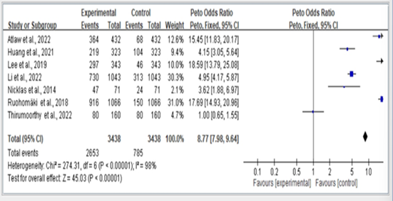
Figure 1. Summary estimates for the Gestational Diabetes Mellitus status compared to depression outcome.

Recent Publications (minimum 5)
- Yu-Chen Su., Shu-Fang Chang. (2023). The Relationship Between Sarcopenia and Fracture Risk In Older Adults: A Systematic Review and Meta-Analysis. The 29th International Council of Nurses (ICN), in Montreal, Canada(post)
- Yu-Chen Su., Shu-Fang Chang. (2023). The Relationship Between S Diabetes and Depression Risk In Adults: A Systematic Review and Meta-Analysis. The 29th International Council of Nurses (ICN), in Montreal, Canada(post)
- Yu-Chen Su., Shu-Fang Chang., and Hsiao-Chi Tsai. (2022). The Relationship between Sarcopenia and Injury Events: A Systematic Review and Meta-Analysis of 98,754 Older Adults. J. Clin. Med. 11, 6474, 1–16.
- Yu-Chen Su (2021) Exploring the Relationship between Falls in Older Adults and Sarcopenia: A Systematic Literature Review. Healthcare Technology and Management.Taipei, Taiwan (post).
5. Yu-Chen Su.,(2020). Relationship Between Resillence and Depression in Patients With Stroke in Taiwan. The 26th International Council of Nurses (ICN), Taipei, Taiwan (post).

Photograph



Biography (150 word limit)
Yu-Chen Su is currently a Ph.D. candidate in the Nursing Department at National Taipei University of Health Sciences in Taiwan. She possesses over twenty-five years of nursing clinical practice experience.In 2022, she published a paper titled "The Relationship between Sarcopenia and Injury Events: A Systematic Review and Meta-Analysis of 98,754 Older Adults" in the Journal of Clinical Medicine (J. Clin. Med.) (SCI).In 2023, she attended the 29th International Council of Nurses (ICN) conference in Montreal, Canada, and successfully presented two papers, exploring "The Relationship Between Sarcopenia and Fracture Risk in Older Adults" and "The Relationship Between Diabetes and Depression Risk in Adults.
Email: 13448s.hr@gmail.com

Notes/Comments:

