Abstract
High grade endometrial stromal sarcoma (HG-ESS) is a very rare entity with poor outcome in compared to other endometrial stromal sarcoma as it is usually diagnosed in late stage. The stage of the disease, age and complete surgery are most important prognostic factors. In this case report, we present a case of 40 years female who came with the complain of per vaginal bleeding for which the patient underwent endometrial biopsy which revealed low grade endometrial stromal sarcoma which was managed by surgical laparotomy but the final histopathological report confirmed high grade endometrial stromal sarcoma.
Image
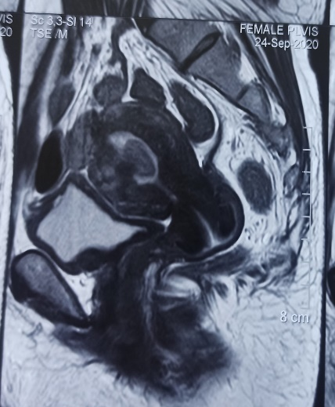 Fig 1: MRI showing single nodule in endometrial cavity
11*20 mm nodule within endometrial cavity
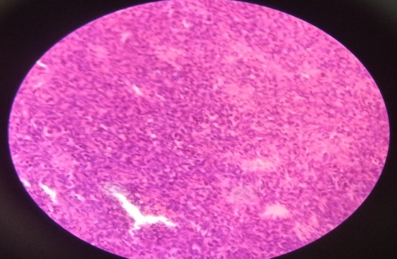
Focal necrosis
Fig 3: 40X showing areas of focal necrosis
Recent Publications
- Zhang Y, Chen C, Ren M, Cong X, Yang L (2019). Treatment of uterine high grade endometrial stromal sarcoma with apatininb combined with chemotherapy. Medicine.98(13):1-3.
- Angelos D, Anastasios L, Dimosthenis M, Roxani D, Alexia P, Konstantinos D (2020). Endomerial stromal sarcoma presented as endometrial polyp: a rare case. Gynaecological surgery. 17:6.
- Eamudomkarn N, Itarat Y, Kleebkaow P, Kietpeerkool C (2018). A case report of high grade endometrial stromal sarcoma: A rare cause of abnormal uterine bleeding in a young women. Case rep in Obstet Gynecol. 2018, 5906760.
- Zhang YY, Li Y, Qin M, Cai Y, Jin Y, Pan LY. High-grade endometrial stromal sarcoma: a retrospective study of factors influencing prognosis. Cancer Manag Res. 11, 831–837.
- Agrawal R, Rajanbabu A, Nair IR, Chandramouli S, Georgeena J (2017). Endometrial stromal sarcoma- A retrospective analysis of factors affecting recurrence. Eur J Obstet Gynecol Reprod Bio.216:92-7

