Individual dynamic endometrial maturation: a new fact that leads to reconsider strategies for timing of embryo transfers

Statement of the Problem: The knowledge about the endometrial receptive stage for embryo transfer in IVF treatment is very important but unknown as well. Measuring the endometrial thickness and trilaminar pattern by ultrasound provides only a hind of a sucessful start of the menstrual cycle at the end of the follicular phase. Aim of this study was to monitor the endometrial transformation process applying our Personal Endometrial Maturation Analysis (PEMA®). We wanted to get information about the transformation process and to exclude an arrest of that organ, which cannot be done by one biopsy. Methodology & Theoretical Orientation: Two biopsies were taken mainly at days +5 and +10 after ovulation (OV, n = 76)/hormone replacement therapy (HRT, n = 58) within one cycle. Endometrial dating is done with our new modified endometrial dating method, a combination of histomorphological analysis, based on the Noyes criteria, with a typical pattern of hormone receptors and the proliferation marker Ki-67 for each cycle day between OV/P +2 and +11. Findings: The results were correlated with the clinically expected day of the cycle and showed temporal delays or hypercompensations, diverging from the expected cycle days by 0.5–5 days. In comparison with the first biopsies, the transformation rate in the second biopsies showed constant transformation, compensation or augmented delay in 28.94, 48.69 and 22.37 % of cases for ovulation in natural cycles and 17.26, 56.89 and
25.85 % for HRT cycles respectively. Conclusion & Significance: The study revealed an individually dynamic transformation process of the endometrium using PEMA®, with the ability to compensate or enlarge an initial “delay”, which is now identified as a normal individual transformation process during the secretory phase. This information will lead to a new consideration of IVF procedures and will influence timing of embryo transfers.

Image

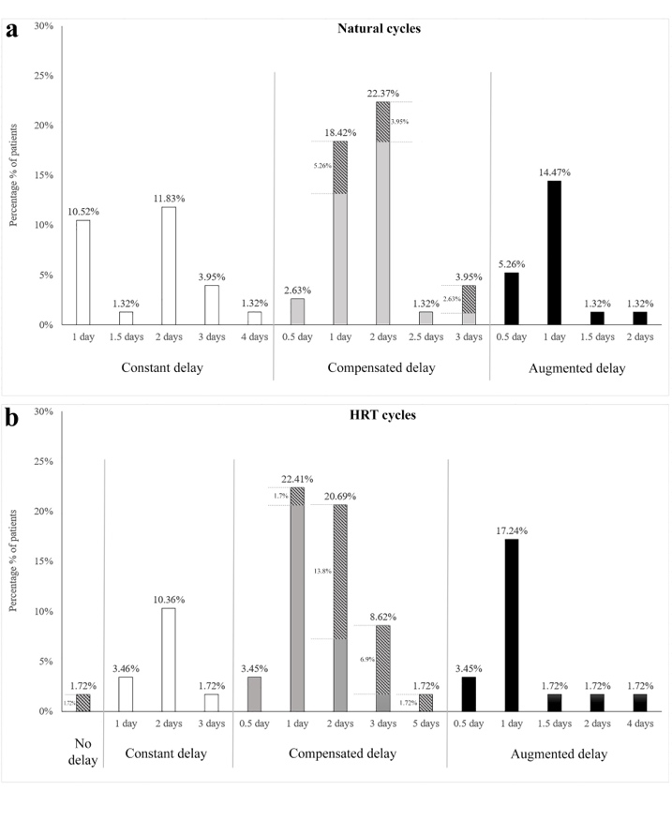
Fig. 1 Behavior of endometrial transformation speed between first
and second biopsies of natural and HRT cycles. Constant, compensated,
and augmented delay in the endometrial tissues observed on
day OV/P + 10 in comparison with day OV/P + 5. a Constant, compensated,
and augmented delay in the natural cycles; b constant, compensated,
and augmented delay in the HRT cycles. The hatched parts
of the columns in compensated delays in a and b indicate the percentage
of endometrium that was able to enter the expected day of
transformation (OV/P + 10) or hypercompensation (OV/P + 11). OV
ovulation in natural cycles, P progesterone administration in hormone
replacement therapy (HRT) cycles.

Alfer, J MD, Department of Pathology, Erlangen University Hospital, Friedrich–Alexander University of Erlangen–Nürnberg, Erlangen, Germany and Kaufbeuren–Ravensburg Institute of Pathology, Ravensburg, Germany
Popovici, RM MD, Munich Fertility Center, Munich, Germany
Fattahi, A MD, Women’s Reproductive Health Research Center, Tabriz University of Medical Sciences, Tabriz, Iran and Department of Obstetrics and Gynecology, Erlangen University Hospital, Friedrich– Alexander University of Erlangen–Nürnberg, Erlangen, Germany
Krieg, J MD, Amberg Fertility Center, Amberg, Germany
Dittrich, R PhD, Department of Obstetrics and Gynecology, Erlangen University Hospital, Friedrich– Alexander University of Erlangen–Nürnberg, Erlangen, Germany
Beckman, MW MD, Department of Obstetrics and Gynecology, Erlangen University Hospital, Friedrich– Alexander University of Erlangen–Nürnberg, Erlangen, Germany
Hartmann, A MD, Department of Pathology, Erlangen University Hospital, Friedrich–Alexander University of Erlangen–Nürnberg, Erlangen, Germany
Bleisinger, N PhD, Department of Obstetrics and Gynecology, Erlangen University Hospital, Friedrich– Alexander University of Erlangen–Nürnberg, Erlangen, Germany

Recent Publications:

- J Alfer, RM Popovici, A Fattahi, J Krieg, R Dittrich, M Beckmann, A Hartmann, N Bleisinger
Endometrial delay is found to be part of a normal individual dynamic transformation process.
Arch Gynecol Obstet Published 19 May 2021

- J Alfer, A Fattahi, N Bleisinger, J Krieg, R Behrens, R Dittrich, MW Beckmann, A Hartmann, I Classen-Linke, RM Popovici
Endometrial Dating Method Detects Individual Maturation Sequences During the Secretory Phase.
IN VIVO 34:1951-1963, 2020

- J Alfer, L Happel, R Dittrich, MW Beckmann, A Hartmann, A Gaumann, VU Buck, I Classen-Linke
Insufficient Angiogenesis: Cause of Abnormally Thin Endometrium in Subfertile Patients?
Geburtshilfe Frauenheilkd 77(7):756-764, 2017



BIOGRAPHY
Joachim Alfer graduated with a dissertation on marker molecules for human endometrial functions at the Institute of Anatomy and Reproductive Biology (Director: Prof. H.M. Beier) in the Medical Faculty of RWTH Aachen University in Germany. With colleagues, he is owner and CEO of the Institutes for Pathology Kaufbeuren-Ravensburg and the Molekularpathologie Südbayern in Munich. Since 2017 he is Visiting Professor at the Mongolian National University of Medical Sciences (MNUMS) of Ulan Bator, Mongolia and lecturer at Friedrich-Alexander University of Erlangen–Nürnberg, Germany as well.

Email: joachim.alfer@pathologie-ravensburg.de

