Role of soluble E-cadherin in intrauterine growth restriction.
V. L. Tyutyunnik¹, N. E. Kan^{1, 2}, А. A. Khachaturyan¹, Z. V. Khachatryan¹, A. M. Krasnyi^{1,3}
- Federal State Budget Institution «National Medical Research Center for Obstetrics, Gynecology and Perinatology named after Academician V.I. Kulakov» of the Ministry of healthcare of Russian Federation, Moscow, Russia
- European Medical Center, Moscow, Russia
- N.K. Koltzov Institute of Developmental Biology of Russian Academy of Sciences, Moscow, Russia
Introduction. Syncytiotrophoblast is an epithelial layer that covers the entire surface of villous tree and interacts with maternal blood. Its differentiation from chorionic trophoblasts is providing by cell fusion. Thus, the cell adhesion mechanisms are of particular interest in intrauterine growth restriction studies (IUGR). E-cadherin is a cell adhesion molecule with molecular weight of 120-kDa that is important for epithelial intercellular adhesion. Soluble form (80-kDa) consists of Ca-dependent proteolysis and can reduce cell adhesion.  Objective. The aim was to study the levels of soluble (80-kDa) and transmembrane (120-kDa) forms of E-cadherin in placentas of IUGR and non-IUGR fetuses.  Materials and methods. 38 pregnant women, among them 18 affected by intrauterine growth restriction (IUGR) and 20 control subjects from normal pregnancies. The Western blotting was used for determination the levels of soluble and transmembrane E-cadherin in placentas. Measurement of E-cadherin gene expression was made by real-time polymerase chain reaction CFX96 («BioRad», USA). The statistical analysis was performed with programs AtteStat and OriginPro 8.1.  Results. In IUGR group the level of the transmembrane form of E-cadherin was reduced by 2.5 times and the soluble form by 4.8 times (p <0.05) compared to normal placentas. Their ratio was of 1.6 in the IUGR group and 0.8 in control group (in both cases p <0.05). We studied the expression of the E-cadherin gene CDH1. The level of expression of the E-cadherin gene CDH1 in the placentas from pregnancies with fetal growth restriction was reduced by 1.4 times compared to the control group (p>0.05). The absence of significant differences indicates the possibility of post-translational modification of E-cadherin.  Conclusion. Thus low levels of soluble E-cadherin in placentas are associated with decreased proliferation and mobility of trophoblast, which may be the cause of placental insufficiency and, consequently, IUGR. | 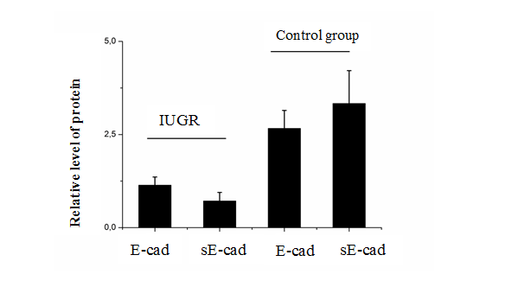  Recent Publications.  1. Longtine MS, Chen B, Odibo AO, Zhong Y, Nelson DM. Villous trophoblast apoptosis is elevated and restricted to cytotrophoblasts in pregnancies complicated by preeclampsia, IUGR, or preeclampsia with IUGR. Placenta. 2012 May;33(5):352-9.  2. Duzyj CM, Buhimschi IA, Motawea H, Laky CA, Cozzini G, Zhao G, Funai EF, Buhimschi CS. The invasive phenotype of placenta accreta extravillous trophoblasts associates with loss of E-cadherin. Placenta. 2015 Jun;36(6):645-51  3. Chikvaidze N, Kintraia N, Muzashvili T, Gachechiladze M, Burkadze G. Phenotypic characteristics of chorionic villi during gestational trophoblastic diseases. Georgian Med News. 2019 Jan;(286):140-145.  - 4. Peng W, Tong C, Li L, Huang C, Ran Y, Chen X, Bai Y, Liu Y, Zhao J, Tan B, Luo X, Wang H, Wen L, Zhang C, Zhang H, Ding Y, Qi H, Baker PN.  Trophoblastic proliferation and invasion regulated by ACTN4 is impaired in early onset preeclampsia. FASEB J. 2019 Feb 18:fj201802058RR  - 5. Iwahashi N, Ikezaki M, Matsuzaki I, Yamamoto M, Toujima S, Murata SI, Ihara Y, Ino K. Calreticulin Regulates Syncytialization Through Control of the Synthesis and Transportation of E-Cadherin in BeWo Cells. Endocrinology. 2019 Feb 1;160(2):359-374.  Figure 1: the levels of soluble and transmembrane E-cadherin in placentas from IUGR and normal pregnancies

About author:
Tyutyunnik Victor L., PhD, MD, Professor, the head of the obstetric physiological department of the National Medical Research Center for Obstetrics, Gynecology and Perinatology named after Academician V.I. Kulakov Ministry of Health of Russia (117997, Moscow, Ac. Oparina, 4 str.).
Tel.: +79039695041. E-mail:tioutiounnik@mail.ru.

