SUCCESFUL DELIVERY OUTCOME WITH EISENMENGER SYNDROME IN LOW RESOURCE SETTING: A RARE CASE REPORT
Suhartomo, DM, University of Indonesia, Cipto Mangunkusumo National Hospital, Indonesia,
Azenda, R, Department Obstetrics and Gynecology, Tangerang Regional Hospital, Indonesia,
Prayudana, S, Department Obstetrics and Gynecology, Tangerang Regional Hospital, Indonesia,
Prabu, D, Department Obstetrics and Gynecology, Tangerang Regional Hospital, Indonesia,
Setiawan, W, Department Obstetrics and Gynecology, Tangerang Regional Hospital, Indonesia,
Andonotopo, W PhD, Fetomaternal Division, Department Obstetrics and Gynecology, Tangerang Regional Hospital, Indonesia,

ES is very rare in pregnant women with an incidence of about 3%. It is rarely reported, but it is associated with significant morbidity and mortality of both mother and baby. It is well known that pregnancy poses an immense risk and maternal mortality reached 56% and even in recent reports mortality rate remains unacceptably high (25-30%).
A woman, 35 years old, G3P1A1 36-37 weeks of gestational age (Her LMP was on 13/07/2017), singleton live head presentation, previous C-section 1 times was referred from clinic due to absent end diastolic on doppler examination to emergency room with complaining of breathless at rest. On examination, peripheral and central cyanosis was noted with presented clubbing finger at upper limb. On further examination, she had a pulse 102/min, BP=127/80mm of Hg, respiratory rate=24/min, oxygen saturation=82 %(on room air), with a raised JVP. On auscultation of the chest bilateral basal crepitations were heard, a pansystolic murmur and loud pulmonary component of second heart sound with no ejection systolic murmur was heard on auscultation. Hemoglobin, leucocyte hematocrit and platelet values were 20.8 g/dL, 50.9%, 5.58x10³ /µL, 189x10³ /µL, respectively. Arterial blood gas analysis revealed a pH 7.34, pCO2 39, pO2 68 and hCO3 21 and Base excess -4.5.
Immediately, multidisciplinary care was initiated, and consultant obstetrician was called in and cardiac and anesthesia teams were involved in planning further care.
The decision for urgent delivery was taken in view of maternal and fetal condition and an emergency LSCS continued with tubectomy pomeroy were done under epidural anesthesia with intra- arterial pressure and CVP for monitoring hemodynamic changes. The baby was reported to be doing well with no immediate complications and was shifted to NICU
Patient was shifted to ICU for post-operative care, and thromboprophylaxis post-operative day 1. She was discharged on the eighth post-operative day.

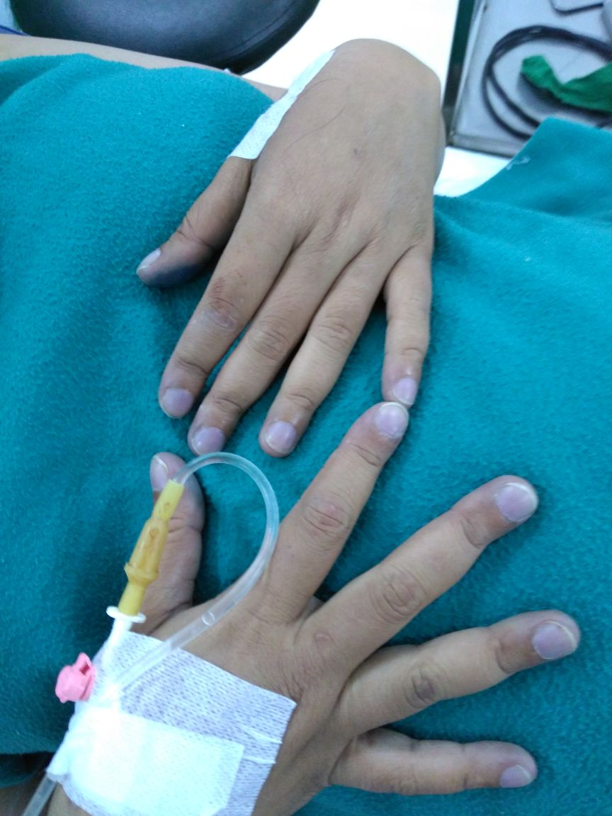

1.Duan R, Xu X, Wang X, Yu H, You Y, Liu X, et al. Pregnancy outcome in women with Eisenmenger’s syndrome: a case series from west China. Duan et al BMC Pregnancy and Childbirth. 2016;16:356.
2.Yuan S-M. Eisenmenger Syndrome in Pregnancy. Braz J Cardiovasc Surg. 2016;31(4):325-9.
3.Rosengarten D, Kramer MR. Pulmonary Hypertension and Pregnancy: Management and Outcom. Rosengarten and Kramer J Pulmon Resp Med. 2013;S4.
4.Partha M, Popli B, Nilofur B. Successful Pregnancy Outcome with Eisenmenger Syndrome. The Journal of Obstetrics and Gynecology of India 2012;62(1):68-9.
5.Bazmi S, Malhotra S, Zaman F. A Rare Case of Pregnancy with Eisenmenger Syndrome. International Journal of Obstetrics and Gynaecology Research (IJOGR). 2015; 2:151-4.
6.Koya R, Mallela AR, T AD, Shetty H. Pregnancy Complicating Patent Ductus Arteriosus With Eisenmenger Syndrome. International Journal of Current Research. 2015;7(7):18589.
7.Tokgöz HC, Kaymaz C, Poci N, Akbal ÖY, Öztürk S. A successful cesarean delivery without fetal or maternal morbidity in an Eisenmenger patient with cor triatriatum sinistrum, double-orifice mitral valve, large ventricular septal defect, and single ventricle who was under long-term bosentan treatment. Turk Kardiyol Dern Ars 2016;45(2):184-8
8.Warnes CA. Pregnancy and Delivery in Women With Congenital Heart Disease. Circulation Journal. 2015;79.

