First Trimester Post Abortal Placenta Increta: A Case Report
Marion Ariadne C. Burgos, FEU-NRMF Medical Center, Philippines

Abstract
Introduction: Obstetrical hemorrhage is one the leading causes of maternal morbidity and mortality in our country. It accounts for 298 out of 1,719 women (17.3 %). Obstetrical complications such as hemorrhage may ensue once the placenta adheres into the myometrium and was not noted during placental delivery.

Case Report: This is a case of a 30-year-old, Gravida 3 Para 1 (1021) who had persistent vaginal bleeding post curettage due to missed abortion at 11 weeks age of gestation.

Case Discussion: Differential diagnosis included retained secundines, gestational trophoblastic neoplasia, uterine arteriovenous malformation, and placental accrete syndrome. This could be differentiated by beta human chorionic gonadotrophic hormone and transvaginal ultrasound.

What made the case interesting is the dilemma in the diagnosis. In a case of persistent vaginal bleeding after curettage and with a history of cesarean delivery, one will initially think of placenta accrete syndrome. But then, initial diagnostic tests pointed out to uterine arteriovenous malformation. Due to the dilemma of the service team in clinching the diagnosis for a single disease entity, pelvic magnetic resonance imaging with contrast was done revealing a possible placenta accreta, but cannot totally rule out vascular tumor.

Since patient was initially desirous of future pregnancy, medical management was started and was scheduled for CT angiography. However, due to persistent vaginal bleeding, she underwent Total Abdominal Hysterectomy. Histopathology result revealed a placenta increta.

Conclusion: In the advent of technology, a wide array of diagnostic modalities can be used to make an appropriate diagnosis. Clinical correlation and a high index of suspicion must be at all times considered above all. No matter how rare the condition, it should still be at the back of our minds.

Image
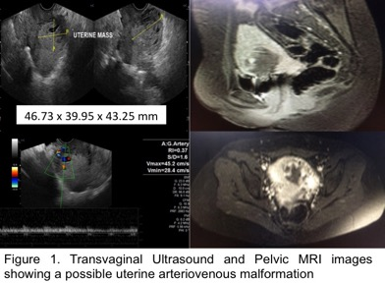
Recent Publications
- Cunningham, Lenovo, Bloom et al, Williams Obstetrics 24th edition, USA 2014
- www. doh.gov.ph
- www.radioaedia.org
- Ping Li et al. Sonographic Features of Placenta Accreta After First Trimester Abortion. American Institute of Ultrasound in Medicine. 2013
- Safoura Rouholamin et al. Placenta Increta in First Trimester of Pregnancy Mimicking Molar Pregnancy:Case Report. 2014
- Safoura Rouholamin et al. Placenta increta as an important case of uterine mass after first trimester curettage (case report).2014
- Sumpaico, Walfrido et al. Obstetric and Gynecologic Ultrasound for the Practicing Clinician. 2nd edition.2006
- Sellmyer, Mark et al. Physiologic, Histologic, and Imaging Features of Retained Products of Conception. RadioGraphics 2013; 33: 781-796
- Montanari, L. et al. Arteriovenous malformation of the uterus: successful pregnancy after medical treatment. Ultrasound in Obstetrics and Gynecology 2007; 30: 537-653
- Singh, Sapna et al. Uterin AVM. The Internet Journal of Radiology. 2007 Volume 9 Number 1.
- Aiyappan, Senthil et al. Case Report. Doppler Sonography and 3D CT Angiography of Acquired Uterine Arteriovenous Malformations (AVMs): Report of Two Cases. Journal of Clinical and Diagnostic Research. February 2014

Photograph

Biography
Dr. Marion Ariadne Burgos has completed her Doctor of Medicine degree from Far Eastern University-Nicanor Reyes Medical Foundation at age of 23.

Email: noiram_burgsos@yahoo.com

Notes/Comments:

