Placenta Percreta Induced Third Trimester Uterine Rupture in an
Unscarred Uterus: A Diagnostic Dilemma
Samantha Quennie Wanasen-Razon
Far Eastern University- Nicanor Reyes Medical Foundation Medical Center

Abstract
Cases of uterine rupture induced by placenta percreta in an unscarred uterus are rare. This is a case of 30-year-old, Gravida 2 Para 1 (1001) Pregnancy Uterine 31 Weeks and 2 days age of gestation with persistent generalized abdominal pain found out to have uterine rupture secondary to placenta percreta. This paper aims to discuss the differential diagnoses for cases of third trimester abdominal pain, the appropriate diagnostic modalities and the best management for such case. Uterine rupture should be considered in the differential diagnosis in all pregnant women who present with acute abdomen even if there are no risk factors. Exploratory laparotomy was done to investigate the cause of the patient’s severe abdominal pain on top of intrauterine fetal bradycardia. During the procedure, uterine rupture with massive bleeding was detected; therefore, subtotal abdominal hysterectomy was performed. The patient was discharged without any complications. Pathological analysis of the uterine specimen revealed placenta percreta to be the cause of the rupture.

Image
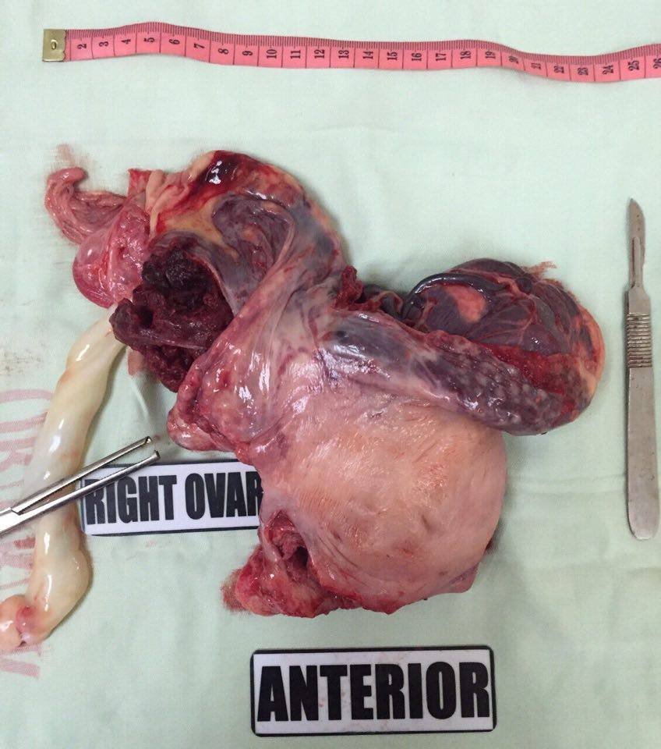
The picture shows the whole uterus and its thick myometrium. The placenta is seen attached almost invading the whole thickness of the uterine layers.

Recent Publications (minimum 5)
1. Jang DG, Lee GSR, Yoon JH, Lee SJ. Placenta Percreta-Induced Uterine Rupture Diagnosed By Laparoscopy in the First Trimester. Int J Med Sci 2011; 8(5):424- 427. doi:10.7150/ijms.8.424.
2. O’Brien JM, Barton JR, Donaldson ES. The management of placenta percreta: conservative and operative strategies. Am J Obstet Gynecol 1996;175:1632–8.
3. Dahiya P, Nayar KD, Gulati AJS, Dahiya K. Placenta Accreta Causing Uterine Rupture in Second Trimester of Pregnancy after in vitro Fertilization: A Case Report. J Reprod Infertil. 2012;13(1):61-63.
4. Hudon L, Belfort MA, Broome DR. Diagnosis and management of placenta percreta: a review. Obstet Gynecol Surv 1998;53:509– 17.
5. Legro RS, Price FV, Hill LM, Caritis SN. Nonsurgical management of placenta percreta: A case report. Obstet Gynecol 1994;83:847-9.

Photograph

Biography
Samantha Quennie Wanasen-Razon has completed her Degree of Medicine at the age of 24 years from Far Eastern University- Nicanor Reyes Memorial Foundation Medical Center. She is currently a Third year Obstetrics and Gynecology Resident in the said institution.
Email: Samwanasenrazon@gmail.com

Notes/Comments:

