HIGH RISK PREGNANCY ASSESSMENT : NEED OF THE HOUR
Introduction:
“Let every mother and child to be counted”
Motherhood is a natural phenomenon, but safe motherhood is fraught with many complications related to of pregnancy and child birth. A “high risk pregnancy” (HRP) is one in which the maternal environment or past reproductive performance presents a significant risk to fetal well being , such as premature birth, small for date infant, full term with low reservoir or still births and early neonatal deaths. Identification of patients at risk for these complicated pregnancies with poor outcome is fundamental to antenatal care. A women is considered to have a high risk pregnancy when health concerns exist that may threaten the natural course of the development or birth of the baby , or that pose a risk to the mother. In such cases the mother may need special care , more investigations and possibly medication to ensure that she can carry the baby safely through to delivery.
Identification of High Risk Pregnancy:
Certain events occurring during the prenatal and intrapartum period can adversely influence the outcome of the infant during post natal life. This emphasises the importance of developing technique for identifying the high risk pregnancy. Nesbitt and Aubry (1969)¹ developed the Maternal –Child Health Care Index (MCHCI). Factors included on tjis scale include previous obstetric history, age, parity , nutrition , emotional social and economical variables. Items were given an arbitrary score and substracted from an arbitrary perfect score of 100. A score of greater than 70 is considered acceptable , which scores below 70 considered “failing” an arbitrary cut –off created by the authors. In 1973 , Hobel , CJ et al ² investigated a high risk pregnancy screening system based on prenatal and intrapartum factors. Total score of prenatal , intrapartum and neonatal period were dichotomised to simply scoring system and less than 10 score was placed in low risk and more than 10 in high risk categories respectively. In 1977, Coopland A et al ³ described evaluation of a simple antenatal high risk assessment form. The total risk scores were analysed in respect to perinatal outcome. As the risk factor increased , the percentage of favourable Apgar ratings decreased . Dutta & Das ⁴ in 1990 devised a prenatal score system whoich was a modification of the system as proposed by Coopland in 1977. According to Dutta & Das scoring system patients patients were classified into three groups : Low risk (1-2), Moderate Risk (3-5) and High risk (6 or above). In 2017 Bhavna Anand et al ⁵ proposed a new scoring system which is a modification of Coopland et al (1977) and elaborated it further to include various other factors which may have an implication on a woman’s obstetrical outcome. Those who fulfilled the required criteria were grouped in three categories ; low risk (Group A) with numerical risk score 0-3, high risk (Group B) with score 4-6 and extremely high risk (Group C) with score ≥ 7.

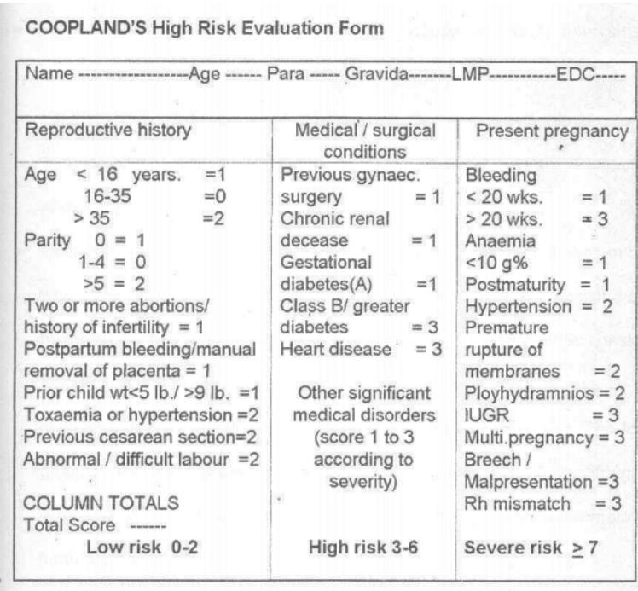
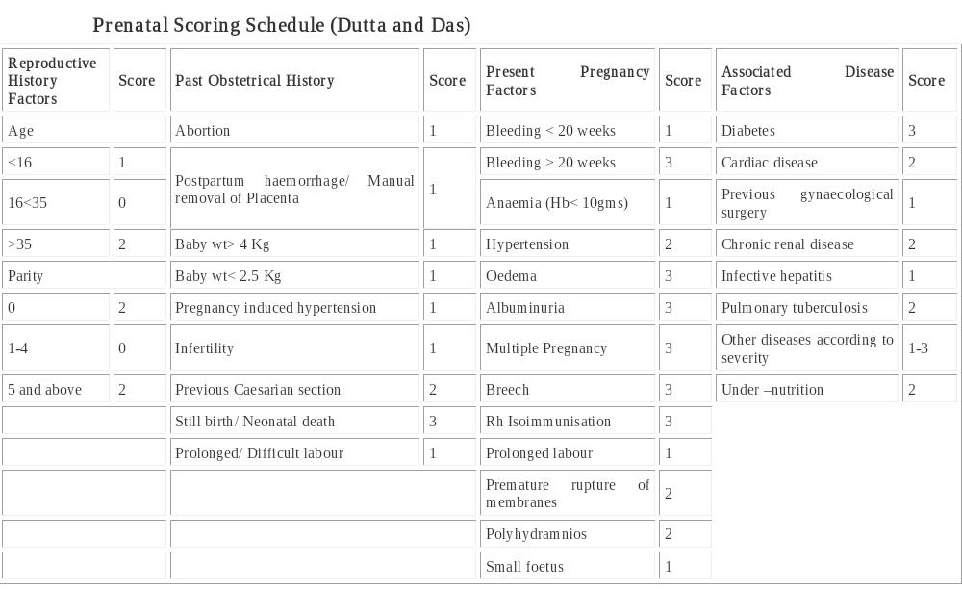

Conclusion:
High risk pregnancy evaluation provides an opportunity to an obstetrician to identify high risk conditions at the earliest and provide optimal management for optimal maternal and perinatal outcomes. It also provides a close insight of the effect of high risk pregnancy on the perinatal outcomes. With the rapid advancement of natural history of many new diseases and technology , high risk pregnancy scoring system is the need of today. Timely appropriate care for those who needs most had definite impact on maternal and neonatal outcomes.
References:
- Nesbitt , R.E.L, & Aubry , R.H. (1969). High –risk obstetrics. American Journal of Obstetrics& Gynaecology, 103, 972-985.
- Hobel CJ, Hyvarinen MA , Okade DM et al . Prenatal and intrapartum high risk screening prediction of the high risk neonate . American Journal of Obstetrics and Gynaecology , 1973;117(1): 1-9.
- Coopland AT, Pebble LJ, Baskett TF, Rollwagen R. Simpson A, Parker E. A simplified antepartum high risk pregnancy scoring form: statistical analysis of 5459 cases . Can Med Assoc. J. 1977; 116(9): 999-1001.
- Dutta S, Das XS. Identification of high risk mothers by a scoring system and its correlation with perinatal outcome . J. Obstet Gynaecol India. 1990; 40: 181-90.
- Bhavna A et al .Importance of developing a new modified high risk pregnancy scoring system. Indian Obstetrics and Gynaecology 2017; 7(1):10-14.


Dr. Surya Malik had done her MBBS from MLNMC , Alllahabad in 2009 & M.D from G.M.C Patiala. She is a proud winner of Prof. P.D Baveja & Smt Nathwanti Baveja Memorial Medal . she was awarded Kamala Memorial Memorial award for best performance in Obs Gynae. She has accomplished several trainings & courses including USG ,NDVH & Endoscopy. She has got various research publications in Indian & International Journals. She has done paper & poster presentations inn various conferences. Presently she is persuing as Specialist in the dept of Obs & Gynae at King Khalid Hospital, Alkharj, Riyadh.

