Risk factors for preterm birth in South Africa and Algeria

Dr. Jónathan Hernández-Núñez, MSc, MD, AP, ASSOCRS. Tshilidzini Hospital, South Africa.
Dr. Fermín Luis-Martínez, MD. Mohamed Golliat Hospital, Algeria
Dr. Ndivhuwo Michael Ndwambi, MD. Tshilidzini Hospital, South Africa.

Abstract
Statement of the Problem: Prematurity continues to be one of the great problems of obstetrics due to the great morbidity and mortality associated with it; a clear prevention strategy to reduce preterm birth rates has not yet been reached. The purpose of this study was to identify the risk factors associated with preterm delivery. Methodology & Theoretical Orientation: A case-control study was conducted at Tshilidzini Hospital in South Africa and Mohamed Golliat Hospital in Algeria between January 2015 and December 2016. The universe was 97 patients with preterm delivery and the initial sample was matched with the universe for the group of cases, also a control group of 291 patients with term delivery were selected, all randomly selected from a list of random numbers following a 3:1 ratio; the sample was definitively made up of 89 cases and 255 controls. The data were collected through a form filled by review of the obstetric and hospital files; statistically we used the frequency distribution, mean, standard deviation, percentage, Ji square test, Student's test and Odds Ratio. Findings: The risk factors for preterm delivery were the maternal age of 35 years or older (OR = 2.94), single marital status (OR = 2.98), maternal obesity at the beginning of pregnancy (OR = 1.78 ), previous history of chronic hypertension (OR = 3.77), seven or more prior abortions (OR = 7.17), previous preterm delivery (OR = 3.46), preeclampsia-eclampsia (OR=5.99), urinary tract infection (OR = 3.41), multiple pregnancy (OR = 5.00) and oligohydramnios (OR = 6.06); not the cultural level, the toxic habits, the parity, nor the short interpregnancy intervals. Conclusion & Significance: There are multiple risk factors that predispose to preterm delivery and contribute to increase perinatal morbidity and mortality, many of which are susceptible to be modified from primary health care.

Image
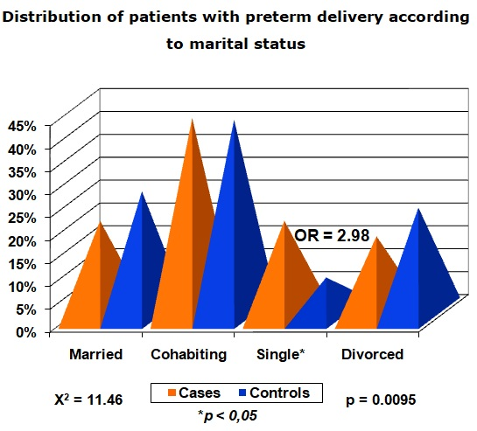
Recent Publications
- Begum K, Islam MN, Hossain MA, Ali MA, Islam MK, Islam MA, et al. Risk Factors and Immediate Outcome of Very Low Birth Weight Babies (Appropriate For Gestational Age) In Newly Established SCANU, Mymensingh Medical College Hospital. Mymensingh Med J. 2017 Jul; 26(3): 477-82.
- Abdel Razeq NM, Khader YS, Batieha AM. The incidence, risk factors, and mortality of preterm neonates: A prospective study from Jordan (2012-2013). Turk J Obstet Gynecol. 2017 Mar; 14(1): 28-36.
- Zhang G, Feenstra B, Bacelis J, Liu X, Muglia LM, Juodakis J, et al. Genetic Associations with Gestational Duration and Spontaneous Preterm Birth. N Engl J Med. 2017 Sep 21; 377(12): 1156-67.
- Amini P, Maroufizadeh S, Samani RO, Hamidi O, Sepidarkish M. Prevalence and Determinants of Preterm Birth in Tehran, Iran: A Comparison between Logistic Regression and Decision Tree Methods. Osong Public Health Res Perspect. 2017 Jun; 8(3): 195-200.
- Tsur A, Mayo JA, Wong RJ, Shaw GM, Stevenson DK, Gould JB. 'The obesity paradox': a reconsideration of obesity and the risk of preterm birth. J Perinatol. 2017 Oct; 37(10): 1088-92.
- Escobar-Padilla B, Gordillo-Lara LD, Martínez-Puon H. Risk factors associated with preterm birth in a second level hospital. Rev Med Inst Mex Seguro Soc. 2017 Jul-Aug; 55(4): 424-8.

Photograph

Biography
Medical doctor, specialist in obstetrics and gynecology, master's degree in integral care for women, assistant professor, research associate.

Email: johnhdez1973@gmail.com

Notes/Comments:

