Abstract
Abstract Title: Assessment of organochlorine pesticides in Ogun River and abattoir meat products from Kara abattoir, near Berger, Lagos, Nigeria
First R. Alani, Second B. Alo

¹ First Author Affiliation (University of Lagos, Nigeria)
²Second Author Affiliation (University of Lagos, Nigeria)

Abstract (not more than 300 words)

Our previous study on Ogun River at Kara abattoir revealed high concentration of gamma hexachlorocyclohexane (HCH) also called lindane, in water and sediment of the river. The use of this river as drinking water for the animals, coupled with the serious short and long-term health effects of lindane prompted this research. In the present study, water and sediment samples were taken from twenty locations in Ogun River and assessed for physico-chemical parameters and seventeen organochlorine pesticides (OCs) which include α-HCH, β-HCH, γ-HCH, δ-HCH, Endrin, Endrin aldehyne, Endrin, Hepthachlor, Hepthachlor epoxide, Aldrin, Dieldrin, Endosulfane 1, Endosulfane 11, Endosulfane sulphate, Methoxychlor, α-chlordane, γ-chlordane, DDE, and DDT. Crabs and fish samples from the river were also assessed. Meat parts including beef, blood, heart, kidney, lung, liver, skin, tongue, milk, large intestine, small intestine and urine were also taken from three bulls and three cows; one male goat and one female goat; one ram and one ewe; and their feeds, were assessed for the OCs using Gas chromatography/Electron capture detector (GC/ECD). Most of the physico-chemical parameters were within WHO limits, except chemical oxygen demand (COD), dissolved oxygen (DO) and biochemical oxygen demand (BOD) at some locations. Generally, OCs were higher in the sediments than in the water, meat parts, animal feeds, fish and crabs. γ-HCH, DDT, Aldrin, Endrin, Dieldrin, and Endosulfan all exceeded the Canadian water quality guidelines (CWQG) where present. Dieldrin (12.33ug/Kg) exceeded the Canadian interim sediment quality guideline (ISQGs) of 2.58ug/Kg while Endosulfan sulfate (2.047-42.748 ug/Kg), Endosulfan II (3.54-154.37 ug/Kg), Endrin aldehyde (5.98-13.53 ug/Kg) and methoxichlor (1.71-2.86 ug/Kg) were quite high. OCs in other samples were below WHO maximum residue level (MRL). The male animals had more OCs than their females. Sum OCs were highest in tongues, large intestines, liver, heart, with one bull blood sample having the highest sum concentration of 21.16ug/Kg.
Keywords—Abattoir, Meat products, Ogun River, Organochlorine pesticides

Professional Biography (100-150 words)

Dr. Rose Alani completed her PhD on Environmental/Analytical Chemistry in 2011 from the University of Lagos, Nigeria, after being trained at the Great Lakes Institute for Environmental Research (GLIER), University of Windsor, ON, Canada, under the Canadian Association for Environmental Analytical Laboratories (CAEAL) requirements as a trained Analyst. She participated in the 11th Summer school on “toxic compounds in the environment”, in the Research Centre for Toxic Compounds in the Environment (RECETOX), Brno, Czech Republic, in June 2015. She is a senior lecturer in the University of Lagos, and currently a visiting scientist to the Institute of Photonic Sciences (ICFO) in Barcelona, Spain, from March to August 2018. She has published more than 18 papers in reputed journals and has been serving as an editorial board member of repute. She has presented papers in twelve local and eight international conferences. She is a member of Local and International professional organizations.

Recent Publications (up to 5)

- Alani, R., Odunuga, S., Andrew-Essien, N., Appia, Y. and Muyiolu, K. (2017) Assessment of the Effects of Temperature, Precipitation and Al titude on Greenhouse Gas Emission from Soils in Lagos Metropolis. Journal of Env ironmental Protection, 8, 98-107.
- Alani Rose, Akinsanya B., Erhabor-Chimezie M., Nwude D. (2017) Earthworm Biomass as Additional Information for Risk Assessment of PCBs: A Case Study of Olusosun Dumpsite, Ojota, Lagos, Nigeria. American Journal of Life Sciences. Special Issue: Environmental Toxicology. Vol. 5, No. 3-1, pp. 52-59. doi: 10.11648/j.ajls.s.2017050301.18
- Alani Rose, Abdulfatai Mustapha, Ogbe Rachael, Akinade Bayo (2017). Health Hazards, Safety Risks and Security Threats Posed by Olusosun Dumpsite on Olusosun Community at Ojota, Lagos, Nigeria. American Journal of Life Sciences. Special Issue: Environmental Toxicology. Vol. 5, No. 3-1, pp. 43-51. doi: 10.11648/j.ajls.s.2017050301.17
- Akinsanya, B., Alani, R., Ukwa, U., Bamidele, F., and Saliu, J. (2015). Bioaccumulation and distribution of organochlorine residues across the food web in Lagos Lagoon, Nigeria. African Journal of Aquatic Science Vol. 40(4): 403-408.
- Alo, B. I, Alani, R. A., Olayinka, K. O., and Drouillard, K. G. (2014). An Evaluation Of The Levels Of Polychlorinated Biphenyls (PCBs) Contamination Of The Lagos Lagoon, Nigeria. PROCEEDINGS of the Nigerian Academy of Science. Vol. 7. ISSN:0794-7976: 45-67.

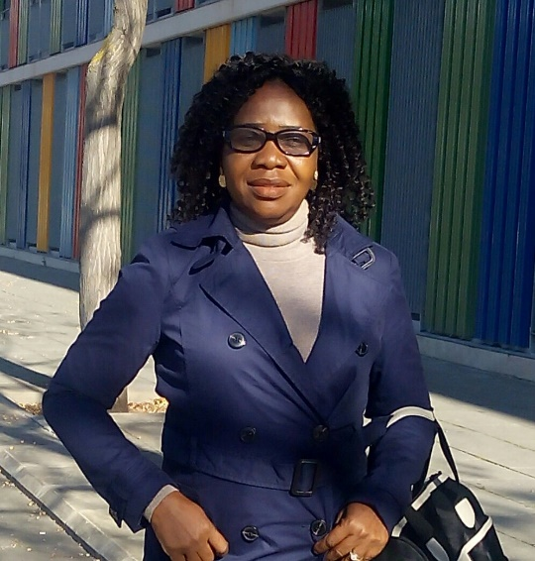
Paste your Photograph here

Email Id: ralani@unilag.edu.ng

Any Comments: Other email addresses rosealanito@yahoo.com, Rose.Alani@icfo.eu
Co-Author´s email addresses: balo@unilag.edu.ng, profjidealo@yahoo.com.
Kindly use this because one of the email addresses of the co-author was wrong in my first submission. Thank you.

