Abstract
Title: Assessment of the effects of physical disturbances in simple micro-universes by measurement of DOC-levels
Zilinskaite Nemira, Calle Edo Vargas Javier
Nemira Zilinskaite (University of Nottingham, UK)
Javier Edo Vargas Calle (University of Uppsala, Sweden)

Abstract (not more than 300 words)

An increasing problem with today's way of living is the rising of anthropologically influenced pollutions. Quite recently has research been directed towards the effects and consequences these disturbances may cause within freshwater environments, which has inspired this study. Hoping to assess the effects of different disturbances that are likely to occur in lakes, DOC-levels (Dissolved Organic Carbon) were measured to get an idea of what might happen to the microbial ecology when these are introduced. The research was conducted by introducing a heavy reduction of bacteria, microplastics, SDS (Sodium dodecyl sulfate) and microplastics and SDS together to enclosed environments. The purpose of this, and also the aims of this study being to 1) find out of DOC-levels were affected, if 2) a difference could be observed between exposure to microplastics + SDS versus microplastics and SDS alone, and 3) to assess the recovery after each disturbance. Following exposure DOC-levels remained generally unchanged in the reduced bacteria and microplastics mesocosms, whereas these levels were heavily reduced after exposure to SDS. It was also found that SDS + microplastics required a shorter exposure time before mortality was observed than SDS alone, and resulted in a much higher mortality rate than microplastics alone.

DOC, mesocosm, microplastics, SDS

Professional Biography (100-150 words)
Nemira Zilinskaite is a first-year student of University of Nottingham, studying Biotechnology. She has a practice in working in her first research in University of Uppsala, which was the one she wants to present in this conference. She finished the Siauliai Didzdvaris gymnasium in Lithuania in 2017 July.
Paste your Photograph here
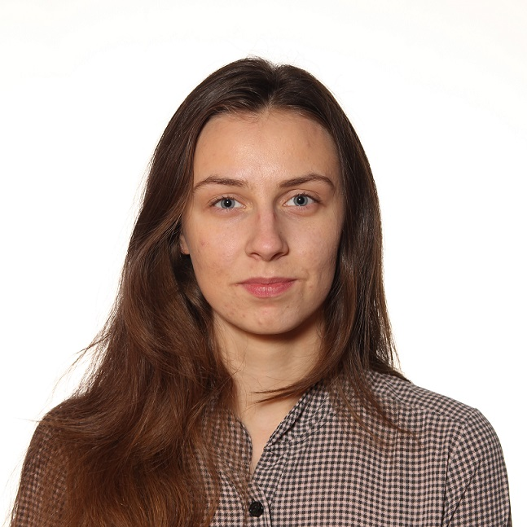

Email Id: zilinskaite.nemira@gmail.com

