Abstract Template
Abstract Title: Storm water treatment in a subsurface constructed wetland in a farmyard in Latvia
Linda Grinberga, Ainis Lagzdins

Latvia University of Agriculture, Department of Environmental Engineering and Water Management

Abstract (not more than 300 words)

The water treatment system examined in this study consists of a sedimentation pond as a pre-treatment plant, a water pump and a horizontal subsurface flow constructed wetland with the surface area of 160 m². This treatment system was installed at the farm Mezaciruli, Zalenieki County, Jelgava region, in the middle part of Latvia, in August 2014 to improve storm water quality collected from the farmyard and demonstrate applicability of constructed wetland as a suitable treatment option for contaminated surface runoff. During the observation period of 32 months (2014-2017) water quality parameters such as total suspended solids (TSS), nitrate - nitrogen (NO₃-N), ammonium - nitrogen (NH₄-N), total nitrogen (TN), orthophosphate - phosphorus (PO₄-P), and total phosphorus (TP) were monitored and nutrient removal efficiency of the system was calculated. Nutrient concentrations in water samples collected at the inlet and outlet were compared.
The monitoring results obtained during this study showed that on average concentrations of TN and TP were reduced by 34% and 82%, respectively. Overall, the subsurface flow constructed wetland displayed a steady decrease for all measured water quality parameters when average monthly nutrient retention values were compared. However, in some cases, an increase in the amount of nutrients leaving the constructed wetland was observed. The wetland retained suspended solids on average by 59% and similarity as for nutrients showed occasional increase in concentration during the non-vegetation period (October to March). This study illustrated that subsurface flow constructed wetland has a potential to reduce nitrogen and phosphorus concentrations in storm water.

Keywords — Constructed wetland, nutrients, retention, storm water.

Professional Biography (100-150 words)

Linda Grinberga is a PhD student in Latvia University of Agriculture. She is a departmental international coordinator at the Faculty of Environment and Civil Engineering. She is a lecturer and researcher at the Department of Environmental Engineering and Water Management. She has participated in 9 scientific projects.

Recent Publications (up to 5)

- Grinberga L., Lagzdins A. (2017) Nutrient removal by subsurface flow constructed wetland in the farm Mezaciruli. Research for Rural Development 2017: Annual 23rd International Scientific Conference Proceedings, Vol. 1, p. 160 – 165.
- Sudars R., Berzina L., Grinberga L. (2016) Analysis of agricultural run-off monitoring program results for estimation of nitrous oxide indirect emissions in Latvia. In: Proceedings of the 15th International scientific conference "Engineering for rural development". Jelgava, Latvia, Latvia University of Agriculture. Faculty of Engineering. Vol.15, p. 1030-1035 URL: https://www.scopus.com/inward/record.uri?eid=2-s2.0-84976563513&partnerID=40&md5=0afe051d1fec5fa417c06c40d635eca3
- Lagzdins A., Grinberga L., Siksnane I. (2016) Drainage Water Management in Open Ditches – Solutions and Effects in Latvia. In: Proceedings of the 10th International Drainage Symposium. American Society of Agricultural and Biological Engineers, p. 70 – 75.
- Lagzdiņš A., Jansons V., Veinbergs A., Grinberga L., Siksnāne I. (2016) The Effects of Water Level Control Structures on Nutrient Reduction in Agricultural Runoff. In: Abstracts of the XXIX Nordic Hydrological Conference “The Role of Hydrology Towards Water Resources Sustainability”, p. 73. ISSN 1650-8610, ISBN 978-609-449-096-5.
- Lagzdiņš A., Jansons V., Sudārs R., Grinberga L., Veinbergs A., Abramenko K. (2015) Nutrient losses from subsurface drainage systems in Latvia. Acta Agriculturae Scandinavica, Section B - Plant Soil Science, Vol. 65, p. 66 – 79. URL: http://www.scopus.com/inward/record.url?eid=2-s2.0-84925954873&partnerID=40&md5=970a4a16cfa68133080a62af8b6018c7

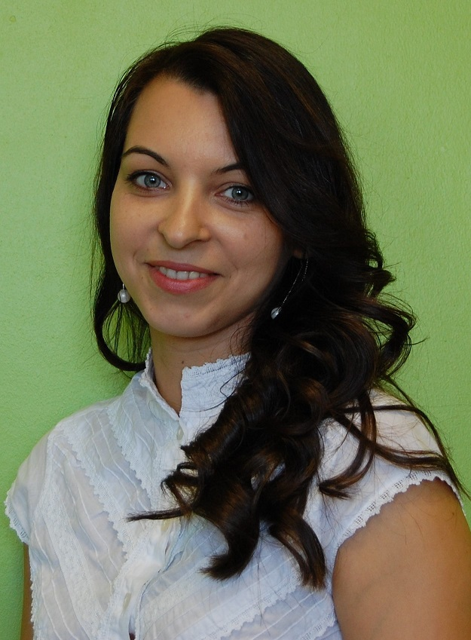
Paste your Photograph here

Email Id: linda.grinberga@llu.lv

Any Comments:

