KEY OPTIONS FOR AMMONIACAL NITROGEN REMOVAL,
RECOVERY AND REUSE

Dr. Robert Eden ¹, Bryan Johnson ²
1. Organics, Ltd, University of Warwick Science Park, Coventry, CV47EZ, England

Keywords

Ammonia, Removal, Recovery, Reuse

EXECUTIVE SUMMARY (100 words maximum)

The paper provides a summary of the processes involved with thermal ammonia desorption, widely employed in Hong Kong, where the demand for high-concentration ammonia removal, the lack of space for extensive biological lagoons and the availability of waste-heat, provides conditions conducive for this technology to be applied. In addition to ammonia removal, a summary of the processes of ammonia recovery, especially as anhydrous ammonium, will be outlined. The topic will be taken further with a review of options for reuse of ammonia, primarily in ammonia fuel-cells for “green” electricity production. The paper presents operational data, performance charts and mass-energy balances for thermal destruction, ammonia recovery and ammonia reuse.

HIGHLIGHTS

- The paper reviews in outline the major process alternatives for removal of ammonia, highlighting important strengths and weaknesses.

- The paper analyses the processes involved in thermally stripping ammonia from wastewater, looking at both thermal destruction of the extracted amminia as well as recovery as ammonium hydroxide, an ammonium salt or anyhydrous ammonia.

- The paper explains how the recovery of ammonia from wastewater provides an opportunity for re-use, supporting sustainability, additional revenue generation and the circular economy

- The paper discusses the evolution of Sustainable Development Goals (SDGs), which has created the conditions where high-strength ammonia removal has become an important objective to pursue in Europe.

METHODOLOGY/ PROCESS

Introduction
The removal of ammonia from wastewater can be accomplished by means of biological processes or physicochemical process technologies, such as membrane ion-exchange. The objective of the proposed paper is to review in outline each of the major options for removal of ammonia, highlighting important strengths and weaknesses.

Methodology
This assessment is followed by a more detailed analysis of a process to thermally desorb ammonia from wastewater for thermal destruction, recovery as ammonium hydroxide, recovery as an ammonium salt, such as ammonium sulphate, or recovery as anhydrous ammonia. Such arrangements require thermal energy for the heating of wastewater and the cooling of scrubber water. Recovery as ammonium hydroxide or anhydrous ammonia does not require the addition of chemicals, which ensures a low operating cost where waste heat is available. Such recovery of ammonia provides a product with a commercial value.

The paper also provides a summary of the processes involved with thermal ammonia desorption, widely employed in Hong Kong, where the demand for high-concentration ammonia removal, the lack of space for extensive biological lagoons and the availability of waste-heat, provides conditions conducive for this technology to be applied.

The paper addresses the prospect of producing anhydrous ammonia, which can also be sold or used for on-site power generation. Examples of ammonia power generation will be provided. The recovery of ammonia from wastewater provides an opportunity for re-use, supporting sustainability and the circular economy.

Organics has designed and built sixteen thermal ammonia strippers in Hong Kong; the smallest having a flow rate of 480 m3/day and the largest 2,600 m3/day.

Conclusion
The paper concludes with and overview of the economics involved in the operation of such facilities. It is specifically geared towards the economics of operation in Europe.

In the Europe, the evolution of Sustainable Development Goals (SDG) has created conditions where high-strength ammonia removal has become an important objective to pursue.

RESULTS/ OUTCOMES

Figures and Tables
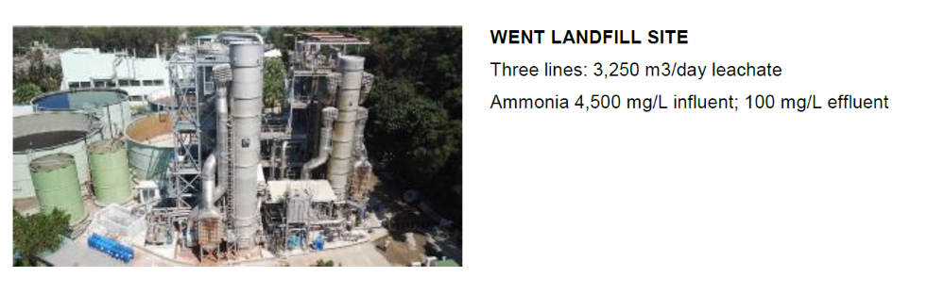
Figure 1 West New Territories Landfill – first commission in 1999. Expanded twice and currently operational
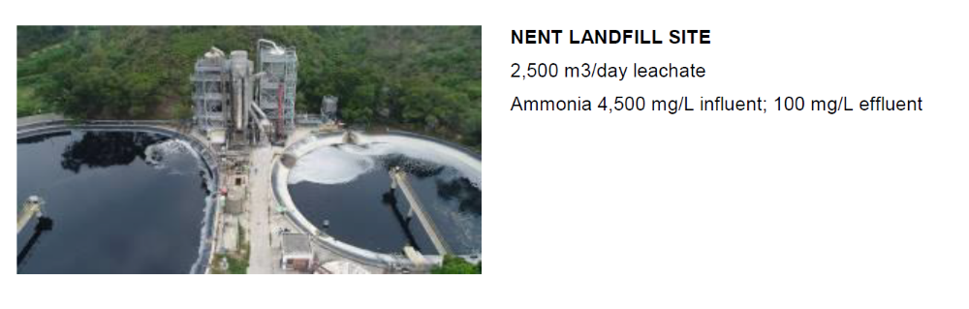
Figure 2 North East New Territories Landfill – Commissioned in 2001. Expanded once. Currently operational

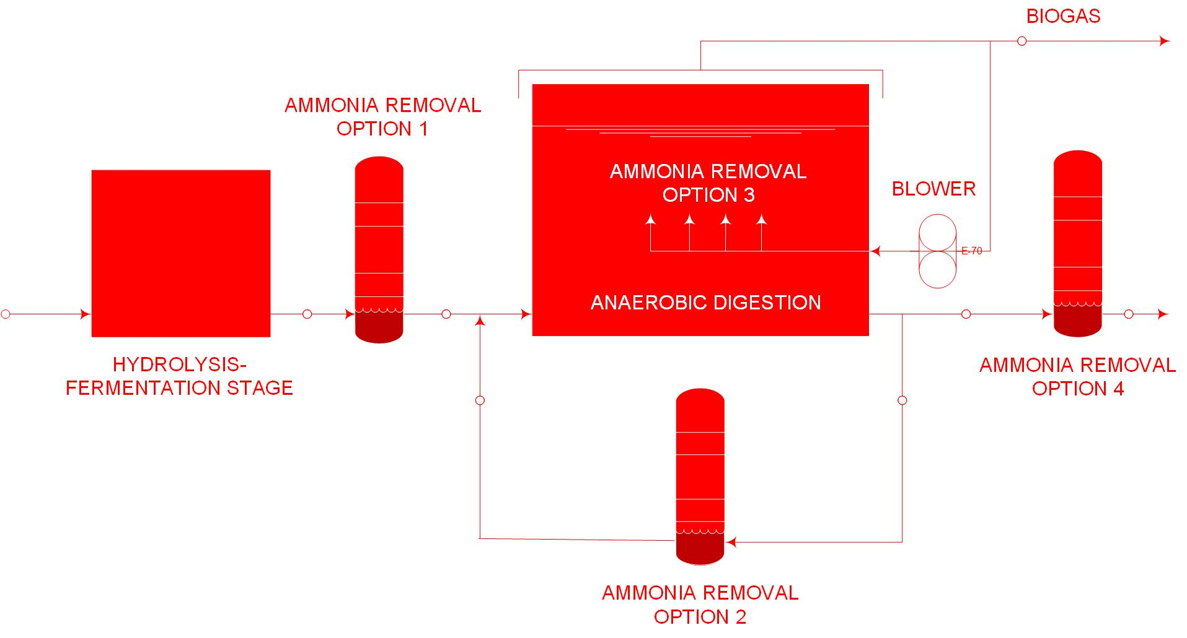
Figure 3: Optional locations for ammonia removal in the operation of an anaerobic digester

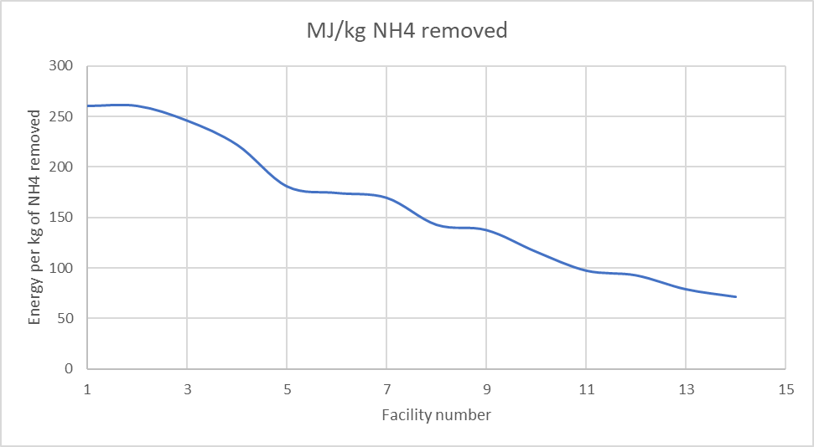

Figure 4 Improvements in thermal energy use against time
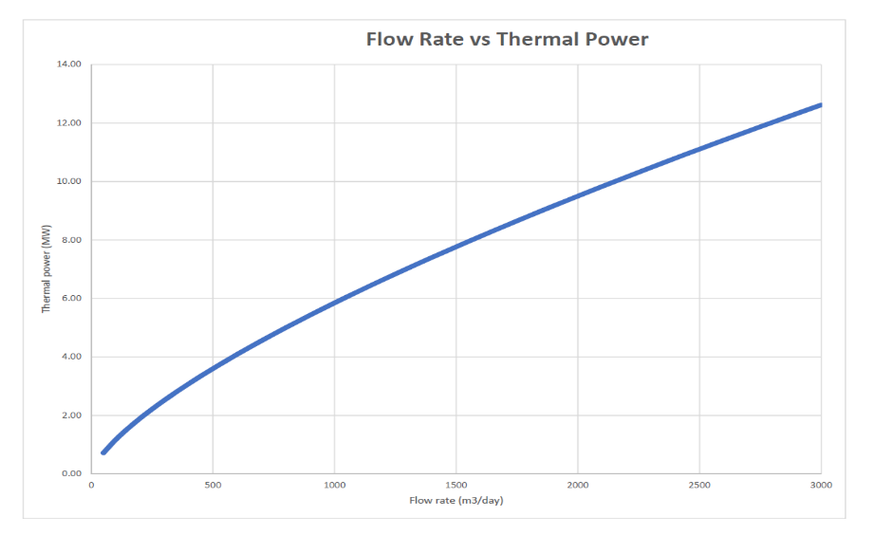

Figure 5 Thermal power requirement vs wastewater flow rate – NH₄-N 4500 mg/L to < 100 mg/L
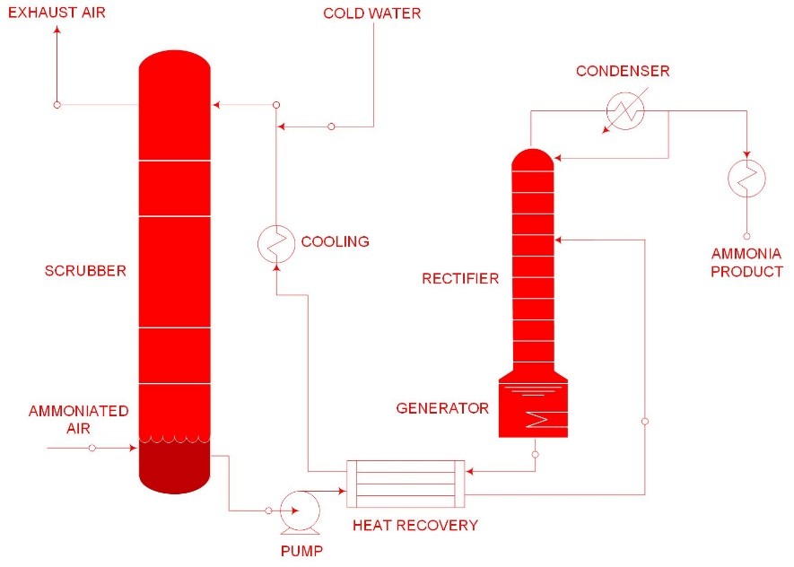

Figure 6 Process flow diagram for recovery of anhydrous ammonia

