Abstract Template
Abstract Title: Waste Management – Where Have We Been and What’s Ahead?
Ellen Moyer, PhD, PE

¹Greenvironment, LLC

Abstract (not more than 300 words)

Humans, like all species, have always generated wastes. While human populations were small and technology was relatively simple, waste impacts were small and materials were mostly recycled. As our population increased and technology advanced, wastes increased in volume and toxicity. After World War II, waste generation even became a desirable end in itself in our “throw-away” society (especially in my country, the United States); the practice of planned obsolescence requiring us to repeatedly buy and dispose of things that don’t last long, such as light bulbs, helped to sustain an economic boom. The habit of throwing things “away” means that today 40 percent of the food grown in the United State is wasted while children go hungry.
With recent skyrocketing human population growth and industrial technology development, waste management practices have created devastating problems. Though we came to view ourselves as separate from - and superior to - nature, environmental damage from waste is directly mirrored in human health damage because we are interconnected with our environment. For example, the environmental problem of plastics in oceans and soils is accompanied by human health problems from exposure to harmful chemicals in plastics.
Escalating waste problems are motivating us to move toward “cradle-to-cradle” technology in which waste from one process is used as feed to another process. This necessitates a transition from petroleum- and halogen-based chemistry to more benign “green chemistry.” Could we be on our way to a healthier, more prosperous, and more secure “high-tech and high-nature” way of life in which materials are recycled, without the continued accumulation of unwanted wastes?

Keywords—cradle-to-cradle, green chemistry, human health, waste management

Professional Biography (100-150 words)

Ellen Moyer’s mission is to help restore the environment and promote a healthier way for us to inhabit the Earth. With a B.A. in anthropology, an M.S. in environmental engineering, a Ph.D. in civil engineering, and 30 years of consulting experience, Dr. Moyer is a registered professional engineer and a U.S. Green Building Council LEED Accredited Professional. She helps government agencies and Fortune 500 companies clean up hazardous waste sites, protect environmental resources, and develop green solutions. She writes and speaks extensively, with 30 articles and several books, including her multiple award-winning third book, Our Earth, Our Species, Our Selves: How to Thrive While Creating a Sustainable World. She is a member of the editorial board of Soil and Sediment Contamination: An International Journal and the scientific advisory board of the AEHS Annual International Conference on Soils, Sediment, Water, and Energy. www.ellenmoyerphd.com.

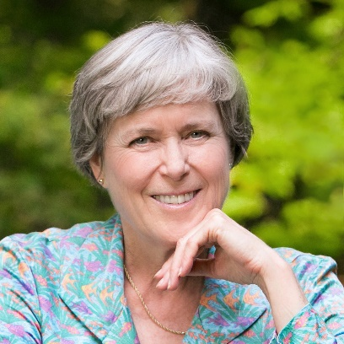

Email Id: ellenmoyer@em-green.com

Any Comments: I’m submitting the abstract for a video presentation

