Industrial Scale Plant for Sewage Sludge Valorization by
Hydrothermal Carbonization in Jining/China and
Phosphate Recovery by TerraNova® Ultra HTC Process
Buttmann, M.¹
¹TerraNova Energy GmbH, Germany
marc.buttmann@terranova-energy.com

Abstract
In Jining/China 14.000 t of dewatered sewage sludge are treated by TerraNova® Ultra Hydrothermal Carbonization (HTC) technology per year to generate a regenerative, solid fuel for energy production.
The technology is economically attractive as the sewage sludge is considerably reduced in mass during HTC and subsequent purely mechanical dewatering of up to 70% DM. It requires only 20% of the energy input compared to conventional sludge treatment drying technologies.
Furthermore, TerraNova® Ultra enables the recovery of Phosphorous from sewage sludge. By adjusting the pH level during the HTC process, Phosphorous is leached into the liquid phase and transferred into the filtrate. By adding CSH minerals to the filtrate >80% of the Phosphorous is recovered as fertilizer product. The moderate use of reagents and the one-step process allow for low specific cost.
In the lecture the energy- and mass- balance of TerraNova® Ultra, the Phosphorous recycling process and the fertilizer specification as well as typical project economics for an installation in Europe will be presented.
Keywords
Sludge dewatering, thermal conditioning, Hydrothermal Carbonization, Phosphorous recovery
Introduction
The economic disposal of sewage sludge is an increasing challenge for municipalities due to the increase of environmental standards and the closing down of traditional disposal paths. Mass reduction by anaerobic treatment or thermal sludge drying are solutions widely seen but with some disadvantages in terms of energy and cost efficiency.
The TerraNova® Ultra technology includes a thermo-chemical sludge conditioning followed by an ultra-dewatering step for highly energy efficient mass reduction. The final product is sterilized with low water content and can be used as CO2-neutral fuel for energy production or for agricultural application.
Phosphorous can be recovered from sewage sludge within the TerraNova® Ultra process at little cost in form of a Calcium-based recycling product.
Technology
The following process flow diagram shows the basic principal of the TerraNova® Ultra technology:

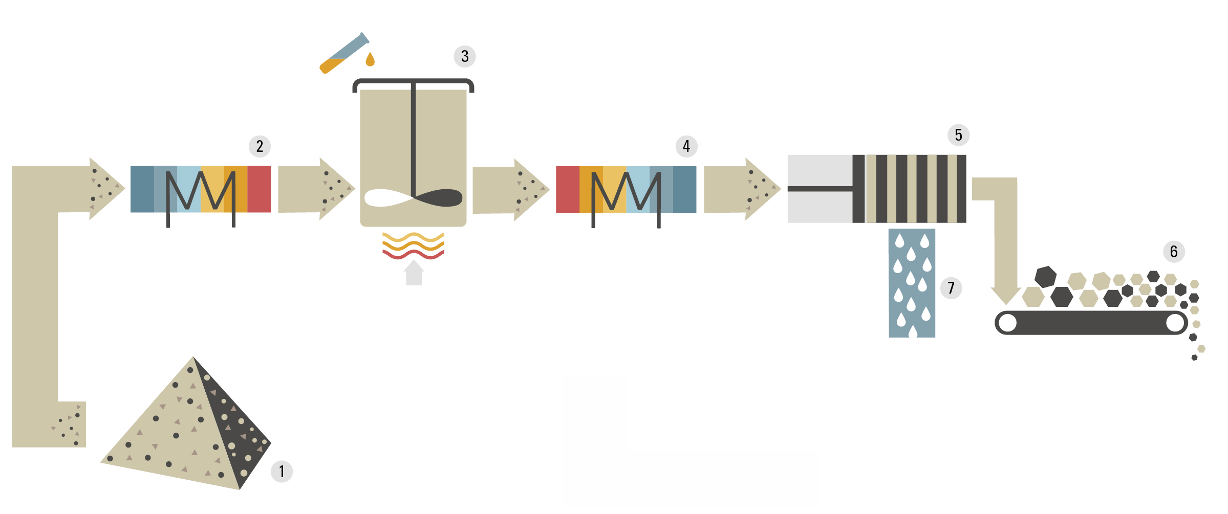
Figure 1: Basic principal of TerraNova® Ultra
- Dewatered sewage sludge (1) with a dry matter content of 5-30% is conveyed into the input heat exchanger (2) by means of a high pressure sludge pump.
- The preheated sewage sludge is carbonized in an agitated reactor (3) with the addition of a catalyst for three hours at a temperature level of around 200°C. The reactor is heated with thermo oil. The heat source can be, for example, the waste heat of a Combined Heat and Power Plant (CHP).
- The resulting coal slurry is cooled down in the output heat exchanger (4). The dissipated heat is fed back to the input heat exchanger (2) by means of a separate thermo-oil-circuit.
- In a dewatering unit, for example a fully automated chamber filter press, the coal slurry is dewatered to a dry matter content of 65-70% (5). In a consequent vacuum drying step the final product can be dried to 90% dry matter.
- The dried sewage sludge coal (6) can be disposed of in incineration plants for energy production. The volume is reduced to less than 1/3 of the original volume.
- In the filtrate (7), that was obtained by solid-liquid-separation, a large part of the Nitrogen and Phosphorous contained in the sewage sludge can be recovered in a highly plant-available form - even when the Phosphorous was precipitated with FeCl or Aluminum. Since its carbon content is easily bio-degradable, the biogas yield of the sewage sludge digestion is increased by 15% if the filtrate is fed back into the digesters.

Sludge volume reduction
For most wastewater treatment plants mass reduction of sewage sludge is the best option to save disposal costs. Traditionally, thermal drying is applied, reducing the water content of mechanically predewatered sludge to around 10%.
With TerraNova® Ultra, sludge dry matter is additionally reduced by the Hydrothermal Carbonization reaction. This exothermal reaction results in a conversion of solid hydrocarbon matter into CO2 as part of the process gas and liquid compounds found in the filtrate. These compounds, to be measured as high levels of COD, are 90% biodegradable and allow for additional biogas production in digesters.
With the additional dilution of non-organic salts, mostly N compounds, the dry matter found in the final solid product, is overall decreased by 25%.
The following table shows a comparison of the mass reduction between thermal drying and TerraNova® Ultra with or without the final drying step:

Table 1: Comparison of disposal mass after different sludge treatment technologies
Material to be disposed: | Dewatered sludge | Dewatered sludge after thermal drying | Dewatered sludge after TerraNova® Ultra | Dewatered sludge after TerraNova® Ultra including final drying
Dry matter content: | 25% | 90% | 65% | 90%
Dry matter mass: | 250 kg | 250 kg | 188 kg | 188 kg
Water mass: | 750 kg | 28 kg | 102 kg | 21 kg
Disposal mass: | 1000 kg | 278 kg | 290 kg | 209 kg
The disposal mass of TerraNova® Ultra is comparable with thermal drying technologies. More than 85% of the water originally contained in the dewatered sludge is removed by a purely mechanically process. If TerraNova® Ultra is followed by a final thermal drying step to further increase the dry matter content to 90%, the disposal mass will be more than 25% lower than with conventional thermal drying.

Operation data
The TerraNova® Ultra plant in Jining has passed its first year of continuous operation. The average dry matter content of the input sludge is at 23%, the average dry matter content of the dewatered sludge is at 68%. This value is above average and caused by the high mineral content of the input sewage sludge. The mass related reduction is around 75%. The electrical energy consumption of the core plant - the high pressure section between inlet pump and pressure release system - accounts to 12 kWh per ton of input sludge. The total power consumption, that includes sludge conveyor and storage systems, filter press operation and process gas treatment, is 18 kWh per ton of input sludge. Thermal energy is provided by a natural gas furnace which has a consumption of 13 m3 or 130 kWh per ton of input sludge. Commercially available acid is used as catalyst and is added at a rate of 2% to the sludge input mass. Based on tons per extracted water (t_{EW}). the energy consumption of TerraNova® Ultra is 174 kWh/t_{EW} for heat and 24 kWh/t_{EW} for electrical energy respectively. This compares to different thermal drying technologies of which low heat level dryers are considered the most energy efficient with consumption levels of 800 kWh/t_{EW} for heat and 80 kWh/t_{EW} for electricity. Thus the Jining project contributes to primary energy savings of 7,5 Mio kWh per year, an equivalent of 340 households.

Profitability calculation
Table 2: Economics of a TerraNova® Ultra Installation in Europe
TerraNova® Ultra |  | Comment
Annual input capacity: | 21.000 t | Sewage sludge with 23% dry matter
Investment: | 2,7 Mio EUR | EXW net
Project other cost: | 800.000 EUR | local engineering, project management, side preparation
Capex: | 282.695 EUR | Annuity 15 years, 2,5% interest
Cost electricity: | 56.700 EUR | 18 kWh/t; 0,15 EUR/kWh
Cost heat: | 27.300 EUR | 130 kWh/t; waste heat from CHP, only cost for thermo oil circle apply; 0,01 EUR/KWh
Catalyst: | 105.000 EUR
Spare and Wear parts | 30.000 EUR
Personnel | 50.000 EUR | only supervision
Service Contract | 25.000 EUR | provided by TerraNova Energy
Disposal cost coal | 250.788 EUR | 45 EUR / t disposal cost incl. transport
OPEX+CAPEX: | 827.483 EUR
Specific cost | 39,40 EUR/t | Total cost per ton of input sludge incl. final disposal of coal

Phosphorous recovery
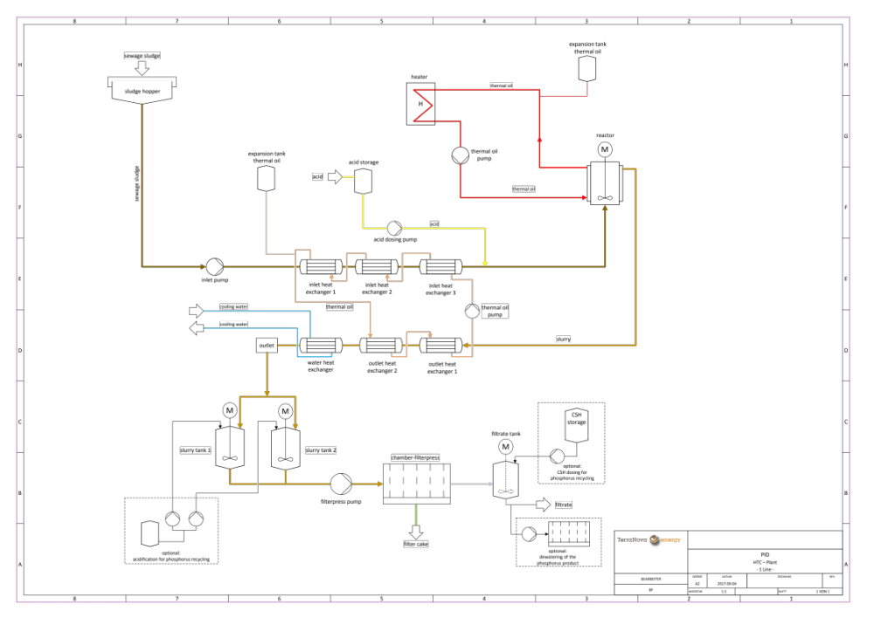
Figure 2: TerraNova® Ultra Process Flow Diagram with Phosphorous Recovery
Phosphorous recovery can be added to the TerraNova® Ultra technology as an option. It only requires small extensions of the plant design, shown as dotted areas in Figure 2:
- An acid dosing device is added to the coal slurry tanks after the output heat exchanger. Depending on the precipitant used in the wastewater treatment plant the pH of the slurry is decreased to between pH 1,5 and pH 3. This will lead to P-leaching of around 80% into the liquid phase. Due to strong bonding forces of the coal structure heavy metals are retained in the solid phase.
- After the solid-liquid-separation Calcium Silicate Hydrate (CSH) is added to the filtrate. CSH is a waste product from the construction industry. The addition of CSH leads to an increase in the pH value and subsequently to the bonding of diluted Phosphorous to the CSH-particles.
- In a final solid-liquid-separation the CSH-P-particles are separated from the P-depleted filtrate.
The TerraNova® Ultra process allows for economic Phosphorous recovery thanks to the simplicity of the process and the low consumption of chemicals. The following table shows the Phosphorous product quality with high plant availability and low heavy metal concentrations:
Table 3: TerraNova® Ultra Recycling Phosphorous Product
Compound: | Concentration:
Phosphorous P2O5: | > 16 %
Plant Availability (Citric Acid): | > 75%
Total Nitrogen N: | 1-2%
Potassium K2O: | < 1%
Magnesium MgO: | < 1%
Lead Pb: | < 10 mg/kg
Cadmium Cd: | < 0,5 mg/kg
Chromium Cr: | < 50 mg/kg
Copper Cu: | < 20 mg/kg
Nickel Ni: | < 10 mg/kg
Mercury Hg: | < detection limit
Zinc Zn: | < 200 mg/kg
P total recovery rate: | 60-80%

Conclusions
1. The TerraNova® Ultra technology breaks the carbon structure of sewage sludge and allows for the purely mechanical dewatering of up to 70% dry matter.
2. The overall mass of sewage sludge for disposal is reduced by 75% to minimize cost of operation for wastewater treatment plants.
3. The energy consumption is 70-80% lower than state of the art low heat dryers.
4. Phosphorous recovery can be added by a few modifications at low production cost.

