Characterisation of aluminium black dross before and after leaching
K. Hu¹, D. Reed², R.M. Smith¹, M.D. Ogden¹

¹Department of Chemical & Biological Engineering, University of Sheffield, Sheffield, South Yorkshire, S1 3JD, United Kingdom
²ALTEK Europe Ltd, Burley Close, Lakeside House, Chesterfield, South Yorkshire, S40 2UB, United Kingdom

Presenting author email: k.hu@sheffield.ac.uk
corresponding author email: m.d.ogden@sheffield.ac.uk

Abstract

Aluminium black dross is classified as a toxic and hazardous waste by the EU. Not only is it high in salts (e.g., 50-60 wt. % NaCl, KCl), it also contains small amounts of chemically active phases like nitrides and sulfides. One of the treatments in the commercial recycle process is salt recovery by aqueous leaching. The leaching residue, or non-metallic product (NMP), can be utilised in a variety of industries but must meet environmental standards before use in the cement, ceramic, and building industries. In this paper, 20g aluminium black dross was leached with 400 ml deionized water (15 min contact, 175 rpm agitation, 25 °C). Then two samples (before and after leaching) were used for various characterisation analysis: X-ray diffraction (XRD), X-ray Fluorescence analyzer (XRF), Scanning Electron Microscopy and Energy Dispersive Spectrometer (SEM/EDS), Fourier-transform infrared spectroscopy (FTIR) and Raman Spectroscopy. The results show that there was about 50.62% weight loss during leaching, the main loss composition was salts (NaCl, KCl). It can be noticed that the characteristic peaks of aluminium nitride in the leaching residue characterised by XRD seemed more obvious compared to sample before leaching, which could be one of the problems restricting the leaching residue’s further application.

Keywords— black dross, leaching, characterisation, non-metallic product, nitride

Professional Biography (100-150 words)

Dr. Keting Hu has an extensive background in Minerals Process Engineering and completed her PhD in 2014 in the School of Minerals Processing and Bioengineering, Central South University in the People’s Republic of China. Currently She is the lead researcher stationed between The University of Sheffield and Altek Ltd on Knowledge Transfer Partnership (KTP010597) which is focused upon developing black dross treatment processes.

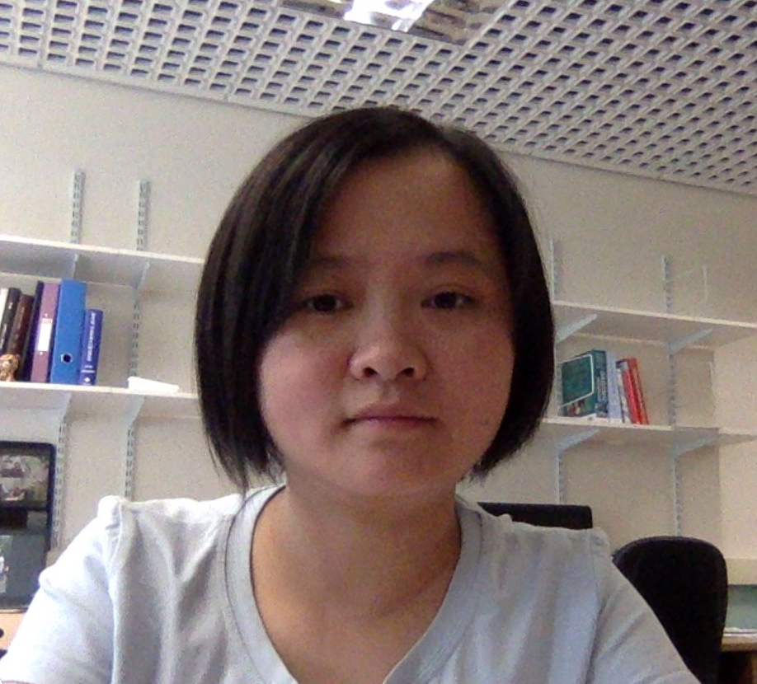
Email Id: k.hu@sheffield.ac.uk

Any Comments:

