Abstract Template
Abstract Title: Methodology for C&D waste collection and disposal and associated greenhouse gas emissions: Experiences from project SAMCODE in Skopje planning region

Igor Ristovski¹

¹ Igor Ristovski, NGO Gaya CER, Skopje

Abstract (not more than 300 words)

NGO Gaya CER from Skopje signed the contact with the Ferrara University from Italy and Civil Engineering Institute (IECE) Skopje for the project: SAMCODE, funded by KEP Italy 2017 programme.
One of the key outcomes is to develop a model for integrated management of solid waste that can be applied in the countries were waste collection is insufficient.
The methodology used in the project was made on the basis of observation and analysis of similar methodologies and experiences in other countries, by the Department of Environmental Engineering, Faculty of Technical Sciences in Novi Sad, in cooperation with the German Organization for International Cooperation – GIZ.
Appropriate integrated waste collection model was developed using a harmonized methodology, including:
- Analysis of the morphological composition of C&D waste - sorting the waste sample on fractions defined by EWC codes according to EU Directive on C&D;
- Analysis of current C&D waste management practices and needs of Public communal enterprises and construction companies;
- Analysis of illegal dump sites, planning waste collection routes, including transfer stations, selection of wastes and regional landfill planning, with WRATE-LCA software;
- Use of drone imagery, GIS mapping and analysis, including Monte-Carlo likelihood for the best integrated model;
- Analysis of different fractions of C&D waste samples (over four seasons) from over 50 locations in the Skopje planning region in respect to their radioactivity, traces of heavy metals, hazardous properties, C/N ratios and their possibility for reuse / recycle in construction industry;
- Determination of greenhouse gas emissions in the waste samples, analysis of emissions for reuse/recycle of construction materials;
- Cost benefit and socio-economic analysis of several alternatives for integrated C&D waste management.

Study area was the Skopje planning region in Republic of Macedonia, or the 13 municipalities.
Economic costs and benefits to society (welfare effects) were analysed at the end to give a clear picture to all relevant stakeholders and decision makers and determine where they should plan future strategies and investments in respect to construction and demolition waste management.

Keywords: C&D waste collection model, greenhouse gas emissions, regional planning, illegal dumping, transfer stations.

Professional Biography (100-150 words)

Igor Ristovski is Experienced Environmental Engineer and Manager with a demonstrated history of working in the field of environmental protection and research. Skilled in ISO 14001, ESIA, SEA, Environmental Awareness, GIS & Spatial Modeling, Water Resource Management, Waste management, Climate Change and Industrial Safety. Strong research professional with a Master of Science (MSc) focused in Environmental Management from University of Wales, Aberystwyth.
Currently working in Queensland Government in Australia, as an Environmental Officer on preparation of environmental authorities, progressive certification, plan of operations and financial assurance approvals for coal mines, exploration permits and small scale mining claims, drafting responses to public concerns on various environmental topics, EIS reviews, negotiating environmental offsets and rehabilitation plans (now PRCP) across Queensland.
He is in a Roster of experts on climate change review (UN) and member of Macedonian national inventory team, sectors Waste and AFOLU.
Paste your Photograph here
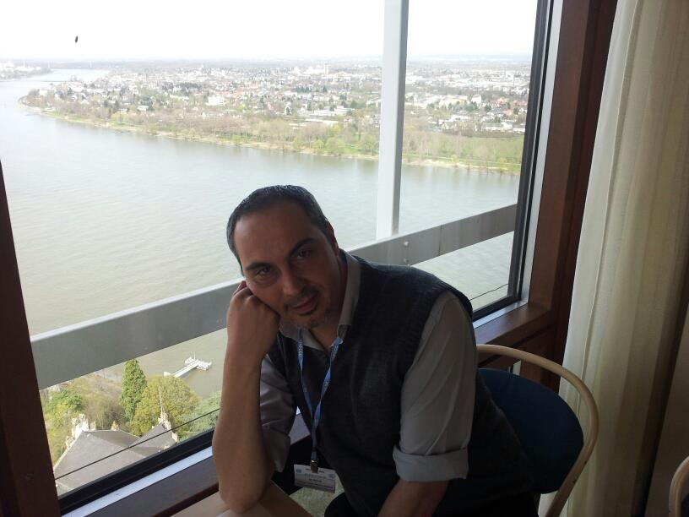
Email Id: igor.ristovski@gmail.com

Any Comments:

