Abstract
Environment is an envelope which has enclosed all physical and virtual development around the world. Being a common factor for all strata, environment should be given its due worth for any infrastructure, firstly to distinguish it from the rest of spaces and secondly to enhance the quality and use of that particular space. There are several methods of handling the environment in its utmost workable and suitable fashion, up-gradation being the continuous factor for an already defined environment. Though the up-graded technological environments have captured the world, yet more work is left to be done. The result is the technological revolution on one side and degradation of environment on the other. In order to provide a sustainable and naturally sufficient environment to all the inhabitants of the world, some of the problems need to be addressed on priority basis. Environmental degradation is one of them.
Environmental up-gradation of the basic civic facilities in the Katchi Abadis is the need of the day. As mankind is approaching towards the pure mechanical solutions to all problems, environmental up-gradation strategies prove to be realistic, workable and sustainable solution to these problems.
A large proportion of the urban population live in poor quality housing – for instance whole households live in one or two rooms in cramped, overcrowded dwellings such as tenements, cheap broadly-houses or shelters built on illegally occupied or subdivided land. My main objective “as an engineer” or “an environmentalist” to improve environmental conditions in Kachi Abadi of Lahore so that I can contribute to some extent.

Table of Contents
Abstract 1
List of Figure 8
List of Graph 9
List of Photograph 10
CHAPTER: 1 INTRODUCTION 11
1.1 Historical Background 11
1.2 Administrative Setup in Pakistan 13
1.3 Statement of the Problem 14
1.4 Research Objectives 14
1.5 Research Questions 15
1.6 Significance of Study 15
1.7 Research Methodology 16
1.8 Delimitations of the Study 16
1.9 Limitations of the Study 16
CHAPTER-2: REVIEW OF RELATED LITERATURE 17
2.1 Definitions 17
2.2 Squatter Settlement at Global Level 18
2.2.1 Identifying the Challenge 18
2.3 A Case Study of Squatter Settlement, Accessibility of Land and the Urban Poor Mustapha Oyewole Bello, Nigeria 21
2.3.1 The Evolution and Types of Squatter Settlements in Nigeria 22
2.3.2 Unwholesome Effects of Squatting 23
2.3.3 Management of Squatting Activities and Squatter Settlements 24
2.3.4 Conclusions and Policy Implication 26
2.4 A Case Study of Rural Water and Sanitation in Ukraine: Problems and NGOs participation 26
2.4.1 Health situation related to Water supply and sanitation sector 27
2.4.2 Rural Sanitation 28
2.4.3 Ukrainian State Programs on Drinking Water for Rural Areas 28
2.4.4 Ukraine – Millennium Development Goals – 2000+5 29
2.4.5 MAMA-86’s Drinking Water Campaign 29
2.4.6 "MAMA-86" Pilot Projects in the Rural Area in 2001-2004 29
2.4.7 The Pilots’ Results 29
2.4.8 Ecosan Projects in Ukraine 30
2.4.9 Results of Ecosan Pilots 2003-2006 30
2.5 A Case Study of Municipal Solid Waste Management in Kohima’Nagaland-India 31
2.5.1 Data Collection 33
2.5.2 Transportation of Waste 35
2.5.3 Processing and Disposal 35
2.5.4 Results 36
2.5.5 Waste Generation and Quality 37
2.5.6 Segregation, Collection and Transport 37
2.5.7 Treatment and Final Disposal 38
2.5.8 Discussion 39
2.6 Background of Development of Katchi Abadis in Pakistan 40
2.6.1 Previous attempts taken in Pakistan for the improvement of environment of katchi abadis in Pakistan 40
2.7 Problem as Seen in Punjab 41
2.7.1 Provincial Government 42
2.8 A Case Study to assess the Impact of Katchi Abadi Improvement Programme (KIP) on Health of the Dwellers in Punjab 43
2.8.1 Impact on Demographic Characteristics 45
2.8.2 Effects and Impact on Size of Household 45
2.8.3 Effects and Impact on Number of Households per Structure 45
2.8.4 Effects on Health of the Household Members 46
2.8.5 Effects on Infants’ Mortality 48
2.8.6 Perception of Respondents about Improvement made in Environment and Health Status of Dwellers 49
2.8.7 Perception of Improvement about Environmental, and Health Related Aspects 49
2.8.8 Impact on Satisfaction Level of the Respondents Regarding Improvement made in Provision of Health Related Facilities 50
2.8.9 Impact on Satisfaction Level Regarding Provision of Utilities 51
2.9 Introduction of Lahore 52
2.9.1 Location 52
Fig: 2.1 Location of Lahore in Pakistan 53
2.9.2 Geography 53
2.9.3 Population 54
According to the 1998 census, Lahore's population was 6,318,745. Mid-2006 government estimates put the population at somewhere around 10 million, which makes it the second largest city in Pakistan, after Karachi. It is considered to be one of the 30 largest cities of the world. 54
2.10 Background of Development of Katchi Abadis in Lahore 54
2.11 Listed Katchi Abadis in Lahore 54
2.12 Problems of Katchi Abadis 58
2.12.1 Main Problems 59
CHAPTER 3: RESEARCH METHODOLOGY 60
3.1 Research Design 60
3.2 Population 60
3.3 Sample 60
3.3.1 Reason of Selection 60
3.3.2 Sikandaria Colony 61
3.3.3 Marriyam Colony 62
3.4 Research tool and Analysis 64
3.4.1 Tools Used 64
3.5 Data Analysis 65
3.6 Findings 65
CHAPTER 4: ANALYSIS OF DATA 68
4.1 Criteria of the Field Research 68
4.2 Existing Environmental Condition of Sikandria Colony and Marriyam Colony 69
4.2.1 Collection of Data through Questionnaires 73
4.3 Field Survey Results Regarding Population 73
4.4 Field Survey Results of Drinking Water Supply 74
4.5 Field Survey Results of Solid Waste management 80
4.6 Collection of DATA through Water Samplings 84
CHAPTER 5: CONCLUSION & RECOMMENDATIONS 90
5.1 Summary 90
5.2 Conclusions 90
5.3 Recommendations 92
Bibliography 94

List of Tables
Table 1.1 Sourece Report from LDA December, 2011………………………………12 Table 2.1 Source: Directorate General of Katchi Abadis and Urban ImprovementPunjab………………………………………………………………………………...28Table 2.2 Sources of Solid Wastes in Kohima City………………………………….48Table 2.3Results of physical analysis of the solid wastes…………………………...51Table2.4 Changes in Demographic Characteristics (Indicators)…………………….55
Table 2.5 How Many Households were living in the Structure in 1985?....................56Table 2.6 How Many Households are living in the Structure at Present? …………...57Table 2.7 Distribution of Respondents According Change in Visits Paid to Doctor...57Table2.8 Distribution of Respondents According to Opinion about Status Infants’Mortality……………………..……………………………………………………….57Table2.9 Perception of Respondents about the Environmental and SocialImprovements…………...……………………………………………………………60Table 2.10 Indices of Improvement Perceptions for Various Environmental and Health Aspects……………………………………………………………………..…61Table 2.11 Satisfaction Level of Respondents Regarding Provision of Health RelatedAspects…………….…………………………………………………………………62Table 4.1 Field Survey Results Regarding Population……………………………….76Table 4.2 Number of WASA connections, type of connections and satisfaction of thepeople of Katchi Abadis………………………………………………………...……77Table 4.3 Time Duration of Water supply by WASA to the people of KatchiAbadis………………………………………………………………………………...79Table 4.4 Satisfaction about the quality of water………………………...…………..81Table 4.5 In case of contamination option adopted by peoples……………………...81Table 4.6 Disease caused by water supply………………………..………………….83Table 4.7 Solid waste collection system……………………………………………..83Table 4.8 Method used for Solid Waste Collection……………………………….…84Table 4.9 Solid Waste Collection Time Interval……………………………………..84Table 4.10 Solid Waste Collection Time in a Day………………………………...…85Table 4.11 Type of solid waste produced…………………………………………….85Table 4.12 Street sweeping activity…………………………………………….……86Table 4.13 Disease due to Solid Waste……………………………………………....86Table 4.14 Satisfaction regarding SWM Services……………………………………87Table 4.15 Bacteriological Analysis Report…………………………………………..88Table 4.16 Chemical Analysis Report of Drinking Water (Sikandria Colony)……...88Table 4.17 Chemical Analysis Report of Drinking Water (Marriyam Colony)……...89

List of Figure
Fig2.1 Location of Lahore in Pakistan…………………………………………........24Fig 2.2 View of Lahore ……………………………………………………………...25Fig 2.3Map of City District Lahore …………………………………………………25 Fig 3.1Map of SikanderiaColony…………………………………………………...65Fig 3.2 Map of Marriyam Colony………………………………………………...….66

List of Graph
Graph 4.1 Graphical Representation of Results….…………………………….........78 Graph4.2Graphical Representation of Time Duration of Water Supply in BothKatchiAbadis………...……………………………………………………………....80Graph 4.3Graphical Representation in case of Contamination Option Adopted by thePeople of Katchi Abadis……………………………………………………………...82

List of Photograph
Pic1Solid waste lying in the street………………………………………………….72Pic 2 Street sweeping practices in Sikandar Colony…………………………………72Pic3 Living condition of Sikandar Colony…………………………………………..72Pic 4 Kabaria shop in Sikandar Colony………………………………………………72Pic 5 Overcrowding in Sikandar Colony……………………………………………..73Pic 6 Vegetable shop in Sikandar Colony……………………………………………73Pic 7 Condition of graveyard in Sikandar Colony…………………………………...73Pic 8 Commercial Area of Sikandar Colony…………………………………………73Pic 9 Street conditions in Marriyam Colony…………………………………………74Pic10 Poor condition of dwellings…………………………………………………..74Pic11Street conditions in Marriyam Colony……………………………………......74Pic12Unpaived street………………………………………………………………..74Pic13 Life Style of residents………………………………………………………...75Pic14 Overcrowding in street……………………………………………………….75Pic 15 Inner side of Marriyam Colony……………………………………………….75Pic 16 Congested dwelling…………………………………………………………...75

CHAPTER: 1 INTRODUCTION

1.1Historical Background
During the 1940s & 1950s due to migration from India following partition, extensive unorganized land invasion led to the establishment of extensive squatter settlements (Katchi Abadis) on the then Karachi periphery and on empty urban lands. Traditional urban institutions based on clan, caste and religion quickly collapsed. The settlements densified over time as political instability prevented coherent urban planning. The 1950s saw sharp urban increases as infant mortality rates fell and rural-to-urban migration exploded when agricultural production was modernized.
Katchi Abadi is a cluster of houses built unauthorized on Government or Private land and the term “Katchi Abadi” is equivalent to the term squatter settlement in Pakistan. First of all, Mr. Zulfiqar Ali Bhutto, who became Prime Minister of Pakistan in December, 1971, and announced his housing policy to provide the shelter to the poor. In this regard, Awami Rehaishi Tanzeem (ART) was created in Lahore 1973. The ART was the first government sponsored organization to activate the residents of squatter areas in order to improve their living condition and to grant them proprietary rights.
According to the 1998 census Pakistan’s urban population is 42.5 million, representing 32.5% of the total national population, and growing at a rate of 3.5% per annum. Pakistan’s national population is 130.6 million and is growing at a rate of 2.5% per annum. (Census, 1998)
Over the past thirty years, the urban growth due to migration has varied between 19-20%. This figure has remained nearly constant for the census period 19972-81 and 19981-98. The estimates for the urban population living in Katchi Abadis and low/under-serviced area range from 33-35%. The unchecked growth of Katchi Abadis on public land and the growth of low/under-serviced settlements are the direct result of the shortcomings in the housing delivery system and lack of access to affordable tenure by the poor. In metropolitan cities of Karachi, Lahore, Hyderabad, Peshawar, and Quetta, nearly 40% of the population is living in Katchi Abadis and low/under-serviced areas. (Dept. of KA&UI Punjab,2011)
The urban population comprises of people living in Katchi Abadis, inner cities and new urban settlements (peri-urban areas and ribbons) which can be categorized into two main groups:-
- Katchi Abadis: low/under-serviced area on public land (existing prior to 1985).
- Settlements on state land: low/under-serviced areas on public land (occupied after, or not listed in, the 1985 policy regarding regularization of Katchi Abadis).
Realizing the basic need of poor urban population the Government of Pakistan decided to recognize Katchi Abadis established on state land and avoid eviction from their shelters. Regularization of Katchi Abadis has been tried twice before, during the regime of General Zia-ul-Haq. The attempt in 1986 declared any informal settlement comprising 40 housing units or more a Katchi Abadis and called for its immediate regularization. This policy was only partially implemented and there are many Katchi Abadis that have yet to gain from this policy. In the meantime, many more low/under-serviced settlements have emerged as the urban planning process across the country continues to be skewed toward the preference of the urban elite.
National Policy on Katchi Abadis, Urban Renewal and Slum Up-gradation was formulated in November 2000 by the Ministry of Environment, Local Government and Rural Development (LG&RD) Department. Development plan for regularization, were prepared under 1985 Policy, through physical and aerial surveys. The Katchi Abadis legislation/regularizations enacted in the provinces of Sindh/Balouchistan (1987) and Punjab (1992), only Khyber Pakhtonkhawa apply other provincial legislation.
The Punjab Government is also committed to alleviate poverty from the Province by providing shelter to the homeless people and civic facilities to the deprived segment of the society living in Katchi Abadis. Therefore, on the consistent demand of the dwellers of Katchi Abadis established after March 23rd 1985, the cut off date was extended upto December 31st2006 with the continuation of existing policy of March 23rd 1985.
In this regard, the Punjab Katchi Abadis Amendment (Ordinance) 2007 has also been promulgated.
The 1641 Katchi Abadis over an area of 40,180 acres and 0.87 million housing units housing 5.6 million people were regularized between 1985 & 2008 all over Pakistan.

1.2 Administrative Setup in Pakistan
1) Federal Coordination:
Ministry of Local Government & Rural Development (LG&RD).
2) Provincial Agencies:
Sindh Katchi Abadis Authority.
Punjab Directorate General of Katchi Abadis and Urban Improvement.
Khyber Pakhtonkhawa Katchi Abadi Cell in Local Government and Rural Development (LG&RD) Department.
Balouchistan Katchi Abadi Cell in Local Government and Rural Development (LG&RD) Department.
In the province of Punjab, there are 1210 Katchi Abadis in the urban areas. About 900 Katchi Abadis have been declared / notified whereas remaining 310 Katchi Abadis are under process. As regards to Lahore, 152 Katchi Abadis are declared/notified whereas about 41 Katchi Abadis are under process. The complete detail of Kacchi Abbadis in Lahore is given in table 1.1
Table No: 1.1(Report from LDA, 2011)
Category | Katchi Abadis | Total No. | Dwelling Units | PKR Granted
A | Notified/Declared and Mutated in favour of LDA | 152 | 37,888 | 8945
B | Non-Transferred | 41 | Under process
C | Deleted Katchi Abadis | 117 | Being Established on Private land
 | Total | 310 |  | 8945

1.3 Statement of the Problem
People of Katchi Abbadis usually occupy a particular location, where pollution levels are highest because these are the only locations where they can find affordable land. People of the Katchi Abadis are living in very poor quality environment which contributes the stress to both physical and mental health. Usually theses places are without basic civic facilities such as:
- Roads
- Drains
- Water Supply
- Sewerage
- Street Lights/ Electricity
- Sui Gas
- Sanitation
- Education
- Health Facility
- Social and cultural services etc
- Availability of Emergency Services

1.4 Research Objectives
The study in general is an effort to consider the large and varied range of environmental measures that not only reduce the risk of illness but also make cities, neighbourhoods and shelter more pleasant, safe and valued by their inhabitants. By doing so, these measures in the form of up-gradation of basic facilities will reduce stress that contributes to both physical and mental health of the people of Katchi Abadis.
The following research objectives are put forth to focus and proceed with the study:
- To investigate the existing environmental conditions prevailing in the Katchi Abadis of Lahore regarding supply of drinking water solid waste management.
- To study the efforts that have been made in past to examine basic civic facilities in Pakistan.
- To determine the adopted solutions around the world to address similar issues in Katchi Abadis,
- To find out the best possible solutions options for the selected Katchi Abadis regarding the improvement in their living environment.

1.5 Research Questions
- To investigate the existing environmental conditions prevailing in the Katchi Abadis of Lahore regarding supply of drinking water solid waste management.
- To study the efforts that have been made in past to examine basic civic facilities in Pakistan.
- To determine the adopted solutions around the world to address similar issues in Katchi Abadis,
- To find out the best possible solutions options for the selected Katchi Abadis regarding the improvement in their living environment.

1.6 Significance of Study
In Lahore there are total 310 Katchi Abadis situated in the urban areas, out of which only 152 Katchi Abadis are declared/notified, whereas remaining Katchi Abadis are established on private land. The study is limited to the notified Katchi Abadis of Lahore in which people are living in poor Environmental conditions due to lack of basic civic facilities such as drinking water, sewerage, solid waste management, electricity, Sui-Gas, roads and parks etc. focus of this study is on the following two parameters:
- Drinking Water Supply
- Solid Waste Management

1.7 Research Methodology
The research methodologyadapted for the study basically follows the case study method. The basic research questions, focused upon, describe the scope of the study as well as methodology itself.
Initially research questions provided the way forward to the adoption of a process. This followed collection of data for which primary and secondary data collection was involved. Observations and questionnaires as one category whereas documents, government publications, earlier research, census as second category were used for Primary and Secondary data collections respectively. It is important to mention here that the tools used for data collection through primary sources are closed ended questionnaires and observations by the researcher.
Case studies selected as a part of secondary data collection, were considered relevant to the social, economic and meteorological similarities with the selected area.
After the collection of data through questionnaires the results were analyzed for each and every question to give conclusions and recommendations to produce the final set of proposals.

1.8 Delimitations of the Study
1) The study is limited to two notified Katchi Abadi of Lahore.
2) The Focus of research is on the two parameters i.e.Drinking Water Supply,Solid Waste Management.

1.9Limitations of the Study
1) Time is also limited to cover this vast issue of Katchi Abadis in Lahore.
2) The reluctant attitude of both concerned individual and community was the major obstacle in the data collection.

CHAPTER-2: REVIEW OF RELATED LITERATURE

2.1 Definitions
The term squatter settlement is often used as a general term to encompass low quality housing, occupied by the poor, usually on the periphery of cities in the Global South. Such use makes it synonymous with other terms such as ‘shanty town’ and ‘informal settlement’. Despite the fact that they are often used interchangeably, these terms actually refer to different forms of shelter, with distinctions by land tenure, building type, construction method, and legal status. Formally, a squatter settlement is identified by land tenure, with residents occupying land illegally, that is, squatting. This may be through an organized land invasion, but is more often through the gradual accretion of the settlement as people move in over time. In many parts Of the Global South, squatters occupy public or communal land as it is often harder to remove them from such locations, rather than privately held terrain.
In contrast, shanty towns are formally defined according to the quality of the buildings; shanties are usually flimsy constructions made out of materials such as cardboard, plastic, and corrugated iron. The buildings lack access to services such as water, electricity, and sanitation. Poor housing quality is also implied by the term ‘slum’, but this term also encompasses rental housing and overcrowded conditions in buildings constructed from more permanent materials.
The more general term ‘informal settlement’ is used to encompass residential areas which may have dubious land tenure, for example, when settlers buy plots of land from landowners who have subdivided and sold theirproperly without legal permission. Informal settlements are also those where housing regulations have not been followed and the houses have been built by the occupants (hence the terms ‘sell-built housing’ or ‘self—help housing’) or informally employed builders. Such settlements usually lack services early in their history doe to their informal status, but this may change over time as discussed below. Due to its broad scope, time term informal settlement is often used in official documents and will be used in this article unless land tenure is the locus of the discussion. Local terms for such forms of housing are also found throughout the world (see Table I).

2.2 Squatter Settlement at Global Level
As more and more of the world’s population lives in urban areas, access to housinghas become a growing concern, This is not because housing is necessarily difficult to find in urban areas, but because the rates of urbanization and the availability of appropriate housing do not march. The majority of people living in the cities of the Global South (where rates of urban growth are highest) are poor. Governments are unable or unwilling to provide sufficient housing, and private sector housing provision is too expensive for most households. Given this housing gap, poor urban households have developed their own solutions. These often include what have been termed ‘squatter settlements’ where house holdsoccupy land and build their own houses. While housing quality and access to services may be limited, such opportunities are key in providing millions of people shelter.

2.2.1Identifying the Challenge
In most cities, according to the United Nations Human Settlements Program (UN-Habitat), “the worsening state of access to shelter and security of tenure results in severe overcrowding, homelessness, and environmental health problems”. This global rise of urban poverty and insecure occupancy status takes place in a context of accelerated globalization and structural adjustment policies combining: (i) deregulation measures; (ii) massive government disengagement from the urban and housing sector; (iii) attempts to integrate informal markets — including land and housing markets — within the sphere of the formal market economy, especially through large-scale land ownership registration and titling programs.
These policies, along with the lack of, or inefficiency of, safety net programs and poverty alleviation policies have resulted in increased inequalities in the distribution of wealth and resources at all levels. In most countries, the public sector no longer contributes to the provision of serviced land or housing for low-income groups. Furthermore, the private sector targets its land and housing development activities at high-income and middle-income groups with regular employment and access to formal credit.
As a result, the urban poor and large segments of low- and moderate-income groups have no choice but to rely on informal land and housing markets for access to land and shelter, thus fostering the expansion of irregular settlements in cities. Informal land and housing delivery systems remain the only realistic alternative for meeting the needs of low-income households.
Nonetheless, there is great variation within this realm of informal housing delivery. For at least three decades (ever since the expansion of “irregular” settlements has been perceived as a lasting structural phenomenon), the debate on housing policy insistently refers to the question of the informality and illegality of human settlements. The term “informality” raises the same definitional problems for human settlements as when it is applied to economic activities and to employment: it is defined negatively. Its main characteristics are known, but in many situations the borderline between formal and informal remains blurred. A settlement with the same characteristics regarding land, urban planning, and housing (depending on the contexts and public authority interpretations), can be considered either as formal or informal.
The term “illegality” poses similar definitional problems, but with distinctively more repressive connotations. When used by government authorities, it reveals a clearly repressive intention, or hints at a menace. The most visible expression — if not the most common — of repression is eviction. References to illegality in human settlements refers mainly to conformity with planning and construction norms and, more importantly, to tenure situations.
Settlement type also has direct ramifications on the core issue of impact on the lives of slum dwellers: tenure. Land tenure refers to the rights of individuals or groups in relation to land. The exact nature and content of these rights, the extent to which people have confidence that they will be honored, and their various degrees of recognition by the public authorities and communities concerned, will all have a direct impact on how land will be used. Tenure often involves a complex set of rules. Some users may have access to full use and transfer rights. Other users may be more legally limited in their use of these resources, which illustrates both the diversity of rights to land and the existence of a wide range of options, from full ownership to less singular forms of possession and use.
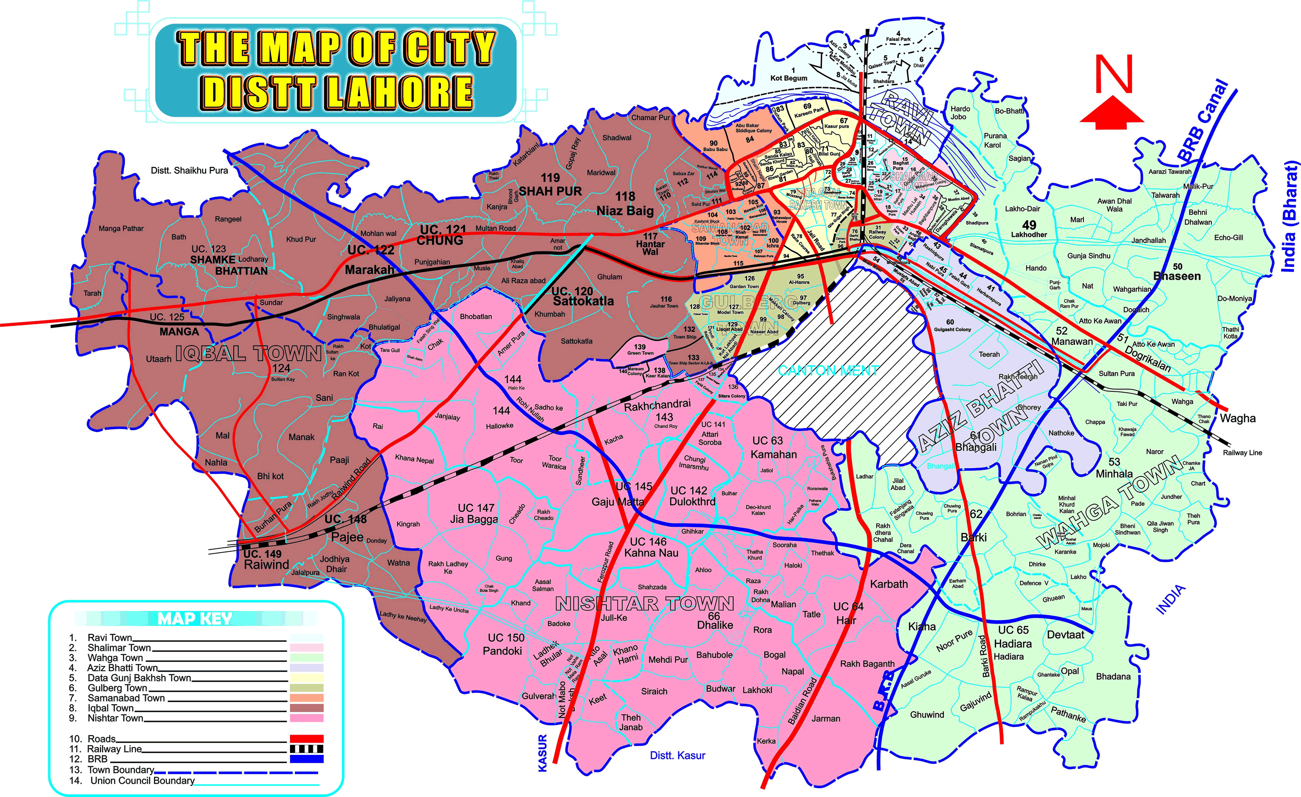
UN-Habitat defines slums as contiguous settlements where inhabitants are characterized as having (i) insecure residential status; (ii) inadequate access to safe water; (iii) inadequate access to sanitation and other basic infrastructure and services; (iv) poor structural quality of housing; (v) overcrowding. But for the majority of slums dwellers, according to UN-Habitat, insecure residential status means first of all insecure tenure, as opposed to secure tenure, which “is the right of all individuals and groups to effective protection by the State against unlawful evictions”. Insecure tenure covers a wide range of local situations, from total illegality to various forms of tolerated occupation, or occupation legitimized by customary practices. According to UN-Habitat, security of tenure describes an agreement between an individual or group for the rights to use land and residential property, which is governed and regulated by a legal and administrative framework (legal framework includes both customary and statutory systems). The security of tenure derives from the fact that the right of access to and use of the land and property is underwritten by a known set of rules, and that this right is justifiable. The tenure can be affected in a variety of ways, depending on the constitutional and legal framework, social norms, cultural values, and to some extent, individual preferences. In summary, a person or household can be said to have secure tenure when they are protected from involuntary removal from their land or residence by the State, except in exceptional circumstances, and then only by means of a known and agreed legal procedure, which must itself be objective, equally applicable, contestable and independent. Such exceptional circumstances might include situations where physical safety of life and property is threatened, or where the persons to be evicted have themselves taken occupation of the property by force or intimidation.

Fig: 2.2The Map of City District Lahore

2.3 A Case Study of Squatter Settlement, Accessibility of Land and the Urban Poor Mustapha Oyewole Bello, Nigeria
Land in sub Saharan Africa, is a significant factor and an indispensable asset that determines the quality of life of not only the rural communities but also that of the urban dwellers too.
From the land needed for cultivation by the rural farmers, the site required for urban housing, the workshop needed by roadside auto mechanics and spaces required by various government and developmental agencies, land has proved not only to be central to mans need and activities but also as the most crucial factor of production. Consequently, access to land has continued to be a tool for obtaining social prestige, economic security and political power.
The growth of the economy generates physical development in our cities which most often results in increase in values of land. Naturally, in a market economy, access to the use and enjoyment of this land depends on the purchasing power of individuals concerned. Where the affluent individuals are able to purchase and occupy a choice location, the urban poor are left to grope with the marginal areas. In addition, the centripetal nature of the cities which brings about an increasing spate of economic activities also creates intense pressure on municipal services and facilities like hospitals, educational institutions, housing, transport, telecommunication systems and energy supply. With the limited funds available to the government, provision of these services is always tilted against the area occupied by the urban poor. This is more so where they encroach upon government lands or other areas where development permits cannot be given. With the influx of more squatters driven by their inability to acquire a better developable site within the city, the resulting squatter settlement will grow into a full blown slum.
Once it has evolved, the question is; what do we do to a squatter settlement? In a bid to provide answer to this question, the remainder of the paper is structured as follows: the next section (section 2) provides information on the evolution and different types of squatter settlements in Nigeria. Section 3 deals with the unwholesome effects of squatting; this is followed in section 4 by the management options proposed to deal with squatter settlement.

2.3.1 The Evolution and Types of Squatter Settlements in Nigeria
In Nigeria, squatter settlements can be categorized into two main groups namely the illegally occupied settlements and the illegally developed settlements. Squatter settlement can either at first begin as a commercial or a residential enclave which at the latter stage would evolve into a settlement of mixed activities.
Squatting activities on illegally occupied land is peculiar with government acquired lands. For reasons which include non- payment of compensation, project abandonments and change in government personnel, government often times do not put the acquired lands into use.
Encroachment begins when the lands are put to agricultural uses by the former owners and their tenants. The problem is further compounded by the insatiable desires of the original land owning families (who own it before government acquisition) who pounce on this land and sell it to unsuspecting buyers. Other group of squatter settlements in this category includes those located on less desirable areas of the city such as wet land, refuse dump, over pipe lines and under high tension electricity transmission line.
Illegally developed squatter settlements on the other hand, usually emerged at rural urban fringe as a result of land speculators buying agricultural land and laying it out without provision for adequate roads, facilities for health, education and recreation. The expectation is that government in the future would provide these basic infrastructures. In this circumstance, plots were bought, developed and occupied without necessary approval from Town Planning Authorities (Olanrewaju, 2001).
According to Omirin (2003), most Nigerian cities are squalid, because majority is confined to marginal areas without services or infrastructure. In this wise, city dwellers are forced to provide inefficient solutions to their refuse disposal, water supply and other needs. Whatever the type of squatter settlement, the underlying causes is the same- the inaccessibility of developable land to the urban poor.

2.3.2 Unwholesome Effects of Squatting
The harbinger of squatting activities is inaccessibility of land engendered by low income of the urban poor. The end product is the creation of a slum. The effects of slums have been seen from various perspectives; the commonest one being on the deplorable environmental conditions. In this wise, the World Bank Thematic Group on Services to the Urban Poor described slums as unplanned and under-served neighborhoods typically settled bysquatters (The World Bank, 2002).
Where squatting is on government or any derelict land; layout are never prepared and developments are not subject to any control. In cases where the land owning families design layouts; such layout in most cases may not conform to acceptable standard and development approval on such lands are never sought from the Town Planning Authority. The absence of meaningful development control in these cases will invariably lead to haphazard or uncoordinated development which characterizes slum formation.
Another effect of squatting is that the necessary municipal services and infrastructure like roads, water supply, sanitation and waste collection are never provided. Within this neighborhood, wastes generated are thrown indiscriminately into drainage channels thereby causing blockages (Fadairo, 2006); which might eventually result in the flooding and erosion of the area.
The problem of their low income affects the level of capital formation, which deprives the people of sufficient resources to utilize in improving their homes and keep their environment healthy for comfortable living (George, 1999). The slum residents lack the basic municipal facilities; and thus are exposed to disease, crime and natural disasters (The World Bank, 2002).
Generally, squatters are usually stigmatized, especially, where the squatters are on derelict land or such area as existing or disused refuse dumps, such people are often looked at as hoodlums or miscreants; and any case of robbery attack on the neighboring settlement are usually attributed to them, even when empirical evidence does not indicate that crimes occur with more frequency within squatter settlements than outside (Mangin, 1967).
Since residents of squatter settlements lack legal titles; they are usually suffering from the problem of uncertainty in tenure. They live daily with the perpetual fear of eviction and demolition by authority. As a result of which there is no incentive to spend on housing improvements; hence they live in houses constructed with substandard materials.

2.3.3 Management of Squatting Activities and Squatter Settlements
Two basic approaches are of relevance in this case, preventive measures should be taken to prevent the emergent of squatter settlements. Where the squatter settlement had evolved with its attendant slum conditions, appropriate curative measures should be undertaken taking cognizance of the socio-economic implication of the options to be adopted.
The best option should be to prevent or at least curtail squatting activity. In this wise, effort should be geared towards checking the development of new squatter settlements. This can be achieved in two ways. First, by providing cheap land and services for the urban poor; for example in Owerri, the capital of Imo state in Nigeria; it will be difficult for low income earner to have access to good developable land if no support is given in a situation where cost of land is more than 30% of the total development cost (Onyike, 2007). Secondly, early occupation and adequate policing of acquired land will prevent encroachment. Erection of signposts informing and warning unsuspecting buyers and developers that the land is committed will help a lot in this regard.
However, where squatting has already taken place and slum and shanty town have evolved; what do we do? In this wise, there are three options available which are eradicating and relocating the slum residents, clearance and redevelopment; and slum upgrading (The World Bank, 2002).
Eradicating and relocating of squatters has been described as a failed response of the 1960s and 1970s by the World Bank (The World Bank, 2002). This notwithstanding, what operates in Nigeria is worse than eradication and relocation of squatters residents. In the country, the squatters are ejected and their property which are described as illegal structures are demolished. The demolition of entire Maroko settlements in 1991 and the various demolition exercises in Abuja epitomized this.Ejection of squatters and demolition of illegal structures generates social, economic and political problems with their attendant security implications. It tends to portray government as insensitive to the plight of the citizenry. Demolition also results in financial losses both to the squatters and the government; and depletes the national housing stock (Lands Division, 1996). This approach is socially destructive and involves high community cost. “The ultimate result has been the loss of these dwellings and the dispersal of the populations either into new slums or to swell the ranks of the existing slums while the area is being laid out and allocated for high class residential development” (Omirin, 2003).
Clearance and Redevelopment which is the second curative approach involves a temporary movement of the residents while the place will be cleared and new structures, usually high rise buildings erected for them on the same site. This approach involves high social and economic costs which are almost unaffordable. Besides, the developments of high rise buildings will not provide sufficient ground level spaces which are needed by these low income families to operate their small businesses which they use to augment their meager incomes.
The third and the best curative approach is to upgrade the squatter settlements. This is the most palatable of the three curative approaches to the management of squatter settlements because it has the ultimate effect of preserving the extensive development that had been erected and putting some order in the area. According to a report of the World Bank, upgrading rejuvenates the existing community with minimum disruption and loss of physical and social assets (The World Bank, 2002). The first step in this approach is to ensure security of tenure for the property owners in this settlement. When the fear of perpetual ejection is removed, property owners will now be interested to invest in the improvement of their houses and environment. Also private developers will be attracted to the area. In Nigeria, illegal structures in some cases are accommodated under a similar policy called regularization or ratification. The next stage is to commence on the provision of municipal facilities within the area. There are many approaches to do this, starting from the provision of a single infrastructure piece such as water supply alone to a package of services. Whatever the method being adopted, the planning and implementation should involve the community on a sustainable level.

2.3.4 Conclusions and Policy Implication
The appropriate handling of squatting activities requires a lot of political will and financial commitment on the part of the government. Political will is essential in order to embark on land reform that will not put the urban poor at a disadvantageous position with regard to access to land. In Nigeria for example, there is the need to review the Land Use Act to facilitate land accessibility most especially to the urban poor.
Since Government is becoming incapable to provide funds for the provision of these essential facilities in the face of other competing needs of the citizenry, government should be innovative in their financing. In this wise, Public – Private - Initiative should be explored.
Since private investors are going to be involved, they need adequate return to make their involvement remain on a sustainable level, consequently; the urban poor need to be economically empowered in order to be able to afford the provision of; and payment for some of these facilities which will be provided under this arrangement.

2.4 A Case Study of Rural Water and Sanitation in Ukraine: Problems and NGOs participation
Ukraine is an Eastern European country, new neighbor of EU, territory of 603,7 thousands km², with Population about 46,5 million: 68% – urban population and 32% – rural population. Ukraine is water limited country with less than 1 thousand m³ per capita per year.
Ukraine: Population Distribution
Cities:
  - Mega 15%
  - Large 6%
  - Medium 19%
  - Smaller 6%
  - Settlements 23%
  - Rural areas 31% (COWI Report 2002)
Ukraine: water sector
  - 70% of population is provided by centralized water supply, in rural areas - 26%
  - The main sources for drinking water is the surface waters, 75% of population is supplied from it.
  - 53% population have access to sewage system/sanitation:
  - 74% - in urban areas and 9% - in rural areas.
Rural areas: access to Water
4.1 million (26%) use centralised water supply
  - 55 thousand km of water pipelines and 70 thousand artesian wells were constructed in rural areas
  - The overall rate of provision of centralised water supply services in rural areas was almost twice lower comparatively to average figures of the former USSR.
  - Now, the number of rural buildings in Ukraine equipped by internal water supply and sanitation networks is 3 times lower than in Russia and 4 times lower than in Belarus
  - 11 mln (74%) of rural population use wells, captures
  - 18 mln wells are contaminated by nitrates, microorganizms, pesticides, fluorine, oil
  - 800,000 in 1200 rural settlements use transported water
  - Rural water consumption norm reached only 60 litres /cap./d, while in urban areas the relevant figure is in between 290- 320 litres

2.4.1 Health situation related to Water supply and sanitation sector
- According to WHO poor water quality poses a health hazard for 25% of the Ukrainian population.
- Acute problems are connected with :
- viral hepatitis A disease:
- rota viral infections:
- blue baby syndrome:
till 2001 -10 -15cases in rural areas of Poltava oblast dental fluorosis:in Poltava region , Gozhuly village - 80% schoolchildren are suffering.

2.4.2 Rural Sanitation
- 88% rural population use centralized sanitation.
- From 52 million m³ of wastewater collected by rural sanitation systems
- about 22% are discharged without treatment to surface water bodies
- 37% primary treated and
- 41% undergo primary and secondary treated
- 14.3 mln (91%) use pit latrines and sep tanks
- about 0.9 billion m³ (or 20% of the overall amount) of municipal wastewater are accumulated annually in septic tanks and cesspits, that are outside governmental control and regulation
- As usual pit latrines and septic tanks are the sources of nitrates and biological contamination of ground water
Rural Water Supply and Sanitation Sector is out of reforms, decentralization and delegation of rural infrastructure management functions and responsibilities to rural local authorities without financing, knowledge support and with degradation of the rural service providers creates the critical situation in the rural WSS sector.

2.4.3 Ukrainian State Programs on Drinking Water for Rural Areas
There are several State Programs related to improve water supply and sanitation developed during the independent time (since 1995), the main are:
- State Program on centralized water supply for the rural settlements which use the transported water for 2002-2008. Now it will be prolong till 2010.
- State Program 2005 “Drinking Water of Ukraine”

2.4.4 Ukraine – Millennium Development Goals – 2000+5
During 2001- 2004
Portion of urban population, who has access to clean water has increased on 1 % (from 86 till 87%), water supply of the rural population did not changed–63% (Analytical Report 2005).

2.4.5 MAMA-86’s Drinking Water Campaign
MAMA-86 is a network of 17 NGOs initiated by mothers in 1990 to raise public awareness and to work with environment and health problems. Drinking Water Campaign was launched in 1997 It is women grass root initiative aimed to improve Ukrainian citizens’ access to safe drinking water. 11 local organizations participate in the campaign activities

2.4.6 "MAMA-86" Pilot Projects in the Rural Area in 2001-2004
Implemented in Poltava oblast, Yaremche district and the Nizhyn rayon focused on:
- well water quality analysis;
- raising public awareness on wells water problems;
- implementation of technical solutions on improvement of access to safe drinking water;
- facilitation of arrangements for water supply and its maintenance based on self-governing

2.4.7 The Pilots’ Results
- Inventories of over 150 collective and individual wells;
- initiation of wells passportization in Chernihiv Oblast, Yaremche District of Ivano-Frankivsk Oblast;
- Water analysis of over 200 wells in Yaremche District of IvanoFrankivsk Oblast, in the Nizhyn Rayon Chernigiv oblast and in Lokhvytsa Rayon, Poltava oblast;
- cleaning and disinfecting of more than 50 wells in Yaremche Rayon of Ivano-Frankivsk Oblast and in the town of Nizhyn and Nizhyn Rayon; establishment of wells cleaning service in Yaremche rayon.
- Rehabilitation of water pumps and repair of old water pipeline for 8000 residents of the 6 villages in Poltava Oblast.

2.4.8 Ecosan Projects in Ukraine
1. MATRA Project MAMA-86 & WECF 2003-2006, 3 project areas:Poltava,Nizhyn,Yaremche, focus on water supply, eco-sanitation and organic agricult agriculture
2. FE Project MAMA-86 & WECF 2005-2006, 2 project areas: Odessa, Sevastopol, focus on eco-sanitation
3. FE+ELA projects MAMA-86 & WECF start 2007-2010, 10 project areas: Kyiv, Artemivsk, Feodosia,Mykolaiiv,Nizhyn,Nova Kahovka,Poltava,Sevastopol, Ternopil, Yaremche, focus on eco-sanitation promotion
Projects goal on sanitation:
- To introduce environmentally friendly, affordable and alternative technologies
- To implement Pilots in rural/peri-urban areas of Ukraine

2.4.9 Results of Ecosan Pilots 2003-2006
- 12 pilots were implemented in 5 oblasts of Ukraine:
- school dry urine diverting toilets (DUDT) for 640 children and staff
- 8 private DUDTs for 45 villagers
- DUDT design was made by TUHH experts and firstly implemented in Romania by WECF+ Media & Sanitas.
Local implementation by MAMA-86 and PS - builder companies. Technical documentation made by local engineers.

2.5 A Case Study of Municipal Solid Waste Management in Kohima’Nagaland-India
This paper presents an overview of current solid waste management practices in Kohima, Nagaland, India and suggests solutions to some of the major problems. The levels of socio-economic development determine the quantity and composition of solid waste. Higher the level of economic development, greater the proportion of waste composition. The total population of the city is 1,32,836, among those, 90% population is predominantly tribal. Hence, solid waste is not that much problem in rural economy compared to urban areas. As a result of that, the problem of municipal solid waste management is not yet felt in the rural areas of Nagaland. Compared to that, the concentration of population with higher densities in Kohima towns as well as unmanaged growth of settlements are among major causes leading to the problem of municipal solid waste affecting public health and natural environmental systems. So the total elimination of the waste is an impractical suggestion, rather than it should be managed in an effective manner. The surveys have shown that the collection process is deficient in terms of manpower and vehicle availability. Bin capacity provided is adequate but locations were found to be inappropriate, thus contributing to the inefficiency of the system.
At this time, no treatment is provided to the waste and waste is dumped on open land at Dhapa after collection. Lack of suitable facilities (equipment and infrastructure) and underestimates of waste generation rates, inadequate management and technical skills, improper bin collection, and route planning are responsible for poor collection and transportation of municipal solid wastes. This study was on field visit, secondary data collection, interviews with different individuals who were directly or indirectly involved with the project and also through the discussions with the relevant Kohima Town Committee officials to get a clear idea about the present situation of the town. The effective management of municipal solid waste has become a monumental challenge in the town with high population density and experiencing the problem of rapid urbanization. This study mainly focuses on the issue of management of municipal solid waste in Kohima town and also describes its existing systems, the way of dealing with the present upcoming problems and also suggests new innovative approach for effective management of municipal solid waste in Kohima town. The overall objective was to create an efficient, reliable and holistic system for management of municipal solid waste, so as to achieve a cleaner environment and improve the quality of life.
Environmentally acceptable management of municipal solid waste (MSW) has become a global challenge due to limited resources, an exponentially increasing population, rapid urbanization and worldwide industrialization. In developing Asian countries, these factors are further exacerbated by inadequate financial resources, inadequate management and technical skills within municipalities and government authorities.
Waste generation is not rare in urban areas or any part of the world. The only aspect that may differ is the way of managing or handling the wastes. The explosion in world population is changing the nature of municipal solid waste management mainly from a low priority, localized issue to an internationally social problem. The problem of managing municipal solid wastes is growing day by day, which results into a direct threat to the public health and to the environment. Improper management of solid waste has been reported by several researchers in different cities of developing countries (Berkunet al., 2005; Sharholyet al., 2008; Imam et al., 2008; Chung et al., 2008). Inadequate management of solid waste in most cities of developing countries leads to problems that impair human and animal health and ultimately result in economic, environmental and biological losses (Sharholyet al., 2008).
More than 90% of the MSW generated in India is directly disposed on land in an unsatisfactory manner (Das et al., 1998). The problem is already acute in cities and towns as disposal facilities have not been able to keep pace with the quantum of wastes generated. It is common to find large heaps of garbage lying in a disorganized manner in every nook and corner in large cities. An effective, efficient, suitable, systematic and sustainable waste management system is still non-existent in the Kohima city. The objective of this paper is to analyze some of the strengths and deficiencies in the current MSW management (MSWM) system in Kohima and propose feasible solutions like implementation of MSW Rules 2000 throughout the city, setting up of a system for waste collection, segregation of waste at source into biodegradable and non biodegradable and development of sanitary landfill as well as waste processing facility, capacity building for various stakeholders.
The methodology adopted for management of MSW, included collection of information pertaining to solid waste management (SWM), from published documents, data available with the agencies and through consultations. It was done through primary surveys, especially on the assessment of the physical and chemical characteristics of wastes, socio-economic surveys, and consultations to understand the felt needs and priorities of the communities and the key stakeholders. In addition, secondary data was collected on the existing facilities available, such as sweeping staff, implements for primary collection, storage capacities, transportation facilities, existing institutional and organizational framework for SWM, operational and maintenance costs towards SWM, major wastes generating sources, existing collection routes and collection frequency, different maps on the existing and proposed disposal sites and cost estimation for SWM for certain years.
To maintain the proper management of MSW, a survey was carried out using a pre-designed questionnaire, which involved randomly selected households. The questionnaire was designed to assess the source, quantity, composition of waste generated per person per day. The sample collection procedure was based on the methodology of expert committee. Solid waste was collected from 10 different sampling points after proper selection so that the sampling points were distributed uniformly all over the study area. These points were selected based on the type of area, such as commercial, institutional, market and residential.
In the methodology of MSW management, it requires certain basic things, such as collection and storage, transportation, processing, treatment and disposal. To apply this in a proper and effective manner, different formats have been compiled for data collection through urban local bodies (ULB). These can be also used in different comprehensive training program conducted for the ULBs. Knowing the limitations of the urban local bodies, these formats are prepared with full efforts. Using these formats, the process of collection and storage, transportation, processing, treatment and disposal can be done in a systematic manner. It can be described as follows:

2.5.1 Data Collection
Format 1 – Streetwise Data:
- Identification of the street/road/lane/small passages by name or number.
- Identification of junctions of roads/streets/lane
- Length, width and type of surface.
- Identification of the generators and
- Quantity of waste on both sides of the streets.
- From residential layout of buildings,
- High rise buildings and bungalows.
Format 2 – Sector wise Data:
- It is done through compilation of the information collected in Format 1 and entering it in this format.
- It is also available through lists on each side of the roads.
- Can be obtained from shopping centers, hospital buildings, hotels, resorts, markets, slums, etc.
Format 3 – Route Wise Collection:
- Separate routes should be planned for each category of wastes.
- In a shift of eight hours, number of trips should be assigned for each route.
- Vehicle/ Equipment name/ Number, type, capacity and trips assigned need to be specified for the route.
- At the end of each trip, the weight of the contents and time taken for collection should be recorded in the program sheet of each route.
- The backlog of collection points should be highlighted and reported for corrective action.
- The status should be reported at the end of each shift to the officer in charge.
- The corrective action should be so timed that there should not be any complaints from the users.
- A route plan was drawn out for collection of waste from door to door. In the residential area, the wastes are stored in a segregated manner within the complex and then carried up to the transport vehicle at a certain time or when the bell rings. Collection of waste can also be done from community bins, transfer points and transfer stations.

2.5.2 Transportation of Waste
In case of transportation of waste, the wastes are collected from doorstep to community bins and bulk transportation of waste is done from community collection units to centralized or decentralized processing sites. In the single stage system the wastes are collected from the households and are directly transported to the processing site or disposal sites. Transportation system involves minimum manual handling and exposure to the waste and processing of the waste. Two types of models are used for the transportation of wastes. Depending on the quantity of wastes generated per day, such as 5MT, 10MT, 15MT, 20MT, up to 50MT, and more than 50MT the transportation of wastes have been done. Waste generated more than 50MT per day and having disposal sites of more than 5km, is classified as “A” class council cities, where waste transportation is done accordingly to the city lay out. Different types of vehicles are used such as, truck, tipper truck, tractor-trailer and dumper placer for the transportation of wastes. Transportation of waste can also be done through manual loading or hydraulic loading systems.

2.5.3 Processing and Disposal
According to the MSW rules 2000, the wastes must be stabilized or processed completely and only the residues are disposed in the sanitary landfill sites. Through aerobic windrow composting the wastes are processed at the disposal site.
Waste to Energy (WTE) process, such as biogas plant or any appropriate technology is used. To process the biodegradable wastes locally at the point of generation, such as in societies or at homes, composting or vermin composting may be used. Compost processing is done with the help of manual screening. For the graded product of compost, full infrastructure, full machinery and fine screening is required and only inert mass will go to the landfill.
At present, for the disposal of wastes, open dumping is also practiced. For the purpose of disposal of wastes to the dumpsites, the different up-gradation of the dumpsites can be noticed, (open dumping to controlled dumping), which involves reduction of the working area of the site to a more manageable size. Engineered landfill and scientifically designed sanitary landfill sites are also used as dumping of wastes in the disposal site. The lifetime of the existing dumpsite should be assessed for the purpose of disposal of wastes.
Table: 2.2(Sources of Solid Wastes in Kohima City)
Waste Generation Sources | Proportion of Waste (%)
Residential | 57.00
Commercial (markets, shops etc.) | 19.00
Institutional (offices, banks, colleges, schools, etc.) | 15.50
Industrial | 3.00
Biomedical wastes in hospitals and nursing homes | 0.50
Construction and demolition wastes | 5.00
Source: Kohima Municipal Corporation
The stabilization of waste can be done through windrow composting, spraying bio-cultures to hasten the process of composting which results into less generation of leachate. Pushing the waste to one side of the dumpsite can also do the stabilization of waste. The inert materials should cover the waste, either by soil or construction debris.
Compressing the waste and covering the material can improve the landfill operation and reduce the nuisance of flies, stray animals, birds etc. Ultimately if the existing sites are inadequate for 25 years of use, then it is necessary to acquire new sites.

2.5.4 Results
MSWM in Kohima city depicts certain crucial issues or major findings through the city. It involves managing activities associated with collection, generation, storage, transportation, processing and disposal of wastes in an environmentally compatible manner, along with adopting the principles of economy, energy, aesthetics and conservation.
In the year 2006, the projected waste generation was 0.40 kg of waste per capita per day. For the GKPA, the waste generation projection was made up to the year 2041. By 2041, the generation of waste should be increased in a large amount with respect to the growth of the population.
In Kohima, the responsibility of the waste management lies with the Kohima Municipal Council (KMC). The present system of municipal solid waste management gives a broader view of the entire system.
At present, the amount of waste generated from the Kohima city is around 54 MT per day. Out of this, around 35-40% of wastes are collected from the entire city as per the present data available.

2.5.5 Waste Generation and Quality
The daily generation of wastes (54 MT) are generated mainly from the major sources, such as residential (57%), commercial (19%), and institutional (15.50%), industrial (3%), biomedical wastes (0.50%) and construction and demolition (5%).
Physical and chemical analysis of municipal solid waste in Kohima was performed on samples collected from 5 locations, 3 from the city and 2 from disposal sites.
In the composition of MSW, large amounts of biodegradable wastes are present. Almost 64% is composed of biodegradable waste. The biomedical waste generated is 155Kg. In the chemical analysis of MSW in Kohima, it has been observed that the moisture content is very high compared to other materials. Municipal solid wastes are also composed of papers, plastics, glasses, metals, inorganic matters, etc. The composition of MSW varies from place to place, on the basis of factors such as population, source, average income, social behaviour, industrial production and market for waste materials.

2.5.6 Segregation, Collection and Transport
In Kohima, the responsibility of waste management lies with the Kohima Municipal Council. Different types of wastes such as plastics, scrap metal and bottles, i.e. all recyclable wastes, are generally segregated and either sold to rag pickers at household level or scavenged at community bins or disposal sites.
Waste storing capacity is inadequate in the city. There are around 30 storage bins available. Few mechanized containers of 4.5 m³ capacity are introduced in the areas for the proper enhancement of the waste storing capacity.
In the collection of municipal waste in Kohima city, main sources are dustbins and community bins. Two types of community bins (large and small) are used for a total of approximately 1200 collection bins. Specified capacity colour bins are used to collect segregated biodegradable and non-biodegradable wastes at source.
Eight different types of vehicles are used for the transportation of wastes. The average waste-carrying capacity of vehicles is around 2.5-4.48 m³. On an average, 20 MT per day of wastes are transported as compared to the average American cities of 95 kg/m³, (Tchobanoglouset al., 1993), which makes compaction largely unnecessary. Spillage occurs during the transportation of wastes, as vehicles are not covered or properly sealed. Manual or hydraulic loading and unloading may be performed. Wastes are cleared daily with the majority of vehicles carrying out 2 trips and a few carrying out only 1 trip.

2.5.7 Treatment and Final Disposal
The total area of the disposal site is about 56.53 acres located at the southeast of the city. All municipal wastes are dumped on a sloping site about 8 km from the city. Wastes are generally dumped in open streams or burnt in empty spaces. The SisteRu river flows just below the disposal site and, as a result, the majority of dumped wastes accumulate in the river.
Huge amounts of biomass, suited for use in soil nourishment to increase fertility, are lost through the burning of wastes. Frequency rates for irregular disposal are high. Almost 49% of the population is served by an unofficial service, whereas only 31% by the Biweekly basis and in regular/irregular manner.The disposal of biomedical waste is usually carried out by open burning at the disposal site using old tyres. Processing or recycling procedures are not currently applied in Kohima. The only recycling performed is carried out to some extent by rag pickers exposed to harsh, unprotected conditions.

2.5.8 Discussion
Solid waste is a serious environmental problem in both developed and developing countries. In recent years, most developing countries have improved their municipal solid waste management practices. The increasing amount of wastes generated by rapid urbanization in these countries is usually not properly managed. Solid waste management systems in developing countries must deal with many difficulties, including low technical experience and low financial resources which often cover only collection and transfer costs, leaving no resources for safe final disposal (Collivignarelliet al., 2004).
Table:2.3 Results of Physical Analysis of the Solid Wastes
Parameters | Different Locations
Parameters | Para Medical Ward | Agri Colony | T-Khel market (Porter Land) | Disposal Site-I, NH-39 | Disposal Site-ІІ, NH-39
Biodegradable organic fraction (%) | 62.8 | 73.6 | 77.0 | 69.8 | 69.3
Paper and cardboard (%) | 7.9 | 6.2 | 6.1 | 8.6 | 9.2
Plastic (%) | 8.2 | 4.3 | 4.9 | 4.9 | 3.8
Metal (%) | 3.8 | 2.6 | 2.1 | 2.3 | 4.9
Glass or ceramic (%) | 4.1 | 1.8 | 3.9 | 2.9 | 3.2
Bio-resistant (cloths, leather, napkin), (%) | 1.5 | 1.9 | 1.2 | 1.2 | 1.0
Inert (stone, brick, earth wares), (%) | 2.0 | 1.6 | 1.3 | 2.3 | 3.1
Fine earth (ash, dust, soil), (%) | 3.9 | 3.9 | 1.6 | 2.8 | 2.2
Others (wooden substances, rubber, bone, coal), (%) | 5.8 | 6.1 | 2.1 | 5.2 | 4.3

As the present scenario of the entire city of Kohmia, and concerning problems associated with the municipal solid waste management, it is variable in terms of characteristics and quantity of the wastes from place to place. At present, no treatment is provided for collected solid waste. The same prevailing situation is also present in Kolkata, where more than 90% of the total collected waste is directly disposed in Dhapa in an unsatisfactory manner without providing earth cover. This method of dumping has led to heavy metal pollution in groundwater, since no leachate collection and treatment option is available (Goel and Hazra, 2009). Sanitary land filling with leachate and gas collection is the recommended method for disposal of MSW. So, the recommendations should not be taken up as a whole. These are the several attempts to improve better management of municipal solid wastes in the city of Kohima.

2.6 Background of Development of Katchi Abadis in Pakistan
The phenomenon of squatting took the shape of mushroom growth of Katchi Abadis on public or private land lying vacant in major urban centers of Pakistan. There are over 3000 Katchi Abadis in the country with a population approximating 7 million, which has increased from the recognized 2302-Katchi Abadis with a population of 5.5 million declared eligible for regularization and subsequent upgrading in 1985 by the Government of Pakistan (EUAD, 1987) and about 9.5 million at present (GOPU, 2009).
Reasons for emergence of Katchi Abadis in Pakistan are given as;
- Migration in 1947 after independence when over 600,000 refugees arrived from India
- No major investment was made in agriculture during this period. This policy contributed to the rural-to-urban migration in 1960’s and in the succeeding years
- Migration in 1971 after separation of Bangladesh, a large no. of peoples migrated to urban Sindh from former East Pakistan.
- The third major influx took place in early 1980’s the arrival of illegal immigrants from Afghanistan.
- No social policy on an appropriate scale exists to address the shelter issue of low income communities.
- Shortage of affordable housing

2.6.1 Previous attempts taken in Pakistan for the improvement of environment of katchi abadis in Pakistan
Of late, the government of Pakistan also realized that the programs of providing public housing have been inadequate to achieve the real target of providing housing, particularly to low-income people. The government decided to take measures for the formalization and regularization and as well as improvement of the Katchi Abadis, so that these may be made suitable for including in the housing stock. Therefore, different Katchi abadi regularization and improvement programs were started at different times by the government, directing the local authorities for their implementation. However, the government made considerable efforts to regularize and improve the Katchi Abadis during 1985 to 1990 and a formal Katchi Abadi Improvement Program (KIP) was launched in 1985 (Anwar, 2002).
The previous researches did not clearly indicate and explore the impact of these improvement programs of Katchi Abadis on the health of the dwellers of these low-income areas. This paper is about the health impact assessment of the KIP implemented in Punjab from 1985 to 1990. The main objective of the study was to examine the effects and impact of the KIP on the health related aspects of the residents (infants, young and adults) of squatter settlements (Katchi Abadis).
In majority of the squatter settlements, the health facilities were absent, shortage of provision or inadequately provided. Secondly, the provision of health facility in every locality is essential. (Lewinet, al, 1981)
The provision of potable drinking water, improvement of sanitation-sewerage, pavement of streets, improvement of drainage and solid waste collection were included in KIP for the environmental improvement.
In the following section case studies are quoted as published to learn from them and for this thesis, I have taken inspiration from these studies.

2.7 Problem as Seen in Punjab
In Punjab a full-fledged Directorate General of Katchi Abadis & Urban Improvement is working under the Local Government of the Punjab. All policy matters are being looked after by the Directorate General in liaison with the KatchiAbadis Cell of Ministry of Environment, Local Government & Community Development and Government of Punjab. At the lower levels the Development Authorities are performing the functions of Executing Agencies and are responsible for implementing the KatchiAbadis Regularization/ Development Program in big cities like Lahore, Faisalabad, Multan, etc. As such the Lahore
Development Authority is working as Executing Agency on behalf of Directorate General Katchi Abadis and Urban Improvement, Punjab, for implementing the policy decisions of the Federal/ Provincial Government.

2.7.1 Provincial Government
After the constitution of Directorate General of Katchi Abadis and Urban Improvement in 1987, the government of Punjab has taken many steps to up-grade the basic civic amenities in katchi abadis of Punjab and especially in Lahore. These steps are the followings:
- Junejo Five Point Program
- Peoples Program
- Tameer-e-Watan Program
The main focus of all these above mentioned programs is to uplift the living standard of poor and especially urban poor.
In the year 2008, the government of Punjab was committed to uplift the deprived segment of the society living in katchi abadis and bring them at par with the surrounding well developed areas. The core idea is to develop a katchi abadis complete in all respects. Therefore, it has been decided to provide missing facilities in all the regulated/ notified katchi abadis in the Punjab. The chief minister, Punjab has been pleased to constitute a Provincial Monitoring Committee (PMC) headed by the minister for Local Government and Community Development department regarding katchi abadies in the Punjab vide notification dated 17th December 2008.
The following components which constitute basic priorities for development works in katchi abadis were approved priority wise by the PMC as given below:
- Water supply
- Sewerage
- Main Gas Line
- Metalled roads/ streets
- Electricity/ street light
- Public parks
- An open space for the marriages or death occasions
The above mentioned criteria are notified by the Government of Punjab dated 17th Dec. 2008.
The most important aspect of the government of Punjab is that during the financial year 2008-09, an amount of rupees 2,000 million was provided in annual development program as block allocation for development of katchi abadis in the Punjab. And finally an amount of rupees 1712.446 million was released to all the executing agencies in all over the Punjab for 364 schemes for the development of katchi abadis.
But unfortunately, a small amount 43.747 million rupees for only four schemes was released to katchi abadis of Lahore namely Harbans Pura and Qalandar Pura katchi abadis.

2.8A Case Study to assess the Impact of Katchi Abadi Improvement Programme (KIP) on Health of the Dwellers in Punjab
The overall objective of the study was to assess the impact of the Katch Abadi Program (KIP) on health of the dwellers that was implemented from 1985 to 1990 in Punjab. Three districts (Rawalpindi, Faisalabad and Multan) of Punjab were the universe of the study. A sample of 700 respondents was proportionately selected by using random sampling technique. The data was analyzed by using the Statistical Package for Social Sciences (SPSS) and Yeh’s Index of satisfaction. The analysis of the data revealed that visits paid to doctors by the dwellers for their treatment were decreased and the infants’ mortality was also decreased due to improvement made in the environment and provision of health services. Moreover, the dwellers perceived better about provision of health services and they are satisfied from the improvement made in the environment and positive impact of KIP on the health of dwellers.
Three districts of the Punjab province i.e. Rawalpindi, Faisalabad and Multan were selected to assess the health impact of KIP in Punjab as universe of the study. There were 73 Katchi Abadi in Faisalabad, 25 in Multan and 8 in Rawalpindi as per the list provided by the Directorate General of Katchi Abadis and Urban Improvement, Local Government and Rural Development Department, government of the Punjab, Lahore (2009). A proportionate number of katchi abadis from each district was taken.
Fitzgibbon and Morris, 1987:163 stated a simple principle or rule of thumb that “as the size of the population increases the sample size decreases”. Therefore, a sample of 700 respondents was envisaged as appropriate for this study. The sampling weights technique has been advocated by Kish (1965). This proportionate technique was also used by Anwar (2002). The interview schedule was used as data collection tool. The Statistical Package for Social Sciences (SPSS) was used to analyze the data. Yeh’s Index of satisfaction (YIS) was also used to analyze the people’s satisfaction level regarding the various factors of environment related and having impact on health status of the dwellers. Putting it into a symbolic form, the YIS can be written into the following expression:
YIS = S-D/R
Where:
S = the number of people satisfied with one attribute.
D = the number of people dissatisfied with one attribute; and
R = the total number of responses
This index ranges from +1 to –1. A positive value indicates that there are more respondents who are satisfied than those who are dissatisfied. The larger the value, the more intensive is the degree of satisfaction or dissatisfaction.
Lewin (1981) viewed that in majority of the squatter settlements, the health facilities were absent, shortage of provision or inadequately provided. Secondly, the provision of health facility in every locality is essential. Moreover, the poor sanitation facilities-non availability of sewerage, drainage, solid waste collection facilities and non-development of parks as well as shortage of water supply also affects the health status of the squatters and especially on infants’ mortality. The provision of health facility i.e. construction and/or establishment of dispensaries in Katchi Abadis was one of the components of KIP. To assess the overall positive impact of KIP on the improvement mad in the environment and how it directly and indirectly brought changes in the health status of the squatters, the views of the respondents were ascertained through the survey. The demographic characteristics of the squatters have also some effects on the health of the squatters, therefore, the changes occurred in the demographic characteristics of the squatters due to implementation of KIP were also explored in order to determine the composite impact of KIP on the health of the squatters.

2.8.1Impact on Demographic Characteristics
The changes in demographic factors like the household size, and number of households per structure are described in this section. The household size determines the level of overcrowding in the dwellings of katchi abadis. In some of the katchiabadis the average household size was large and about 10 to 15 people were living in one house of small size before the implementation of KIP (Alimmudin et alibid).

2.8.2 Effects and Impact on Size of Household
The analysis of data (Table:1) indicates that the percentage of household size from 7-10 and from 11- 13 is 63.7 and 16.4 respectively and average household size is 8.17 as compared to average household size of 11 before the implementation of KIP. This indicates that the size of household in the katchi abadis where the KIP was implemented is medium level and it is due to improvement made under the KIP, which can be attributed to KIP and resultantly the overcrowding and congestion has reduced, which will have impact on the health of dwellers.

2.8.3Effects and Impact on Number of Households per Structure
The number of households in the structure is an important parameter in relation to accommodation density. The analysis of data (Table: 1) reveals that the percentage of I-household, 2-households and 3-households per structure in 1985 (before KIP) was 27.4, 61.0 and 11.1 respectively. At present the percentage of I-household, 2-households and 3- households per structure is 69.3, 29.0 and 1.7 respectively. This indicates a major reduction in number of households per structure after the implementation of KIP, which is a positive impact and it have reduced the accommodation density per unit area. Therefore, it will have definitely good impacts on the health of squatters.

2.8.4 Effects on Health of the Household Members
Easy access to potable drinking water is one of the basic human needs upon which the health status of people largely depends. In Pakistan more than 50% diseases are spread due to non-availability of safe drinking water. The provision of potable drinking water to Katchi Abadis was included in KIP. It was difficult to get the views of the respondents by directly asking about the improvement occurred in the health status of the squatters that was attributed to KIP. Therefore, some indicators for indirect measure of health status were made. A question was asked from the respondents that did they notice any change in the number of visits paid to doctor for check up after the implementation of KIP? This was the indirect way of getting the reflection of the respondents about the better impacts of KIP on the health status of the households’ members due to improvement made in the sanitation.
The results are presented in Table 2: The analysis of data (Table: 2) reveals that a majority (54.28%) of respondents reported that the number of visits paid to doctor for check up were decreased after the implementation of KIP and another 32.28 percent of respondents reported no change. The reduction in number of visits paid to doctor for check up was the positive effect of the provision of health facilities in katchi abadis under the KIP. It appeared that there were positive impacts of KIP on the health of the dwellers.
Table: 2.4 Changes in Demographic Characteristics (Indicators)
Demographic Factors | Frequency | Percentage
Household Members at Present
3-6 members | 139 | 19.19
7-10 members | 446 | 63.7
11-13 members | 115 | 16.4
Total | 700 | 100.0
Average household size = 8.17

Table: 2.5How Many Households were living in the Structure in 1985?
Demographic Factors | Frequency | Percentage
1-household | 192 | 27.4
2-household | 427 | 61.0
3-household | 81 | 11.6
Total | 700 | 100.0

Table: 2.6How Many Households are living in the Structure at Present?
Demographic Factors | Frequency | Percentage
1-household | 485 | 69.3
2-household | 203 | 29.0
3-household | 12 | 1.7
Total | 700 | 100.0

Table: 2.7Distribution of Respondents According Change in Visits Paid to Doctor
Health Related Aspects | Frequency | Percent
Decreased | 380 | 54.28
No change | 230 | 32.86
Increased | 90 | 12.86
Total | 700 | 100.0

Table: 2.8Distribution of Respondents According to Opinion about Status Infants’ Mortality
Opinion about Infants Mortality | Frequency | Percent
Decreased | 450 | 64.3
No Change | 166 | 23.7
Increased | 84 | 12.0
Total | 700 | 100.0

2.8.5Effects on Infants’ Mortality
Diarrheal diseases are a major cause of infants and child’s mortality in Pakistan. It was revealed from the findings of the Pakistan Integrated Household Survey (PIHS) of 1998 that almost 250,000 children under 5 years of age died due to these diseases every year. Similarly in MICS 2007-08 in Punjab it was revealed that 13% of children aged 0-59 moths had a recent illness (diarrhea or acute respiratory infection) in the last two weeks before the survey.
In the same survey it was found that the infant mortality rate (IMR) was 86 per 1000 for rural areas while mortality in urban areas is about 35-40% lower than urban areas.
The underlying cause of diarrheal disease includes inadequate access to safe drinking water, household and environmental sanitation and poor hygienic practices. The provision of potable drinking water, improvement of sanitation-sewerage, pavement of streets, improvement of drainage and solid waste collection were included in KIP for the environmental improvement.The change in the infants’ mortality would reflect the environmental improvement occurred due to implementation of KIP. A question was asked from the respondents that did changes occur in Infants’ mortality after the implementation of KIP. The respondents’ responses are presented in Table 3.
The analysis of the data (Table: 3) reveals that 64.3 percent respondents replied that the infants’ mortality was reduced after the implementation of KIP. This is a positive effect that brought good impact of KIP. The association between the environmental improvements of squatter settlements and reduction in infants’ mortality (cause and effect relationship) has been confirmed by many studies. For example in a study conducted in upgraded area of El Mezquital, Guatemala, infant mortality rates fell by 90 percent and crime by 43 percent (The World Bank Group, 2000).
It has been concluded by many research scientists that in most of the empirical research studies, per capita income, nutritional status, adult literacy and the availability of health services are included as important determinants of development status like Correa (1992), Folop and Rink (1983), Gredtham and Jonsson (1992), Grosse and Perry (1983), Hitiris and Posnett (1992), and Wheelor (1980).

2.8.6Perception of Respondents about Improvement made in Environment and Health Status of Dwellers
The perception of improvement about living conditions tells that how much the KIP has been able to achieve its objectives. The higher the level of improvement perceived by the respondents, better the impacts of the program on health.

2.8.7Perception of Improvement about Environmental, and Health Related Aspects
The user’s opinion about the change in the environment was one of parameters, which was used for measuring the impacts of KIP on the social and physical environment as well as on health of dwellers. The perception of the respondents about the physical improvement was cross-triangulated with the secondary data collected from the implementing agencies, which were responsible for implementing the KIP.
The analysis of the data from Table 4 reveals that the percentage of the respondents who perceived better improvement made in cleanliness, health of the households’ members, physical outlook of the area, distance to water supply and access to dispensary was 64.1, 67.1, 71.9, 67.3, and 71.0 respectively. It reveals from the analysis that majority of the respondents perceived that the present environmental and social situations were better than before the implementation of KIP. Moreover, they have perceived that the accesses to water supply and dispensary and health of the household members have improved. The above results reveal that a majority (69.3%) of respondents replied that they overall perceived better about the improvement made in environment and status of the dwellers.
Above Table 2.5: indicates that the majority of inhabitants perceived that the present environmental conditions in katchiabadisare better than before the implementation of KIP. The index values of perception for health of households’ members, like cleanliness of the area, physical outlook of the area, access to open spaces, access to water supply and access to dispensary indicating the perception of respondents about the improvement due to KIP were 0.551, 0.447, 0.611, 0.610, 0.501 and 0.580 respectively.
The overall index value of perception was 0.550 indicating that people had better perception about the improvement made due to intervention of KIP. This indicated that the people had perceived a high level of improvement in physical environment as well as provision of health services and its impact on health of the dwellers.

2.8.8Impact on Satisfaction Level of the Respondents Regarding Improvement made in Provision of Health Related Facilities
The level of satisfaction with various elements of KIP related to health aspects of the dwellers gives us a very useful yardstick to measure the quality of various services provided in the katchi abadis and their subsequent impact on health of the dwellers.
Table: 2.9Perception of Respondents about the Environmental and Social Improvements
Sr. # | Social and Environmental Aspects | Perception Levels
Sr. # | Social and Environmental Aspects | Better |  | No Change |  | Worst
Sr. # | Social and Environmental Aspects | Frequency | Percent | Frequency | Percent | Frequency | Percent
1. | Cleanliness | 499 | 64.1 | 115 | 16.4 | 136 | 19.4
2. | Health of the Household Members | 470 | 67.1 | 146 | 20.9 | 84 | 12.0
3. | Physical Outlook of the Area | 503 | 71.9 | 122 | 17.4 | 75 | 10.7
4. | Distance to Water Supply | 471 | 67.3 | 119 | 17.0 | 110 | 15.7
5. | Access to Dispensary | 496 | 71.0 | 112 | 16.0 | 91 | 13.0
Overall Perception Level |  | 485 | 69.3 | 123 | 17.6 | 92 | 13.1
Table 2.10: Indices of Improvement Perceptions for Various Environmental and Health Aspects
Environmental and Social Aspects | Index of Improvement
Health of the Household Members | 0.551
Cleanliness of the area | 0.447
Physical outlook of the Area | 0.611
Access to Open Spaces/Parks | 0.610
Access to Water Supply | 0.501
Access to Dispensary | 0.580
Overall Index of Perception | 0.550

The higher the level of satisfaction, the more effective is the impact of KIP on health of the inhabitants as community satisfaction is prime objective all development projects.

2.8.9Impact on Satisfaction Level Regarding Provision of Utilities
Table 6 portrays the inhabitants’ level of satisfaction regarding improvement made in provision of utility services and community facilities under KIP in various katchi abadis that have impact on health directly or indirectly. The analysis of the data depicts that the percentages of the respondents who were satisfied with the dispensary facility, water supply, and sewerage, drainage of the area, and open spaces, are 52.9, 62.1, 51.0, 56.7, and 58.7 respectively. The percentage of respondents who were overall satisfied with the provision of these services and improvement in the health status of the dwellers in katchi abadis under the KIP was 65.9 which is a major proportion. This reveals that more people in kathci abadis were satisfied with the provision of these health related utility services under the KIP. However, the percentage of the respondents who were satisfied with solid waste management and garbage disposal was 33.1 and 41.4 respectively. The lower percentage for these two items indicates that dwellers were not satisfied with solid waste management and garbage disposal.
Table 2.11: Satisfaction Level of Respondents Regarding Provision of Health Related Aspects
Sr. # | Health Related Aspects | Satisfaction Levels
Sr. # | Health Related Aspects | Satisfied |  | No Opinion |  | Dissatisfied
Sr. # | Health Related Aspects | Frequency | Percent | Frequency | Percent | Frequency | Percent
1. | Dispensary facility | 370 | 52.9 | 135 | 19.3 | 195 | 27.9
2. | Access Water Supply | 435 | 62.1 | 84 | 12.0 | 181 | 25.9
3. | Sewerage facility | 357 | 51.0 | 142 | 203 | 201 | 28.7
4. | Drainage of Area | 397 | 56.7 1 | 31 | 18.7 | 172 | 24.6
5. | Open Spaces | 411 | 58.7 | 107 | 15.3 | 182 | 26.0
6. | Garbage Disposal | 290 | 41.4 | 170 | 24.3 | 240 | 34.3
Overall Satisfaction Level |  | 461 | 65.9 | 95 | 13.6 | 144 | 20.6

2.9 Introduction of Lahore
Lahore is the capital of the Pakistani province of Punjab and the second largest city in Pakistan, after Karachi. The city lies along the Ravi River, situated approximately 25 kilometers (16 miles) from the WagahBorder crossing and is 32 kilometers (20 miles) from the Indian city of Amritsar.
Lahore is also referred to as the cultural heart of Pakistan as it hosts most of the arts, cuisine, festivals, film making, music, gardening and intelligentsia of the country. Lahore is also known for its affiliation with poets and artists; it has the largest number of educational institutions in the country and some of the finest gardens in the continent.
Lahore has been a centre for publications and to date holds that distinction as more than 80 percent of books in Pakistan and remains the centre of literary, educational and cultural activity in Pakistan. It is also an important religious center as it is a home to many temples, mosques and shrines like Data Durbar Complex.

2.9.1 Location
Lying between 31°15′—31°45′ N and 74°01′—74°39′ E, Lahore is bounded on the north and west by the Sheikhupura District, on the east by Wagah, and on the south by Kasur District. The Ravi River flows on the northern side of Lahore. Lahore city covers a total land area of 404 km² and is still growing. The map of Lahore is given as;
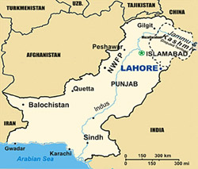
District Lahore

Fig: 2.1 Location of Lahore in Pakistan

2.9.2 Geography
Lahore features a hot semi-arid climate with rainy, long and extremely hot summers, dry and warm winters, a monsoon and dust storms.
The weather of Lahore is extreme during the months of May, June and July, when the temperatures soar to 40–48 °C (104–118 °F). From late June till August, the monsoon seasons starts, with heavy rainfall throughout the province. The city’s highest maximum temperature was 48.3 °C (118.9 °F) recorded on May 30, 1944. And 48 °C (118 °F) was recorded on June 10, 2007.
At the time the meteorological office recorded this official temperature in the shade, it reported a heat index in direct sunlight of 55 °C (131 °F). The lowest temperature recorded in Lahore is −1.1 °C (30 °F) recorded on 13 January 1967. The highest rainfall in the city recorded during 24 hours is 221 millimeters (8.7 in), which occurred on 13 August 2008.
The city on 26 February 2011, received heavy rain and hailstorm measuring 4.5 millimeters, which carpeted several roads and sidewalks with measurable hail for the first time in the climatic history of Lahore.

2.9.3 Population

According to the 1998 census, Lahore's population was 6,318,745. Mid-2006 government estimates put the population at somewhere around 10 million, which makes it the second largest city in Pakistan, after Karachi. It is considered to be one of the 30 largest cities of the world.

2.10 Background of Development of Katchi Abadis in Lahore
The development of Katchi Abadis in Lahore is due to the main reason is that the local population of Lahore is very short at the time of independence. So the area covered by the territory of Lahore is very short. As the population increased in different area of Punjab there is less resources to meet the problems faced by the incremental people. The moist of people have the agriculture professional. So they can produce their own food but the incremental created the problem of shortage of food and other basic facilities of people. So the people of nearer the Lahore area started to move towards Lahore for the sake basics facilities of their life.
Because Lahore is big city this is law of world that the people belong to undeveloped area always move towards the more developed area so that they can get the comfort in their life. But when they come to the big cities they cause the overpopulation so they have the shortage of houses to live. The same case is with Lahore people from nearer of Lahore such as Kasur, Pattoki, Sahiwal, Burrewala, Vehari, Multan, Faisalabad Sheikhupura etc. started to move towards Lahore. They have no proper places to live therefore these people started to make the illegal abbadies in Lahore. These are unplanned abbadies therefore have not the basic facilities of life such as drinking water, solid waste management, unpaved roads etc.

2.11 Listed Katchi Abadis in Lahore
In Lahore there are total 310 Katchi Abbadis situated in the Urban Areas whereas 152 Katchi Abadis are declared/ notified and the remaining Katchi Abbadis are under process or being established on private land.
Table: 2.12 (Source Directorate General of Katchi Abadis and Urban Improvement Punjab 27 Dec, 2011)
Sr. No. | Name of Declared/ Transferred K.A | UC No. | PP No. | Location | Total Area | Total Units | P.R's Granted
 |  |  |  |  | K − M − SFT | Total Units | P.R's Granted
1 | Farrukhabad | 1 | 137 | Shahdra | 127-11-00 | 675 | 22
2 | Mill Area Shahdra | 1 | 137 | Shahdra | 38-07-00 | 130 | Nil
3 | IslampuraShahdra | 4 | 137 | Shahdra | 97-06-00 | 927 | 22
4 | Gharib Nagar | 5 | 137/138 | Shahdra | 15-07-00 | 105 | 3
5 | Jaffari Park | 5 | 137/138 | Shahdra | 27-15-00 | 92 | 31
6 | Tariqabad Bhutto Colony | 5 | 137/138 | Shahdra | 51-02-00 | 150 | 21
7 | DhairCorole | 6 | 138 | Shahdra | 71-13-00 | 311 | 5
8 | Haji Kot | 6 | 138 | Shahdra | 36-00-00 | 108 | Nil
9 | Farid Colony | 6 | 138 | Shahdra | 32-00-00 | 114 | 5
10 | MandarDhiyan Singh | 9 | 138/141 | LariAdda | 04-08-220 | 61 | 9
11 | YateemKhanaQilalachman Singh | 9 | 138/141 | YateemKhana Old | 07-09-168 | 54 | 14
12 | Shamaspura-I | 10 | 138/141 | Ravi Road Link | 59-00-155 | 410 | Nil
13 | Shamaspura-II | 10 | 138/141 | Ravi Road Link | 16-04-155 | 146 | 98
14 | Qadirabad | 10 | 138/141 | Sabzimandi Ravi Road | 56-11-122 | 448 | 47
15 | Al-Mujahid Colony Ravi Road | 10 | 138/141 | Ravi Road | 11-14-00 | 193 | Nil
16 | MandarBhagat Ram | 10 | 138/141 | Ravi Road Link | 81-11-126 | 411 | 49
17 | Alipura | 10 | 138/141 | Old Ravi Bridge | 44-17-00 | 385 | 6
18 | Siddiquepura 1&2 | 11 | 138/141 | BadamiBagh | 28-17-89 | 160 | 8
19 | NabipuraBangaliBagh | 11 | 138/141 | BadamiBagh | 61-19-78 | 133 | 9
20 | Muhammadia Colony Data Nagar | 12 | 141/138 | Data Nagar | 26-04-00 | 240 | 14
21 | Sanatta Park | 12 | 141/138 | BadamiBagh | 31-13-195 | 125 | Nil
22 | Qazafi Colony | 12 | 141/138 | BadamiBagh | 14-04-07 | 53 | 2
23 | Sheikabad | 13 | 138 | Shadbagh | 49-01-120 | 193 | 49
24 | Gali No.176 ChahMiran | 16 | 143 | ChahMiran | 06-01-120 | 52 | Nil
25 | Bhagatpura | 16 | 143 | Shadbagh | 06-06-00 | 90 | Nil
26 | Sharif Park No.1 & 2 | 18 | 143 | Baghbanpura | 15-08-00 | 119 | 13
27 | Shujha Colony | 18 | 143 | G.T Road (UET) | 120-01-112 | 430 | 38
28 | Gujjarpura | 18 | 143/144 | KotKhawajhaSaeed | 33-17-150 | 135 | 31
29 | Badar Colony (Ranger's HQ ) | 18 | 143/144 | Ranger HQ | 97-11-00 | 237 | 5
30 | Begumpura | 18 | 143/144 | GT Road | 18-02-129 | 189 | 1
31 | Iqbal Park Begumpura | 18 | 143/144 | GT Road | 07-01-158 | 189 | Nil
32 | Wireless Colony | 18 | 143/144 | GT Road (UET) | 14-01-129 | 122 | 44
33 | TibbaAzim Shah | 19 | 141 | Ghorey Shah Road | 23-19-219 | 122 | 55
34 | Rajput Park | 23 | 141 | Shahba | 29-02-49 | 92 | 62
35 | AhataAnandLal | 25 | 141 | Ghorey Shah Road | 32-17-13 | 394 | 134
36 | Sultanpura Masjid Borwali | 25 | 141 | Ghorey Shah Road | 03-04-123 | 58 | 4
37 | KuchaMasoom Shah | 30 | 142 | Masti Gate | 058-09-72 | 52 | Nil
38 | AchantGarh | 31 | 147 | Engineering Univ. | 97-07-186 | 589 | 439
39 | Hope Road No. 1 | 31 | 147 | GhariShahu Bridge | 33-19-155 | 178 | 42
40 | Parachute Factory | 31 | 147 | GhariShahu Bridge | 12-14-81 | 104 | 6
41 | Baja Lines | 31 | 147 | GhariShahu | 76-18-203 | 178 | 89
42 | Tanki No. 56 | 31 | 147 | GhariShahu | 53-07-200 | 376 | 48
43 | Jamilabad | 31 | 147 | GT Road Singhpura | 30-01-00 | 181 | 73
44 | jamilabad (Fiaz Nagar) | 31 | 147 | GT Road Singhpura | 24-19-140 | 106 | 54
45 | Al-Noor Colony | 32 | 144 | Mughupura | 09-07-81 | 89 | 7
46 | Mujahid Colony | 32 | 144 | Mughalpura | 26-13-22 | 132 | 29
47 | Essa Abad | 32 | 144 | Mughalpura | 60-04-57 | 253 | 65
48 | DarasBarayMian | 32 | 144 | Mughalpura | 29-14-202 | 1113 | 84
49 | Ahata Baba Beriwala No.1 | 32 | 144 | Mughalpura | 09-10-129 | 198 | 4
50 | Ahata Baba Beriwala No.2 | 32 | 144 | Mughalpura | 8-12-59 | 203 | 32
51 | Sansi Quarter No.1 | 33 | 144 | Mughalpura | 66-18-85 | 318 | 11
52 | Sansi Quarter No.2 | 33 | 144 | Mughalpura | 45-19-123 | 277 | 23
53 | JhuggianBagarian | 33 | 144 | Singhpura | 13-03-11 | 176 | Nil
54 | New Krole | 37 | 144 | MehmoodBooti | 47-00-114 | 214 | 183
55 | Harbanspura | 41 | 157/145 | HarbansPura | 148-03-00 | 252 | 1
56 | Qalandarpura | 41 | 157/145 | HarbansPura | 356-04-00 | 814 | 51
57 | Tariq colony | 55 | 145 | DharamPura | 25-02-132 | 328 | Nil
58 | Gulistan Colony 1, 2, 3 | 55 | 146 | DharamPura | 875-15-148 | 1600 | 221
59 | QaziMohallah | 55 | 146 | Mian Mir | 14-03-167 | 138 | Nil
60 | Malikpura | 56 | 146 | Mughalpura | 10-11-200 | 81 | 20
61 | Millat Colony | 56 | 146 | Mughalpura | 10-19-11 | 92 | 6
62 | HussainPuraChungi No.3 | 56 | 146 | Mughalpura | 06-09-178 | 59 | 21
63 | AmritsariMohallah | 56 | 146 | Mughalpura | 06-14-214 | 66 | 2
64 | Marzipura (LangeyMandar) | 67 | 139 | Ravi Road | 38-07-94 | 377 | 50
65 | Shamadhi Ganga Ram | 68 | 139 | Ravi Road | 22-02-134 | 165 | 77
66 | Gunj Darya | 68 | 139 | Ravi Road | 40-16-45 | 155 | 145
67 | RandhaKundJhuggian | 68 | 139 | TaxaliChowk | 11-18-43 | 124 | Nil
68 | Channanpura | 70 | 139/140 | Out Fall Road | 04-11-182 | 42 | 42
69 | Umer Colony (Bund road) | 70 | 139/140 | Bund Road | 04-09-00 | 51 | Nil
70 | Ittehad Colony (outside Taxali) | 71 | 139/140 | outside Taxali | 07-11-221 | 154 | 16
71 | Guru DuttBhawan | 71 | 139/140 | Data Darbar | 23-05-88 | 116 | 16
72 | KattriChurigaran | 71 | 139/140 | Data Darbar | 11-03-90 | 165 | Nil
73 | AhattaHukam Chand | 72 | 140/142 | Urdu Bazar | 12-11-19 | 111 | 84
74 | MohallaGawalian | 73 | 142/140 | Gawalmandi | 18-13-112 | 130 | 90
75 | Choor Shah Bandage | 74 | 142 | Mcleod Road | 18-06-222 | 192 | 139
76 | Pathi Ground | 74 | 142 | Dil Mohammad Road | 174-14-00 | 786 | 439
77 | AhataKishan Kishore | 74 | 142 | Mayo Hospital | 07-00-00 | 71 | 48
78 | AhataDittu Singh | 75 | 147 | Railway Station | 32-11-178 | 263 | 84
79 | Survey Colony | 75 | 147 | M.E.O Garden | 13-01-69 | 69 | 20
80 | Davis Road | 75 | 147 | Davis Road | 23-09-163 | 162 | 127
81 | Gosht Market | 76 | 147 | Railway Station | 18-14-84 | 289 | 10
82 | Aqib Police Station | 76 | 147 | GariShahu | 20-00-41 | 85 | 62
83 | mela Ram Park | 77 | 142/140 | TV Station | 22-18-06 | 130 | 110
84 | Janki Devi | 77 | 142/140 | Abbot Road | 01-09-202 | 112 | 49
85 | PC Mehindra | 77 | 142/140 | Abbot Road | 05-04-87 | 45 | Nil
86 | Shah ShamasQari | 78 | 147 | Gor-1 | 45-08-60 | 165 | 5
87 | Mohammadia Colony Lawrence Road | 78 | 147 | Lawrence Road | 06-09-34 | 56 | 27
88 | Patiala House | 78 | 147 | Gor-1 | 44-19-71 | 239 | 215
89 | ChowkRehmanPura | 78 | 147 | Ichra | 05-12-00 | 44 | 1
90 | Katchia Masson Road | 78 | 147 | Mozang | 12-03-215 | 81 | Nil
91 | Awa Pahari | 79 | 147 | Mozang | 06-00-142 | 53 | 38
92 | Aqib MAO Collage | 80 | 147 | MAO Collage | 04-12-175 | 61 | 42
93 | Liaqatabad MAO Collage | 80 | 139/140 | MAO Collage | 09-00-170 | 130 | 50
94 | Gali No. 13 Regal Street | 80 | 139/140 | Regal Street | 07-13-125 | 40 | Nil
95 | MusafirGali | 82 | 139/140 | Kirshan Nagar | 09-08-53 | 116 | 83
96 | MandarChunniLal | 88 | 149/150 | Multan Road | 15-18-62 | 101 | 18
97 | Qaziabad | 89 | 149 | Gulshan Ravi | 15-09-175 | 57 | 45
98 | Sikandar Colony | 92 | 149 | Bund Road | 36-00-110 | 340 | 37
99 | Muhajarabad | 92 | 149 | Multan Road | 113-07-149 | 746 | 299
100 | AhataMool Chand | 94 | 148 | Ichra | 85-15-03 | 564 | 6
101 | Shah Jamal | 94 | 148 | Shah Jamal | 148-18-107 | 661 | 335
102 | Shah Jamal 32,36 | 94 | 148 | Shah Jamal | 09-04-89 | 75 | 47
103 | Shah Jamal 6,7 | 94 | 148 | Shah Jamal | 09-04-40 | 48 | 35
104 | Fazlia Colony | 94 | 148 | Ichra | 119-16-200 | 845 | 79
105 | Saint Marry | 95 | 152 | Ferozpur Road | 56-00-89 | 171 | 80
106 | BastiSaidan Shah | 96 | 147 | Upper Mall | 150-11-155 | 1173 | 821
107 | Nusrat Colony | 96 | 147 | Mian Mir | 51-13-189 | 221 | 109
108 | ShoraKothi | 97 | 152 | Gullberg-III | 60-13-86 | 189 | 112
109 | Nabipura No. 1 | 97 | 152 | Gullberg-III | 30-04-00 | 116 | 79
110 | Nabipura No. II | 97 | 152 | Gullberg-III | 35-15-00 | 151 | 132
111 | Nabipura No. III | 97 | 152 | Gullberg-III | 54-00-00 | 188 | 92
112 | Guru Mangat | 97 | 152 | Gullberg-III | 47-15-10 | 234 | 166
113 | The Zaildaran (Model Colony) | 98 | 152 | Gullberg-III | 145-14-115 | 869 | 290
114 | AraChannan Din/Makkah Colony | 98 | 152 | Gullberg-III | 400-18-00 | 1612 | 281
115 | Rehmat Colony/Nasir Colony | 98 | 152 | Gullberg-III | 11-12-00 | 71 | 30
116 | Old Bhabra | 99 | 152 | Ferozpur Road | 04-15-00 | 140 | 1
117 | New Bhabra I & II | 99 | 152 | Ferozpur Road | 28-17-00 | 223 | 52
118 | Nawaz Sharif Colony | 99 | 152 | Ferozpur Road | 79-14-00 | 416 | 348
119 | Naseer Abad | 99 | 152 | Ferozpur Road | 23-08-00 | 103 | 100
120 | Henry Kay | 99 | 152 | Ferozpur Road | 106-05-00 | 458 | 55
121 | Khan Colony | 99 | 152 | Ferozpur Road | 111-00-00 | 533 | Nil
122 | Mustafa Abad | 99 | 152 | Ferozpur Road | 63-08-00 | 259 | 89
123 | New Gopal Nagar | 99 | 152 | Ferozpur Road | 120-18-00 | 476 | 47
124 | Old Gopal Nagar | 99 | 152 | Ferozpur Road | 35-15-00 | 439 | 5
125 | Chaudhary Colony | 100 | 148 | Ichra | 91-19-122 | 248 | 164
126 | Mata Rani | 100 | 148 | Ichra | 22-18-00 | 136 | 63
127 | MuftPura | 104 | 151 | Shah Noor | 13-06-00 | 72 | 62
128 | Shah Noor | 104 | 151 | Shah Noor | 04-18-64 | 65 | 11
129 | Umer Park Samanabad | 105 | 148 | Samanabad | 23-19-48 | 93 | 4
130 | Najaf Colony | 108 | 151 | AllamaIqbal Town | 96-07-18 | 401 | 89
131 | Ittefaq Colony No. 1 | 115 | 151 | Wahdat Road | 30-13-142 | 154 | 19
132 | Ittefaq Colony No. II | 115 | 151 | Wahdat Road | 16-07-37 | 82 | 30
133 | ThokarNiazBaig | 118 | 160 | NiazBaig | 15-08-00 | 86 | 61
134 | Abu Bakar Block Chughtai Park | 126 | 152 | New Garden Town | 03-04-06 | 42 | 7
135 | Mandar K-Block | 126 | 152 | Model Town | 27-09-00 | 114 | 46
136 | Sher Shah Ataturk Block | 126 | 152 | New Garden Town | 09-13-00 | 60 | 41
137 | Mandar D-Block | 127 | 152 | Model Town | 13-03-144 | 54 | 34
138 | DinpurKothey | 128 | 151 | Faisal Town | 100-18-78 | 409 | 18
139 | Awami Colony | 134 | 153 | General Hospital | 262-04-00 | 924 | 30
140 | Marriyam Colony | 140 | 154 | Township | 36-18-00 | 412 | Nil
141 | Mian Mir Colony | Cantt | 156 | Mian Mir | 332-15-190 | 963 | 196
142 | Ghousia Colony Bab-e-Pak | Cantt | 156 | Walton | 31-08-04 | 74 | 25
143 | Maqbara More | 10 | 138 | Shahdra | 134-07-00 | 395 | Nil
144 | F.C Collage | 95 | 152 | Ferozpur Road | 32-07-131 | 214 | Nil
145 | Ahata Makhan Singh | 55 | 141 | Dharmam Pura | 023-04-203 | 184 | Nil
146 | Basti SaidanShah | 96 | 141 | Upper Mall | 004-08-037 | 49 | 15
147 | Chamba House | 78 | 147 | G.O.R.I | 006-00-000 | 56 | Nil
148 | Junejo Colony No. 1 | 140 | 154 | Green Town | 010-15-000 | 83 | Nil
149 | Junejo Colony No. 2 | 140 | 154 | Green Town | 004-05-000 | 46 | Nil
150 | Mandir Pir Ghazi Road | 94 | 140 | Ichhra | 005-18-150 | 52 | 24
151 | Nala B-2 Township | 140 | 154 | GreenTown | 012-00-000 | 61 | Nil
152 | Shadman Colony | 94 | 148 | Shadman | 009-05-081 | 61 | Nil
 |  |  |  |  |  | 37888 | 8984

2.12 Problems of Katchi Abadis
The situation of these katchi abadis is very miserable and presenting a dismal picture. A research was conducted by Alimuddin, et al (2001:16) which revealed that in some of the squatter settlements there were 10 to 15 persons living in one house on three to five marla (one marla equal to 272.00 sft) plots having one to two rooms and having no safe sanitation facility.
According to Multiple Indicator Cluster Survey (MICS) Punjab, overall, 70 percent population (urban 96% and rural 58%) uses improved sanitation facilities with 67 percent using flush toilets connected to sewerage systems, septic tanks or pit latrines. This is a significant increase from Punjab MICS 2003-04, which reported 58 percent using improved sanitation facilities. Only 57 percent household population disposed of wastewater properly including 96 percent in major cities, 88 percent in other urban areas but only 41 percent in rural areas (MICS, 2007-08).
It was estimated in one of the world level studies that over 300 million urban poor in the developing world have few options but to live in squalid, unsafe environment where they face multiple threats to their health and security. Out of them over 200 million in Asia, over 50 million in Latin America, and over 60 million in the un-serviced areas of Africa’s cities lived which are now growing at a rate unprecedented in human history. These settlements lack the most basic infrastructure and services, causing occupants to be exposed to disease and vulnerable to natural disasters (The World Bank, 2000).

2.12.1 Main Problems
The previous researches did not clearly indicate and explore the impact of these improvement programs of Katchi Abadis on the health of the dwellers of these low-income areas. This study is about the health impact assessment of the KIP implemented in Punjab from 1985 to 1990. The main objective of the study was to examine the effects and impact of the KIP on the health related aspects of the residents (infants, young and adults) of squatter settlements (Katchi Abadis).
In majority of the squatter settlements, the health facilities were absent, shortage of provision or inadequately provided. Secondly, the provision of health facility in every locality is essential.(Lewinet, al, 1981). The provision of potable drinking water, improvement of sanitation-sewerage, pavement of streets, improvement of drainage and solid waste collection were included in KIP for the environmental improvement.
It has been concluded by many research scientists that in most of the empirical research studies, per capita income, nutritional status, adult literacy and the availability of health services are included as important determinants of development status like Correa (1992), Folop and Rink (1983), Hitiris and Posnett (1992), and Wheelor (1980).
Therefore numbers of problems are being born in these settlements. These were the;
- Water supply
- Solids waste management,
- Paved roads,
- Poor Health facilities

CHAPTER3: RESEARCH METHODOLOGY

3.1Research Design
This study was descriptive i.e. survey type in which consecutive field investigations and physical observations were performed to enhance the data accuracy. Close ended questionnaires were used as a tool.
- For the research purpose questionnaires were developed for drinking water and solid waste management respectively.
- Field survey was performed to determine the environmental conditions with photographs etc.
c) Sampling for water was made for analysis about the water quality.

3.2Population
In the Urban Areas of Lahore there are total 310 Katchi Abadis out of which only 152 Katchi Abadis are declared/ notified and whereas the remaining Katchi Abadis are established on private land.

3.3 Sample
Following two Katchi Abadis were studied for supply of drinking water and solid waste disposal.
Sikandar Colony
Marriyam Colony

3.3.1 Reason of Selection
Total notified/ regularizekatchi-abadis in urban areas of Lahore are152 numbers. Out of these 152 katchi-abadis of Lahore, two Katchi-abadis namely sikandar Colony and Marriyam colony are selected for research work. Sikandar colony in situated near
city district bus stand at bund road, it is nearest to chuburgy chowk and not far off to mall road. Where as Marriyum colony is situated at Ghaus-ul-Azam road township at the periphery of the central Lahore. Distance between these two Katch-Abadis is about 16km. Sikanderis colony lied in union council 92 where as Marriyam colony is lied in union council No. 140. It is observed that the problems in almost all the Katchi Abadis of Lahore are of similar nature. By the selection of these Kathi-abadis I think that the results collected from field research, shall be reflected the overall picture of all the Kathchi-Abadis of Lahore.

3.3.2 Sikandaria Colony
Sikandaria Colony is situated at the back of City District Government Bus Stand at Bund Road, Lahore. In the East, Nawankot Police Station is present. Towards West of this Katchi Abadi, City District Bus Terminal and workshop of solid waste management department are located. In the North, Sodiwal Quarters are situated. Rehber Bus Stand and Bund Road are present in the South of this Katchi Abadi.
It is a notified/declared Katchi Abadi. Its area is about 36-Kanal. It lies in the Union Council No. 92 and in the constituency of PP-149. The total numbers of dwelling units in this Katchi Abadi are 340. About 90% population of this katchi Abadiearn their livelihood through daily wages whereas remaining 10% people are working in smaller jobs in government or private sector. Since, this Katchi Abadi is situated nearer to the commercial area of Yateem Khana Bazar, Multan Road and Bund Road, so small household commercial activities are found in this KatchiAbadi.
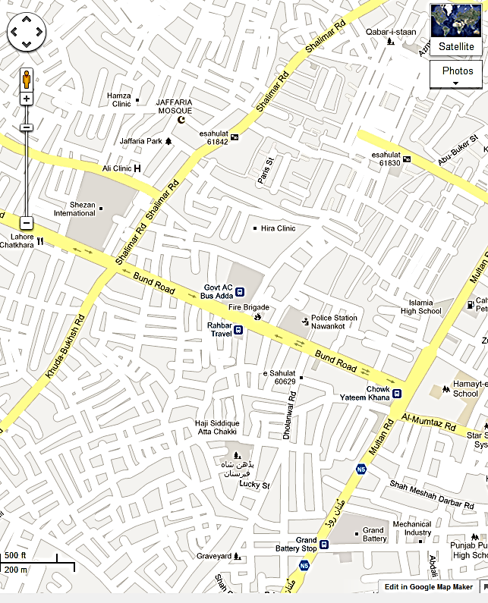
Sikandar Colony
onyy
Figure: 3.1 Map of Sikandar Colony

3.3.3 Marriyam Colony
Marriyam Colony is situated at Ghaus-ul-Azam Road in the area of Township, in the periphery of the Central Lahore. In the East, chand mari open land of army and office of the Union Council are present. Towards West, Abadis of Baghrian and Ghazi chowks are present. In the North, Green Town Madr-e-Millat road is located. Plot number 1, Niazi Colony is situated in the South of this Katchi Abadi.
It is notified/declared Katchi Abadi. It lies in Union Council No. 140 in the constituency PP-154. Its total area is 36 Kanal and 18 Marlas with total number of 412 dwelling units. Most of the people of Marriyam Colony are labourers either skilled or unskilled and some have a small business to earn their livelihood. Since, this Abadi is situated close to the industrial area of Kot lakhpat, many people work in the nearby industries. However unemployed young generation is serious problem in this KatchiAbadi. The majority of the population belongs to Christianity. About 240 families are Christian whereas remaining families are associated with Islam. There is a famous “Saint Marry Church” at the main road of this Katchi Abadi.
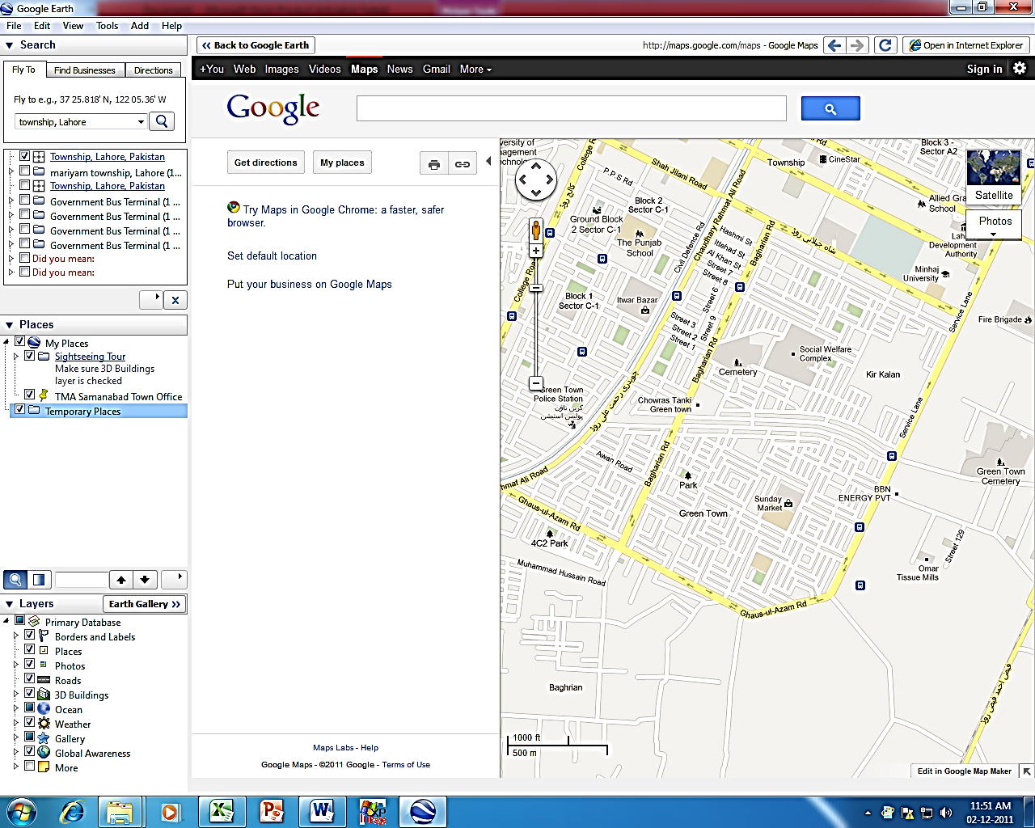
Marriyam Colony
onyy
Figure: 3.2 Map of Marriyam Colony

3.4Research tool and Analysis
The collection of data is carried out by following two major streams:
  - Primary data collection.
  - Secondary data collection.
Collection of Data
Secondary Sources

- Documents, Govt. publications.
- Earlier Research Census.
Primary Sources

- Close Ended Questionnaires.
- Observations.
- By taking sample (5%) of the total No. of dwelling units.

3.4.1Tools Used
The tools that were used to carry out these researches are as follows;
- Observations:
The observations were primarily taken by physically visiting the area in different times of the year and were recorded in the form of photographs. An important part of observations consisted of taking sample (5%) from dwelling units and then analysed according to the sample report.
- Questionnaire:
The content of questionnaire comprised of the queries about the relationship of the user to the area in specific existing environment so that the up-graded environment can be suggested.
The up-gradation of existing services proposed in the responses/reactions of dwellers helped to find the expected improvement.

- Drinking Water and Solid Waste Sampling:
Grab samples for drinking water were collected from different points of case study areas. Chemical Analysis was performed for different important parameters in the testing laboratory in order to comply with the Drinking Water NEQS.
The sampling of solid waste generated from the houses of study areas was also carried out in order to determine the physical composition of solid waste.

3.5Data Analysis
A frame of analysis was formed which evolved from the following factors.
- The study of variables for the development of cause and effect relationship.
- Data analysis for qualitative observations assisted by areal and pictorial views.
- Conversion of quantitative data into tabulated form to show more prescribed form of graphs by using Excel application of MS Office.
- Chemical analysis results of drinking water are shown in tables and graphs while for solid waste physical analysis are performed.
- Research conclusions.
- Recommendations.

3.6Findings
- Inadequate supplies of safe drinking water
- The presence within the home and its immediate surrounds of disease-causing agents (pathogens) because of a lack of basic infrastructures and services (e.g No sewers, no services to collect solid waste and safely dispose of them)
- Overcrowded, cramped living conditions that increase the transmission of airborne infections and those passed by human contact and increase the risk of accidents.
- The Inadequacies in Provision of Drinking Water
Lahore is a big and important city of Pakistan and it is also center of Punjab. These two katchi abadis are situated in the urban area of Lahore. It is seen that most of the dwellers have “access to piped supply” but do not have a piped supply into their houses and thus have to rely on standby piped or other communal or public. They receive water through the pipe intermittently and the general perception is that the quality of water is poor. The difficulties in getting water are often much increased by the fact that water is only available in the piped system for a few hours a day, or water pressure is very low, so it takes a long time to fill up each person’s water container.
- Solid Waste Disposal/ Management
Removing and safely disposing of excreta and wastewater is also a critical environmental health need. In these katchi abadis, it is seen that there is no proper, regular and safe system of removing and safely disposing of excreta and wastewater. It is observed that the agencies and government have neglected theses areas regarding the management of solid waste and also there is lack of coordination of local dwellers in solid waste management. People are illiterate and are unaware of the environmental problems and risks. Heaps of solid wastes are found in the streets and children play with bare feet in these streets that impose a serious health impacts upon them. The streets are over flooded with the wastewater/sewerage due to the blockage and non-cleanliness of open drains. Flies, mosquitoes and other disease vectors are observed in these areas more prominently. Most of the diseases associated with contaminated water including all the water borne diseases listed below
- Health Problems associated with inadequate Water supply and Solid Waste Disposal
A lack of readily available water of sewer (or other systems to safely dispose of human wastes), of drainage systems, rubbish collection and basic measures to prevent disease and provide healthcare result in very large health burdens from easily prevented diseases. They also result in high levels of infant and child death. Many health problems are linked to water- its quality and quantity available. Most of the people were complained that the quality of water is not according to standards. They think that usually water is mixed with sewer-piped water and thus the water is very hazardous to the health of people of these two abadis. Regarding the quantity, most of the people informed that usually water is not available in the pipes or water is provided for a very short time. Following are the important type of diseases due to contaminated water.
- Cholera
- Diarrhoeal disease
- Enteric fevers
- Infectious jaundice
- Pin worm
- Polio
- Round worm
- Leptospirosas
- Whip worm
- Skin and eye infections
- Scabies
- Impetigo
- Trachoma
- Relapsing typhus
- Malaria
- Filarial
- River blindness
- Yellow fever
- Dengue fever
The safety and accessibility of drinking –water are major concerns throughout the world. Health risks may arise from consumption of water contaminated with infectious agents, toxic chemicals, and radiological hazards. Improving access to safe drinking-water can result in tangible Improvements to health. The quality to drinking-water is a powerful environmental determinant of health. Assurance of drinking-water safety is a foundation for the prevention and control of waterborne diseases.

CHAPTER 4: ANALYSIS OF DATA

4.1 Criteria of the Field Research

It is a general observation that environmental conditions and basic civic facilities are sub standard in Katchi Abadis of Lahore. People are living in poor quality environment and they have inadequate access to the basic civic facilities such as water supply, sanitation, sewerage, street sweeping, roads, parks, school, dispensary etc. Environmental up-gradation of the basic facilities in Katchi Abadis of Lahore is the mere need of the time. Environmental up-gradation is the realistic, workable and sustainable approach that will lead to better environment and positive mind change in the area (Katchi Abadis).
In the research questionnaires, we will focus and precede with study of the existing general ambiance, changes in past in relation to basic civic facilities, quantity as well as quality, adopted solutions and best possible solutions for improving the environment.
There are total 310 katchi Abadis in Lahore in which 152 have been declared/ notified by the Government of Punjab. We have selected two notified katchi Abadis as case studies for our research purpose;
A. Sikandria Colony at Bund road Lahore
B. Marriyam Colony near Township Lahore
Out of various civic facilities two parameters in the selected colonies for our research purpose, keeping in view their Importance and significance. These parameters are;
- Drinking water supply
- Solid waste management

4.2Existing Environmental Condition of Sikandria Colony and Marriyam Colony
From the field survey following are the photographic view of the two kachi Abadis which is as follows.
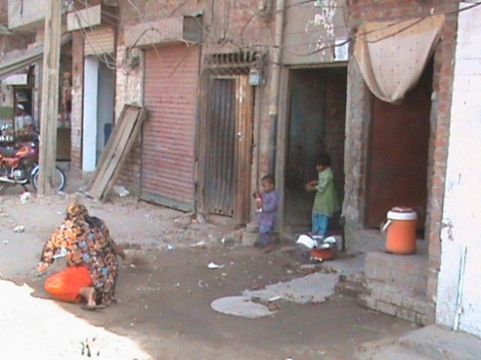
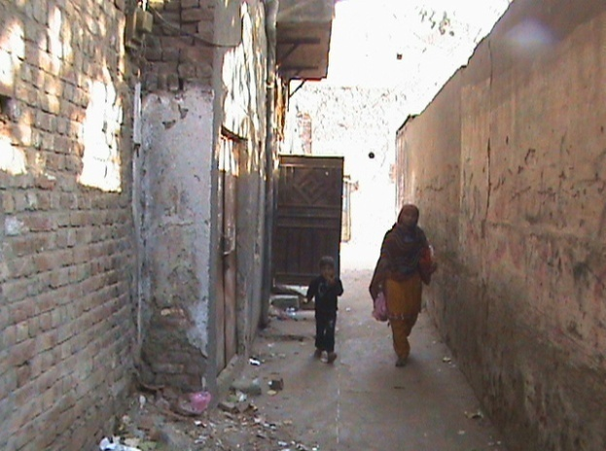

Picture 1: Solid Waste lying in the StreetPicture: 2 Street sweeping practices in
SikandarColony
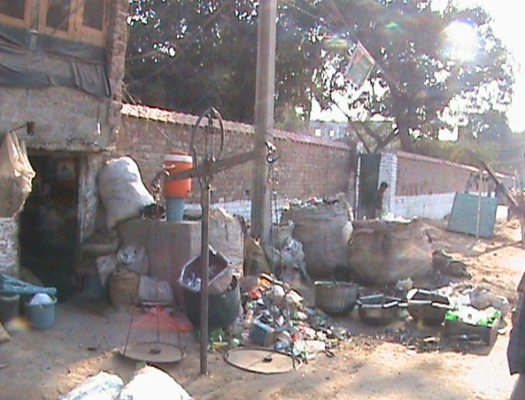
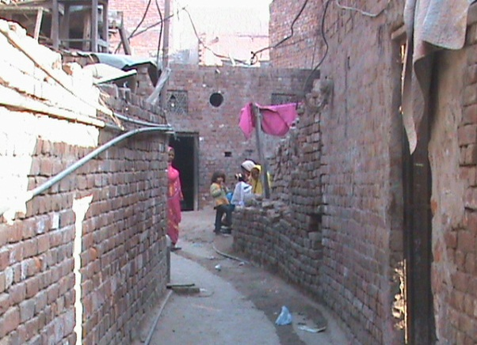
Picture 1 & 2 shows the status of street sweeping and solid waste management in the Sikandar Colony. These pictures clearly show that people are living in poor sanitation and substandard civic facilities.

Picture 3: Living condition of Sikandar Colony Picture: 4 Kabaria Shop in Sikandar Colony
Picture 3 gives us the image of living condition of dwellers in Katchi Abadi. People are living in congested homes. It is clear in picture 4, that recyclable items are collected and segregated at Kabaria shop. Kabaria shop is source of adverse health impacts due to improper handling of waste.

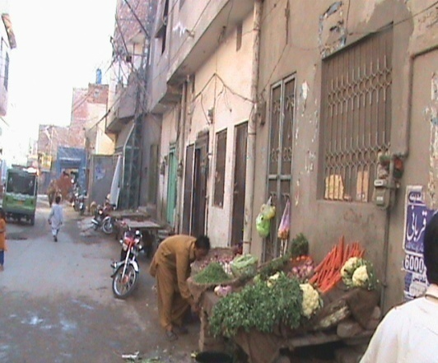
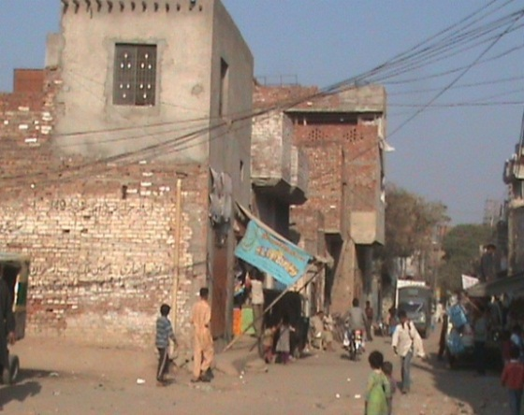

Picture 5: Overcrowding in Sikandar colony Picture 6: Vegetable shop in Sikandar colony
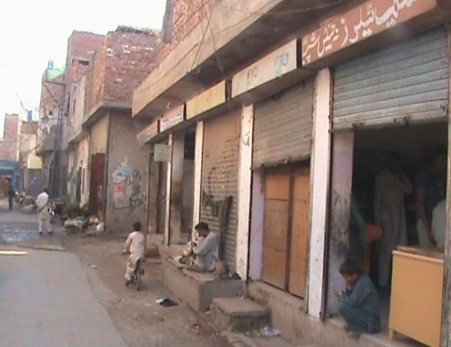
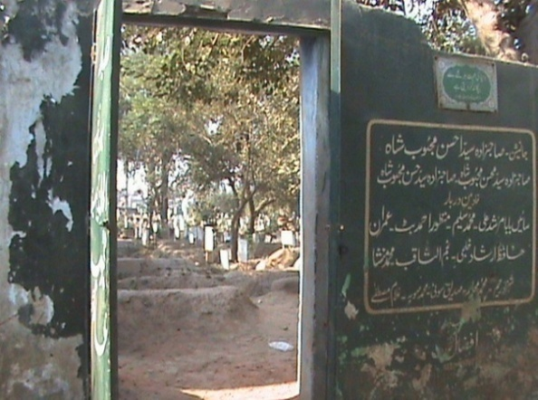
Due to over population, overcrowding is a common phenomenon in streetsas well as dwellings in the Katchi Abadi which is manifested in picture 5. Picture 6 shows the vegetable shop in street. Vegetables are exposing to smoke and dust and can cause health effects.

Picture 7: Condition of Graveyard in Sikandar Colony Picture: 8 Commercial Area of Sikandar Colony
It is found that most of the people are poor and their living standard is very low. The roads and streets are bad condition and many interior streets are still unpaved (katchi). People live in housing units that are of poor quality. Houses are made of materials which provide inadequate protection against the extreme temperatures. Since in Lahore, the temperature is either very high in Summer (50-53 °C) or very low in Winter (0- -2 °C). There is insufficient space relative to the number of persons living in a house and inadequate provision for piped water supply, the removal of excreta, household liquids and solid waste etc. Dust pollution and noise pollution are very serious factors of the locality. It is observed that the electricity and sui-gas are also provided in this Katchi Abadi but people made multi-connections from a single connection in order to distribute to different portions of the houses and even to neighbours. In other words most of the people have “access to piped supplies” but do not have a pipe supply into their homes and thus have to rely on stand-by pipes. Similar is the situation in case of the electricity connections. There is no proper, regular and safe system of removing and safely disposing of solid waste, excreta and wastewater.
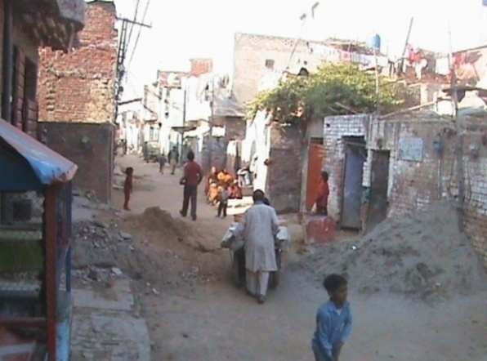
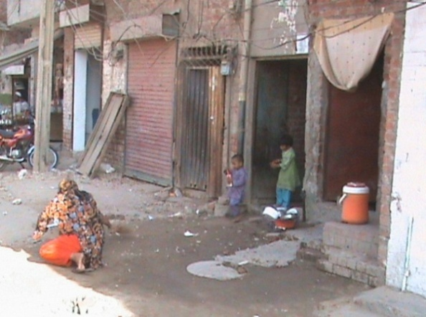

Picture 9: Street conditions in Marriyam Colony Picture 10: Poor condition of dwellings
Picture 9 clearly shows substandard work and poor sanitation condition in the street at marriyam colony. Demolition and construction martial as well as waste is lying in a street which is shown in picture 9 and 12. Picture 10 the shows the poor living conditions in this Katchi Abadi. The congested and poor ventilation status in the streets has shown in the picture 11and 12.
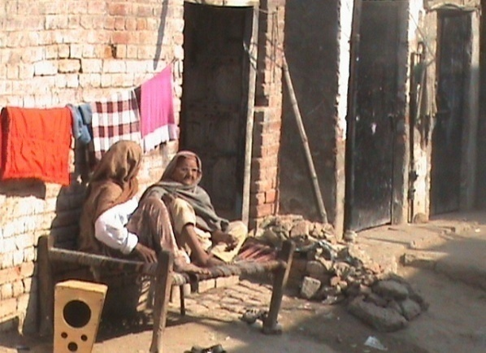
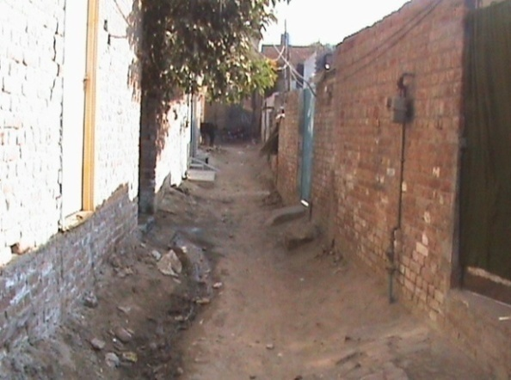

Picture 11: Street conditions in Marriyam Colony Picture 12: Unpaived street

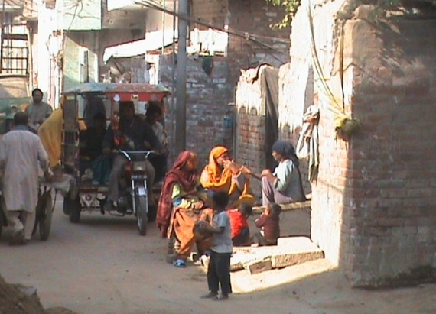
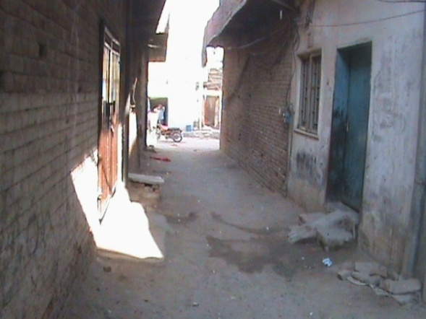

Picture 13: Life Style of residents Picture 14: Overcrowding in street
The overcrowding and congested dwellings in the Marriyam colony are manifested in these pictures. There are small size dowellings in which there is no proper system of ventilation and poor access to the sun light. Large size families are living in congested homes. Poor situation of solid waste management and sanitation is also shown in these pictures.
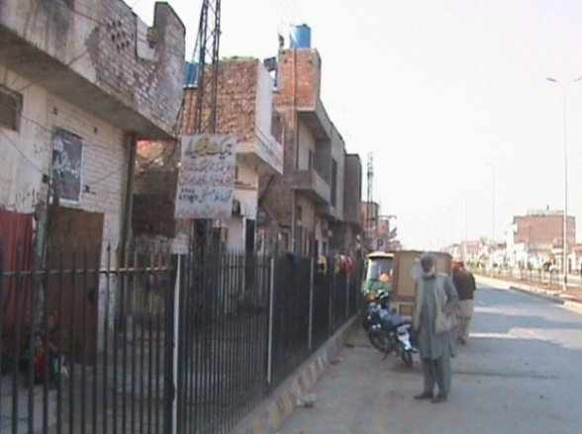
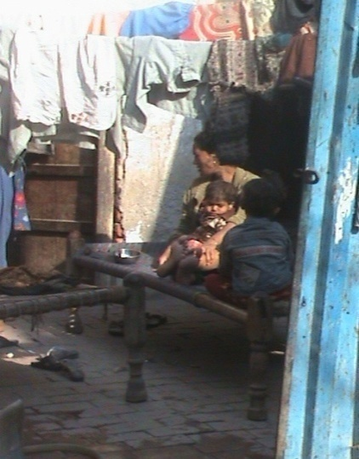

Picture 15: Inner side of Marriyam colony Picture 16: Congested Dwelling
It is observed that most of the people are poor and their living standard is very low. Majority of dwelling units are of size 2.75 marla. There is insufficient space relative to the number of persons living in a house. This abadi is provided with electricity, sui-gas and piped water facilities but the living standard of dwellers needs huge improvement and 20% population is deprived of water connections. Poor infrastructure is observed in this abadi. The condition of the roads and streets is very bad and some are unpaved. There is inadequate provision for piped water supply, the removal of excreta, household liquid and solid waste etc. It is observed that the electricity and sui-gas are also provided in this Katchi Abadi. People have “access to piped supplies” but do not have a pipe supply into their homes and thus have to relyon stand-by pipes. Similar is the situation in case of the electricity connections. It is observed that there is no proper collection and disposal of solid waste. People of the area themselves arranged some worker for the collection and disposal of solid waste on daily basis and each house pays 25 rupees for these workers.

4.2.1 Collection of Data through Questionnaires
Two questionnaires were developed for the collection of data of the two Kachi Abadies are attached Annex-I & II. It is observed the environmental conditions are very poor in almost all the katchi Abadis of Lahore. The research parameter restricted to drinking water supply of solid waste management.As regards to these two parameters generally it was observed that most of the people are not satisfied about the quality as well as quantity of water as people of these Katchi Abadis have least access to safe drinking water. With regard to management of solid waste, it was founded that disposal of solid waste that the street and roads of these Katchi Abadis are not satisfied with cleaness.

4.3Field Survey Results Regarding Population
Table: 4.1 Field Survey Results Regarding Population
Name of Katchi Abadis | Total No of Dwellings | No of persons per home. | Percentage of children | Population
Sikandria colony | 389 | 9.73 | 45.9%  (1739) | 3788
Marriyam colony | 433 | 8.31 | 44.3%  (1595) | 3600
Total | 822 | 9 | 45%  (3325) | 7388
Keeping in view research objectives, survey visits and interviews were conducted to collect primary data and information about population and especially about population of children.
Sikandira colony is a katchi Abadi located near Bund road Lahore. . According to LDA this colony is legally declared as katchi Abadi and total No. of dwellings in this katchi Abadi are 389. The total Population of this colony is estimated 3788 persons and average 9.73 persons per home. The children population in this colony is estimated 45.90% of the total population.
Marriyam colony is legally declared as a katchi Abadi and located Township Lahore. According to our questionnaire survey there are 433 No. of dwellings in this katchi Abadi. The total Population of this colony is estimated 3600 persons and average 8.31 persons per home. The children population in this colony is estimated 44.33% of the total population. Majority of population of Marriyam colony belongs to Christianity.

4.4Field Survey Results of Drinking Water Supply
Table 4.2: Number of WASA Connections, Type of Connections and Satisfaction of the People of Katchi Abadis.
Name of Katchi Abadis | Total No of Dwellings | No of Houses having WASA connection | No of Houses having No WASA connection | No of houses having Proper connection | No of houses having Stand By connection | No of houses having Hand Pump | No of houses having  other temporary arrangement | No of houses satisfied about the quantity of water | No of houses not satisfied about the quantity of water
Sikandria colony | 389 | 381 | 7 | 72 | 11 | 2 | 4 | 39 | 350
Marriyam colony | 433 | 403 | 30 | 401 | 15 | 8 | 9 | 25 | 408

Graph: 4.1Graphical Representationof Results

In sikandria colony WASA has the responsibility to provide water supply services there are 1 Tube Well station across the road of sikandria colony. During our questionnaire survey it was observed that 97.943% of total dwellings have provided water supply services by WASA. 2.056% of dwellings are not provided water supply services.
During questionnaires survey it is observed that 95.62% of dwellings have proper connections and 2.82% of dwellings have stand by connections of water supply. On the other hand 0.51% of dwellings use hand pumps and 1.02% dwellings have temporary arrangements.
Water supply does not meet the household needs of residents in Sikandria colony. 89.97% of people complained that limited water supply does not meet the household needs of family. Due to shortage of water supply, people face difficulties in daily practices like washing, cooking and bathing etc. This is miserable condition of Sikandria colony residents. These results are shown in Graph No: 4.1
Table:4.3Time Duration of Water supply by WASA to the people of Katchi Abadis
Sikindria colony | Marriyam colony

Time Duration | Percentage | Time Duration | Percentage
1 hour | .3 | 4 hour | 1.4
5 | .3 | 5 | 56.8
6 | 2.1 | 6 | 9.9
7 | 9.3 | 7 | 13.2
8 | 8.7 | 8 | 92
9 | 58.1 | 9 | 6.7
10 | 15.9 | 10 | 2.8
11 | 4.9 | 11 | 0.5
12 | .3
13 | .3

Graph: 4.2 Graphical Representation of Time Duration of Water Supply in Both Katchi Abadis.

During investigation it is examined that water is available 9-10 per 24 hours in Sikandria colony and 6-7 hour per 24 hour in Marriyam Colony. It was observed at different time interval in a year i.e. summer and winter season. Load-shedding is the main factor for limited water availability in a day. Resultantly residents of these Katchi-Abadi suffer water supply shortage.

Table: 4.4SatisfactionAbout the Quality of Water
Name of Katchi Abadis | Total No of Dwellings | No of Houses satisfied about quality of water | No of Houses not satisfied about quality of water
Sikandria colony | 389 | 18 (4.63%) | 371
Marriyam colony | 433 | 28 (6.46%) | 405

Table 4.4 shows that 95.37% residents of Sikandria colony are not satisfied about quality of water and they complained about the poor quality of water supply. Water supply provided by WASA in this colony is contaminated. Due to contamination Water cause smell and bad taste. In contrast only 4.62% residents are satisfied about quality of water. Approximately same is the situation in Marriyam colony. During questionnaires survey, mostly people complained about the old/ rusted water supply pipe lines. These pipe lines have expired their lifetime and become rusty. Due to rusty pipe line, sewerage water is mixed with water supply and cause contamination and smell. No attention hadgiven to repair or change these rusty pipelines.
Table: 4.5 In Case of Contamination Option Adopted by Peoples.
Name of Katchi Abadis | Total no of dwellings | No of houses use boil water | No of houses use water filter | No of houses collect water from other source | No of houses use same water
Sikandria colony | 389 | 20 | 12 | 160 | 197
Marriyam colony | 433 | 22 | 10 | 195 | 206

Graph: 4.3Graphical Representationin Case of Contamination Option Adopted
by thePeople of Katchi Abadis

It is observed that 51 % of population of Katchi Abadis are using contaminated water for drinking purposes. Majority of people use contaminated water for cooking and other household needs. People are at risk of water born diseases. The 41.13% of population brings water from outside the colony for their drinking purpose. Only 5.14% of population of these colonies drink water after boiling. Finally people are not satisfied by water supply and they have their considerations. It is need of hour to provide safe and standard quality water to this population. Another factor is that mostly people living in these katchi Abadis are poor and they cannot afford drinking water filters or buy bottled water.

Table: 4.6DiseaseCaused by Water Supply
Name of Katchi Abadis | Total no of dwellings | No of people inform about disease cause by water | No of people not inform about disease cause by water | Percentage
Sikandria colony | 389 | 130 | 259 | 33.41%
Marriyam colony | 433 | 80 | 353 | 81.52%

It was examined that most people are not aware about health risk caused by contaminated water. Child’s are most suspected to water born diseases and they are 45% of population of case study. Majority of people are illiterate and they do not knowledge about disease caused by use of contaminated water and thus they do not adopt precautionary measures.

4.5Field Survey Results of Solid Waste management
Table: 4.7Solid Waste Collection System
Name of Katchi Abadis | Total no of dwelling | Collection system exist | Collection system not exist
Sikandria colony | 389 | 6 | 382
Marriyam colony | 433 | 12 | 421
Total | 822 | 18 | 804

In Sikandria & Marriyam colony, Lahore Waste Management Company has responsibility of solid waste collection and management. There is no proper solid waste collection system in these colonies. Waste collection containers are not provided in streets of these colonies.
Table: 4.8Method used for Solid Waste Collection
Name of Katchi Abadis | Total no of dwelling | House to house collection | Collection container in street | Self managed
Sikandria colony | 389 | 1 | 2 | 386
Marriyam colony | 433 | 5 | 420 | 8
Total | 822 | 6 | 422 | 394

These results show that there is no proper collection system of solid waste by LWMC. People arrange solid waste collection by self-paid. One poor man/woman has responsibility to collect waste door to door. Owners of dwellings pay them 50-100 Rs per month. After collecting solid waste they transport waste to the storage site out of colony.
Table: 4.9Solid Waste Collection Time Interval
Name of Katchi Abadis | Daily | Twice in a week | Weekly | Monthly
Sikandria colony | 55 | 318 | 14 | 2
Marriyam colony | 55 | 350 | 20 | 6
Total | 110 | 668 | 34 | 8

81.26% of solid waste is collected twice in a weak, this practice is repeated at morning time/after noon. These observations are manifested in table above. This collection system of solid waste is totally managed by residents themselves and is not effectively controlled.

Table: 4.10Solid Waste Collection Time in a Day
Name of Katchi Abadis | Total no of dwelling | Morning | After noon | Evening
Sikandria colony | 389 | 362 | 27 | 0
Marriyam colony | 433 | 390 | 33 | 10
Total | 822 | 752 | 60 | 10

Majority of people of Katchi Abadis stated that solid waste is collected at morning time. A little amount is collected at evening. The collection of solid waste is done by poor private man/woman by paying him monthly or daily bases. Rest of solid waste is put in streets and along road sides.
Table: 4.11Type of Solid Waste Produced
Name of Katchi Abadis | Total no of dwelling | Organic | inorganic | Mixed
Sikandria colony | 389 | 6 | 9 | 375
Marriyam colony | 433 | 10 | 15 | 408
Total | 822 | 16 | 24 | 783

It is observed that organic as well as inorganic waste is produced in this colony. Mostly solid waste is consisting of kitchen waste, dust particles, rappers, polythene shoppers, bottles, plastic, paper, vegetables and fruits. People are not aware to segregate the organic and inorganic waste at source. They mix up the waste both organic and inorganic, and it is further difficult to separate the reusable things and recyclables. It is need of hour to aware the people and launch segregated collection system due to increasing environmental pollution.

Table: 4.12Street Sweeping Activity
Name of Katchi Abadis | Total no of dwelling | Street sweeping daily | Street sweeping off and on
Sikandria colony | 389 | 87 | 302
Marriyam colony | 433 | 95 | 338
Total | 822 | 182 | 640

It is examined during questionnaire survey that 77.8% of residents responded that there is not street sweeping practice daily as mentioned in table illustrates. Solid waste is faltered in streets all the day and produce unhealthy condition. Many infections and communicated diseases are caused by poor collection of solid waste. Resultantly people are suffering by this unhealthy situation and they have their concerns about solid waste management.
Table: 4.13DiseaseDue to Solid Waste
Name of Katchi Abadis | Total no of dwelling | Disease due to solid waste (yes) | Disease due to solid waste (no)
Sikandria colony | 389 | 20 | 369
Marriyam colony | 433 | 38 | 395
Total | 822 | 58 | 764

Lahore Waste Management Company does not address these colonies. Generally the departmental negligence is noticed. It is observed that majority of residents of these colonies are illiterate and they have no knowledge about health diseases caused by solid waste. So resultantly they give poor response to this question as manifested in table above.

Table: 4.14SatisfactionRegarding SWM Services
Name of Katchi Abadis | Total no of dwelling | No of people satisfied by LWMC | No of people not satisfied by LWMC
Sikandria colony | 389 | 12 | 377
Marriyam colony | 433 | 25 | 408
Total | 822 | 37 | 785

Lahore Waste Management Company does not properly address these Katchi Abadis. Majority of people of these Katchi Abadis complained about the departmental negligence. It is noticed that people of these colonies are not satisfied by LWMC services. They have their concerns and considerations for the negligence of this colony from LWMC. Residents are suffering very miserable condition. Lahore Waste Management Company should provide an effective collection system for solid waste for these colonies.

4.6 Collection of DATA through Water Samplings
I have taken about 8 samples (2% of total no of dwellings) from sikandria colony and 8 samples(2% of total no of dwellings) from Marriyam colony and sent these samples to labotories namely “Pakistan council of research in water resources (PCRWR) and public health engineering department Lahore”.
The Results of samples are described as below,
Table: 4.15 Bacteriological Analysis Report
Sr No | Laboratory No. | Date/ Time of Collection | Description (Sampling Point) | Date of Analysis | RESULTS |  | Remarks
 |  |  |  |  | No.Coloform Colonies | MPN/100ML | Remarks
1. | B-1/12/566 | 16-05-12 | Water Sample from House of Manshia S/O Jaga. | 17-05-12 | 30 Nos. | -- | UNFIT
2 | B-2/12/566 | 16-05-12 | Water Sample from Sadiq | 17-05-12 | 20 Nos. | -- | UNFIT
3 | B-3/12/566 | 16-05-12 | Water Sample from Imanatg S/O Hameed Masih. | 17-05-12 | 40 Nos. | -- | UNFIT
WHO STANDARD: There should be no colony of Coliform bacterial per 100/ml of sample.

Table: 4.16 Chemical Analysis Report of Drinking Water (Sikandria Colony)
Sr. No. | Water Quality Parameter | Permissible Limits | sample 1 Results | Sample 2 Results | Sample 3 Results | Sample 4 Results | Sample 5 Results | Sample 6 Results | Sample 7 Results | Sample 8 Results
01 | pH | 6.5-8.5 (WHO) | 7.37 | 7.32 | 7.55 | 7.37 | 7.46 | 7.84 | 7.77 | 7.73
02 | TDS(mg/1) | 1000 (WHO) | 480 | 373 | 552 | 480 | 537 | 367 | 485 | 496
03 | Turbidity (NTU) | 5 (WHO) | 0.7 | 0.5 | 0.8 | 0.7 | 0.5 | 0.9 | 0.8 | 0.6
04 | Arsenic (ug/1) | 10 (WHO) | 22.46 |  |  | 22.46 |  |  | 21.88
05 | Lead (ug/1) | 10 (WHO) | 1.28 |  |  | 1.28 |  |  | 1.43
06 | Chromium (ug/1) | 50 (WHO) | 0.86 |  |  | 0.86 |  |  | BDL
07 | Mercury (ug/1) | 1 (WHO) | BDL |  |  | BDL |  |  | BDL

Found to be fit for drinking purpose for analyzed parameters(sample 2)
Found to be fit for drinking purpose for analyzed parameters(sample 3)
Found to be unfit for drinking purpose for analyzed parameters(sample 4)
Found to be fit for drinking purpose for analyzed parameters (sample 5)
Found to be fit for drinking purpose for analyzed parameters (sample 6)
Found to be unfit for drinking purpose for analyzed parameters (sample 7)
Found to be fit for drinking purpose for analyzed parameters (sample 8).
Table 4.17:Chemical Analysis Report of Drinking Water (Marriyam Colony)
Sr. No. | Water Quality Parameter | Permissible Limits | sample 1 Results | Sample 2 Results | Sample 3 Results | Sample 4 Results | Sample 5 Results | Sample 6 Results | Sample 7 Results | Sample 8 Results
01 | pH | 7.0-8.5 | 7.9 | 8 | 7.30 | 8 | 7.80 | 7.80 | 7.2 | 7.5
02 | Odour | Unobjectionable | Odorless | Odorless | Sewage Smell | Odorless | Odorless | Odorless | Sewage Smell | Odorless
03 | Colour | 5 Units | Colorless | Contain White Particles. | Colorless | Colorless | Colorless | Colorless | Contain White Particles. | Colorless
04 | Taste | Unobjectionable | Tasteless | Tasteless | Tasteless | Tasteless | Tasteless | Tasteless | Tasteless | Tasteless
05 | Turbidity ppm Silica Units or N.T.U. | 5 Units | 0.90 NTU | 0.90 NTU | 1.80 NTU | 0.90 NTU | 1.60 NTU | 1.70 NTU | 1.90 NTU | 1.60 NTU
06 | Total Dissolved Solids | 500 | 475 | 525 | 480 | 475 | 580 | 490 | 505 | 525
07 | Calcium | 75 | 25 | 16 | 16 | 20 | 20 | 25 | 35 | 26
08 | Magnesium | 50 | 5 | 15 | 13 | 5 | 20 | 18 | 16 | 15
09 | Hardness mg/l | 100 | 80 | 90 | 90 | 70 | 130 | 80 | 110 | 90
10 | Sulfate | 200 | 95 | 115 | 110 | 115 | 130 | 140 | 120 | 110
11 | Chloride | 200 | 30 | 45 | 40 | 40 | 40 | 45 | 30 | 40
Note: All the reports of water sampling are attached at annexure (7upto 20).

It is pertinent to mention here that the 3 samples from each Katchi Abadis were examined on the bases of chemical analysis, it was found that lead, Chromium, and Mercury were under Permissible Limits whereas Arsenic was beyond the Permissible Limits and resultantly water was not safe for drinking purpose. There-for it is alarming situation in these Katchi Abadis of Lahore that about 7400 peoples are drinking contaminated water(polluted by Arsenic) and their lives are at risk. It is important to mention here that 2.5 million peoples are living in about 300 Katchi Abadis in urban area of Lahore.
It is observed from the reports that people are using subjective quality criteria like brackish, foul smelling, bad tasting turbid or coloured water to determine that it is not suitable for drinking. There are several sources to contaminate drinking water.
- Bacterial contamination
- Ground Water contamination from irrigated areas.
- Ground Water contamination from industrial areas.
- Chemical pollution from toxic substances that is textile dyes, pesticides etc.
- Pollution from municipal waste etc.
- Pollution from oil spills etc.
- Pollution from excessive monsoon rains, floods, herbicides, fungicides etc.
- Major issue.
Health problems are linked to water,its quality, the quantity available. The ease with it can be obtained and the provisions made for its removal, once used. The health links with sanitation are also obvious; human excreta is an extremely hazardous substance. These diseases account for a high proportion of infant and child deaths. The water related diseases are classified by mechanisms into three categories water borne, water washed, water based and water related insect vector.
Diseases water-borne mostly diarrhoeal diseases- are the most common. Diarrhoeal diseases account for a high proportion of infant, child and adult illnesses, and for most water-related infant and child deaths. When combined with under nutrition they can also so weaken the body’s defence that diseases such as measles and pneumonia become major causes of death. Where water supplies and provision for sanitation are inadequate in these Katchi Abadis, water-borne diseases can remain one of the most serious health problems in these Katchi Abadis. Overcrowding and inadequate food hygiene exacerbate the risks from contaminated water and poor sanitation. There are also water-borne intestinal worms that cause severe pain and undermine the nutritional status of hundreds of millions of urban dwellers, but only a small proportion of those infected will die of them.
The water-washed diseasesare associated with a lack of water supplies for washing in these Katchi Abadis. These include various skin and eye infections such as scabies and trachoma. The number of people who can be affected and the extent to which lower-income groups face greater problems (largely because of poorer quality provision for water) (Mali’s capital and largest city). This found the overall prevalence of scabies among the pupils to be 4 percent, ranging from 1.8 percent at the school with the highest socio-economic level to 5 percent at primary schools serving poorer areas. Most water-borne diseases are also ‘water-washed’, as their incidence is associated with inadequate water supplies as well as with contaminated water.
Diseases spread by water-related insect vectorsare among the most pressing environmental problems in these Katchi Abadis. These include malaria. Although commonly considered a ‘rural’ disease, there are severe problems with malaria in urban areas. The Anopbeles mosquitoes that are the vector for malaria breed in standing water, so good drainage is a critical part of malaria control.
Other kinds (or genera) of mosquito can be the vectors for the other serious diseases. The diseases spread by Aedes mosquitoes (which include dengue, dengue hemorrhagic fever and yellow fever) are serious health problems in many cities. Containers used for storing water in houses lacking regular piped supplies (pots and jars, small tanks, drums and cisterns) can provide breeding habitats for these mosquitoes. Many household with piped supplies are also at risk because of intermittent supplies of water in the piped system, so they store water in tanks, when water is available. Small pools of clean water within residential areas in, for instance, discarded tin cans and rubber tyres can also be breeding grounds. Reliable, steady piped water supplies (so household do not need to store water) and good rubbish collection can greatly reduce the risk of diseases spread by Aedes mosquitoes. Culex mosquito, which can be one of the vectors for bancroftian filariasis (a debilitating disease affecting millions of people), can breed in open or cracked septic tanks, folded pit latrines and drains but can be controlled through measures as simple as polystyrene balls in septic tanks and latrines. Even where mosquitoes do nor pose health threats, they are often a severe nuisance and low-income households may spend a significant proportion of their income in insecticides or repellents.
Disease vectors also have and important role in the transmission of many water-borne or water-washed diseases including diarrhoel diseases, scabies (scabies mites), trachoma (face flies) and typhus (body lice and fleas). Many disease vectors thrive when there is poor drainage and inadequate provision which is normally considered a rural disease, since it is usually caught through contact with irrigation water or stored water in which the aquatic snails that are host to the schistosome worms live.

CHAPTER 5: CONCLUSION & RECOMMENDATIONS

5.1Summary
The fact that the high proportion of population are found in these Katchi Abadis, as discussed in chapter 4. It is observed that high proportion that is 9 to 10 person are living in a single dwelling, which shows that it is a densely populated area. People are living and working in very poor condition. Houses are often made of materials which provide inadequate protection against the elements and against the climatic elements like extreme temperatures. There is usually insufficient space relative to the number of people living in a dwelling. The aspect of high proportion of population is very important in these Katchi Abadis and in this context, Government should pay special attention to uplift/ upgrade civic facilities in these Katchi Abadis. In the prospective of all Katchi Abadis of Lahore, it is observed that a high proportion of population (2.4 million) are living in poor quality environment.

5.2Conclusions
As per findings and results obtained from the analysis of the study and based on the discussions made with the professional experts, following conclusions are drawn:
- It is concluded from the field research that Water supply does not meet the household needs of residents of Katchi Abadis. Most of the people complained that limited water supply does not meet the household needs of family.
- It is observed that due to a lack of basis important services for instance, no sewer, inadequate provision for drainage & irregular or no services to collect solid wastes and safety disposal of them.
- Overcrowded, cramped living conditions is a serious problem in Katchi Abadis that increase the transmission of airborne infections and those passed by human contact and increase the risk of accidents.
- Non Availability of sewers or other system, to safely dispose of human wastesor drainage systems, basic measures to prevent diseases from sanitation.
- It is observed from examining the quality of water used by the people of Katchi Abadis are not saved drinking water.
- From the field research it is observed there is a problem of inadequate or no collection of household waste.
- Uncollected waste is obviously a serious health hazard in Katchi Abadis especially for children playing in and around their homes. (and for many playing with items drawn from uncollected rubbish).
- It is important to mention here that Katchi Abadis are the poor areas of the city that generally have the least adequate waste-collection service at all.
- It is concluded from field research that average 45%(3325) are infant and children out of total population 7388 of two Katchi Abadis (Sikandria & Marriyam colony). It is important to mention here that there are total about 300 Katchi Abadis in Lahore and thus high proportion of infants and children are living in poor quality environment and they are more vulnerable to many serious problems of health.
- Women are generally far more severely affected than men by poor-quality and overcrowded housing conditions, and by the inadequate provision of water, sanitation and health care (and also schools and nurseries) because they take most responsibility for looking after infants and children, caring for sick family members and managing the household.
- It is concluded from the field research that there is no quality health care center in the two case study Katchi Abadis. Many health problems are linked to water_ its quality, the quantity available the case with which it can be obtained and the provisions made for its removal, once used. The health links with sanitation are also obvious; human excreta are an extremely hazardous substance. These diseases account for a high proportion for infant and child deaths. Improved water and sanitation can bring great benefits not only in terms of reducing infant and child mortality and improved health, but also in reduced expenditures on water purchased from vendors or kiosks and on treatment for diseases higher real incomes because of less time off work for illness and much reduced physical efforts especially for those who have to collect and carry water from standpipes or other sources far from their shelters. Water-related diseases by the mechanisms by which the disease is transmitted: water-borne, water-washed, water-based and water-related insect vectors.
- It is concluded from the field research that poor quality environment can contribute to the stress that underlies many diseases. Many physical characteristics of the housing and living environment can influence the incidence and severity of psychosocial disorders through stressors such as noise, overcrowding, poor sanitation and waste collection and in adequate maintenance.
- It is concluded from the field research that peoples of Katchi Abadis are at higher level of risk, It is only that low-income groups generally face higher levels of risk but also that most have less possibility of getting rapid and appropriate medical treatment.

5.3Recommendations
- Control on Population in the country (especially in Katchi Abadis)
- The poorer residential areas (KatchiAbadis) must be given preference asregard to basic civic facilities.
- Installation of filtration plantin each Katchi Abadi.
- Ensure readily availability of Water.
- Installe Generator with each tube well for regular supply of water
- Replace rusty/damage water supply pipes
- Improve the water supply system.
- Ensuring regular collection services for solid waste.
- Waste reduction and segregation at source.
- Community participation for safe drinking water and other civic facilities.
- Disposal of wastes in the streets, open spaces, in vacant areas or into drains should be banned.
- Levy of administrative charges for littering of streets.Source segregation of wastes.
- Primary collection of wastes, i.e. door-to-door collection of wastes should be implemented.
- Waste collection should be performed on a regular basis, i.e. daily collection.
- Street sweepers should be equipped with individual containerized wheelbarrows, metal plate and tray, long handled broom and protective gear.
- Mechanized containers should be used to enhance storage capacity.
- Litter bins should be provided at public places, such as—bus stands, taxi stands, market places.
- Abolition of open waste storage sites and manual collection.
- Upgrading of existing dumpsites or disposal sites.
- Open burning of biomedical wastes should be prohibited.

Bibliography
Allama Iqbal Open University Press, Islamabad, (2006). Environmental Planning and Practice.
Anwar, H.N. and M. Iqbal; (2005), “Social-Cultural Impact of Katchi Abadi Improvement Programme in Squatters”, International Journal of Agriculture & Biology, 120-150.
Anwar, H.N; (2009), “Impact of katchi Abadi Improvement Programme on Squatter’s health in Punjab”, Pakistan Journal of Life and Social Sciences, 66-123.
Bell, Fisher and Baum, (2007), Environmental Psychology (Fourth Edition), 26-52.
Brandon, P.S, Lombardi, L.P and Bentivegna, V; (2005), Evaluation of the Built Environment for Sustainability, 1: 137-166.
Caroline O. and N. Moser; (2004).General Planning and Development (Theory, Practice & Training), 1: 145-185.
Chatterjee, R; (2006), Municipal Solid Waste Management in Kohima City-India, Birla Institute of Technology, Mesra, Ranchi, India.
City District Government Lahore, Lahore Waste Management Company (LWMC).
Community Organization Development Institute, (2005), Scaling up Slums and Squatter Settlements upGrading in Thailand Leading to Community-Driven Integrated Social Development at City-Wide Level.
COWI Report, (2002), Water Quality Compliances for Different Supply Structures, Rural Area Access to Water, Ukrainian.
Craig A. Langston and Grace K. C. Ding; (2005), Sustainable Practices in the Built Environment, 2: 178-209.
Department of Community Health Sciences, Aga Khan University, (2006), Proceedings National Conference on Urban Poverty.
Departmental of Home and Health Sciences Allama Iqbal Open University Islamabad, (2011), Introduction to Environmental Design, Study Guide.
Directorate General (Ka & Ui) Punjab, (2011), Breakup of Katchi Abadis in Lahore.134-174.
Faculty of Sciences, (2010), Allama Iqbal Open University Islamabad, Appropriate Technology (Environmental Design Programme).
Government of India, (2007), Urban Infrastructure, Housing, Basic Services and Poverty Alleviation.
Government of Sindh, Sindh Katchi Abadis Authority.
Government of the Punjab (1985), Breakup of Katchi Abadis Established in City District, Lda, Lahore.
Government of the Punjab, (2007).Punjab Municipal Solid Waste Management Guidelines.
Government of the Punjab, (2012), Wasa, Lda.“Preparation of Master Plan for Water Supply, Sewerage & Drainage System for Lahore.
Government of the Punjab, Census Department Lahore.
Government of the Punjab,Department of Local Government &Community Development.
Government of the Punjab, Directorate General Katchi Abadis and Urban Improvement Lahore.
Government of the Punjab,Lahore Development Authority.
Government of the Punjab, Water &Sanitation Agency(Lda) Lahore.
Governorate of Dakahleya, (2005), Solid Waste Management Strategy.
Hardoy, J. E; Mitlin, D. and David, S; (1999), Environmental Problems in an Urbanizing World, 1: 435-465.
Hasan, A; and M. Mohib; (2003), Understanding Slums: Case Studies for the Global, UN- HABITAT, 5: 45-77.
Henley, F; (2003), The Ecology of Building Materials, 2: 134-163.
Hill, R; (2004), Design and their Consequences (Architecture and Aesthetics) 2: 88-106.
Hughes and Bob (1990), “Children’s Play – a Forgotten Right”, Environmental and Urbanization, 2: 58–64.
Kagan, A. R; and L. Levi, (1975), Society, Stress and Disease – Childhood and Adolescence, “Health and Environment: Psycho-Social Stimuli – a Review”,168: 241–260.
Kenny, M. and J. Meadowcroft; (2007), Planning Sustainability, 2: 235-271.
Managing and Improving Dharavi (GCSI) MUMBAI, (2007), Background to the Slum Condition in the Slum, Positives to Dharavi, Recycling in Dharavi.
Marsh, M.W; (1997), Land Scape Planning Environmental Applications, 3: 145-296.
Mayers and Robert; (1991), Strengthening, Programs of Early Child Development in the Third World, The Twelve Who Survive: London and New York.
Mustapha, Dr. S; (2008), Squatter Settlement, Accessibility of Land and the Urban Poor, Akure Ondo State NIGERIA, 24-47.
Papanek, V; (1995), The Green Imperative, 1: 77-134.
Pearson, J.C.G and A. Turton, (2008), Statistical Methods in Environmental Health, 77-110.
Porteous, J.D; (2008), Environmental Aesthetics (Ideas, Politics and planning), 4: 99-137.
Schaeffer. B; (1990), World Health Forum, “Home and Health-on solid foundation”, 11: 38-45.
Swedish Council for Building Research, Stockholm, (1991), Stressors, “Chinese City Dwellings and Quality of Life”, D12.
Turner and C. F. John; (1976), “Housing By people – Towards Autonomy in Building Environments”, Ideas in Progress, Marion Boyars: London.
Visher, F.C; (2006), Work Space Strategies (Environment as a Tool for Work), 3: 78-110.
WHO (1992) Geneva, Who Commission on Health and the Environment: “Our Planet, Our Health”, Summary, who/ehe/92.1.

Annexure: 1
Questionnaire Survey for Water Supply of Kachi Abadis
Name of Researcher: Eng. Sohail Anwar Bajwa
Research Supervisor: Dr. Kiran Farhan

Name of kachi Abadi ________________ location ________________
Total No. of Dwellings ________________Total Family members ___________
No. of Childs ___________ House No.__________ Name of owner_________
Q. 1 Does WASA provide water supply services in your colony?
a) Yes No
b) If No then other sources of water supply? __________________
Q. 2 Is there water supply pipe line available at your home?
a) Yes No
b) If not then other source of water supply?
1) hand pump 2) stand by connection 3) other temporary arrangement
Q. 3 Which of following water supply connection have your?
1) proper connection 2) stand by connection 3) other temporary arrangement
Q. 4 For what time water is available in a day? _____________________
Q. 5 Does water supply meet your household needs? Yes No
Q. 6 Are you use drinking filters at your home? Yes No
Q. 7 Any disease cause by water supply in your family members? Yes No
Q. 8 Are you satisfied by water supply services?
a) Yes No b) If not give reasons _____________________

Annexure: 2
Questionnaire for Solid Waste Management Survey in Kachi Abadies
Q. 1 Which department has responsibility for Solid Waste Management in this colony?
_______________________________________
Q. 2 Is there exist solid waste collection system in this colony? Yes No
Q. 3 Which method is use for solid waste collection?
1) house to house 2) collection containers in street 3) self-management
Q.4 What is solid waste collection time interval?
1) daily 2) twice in a weak 3) weakly 4) monthly
Q. 5 What is solid waste collection time in a day
1) morning 2) afternoon 3) evening
Q. 6 Which type of solid waste is produced?
1) organic 2) inorganic 3) both mixed
Q.7 Does there street sweeping practice daily? Yes No
Q 8 Any your family members have disease due to improper management of solid waste? Yes No
Q. 9 Is there open dumping in this area? Yes No
Q. 10 Are you satisfied by SWM in your colony?
a) Yes No b) If not give reasons __________________

