Abstract Title:Our Universes & Environment
Author: Prof. Wafik Noseir, Egypt

Abstract :
Each creature, family, community, country, planet, star, solar system, galaxy, universe.. Etc.. has its own environment.. In this research/presentation I will fly with you through out the universes starting of the history of how our (humans) knowledge has evolved to know our planet and its surroundings to our latest theories of how do we see our universe and my humble vision of assuming that it's not one universe that came from nothing (before what is called the big bang theory) ...
Then landing on our planet Earth and again with it's own environment that has evolved through out the time, Carring us in a small portion of its lifetime, and how we have evolved on too dealing with its environment, how much we have managed so far and my vision to our better environment and sustainable development with regards to the conference topics; water with its scarceness, wastes with its accumulation & risk & usages and energy with its varieties & advantages & disadvantages.......
Professional Biography:
Member of World Congress For Environment
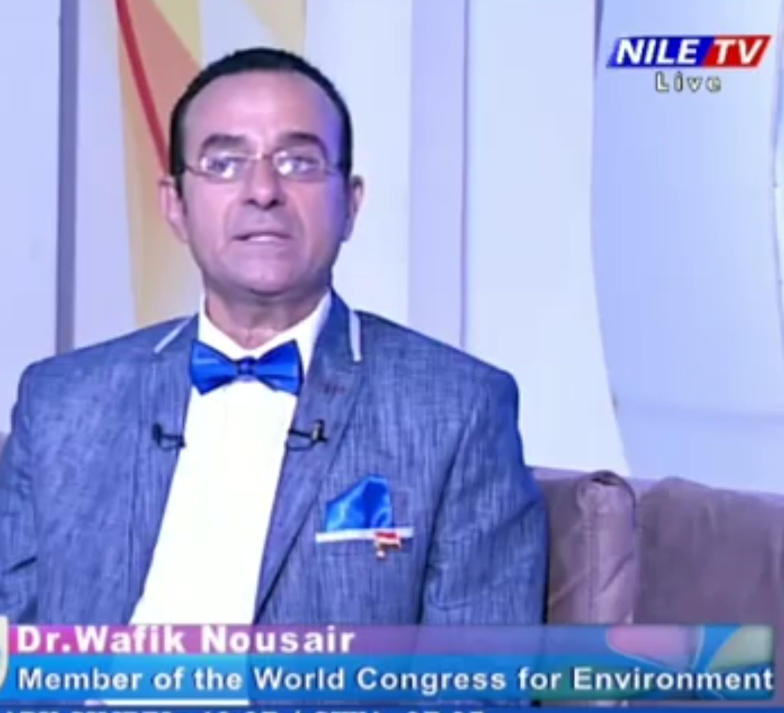
Environmental Engineering Consultant has many publishes in the sustainable development especially with the environment, worked in the first Solar Energy Corporation at Egypt that was established by company "Honeywell" since 1983 , Petroleum sector Planning & follow up manager at 3 main companies at Egypt , and many international companies such as Arthur AndeCenter onsultant firm and Coca-Cola as a projects & Environmental managerProject manager of the National project of Egypt on year 2000 called "Toshka", have participated in many International Conferences inside & outside Egypt especially the World Congress for the Environment that have represented Egypt as a free lancer 9 times lately was at Washington DC, California, Portland and Florida USA & France & Turkey & UK & Denmark, Dubai, China and Thailand .... etc founder & owner of Egyptian Modern Center (EMC), which is an Environmental Engineering Consultation firm that is trying to find its way in a polluted environment..... Please see website: www.drwafik.com

Email Id:drwafik@drwafik.com

