Abstract Template
Abstract Title: Chronic Bilateral Nongranulomatous Anterior Uveitis and Uveitic Glaucoma Requiring Treatment with Noncorticosteroid Immunomodulatory Agents
Jennifer E. Gipp, OD, FAAO, MBA

¹ Jennifer Gipp, OD, FAAO, MBA (Gundersen Health System, USA)

Abstract (not more than 300 words)

The term uveitis refers to group of conditions characterized by intraocular inflammation affecting not only the uveal tract, but also the lens, vitreous, optic nerve, and retina. Although corticosteroids have been the standard for treating noninfectious uveitic flares, corticosteroid-related complications including cataract formation and development of secondary glaucoma are a major concern for patients and in some cases, treatment with topical corticosteroids alone is not effective in controlling intraocular inflammation.
This case report discusses a 48-year-old Caucasian female with idiopathic bilateral nongranulomatous anterior uveitis and uveitic glaucoma. Despite a family history of autoimmune disease and two sisters with Crohn’s disease, the patient’s ESR, CBC, BUN, creatinine, ANA, ANCA, RF, ACE, TPPA, HLA-B27 Lyme Titer, Urinalysis, Urine Beta-2 Microglobulin were all negative.

The patient’s chronic bilateral nongranulomatous uveitis could not be controlled with topical corticosteroids alone, and co-management with Rheumatology was required. Control of uveitis was finally obtained with systemic treatment using methotrexate with folic acid and adalimumab in addition to topical corticosteroids. The patient’s uncontrolled uveitic glaucoma required an Ahmed Valve OD, which had to be repositioned and a Baerveldt Glaucoma Drainage Implant OS, which required tube recovery in addition to topical glaucoma medication.

Alternative, more targeted therapies will be discussed in this case report using information from the VISUAL I and II studies regarding the use of adalimumab and the Fundamentals of Care for UveitiS (FOCUS) Initiative which addresses the treatment of noninfectious uveitis with noncorticosteroid immunomodulatory agents

This case reports demonstrates the importance of collaboration with Rheumatology in cases of uveitis that is unresponsive to topical corticosteroid treatment in order to help patients obtain control over uveitic flares, reduce the risk of vision loss from uveitic glaucoma, and improve overall quality of life.

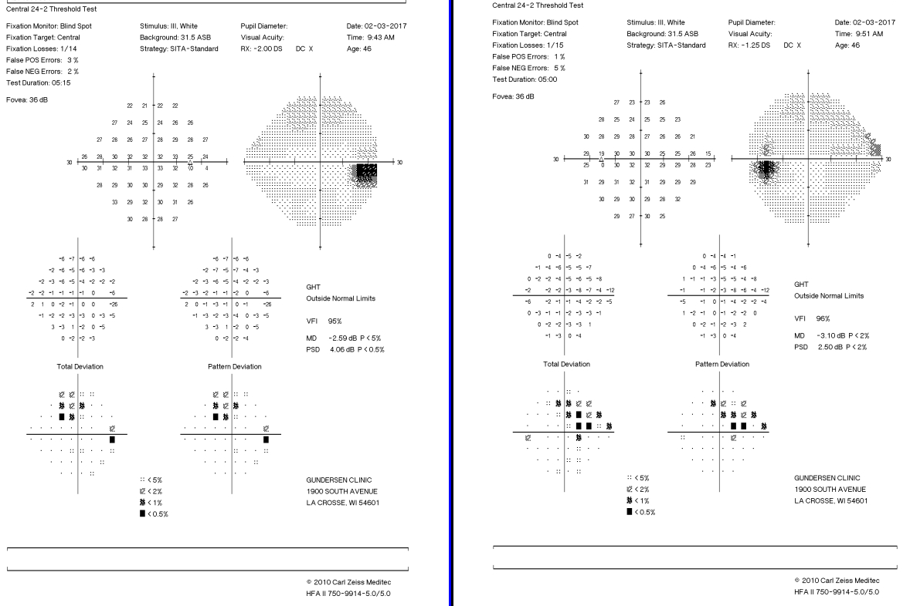
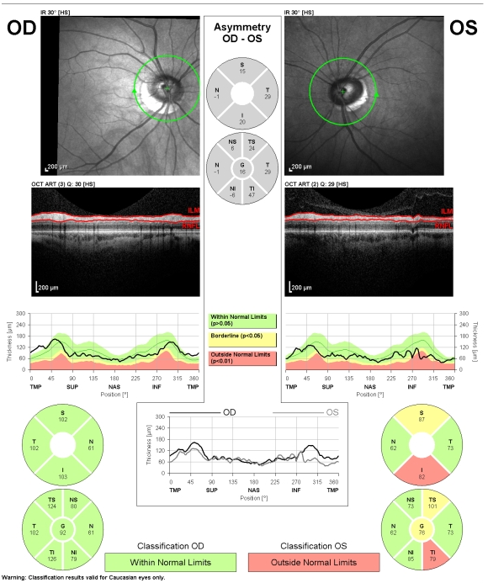
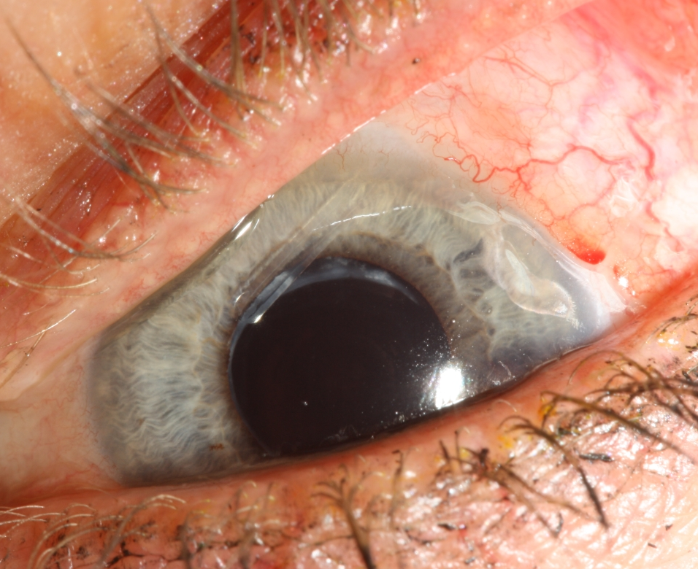

Keywords—Uveitis, HLA-B27, Methotrexate, Baerveldt

Professional Biography (100-150 words)

Jennifer Gipp, OD, FAAO, MBA earned her Doctor of Optometry degree at Indiana University School of Optometry and completed her Residency at the St. Louis Veterans Affairs Medical Center. She also earned an MBA in Healthcare Administration from Western Governor’s University. She is the coordinator of Optometry Residencies and Internships at Gundersen Health System. She has participated on multiple Global Partners eye care trips to Nicaragua and is the recipient of the Dr. and Mrs. Lewis Scott Scholarship, Dr. Seymour Galina Scholarship, and Women’s Overseas Scholarship.


Paste your Photograph here

Email Id: jegipp@gundersenhealth.org

Any Comments:

