Phenotypic and genomic characteristics of a novel atypical mycobacteria related to the Mycobacterium fortuitum complex
Rim Gharbi, Institut Pasteur de Tunis, Tunisia
Varun Khanna, Institut Pasteur, Paris, Fance
Besma Mhenni, Institut Pasteur de Tunis, Tunisia
Roland Brosch, Institut Pasteur, Paris, Fance
Helmi Mardassi, Institut Pasteur de Tunis, Tunisia

Abstract (300 word limit)
Compelling evidence suggests that non tuberculous mycobacteria (NTM) might be responsible of respiratory infections in both immunosuppressed and immunocompetent hosts. Here we describe a rapidly growing, non photochromogenic mycobacteria (referred herein to as Mycobacterium sp. M458), isolated from the sputum of a Tunisian young woman suspected of pulmonary tuberculosis. M458 was unique in that it showed a rough morphotype and a separate phylogenetic branch within the Mycobacteirum fortuitum complex, as revealed by sequence variability in 16S rRNA, hsp65, rpoB, and sodA genes. This has prompted us to sequence its whole genome, which consisted of ~5 526 191-pb with a G+C% of 67,3%, 5,193 protein-coding sequences and 54 RNA genes (including rRNA, tRNA and tmRNA). Toxin-antitoxin and three putative CRISPRs loci were found, along with two regions coding for a putative prophage. The functional annotation of M458 genome revealed large number of genes encoding transport and metabolism (19%). Also 8.66% are implicated in lipid transport and metabolism as well as energy production and conversion, a hallmark of all Mycobacterial species. Also, 8% of the genome is devoted to transcription and 7.95% encode secondary metabolites biosynthesis transport and catabolism. Strikingly, M458 genome harbors a wide variety of putative genes related to virulence.

Image
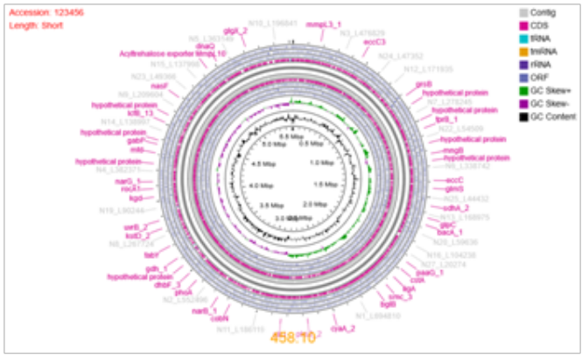
Fig. 1 Genome overview of Mycobacterium sp. M458 isolate
Recent Publications (minimum 5)
1. SAFA BOUJEMAA, AMINA BEN ALLAYA, BÉHIJA MLIK, HELMI MARDASSI, BOUTHEINA BEN ABDELMOUMEN MARDASSI. Phylogenetics of Mycoplasma hominis clinical strains associated with gynecological infections or infertility as disclosed by an expanded multilocus sequence typing scheme. Sci Rep. 2018; 8(1): 14854.
2. DEKHIL N, SKHAIRIA MA, MHENNI B, BEN FRADJ S, WARREN R, MARDASSI H. Automated IS6110-based fingerprinting of Mycobacterium tuberculosis: Reaching unprecedented discriminatory power and versatility. PLoS One. 2018; 13(6): e0197913.
3. RAMMEH S, ROMDHANE E, ARFAOUI TOUMI A, HOUCINE Y, LAHIANI R, SASSI A, MARDASSI H, BEN SALAH M, FERJAOUI M. Efficacy of Fine-Needle Aspiration Cytology in the Diagnosis of Tuberculous Cervical Lymphadenitis. Acta Cytol. 2018; 62(2):99-103.
4. MEFTAHI N, NAMOUCHI A, MHENNI B, BRANDIS G, HUGHES D, MARDASSI H. Evidence for the critical role of a secondary site rpoB mutation in the compensatory evolution and successful transmission of an MDR tuberculosis outbreak strain. J Antimicrob Chemother. 2016; 71(2):324-32.
5. DEKHIL N, MEFTAHI N, MHENNI B, BEN FRAJ S, HALTITI R, BELHAJ S, MARDASSI H. MDR-TB Outbreak among HIV-Negative Tunisian Patients followed during 11 Years. PLoS One 2016, 11(4): e0153983.
Photograph

Biography (150 word limit)
Helmi Mardassi is a Doctor in Veterinary Medicine (DVM), and has carried out a PhD in Virology Immunology at the Institut Armand-Frappier, University of Quebec. Currently, he is head of a research laboratory at the Institut Pasteur de Tunis, focusing on the delineation of the molecular mechanisms underlying emergence of TB outbreaks, the success of particular M. tuberculosis clones and/or mycobacterial species, and the impact of drug resistance on fitness.
.
Email: helmi.merdassi@pasteur.tn

Notes/Comments:

