Predominance of High Risk Human papillomavirus genotype 16 and 39 in women with premalignant and malignant cervical pathology, from Raipur, Chhattisgarh: Clinical evaluation of tagging oligonucleotide cleavage and extension mediated genotyping assay.
Author: Negi SS*, Singh P, Bhargava A, Nikhat H, Aggarwal S.
^{* Presenting author.}

Abstract

Identification of 14 high risk Human Papilloma Virus (HR-HPV) is immensely important in elucidating molecular epidemiology, patient monitoring and evidence based treatment. There is paucity of data from Chhattisgarh state of Central India about elucidating incidence of HR-HPV genotypes in women of premalignant and malignant cervical cancer (CC). Tagging oligonucleotide cleavage and extension(TOCE) mediated Anyplex HR-HPV genotyping assay was evaluated in identification of 14 HR-HPV attributable to premalignant and malignant CC. Anyplex HR-HPV genotyping assay was compared with GP5+/6+ assay, cytology and colposcopy in a total of 185 clinically suspected cases of premalignant and malignant CC. Genotyping assay showed clinical sensitivity and specificity of 86.5% (CI: 80.7-91.0) and 100% (CI: 86.3-100) respectively and found non inferior to GP5+/6+ assay (p>0.05). HR-HPV prevalence was 76.3%, 88.4%, 94.8%, 100%, and 100% among cervical intraepithelial (CIN) grade I-III, squamous cell carcinoma (SCC) and Adenocarcinoma (AC) cases respectively. The four most common genotypes detected in CIN I-III were HPV 16(63.9%), HPV39 (15.0%), HPV 18 (6.0%) and HPV 33(5.3%). In CC cases, HPV 16(44.4%), HPV 39(11.1%), dual infection of HPV16,18(11.1%) and triple infection of HPV16,18,33(11.1%) were the four most identified genotypes. A novel coinfection of HR-HPV 35, 39 were found in two and one cases of CIN I and II. Finding of HPV 39 as the second most prevalent genotype was unusual and underscores the clinical importance of early genotyping screening in premalignant and malignant cervical lesion. Anyplex HR-HPV assay is arguably the useful assay for better patient management by its unique individual identification of all HR-HPV. Finding of HPV 16, 39, 18, 33 and coinfection of 16,18 and 16,18,33 in CIN and CC should be considered during future HPV polyvalent vaccine preparation to curb down the CC associated mortality.


7
6
5
4
3
2
1
110 bp
150 bp
Figure 1: 110bp region of Human β-globin gene to evaluate DNA adequacy and 150 bp amplicon of GP5+/6+ region to detect group specific HPV. Lane 1,2, 3 showed positive for HPV; Lane 5 Negative control; Lane 6,7 Internal control of Human β-globin gene.
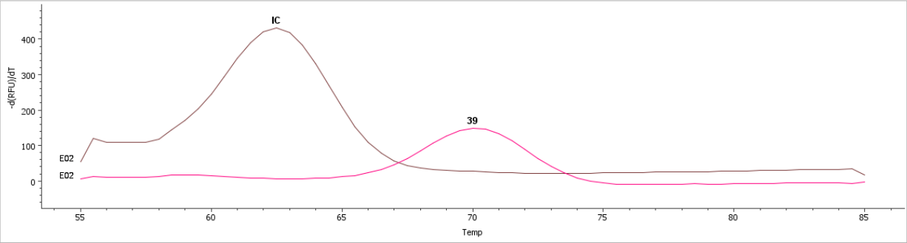

 Dr. Sanjay Singh Negi has been working as Associate Professor in department of Microbiology, AIIMS, Raipur, Chhattisgarh, India. His area of research is viral genetic diagnostic marker and viral molecular epidemiology. He has 12 year of experience in diagnosis of Human Viral Infectious diseases. He has extensively worked in designing primers and probes for developing and standardizing real time PCR for diagnosis of HPV, HBV, HCV and HIV. He has studied the molecular epidemiology of these viruses circulating in Delhi and Chhattisgarh to find out the genetic relatedness with previous submitted nucleotide sequences in genebank. He has 35 research publication in national and international journals.

Biography

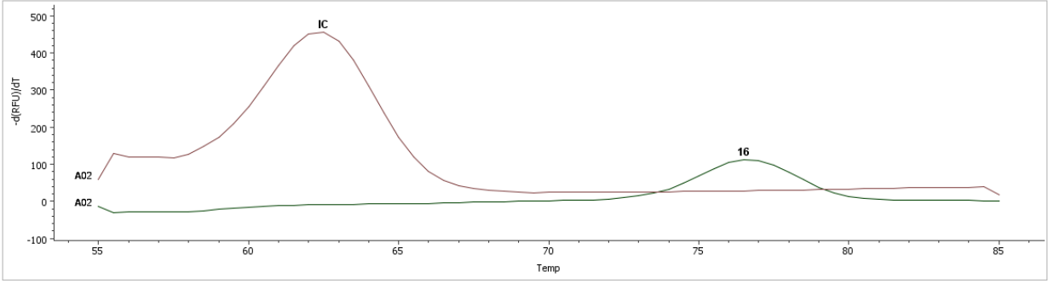
Figure 2: Anyplex 14 HR HPV assay based on TOCETM showed identification of HR HPV genotypes from premalignant and malignant cervical lesion. Graph showed only the frequently observed HR-HPV genotypes.
Reference(Minimum 5)
- Sreedevi A, Javed R, Dinesh A. Epidemiology of cervical cancer with special focus on India. Int J Women’s Health 2015; 7:405-14.
- Globacan. Cervical cancer: estimated incidence mortality and prevalence worldwide in 2012. 2012; http://globocan.iarc.fr/old/FactSheets/cancers/ cervix-new.asp. [Last accessed on 5.02.2019].
- Jung S, Lee B, Lee KN, Kim Y, Oh EJ. Clinical validation of Anyplex II HPV HR detection test for cervical cancer screening in Korea. Arch Pathol Lab Med 2016; 140:276-80.
- Sowjanya AP, Jain M, Poli UR, Padma S, Das M, Shah VK. et al. Prevalence and distribution of high-risk human papilloma virus (HPV) types in invasive squamous cell carcinoma of the cervix and in normal women in Andhra Pradesh, India. BMC infect Dis. 2005; 5:116
- Hesselink AT, Sahli R, Berkhof J, Snijders PJF, Van der Salm ML, Agard D, et al. Clinical validation of AnyplexTM II HPV HR Detection according to the guidelines for HPV test requirements for cervical cancer screening. J Clin Virol 2016; 76:36-39.

