Assessment of Microstructural Changes in the Corpus Callosum

of Post-Covid-19 patients
Ibrahim Ibrahim, MSc., PhD, IKEM, Prague, Czech public
Antonín Škoch, MD, Ph.D. IKEM, Prague, Czech public
Monika Dezortová, MSc., PhD, Prague, Czech public
Jaroslav Tintěra, Ph.D., IKEM, Prague, Czech public

Abstract
Statement of the Problem: Diagnostic imaging methods play an important role in assessing tissue damage and related complications resulting from COVID-19 disease. Advanced MRI techniques such as diffusion-weighted imaging (DWI), diffusion tensor imaging (DTI), MR tractography (MRT). and perfusion measurement can be used to evaluate the pathophysiological changes in brain diffusion and perfusion during both the acute and chronic phase of the disease. Corpus callosum (CC) is the largest commissural bundle connecting the two cerebral hemispheres, consisting of 200-250 million axonal fibers and plays a vital role in interhemispheric cooperation. Furthermore, CC is a well-organized fiber in its normal state, suggesting that any alternations may be more pronounced in the pathology. Consequently, this study focused on measuring diffusion indices and assessing them in the CC. Pathological processes linked to viral infections can modify the integrity of white matter tracts, leading to changes detectable in diffusion parameters, including fractional anisotropy (FA), mean diffusivity (MD), axial diffusivity (AD), radial diffusivity (AD) and others. Methodology: A total of 24 subjects, comprising 12 controls and12 post-COVID patients with neurological symptoms, underwent MR examination on a 3T MR scanner equipped with DWI and prefusion sequences. Fiber tracking of the CC was performed using DSI studio and the DTI data were processed to extract diffusion parameters. Data were subjected to statistical analysis using a linear mixed-effects model with the R framework, incorporating the package nlme. Findings: The linear mixed-effects model revealed significant changes in diffusion parameters in the CC, particularly in the forceps minor (p = < 0.05), in post-COVID patients as compared to the control group. The above-mentioned techniques are challenging but have the potential to improve decision-making in a wide range of pathologies, particularly in achieving accurate diagnosis and guiding treatment.

Supported by AZV grant No. NU22-A124 from the Ministry of Health of the Czech Republic.

Image

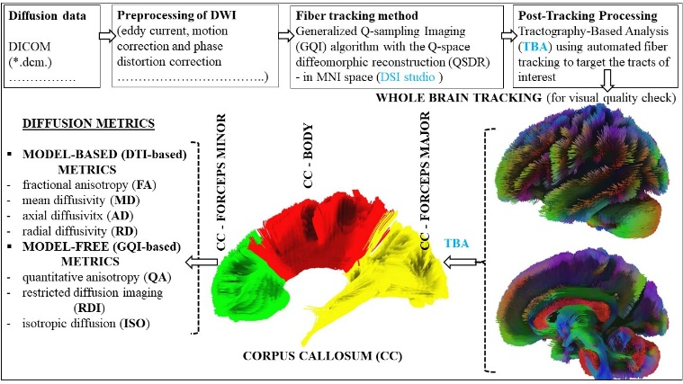
Figure 1. Flowchart describing the pre/post-processing of DWI data.

Recent Publications
- Mallah, Saad I et al. “COVID-19: breaking down a global health crisis.” Annals of clinical microbiology and antimicrobials vol. 20,1 35. 18 May. 2021, doi:10.1186/s12941-021-00438-7
- Sher L. Post-COVID syndrome and suicide risk. QJM. 2021 Apr 27;114(2):95-98. doi: 10.1093/qjmed/hcab007. PMID: 33486531; PMCID: PMC7928695.
- Liu JWTW, de Luca RD, Mello Neto HO, Barcellos I. Post-COVID-19 Syndrome? New daily persistent headache in the aftermath of COVID-19. Arq Neuropsiquiatr. 2020 Nov;78(11):753-754. doi: 10.1590/0004-282X20200187. PMID: 33331469.
- Goldstein A, Covington BP, Mahabadi N, Mesfin FB. Neuroanatomy, Corpus Callosum. 2023 Apr 3. In: StatPearls [Internet]. Treasure Island (FL): StatPearls Publishing; 2023 Jan–. PMID: 28846239.
- Díez-Cirarda M, Yus M, Gómez-Ruiz N, Polidura C, Gil-Martínez L, Delgado-Alonso C, Jorquera M, Gómez-Pinedo U, Matias-Guiu J, Arrazola J, Matias-Guiu JA. Multimodal neuroimaging in post-COVID syndrome and correlation with cognition. Brain. 2023 May 2;146(5):2142-2152. doi: 10.1093/brain/awac384.

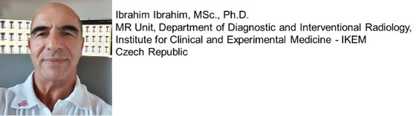
Ibrahim Ibrahim graduated from Charles University of Medicine in Prague, Czech Republic. He earned a master's degree (MSc.) in Medical
Technology and Informatics in 2004 and completed his doctoral study in Medical Biophysics, obtaining a Ph.D. in 2012. His academic and
professional interests encompass various facets of neurology, with a particular focus on peripheral nerve disorders, including brachial and
lumbosacral plexopathies, as well as brain-related conditions. He specializes in utilizing advanced MRI techniques, such as MR tractography (MRT)
and MR neurography (MRN), for imaging and diagnosis. ORCID: https://orcid.org/0000-0003-3530-5165, Email: ibib@ikem.cz,
Notes/Comments:

