Nucleocapsid antibodies as a serological marker of SARS-CoV-2 infection: longitudinal study

Ibrahimová, M. PhD, Thomayer University Hospital, Prague,Czech Republic
Pavelková, K. MD, Thomayer University Hospital, Prague, Czech Republic
Jamriková, V. Thomayer University Hospital, Prague, Czech Republic
Bořecká, K. MD, PhD, Thomayer University Hospital, Prague, Czech Republic

Abstract
Statement of the Problem: The study aimed to map the SARS-CoV-2 antibody response among healthcare workers (HCWs) at Thomayer University Hospital during the early stages of the covid-19 pandemic. The motivation behind this research was the care of approximately 5,000 hospitalized patients with SARS-CoV-2 infection, provided by around 2,500 hospital staff. Methodology & Theoretical Orientation: The study involved monitoring the levels and dynamics of total nucleocapsid antibodies (Roche) after infection, cellular immunity (Euroimmun), and spike IgG antibodies (Euroimmun) after vaccination. The results were further supplemented by a comprehensive questionnaire survey and official data collection. Findings: The study conducted three rounds of testing. In the first round of testing, only a small percentage (1.9%) of HCWs had covid-19, most of them experienced more severe disease course but without requiring hospitalization. In the second round of testing, 28.5% of HCWs tested positive for nucleocapsid antibodies. Notably, up to 21% of those who tested positive had an asymptomatic course of the disease, with half of individuals unaware of their infection. The third round of testing occurred after the initial vaccination efforts. A significant portion (92.7%) of HCWs received the vaccine, leading to the prevention of infection and increasing of nucleocapsid antibody positivity only slightly to 35.9%. Furthermore, specific T cell immunity was detected in 88.7% of HCWs. After one year, the study found that only 19% of those who had previously been infected and vaccinated were affected by a new SARS-CoV-2 infection. On the other hand, 56% of unvaccinated and uninfected HCWs had a primary infection. Conclusion & Significance: In conclusion, this study underscores the importance of nucleocapsid antibodies for detection of past infection and its differentiation from vaccine antibodies. The findings are valuable for understanding and managing the challenges posed by a novel viral agent during a pandemic, and they emphasize the significance of vaccination and cell immunity in protecting healthcare workers and the broader community.

Image
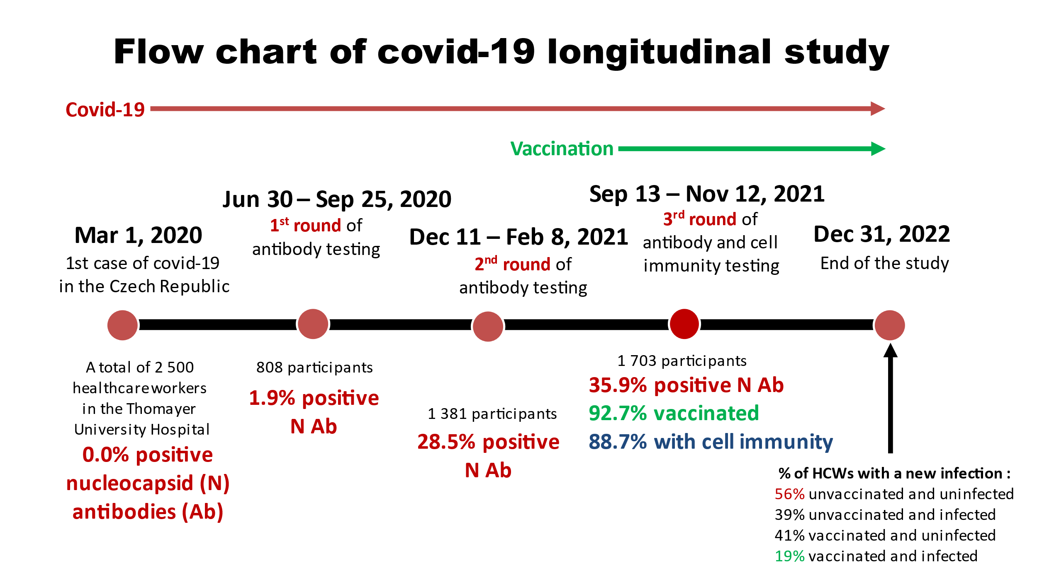
Recent Publications
- Bořecká K., Jamriková V., Sojka P., Khaznadar Z., Ibrahimová M. (2021) Measurement of anti-SARS-CoV-2 antibodies nucleocapsid versus spike, ECLIA versus ELISA. Klin Biochem Metab 29(50):19-24.
- Ibrahimová M., Jamriková V., Sojka P., Khaznadar Z., Bořecká K. (2022) Prevalence of SARS-CoV-2 antibodies in the Thomayer University Hospital staff after the first wave of covid-19. Epidemiol Mikrobiol Imunol 71(1):3–8.
- Gallais F, Gantner P, Bruel T, et al. (2021) Evolution of antibody responses up to 13 months after SARS-CoV-2 infection and risk of reinfection. EBioMedicine 71:103561.
- Tutukina M, Kaznadzey A, Kireeva M, Mazo I. (2021) IgG antibodies develop to spike but not to the nucleocapsid viral protein in many asymptomatic and light covid-19 cases. Viruses 13(10):1 945.
- Bobrovitz N, Ware H, Ma X, et al. (2023) Protective effectiveness of previous SARS-CoV-2 infection and hybrid immunity against the Omicron variant and severe disease: a systematic review and meta-regression. Lancet Infect Dis. 23(5):556-567.

Photograph

Biography
Markéta Ibrahimová graduated from the Faculty of Science at Charles University in Prague, Czech Republic, with a degree in Biology. She subsequently completed her Ph.D. in Immunology. In her research, she focused on the development and application of targeted polymer drugs. Over the past two decades, she has been actively engaged in the field of laboratory medicine, specializing in laboratory automation and the implementation of novel methodologies. She currently holds the position of the Head of the Immunological Laboratory and maintains a keen interest in all facets of clinical immunology.
Email: marketa.ibrahimova@ftn.cz

Notes/Comments:

