Fatal nosocomial pneumonias caused by multiresistant isolates of Pseudomonas aeruginosa in the form of biofilms as a complication of surgical interventions
Dr. Svitlana Malanchuk, PhD, as. professor, V.N. Karazin Kharkiv National University, Ukraine
Dr. Maryna Mishyna, MD, professor, KNMU, Ukraine
Dr. Yuliya Mozgova, PhD, as. professor, KNMU, Ukraine
Dr. Iryna Marchenko, PhD, as. professor, KNMU, Ukraine
Dr. Mykhailo Mishyn, PhD, Kharkiv regional bureau of forensic medical examination, Ukraine

Abstract
Statement of the Problem: Being in a state of war, doctors of Ukraine daily perform surgical interventions due to injuries received in battle, but despite skillfully performed operations and antibiotic therapy, they often lose their patients. Mortality from hospital-acquired pneumonias reaches 70%, of which 30%-50% are caused by multiresistant isolates of Pseudomonas aeruginosa. One of the reasons for the occurrence of multidrug resistance is the ability of bacteria to form dense biofilms. In the case of Pseudomonas aeruginosa, such a biofilm is the main form of its existence.
The purpose of this study is to determine the antibiotic resistance of Pseudomonas aeruginosa isolates and study the architecture of the biofilm, as a protective factor of bacteria from antibiotics.
Methodology & Theoretical Orientation: Exudate from inflammation of the lungs of people who died of pneumonia was collected. Isolation and identification of a pure culture of Pseudomonas aeruginosa was carried out using Micro-la-test kits. The sensitivity of microorganisms to antimicrobial drugs was studied using disk diffusion test. Bacterial biofilms were stained with LIVE/DEAD® dye and examined under a phase contrast microscope.
Findings: All isolates of Pseudomonas aeruginosa were resistant to ampicillin, amoxiclav, cefazolin, cefepime, ceftriaxone, gentamicin, amikacin, ciprofloxacin, doxycycline, clarithromycin, imipenem… After adhesion of individual bacteria of Pseudomonas aeruginosa (Fig. 1) formation of conglomerates surrounded by a matrix occurs with the subsequent development of a biofilm. The daily biofilm isolates of Pseudomonas aeruginosa visualized the dense polysaccharide matrix that moisturizes the biofilm, absorbs toxins, and prevents antibiotics penetration (Fig. 2).
Conclusion & Significance: Antimicrobial postoperative treatment is extremely difficult, as Pseudomonas aeruginosa has a high and multivalent resistance to antibiotics, due to the biofilms formation. Timely administration of adequate antimicrobial therapy to patients is a vital necessity for them and allows control spreading of multiresistant microorganisms in the hospital.

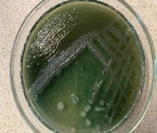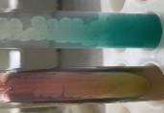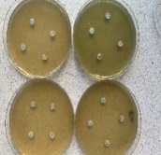
Figure 1 Multiresistant isolates of Pseudomonas aeruginosa
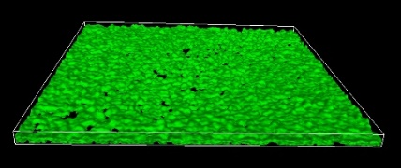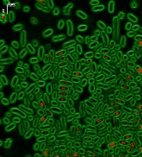
Figure 2 Daily biofilm of Pseudomonas aeruginosa isolates visualized using LIVE/DEAD® dye.
Recent Publications
- Wilton M., Charron-Mazenod L., Moore R., Lewenza S. (2016). Extracellular DNA Acidifies Biofilms and Induces Aminoglycoside Resistance in Pseudomonas aeruginosa. Antimicrob. Agents Chemother. 60, 544–553.
- Bowler L. L., Zhanel G. G., Ball T. B., Saward L. L. (2012). Mature Pseudomonas aeruginosa biofilms prevail compared to young biofilms in the presence of ceftazidime. Antimicrob. Agents Chemother. 56, 4976–4979.
- Beaudoin T., Zhang L., Hinz A. J., Parr C. J., Mah T. F. (2012). The biofilm-specific antibiotic resistance gene ndvB is important for expression of ethanol oxidation genes in Pseudomonas aeruginosa biofilms. J. Bacteriol. 194, 3128–3136.
- Ahmed M. N., Porse A., Sommer M. O. A., Høiby N., Ciofu O. (2018). Evolution of antibiotic resistance in biofilm and planktonic Pseudomonas aeruginosa populations exposed to subinhibitory levels of ciprofloxacin. Antimicrob. Agents Chemother. 62, e00320–e00318.
- Chiang W. C., Pamp S. J., Nilsson M., Givskov M., Tolker-Nielsen T. (2012). The metabolically active subpopulation in Pseudomonas aeruginosa biofilms survives exposure to membrane-targeting antimicrobials via distinct molecular mechanisms. FEMS Immunol. Med. Microbiol. 65, 245–256.

 Biography
Dr. Svitlana Malanchuk PhD, microbiologist with 11 years of teaching experience in higher education institutions. A scientist specializing in bacterial resistance. Author of 14 textbooks, 3 monographs, 4 patents, 11 articles in journals included in scientific databases and having an impact factor, 59 articles in Ukrainian and foreign specialized publications

Email: s.malanchuk@karazin.ua

