Understanding the role of glycoprotein L (UL115 gene) in the pathogenesis of congenital cytomegalovirus infection by molecular recombination
Dr. Basem Jawa BSc, MSc and PhD, Ministry of Health, KSA

Abstract (300-word limit)
Congenital human cytomegalovirus (cHCMV) infection affects around 1% of all live births. Of these infected babies around 10-15% will show symptoms (including microcephaly, mental retardation, and hearing loss). In addition, a further 10-15% of the asymptomatic babies will later develop symptoms, most common of which is sensorineural hearing loss. The pathogenesis underlying the outcome for an infected infant is unknown, but likely multifactorial. One of these factors has been proposed to be variation in the genotype of glycoproteins found in complexes on the surface of the virion, hypothesising that alterations in the glycoproteins may influence the virulence of the viral strain.
we substituted different genotypes of gL within a bacterial artificial chromosome (BAC) using the procedure of homologous gene substitution. In this way we could systematically alter the genotype of glycoprotein L whilst keeping all other glycoprotein genotypes constant. Recombinant viruses were recovered in fibroblast cell culture and their phenotypic characteristics investigated. We were able to demonstrate subtle differences in growth characteristics and considerable changes in the glycosylation of infected cell cultures and in the innate immune response of cells infected with the different recombinant viruses as measured by release of cytokines following infection in cell culture. Comparison of the structural forms of the different glycoprotein L genotypes showed how the conformation of gL within genotypes is constrained by its association with gH and the functional differences observed between genotypes likely represent differences in post-translational glycosylation rather than major change in the conformation of the molecule. This minor change in a glycoprotein genotype can have pronounced biochemical effects which in turn have potential to affect the pathogenesis of the strain of virus.

Image
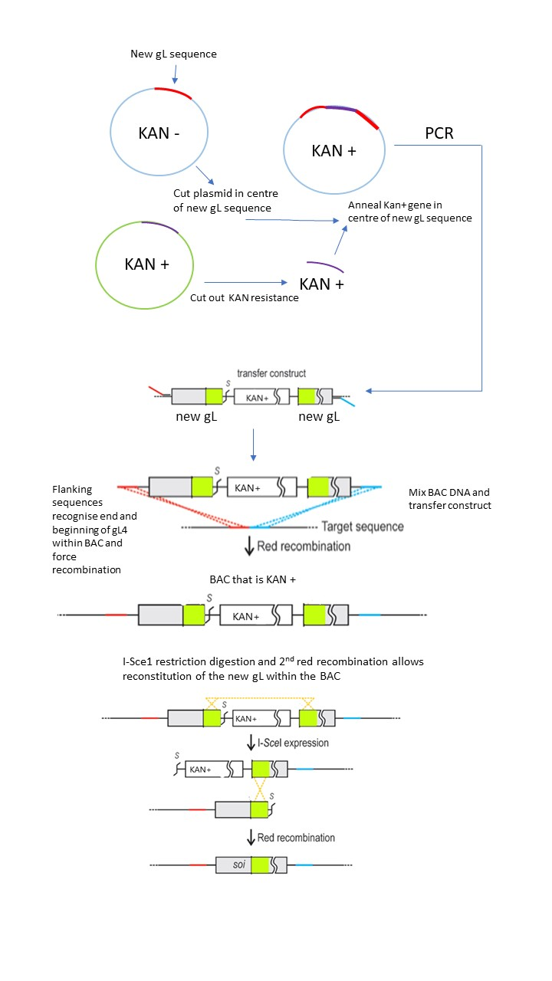
Figure ‎1. Homologous Recombination to allow allelic exchange of one gL genotype with another (Paredes and Yu. 2012) (with permission from John Wiley and Sons).


Photograph

Biography (150-word limit)
Dr Basem Jawa is an expert in Molecular virology. He was graduated from the University of Manchester, UK with a PhD in medical molecular virology. He is the Head of Molecular Diagnostics Department in Al-noor Specialist Hospital in Makkah, KSA. He has a good experience in molecular techniques such as cloning, primer designed, sequencing and viral culture.

Email: bajawa@moh.gov.sa

Notes/Comments:

I prefer contacting via WhatsApp on my number +966 5555 61151

