A bioinformatic approach in the design of polypeptide antigens useful for the serodiagnosis of the viral quasispecies SRLV and EIAV
Angela Ostuni¹, Magnus Monnè¹, Maria Antonietta Crudele¹, Paolo Raimondi², Raffaele Frontoso^{2,3}, Jolanda De Vendel², Alfonso Bavoso¹

¹Department of Sciences, University of Basilicata, Potenza, Italy; ² OneHEco APS, Capaccio Paestum, (SA), Italy- www.oneheco.org; ³ Istituto Zooprofilattico Sperimentale del Mezzogiorno,Portici (Napoli), Italy

Abstract
As a consequence of their intrinsic genetic, structural and phenotypic variability animal Lentiviruses, including small ruminant lentivirus (SRLV) and equine infectious anemia virus (EIAV), are considered viral quasispecies. Immunoenzymatic tests (ELISA) are commonly used in the serodiagnosis of SRLV and EIAV infections.
However, for SRLV the dynamic heterogeneity of the virus makes the development of a diagnostic “gold standard" extremely difficult. In the case of EIAV, ELISA were obtained mainly by using the capsid protein p26, which is derived almost exclusively from a single strain (Wyoming), and do not reflect the great potential epitopic variability of the EIAV quasispecies. Hundreds of protein sequences derived from different viral strains are deposited in GenBank for both SRLV and EIAV. In two different investigations GenBank database was exploited in a systematic approach to design a set of representative protein antigens useful for SRLV and EIAV serodiagnosis. The main bioinformatic tools used were clustering, molecular modelling, molecular dynamics (in the case of SRLV) epitope predictions and aggregative/ solubility predictions. This approach, in the case of SRLV led to the design of two capsidic p25 polypeptide antigens and double-strain polypeptide antigen derived from the gp46 transmembrane protein (TM) whereas for EIAV a full sequence p26 capsid protein and a double-strain polypeptide derived from the gp45 transmembrane protein fused to Maltose Binding Protein (MBP) were designed. The proteins/ polypeptides were expressed by recombinant DNA technology starting from synthetic genes, and analyzed by circular dichroism (CD) spectroscopy in both investigations. An indirect ELISA was developed for SRLV and another for EIAV. Both tests can address some of the high variability of SRLV and EIAV.

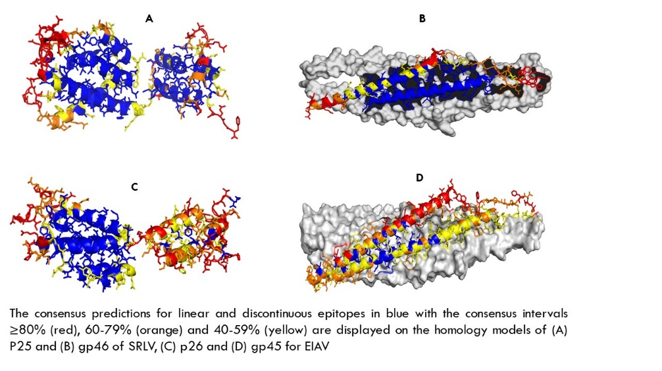
Publications
- Ostuni A, Monné M, Crudele MA, Cristinziano PL, Cecchini S, Amati M, De Vendel J, Raimondi P, Chassalevris T, Dovas CI, Bavoso A. Design and structural bioinformatic analysis of polypeptide antigens useful for the SRLV serodiagnosis. J Virol Methods. 2021; 297:114266.
- Ostuni A, Iovane V, Monné M, Crudele MA, Scicluna MT, Nardini R, Raimondi P, Frontoso R, Boni R, Bavoso A. A double-strain TM (gp45) polypeptide antigen and its application in the serodiagnosis of equine infectious anemia. J Virol Methods. 2023; 315:114704
- Huang, Y., Niu, B., Gao, Y., et al. CD-HIT Suite: a web server for clustering and comparing biological sequences. Bioinformatics 2010, (Oxford, England) 26 (5), 680–682.
- Ashkenazy, H., Abadi, S., Martz, E., Chay, O., Mayrose, I., Pupko, T., and Ben-Tal, N. ConSurf 2016: an improved methodology to estimate and visualize evolutionary conservation in macromolecules. Nucleic Acids Res. 2016, 44, W344-350.
- Fiser, A., Sali, A., 2003. Modeller: generation and refinement of homology-based protein structure models. Methods Enzymol. 374, 461–491.

Biography
Dr. Angela Ostuni is, Assistant Professor in Clinical Biochemistry and Clinical Molecular Biology at the University of Basilicata (Italy), Teaching activity: Medical-Diagnostic Biotechnologies. Main research interests: Immunochemistry: structural design and characterization of antigens; Biological function and structure of ABCC6 membrane transporter in cancer, drug resistance and genetic diseases; Biomarkers in diagnostics of cancer and viral infections. Analysis of follicular fluids of patients who approach techniques of medically assisted procreation. Co-author of 59 publications in Scopus/Wos indexed journals, 20 journal abstracts, 80 abstracts and contributions in conference proceedings. Email: angela.ostuni@unibas.it.

