Anosmia as a screening tool for COVID-19 infection: A prospective cohort study

Dr Esra Alhamadani, MD, Dubai Health Authority, UAE
Dr Sania Zia, MD, Dubai Health Authority, UAE
Dr Ali AlRahma, MD, Dubai Health Authority, UAE
Dr Firas AlNajjar, MD, Dubai Health Authority, UAE

Abstract
Statement of the problem: Several studies promoted anosmia as a possible isolated symptom for COVID-19 as a measure of encouraging individuals with a sudden loss of smell but few or no symptoms of viral infection to self-isolate. No studies used feasible methods of smell testing that the public would use to address the accuracy of these claims. The studies that assess anosmia as a screening tool are predominantly cross-sectional or retrospective in design. The purpose of this study is to prospectively measure the diagnostic value of anosmia at presentation and subsequent COVID-19 diagnosis by reverse-transcriptase polymerase chain reaction (RT-PCR) in asymptomatic or mildly symptomatic patients with upper respiratory tract infection (URTI). Methods: This is a single-center study conducted between April and June 2020. The sense of smell was tested in vitally stable suspected COVID-19 patients with no/mild URTI symptoms prior to nasopharyngeal swabbing for RT-PCR. Patients were instructed to close their eyes. Each nostril was tested separately while the other was blocked with the patient’s index finger. Patients inhaled from 2 concealed vials (coffee, strawberry essence) consecutively, kept within 30 cm of the nostril for 60 seconds. Patients who could not identify both odors with both nostrils were recorded as “anosmia”. Results: Out of 346 eligible subjects, 43 had anosmia of which 26 (60%) tested COVID-19 positive. Chi square test showed a P-value < 0.001. The test showed a sensitivity of 30% (95% CI 21%,41%) and specificity 94% (95% CI 90%,96%). Logistic regression revealed an OR of 5.9(95% CI 3.0,12) P-value < 0.001. Conclusion: Given the low sensitivity (30%) of this method in detecting COVID-19

infection, we conclude that this method is not a useful screening tool for COVID-19 infection. The moderate negative predictive value (80%) is non-generalizable.

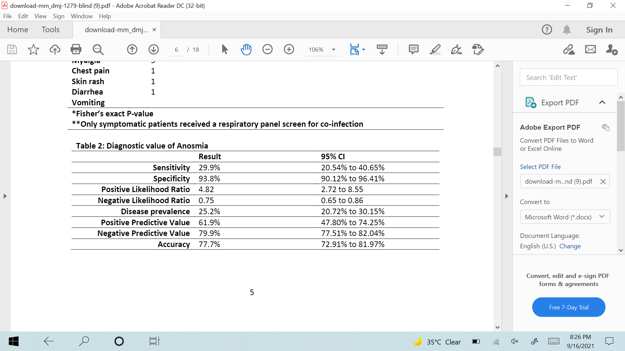
Recent Publications

1. Gautier JF, Ravussin Y. A New Symptom of COVID-19: Loss of Taste and Smell. Obesity.
2020;28(5):848.
2. Hjelmesæth J, Skaare D. Loss of smell or taste as the only symptom of COVID-19.
Tidsskr Nor Laegeforen. 2020;140(7).
3. Tong JY, Wong A, Zhu D, Fastenberg JH, Tham T. The Prevalence of Olfactory and
Gustatory Dysfunction in COVID-19 Patients: A Systematic Review and Meta-analysis.
Otolaryngol - Head Neck Surg (United States). 2020;
4. Moein ST, ED SMR, Mansourafshar B, Khorram-Tousi A, Tabarsi P, Doty RL.
Smell dysfunction: a biomarker for COVID-19. Int Forum Allergy Rhinol. 2020;
5. Vaira LA, Salzano G, Fois AG, Piombino P, De Riu G. Potential pathogenesis of ageusia
and anosmia in COVID-19 patients. International Forum of Allergy and Rhinology. 2020.

Biography
Dr Esra Alhamadani currently works as an emergency resident-physician at Rashid hospital, Dubai Health Authority since 2018. She served as a front-liner during the Covid-19 pandemic. In 2019, Dr Esra completed part of her clinical research training with Harvard Medical School. During her 6 months training, she was exposed to research methodology and biostatistics. Esra holds an MB BCh BAO from the Royal College of Surgeons Ireland.
Email: esraalhamadani08@gmail.com

