Porcine reproductive and respiratory syndrome viruses (PRRSVs) attenuated by synthetic-attenuated virus engineering (SAVE) in NSP1 induced protective immunity in pigs.

Dr. Sang-Ho Cha, DVM, PhD, APQA, Republic of Korea
Dr. Changhoon Park, DVM, PhD, BioPOA, Republic of Korea

Abstract (300 word limit)
A computer-based codon-pairs deoptimization technology, synthetic attenuated virus engineering (SAVE), is utilized to lower virulence of various viruses. The rapid viral attenuation concept by the codon pair deoptimization is to decrease codon pair bias (CPB), which demonstrated the potential usefulness as a technology to develop live attenuated vaccine. For this, we produced field PRRSVs attenuated by codon-pair deoptimization. The affection of SAVE on virulence of the attenuated strains was confirmed in pigs. Type 2 porcine reproductive and respiratory syndrome viruses (PRRSVs) isolated from PRRS-affected swine farms in South Korea were attenuated by de-optimization of codon pair bias in NSP1. In animal infection using 3 weeks-old pigs, the attenuated viruses showed significantly lowered replication ability than the parental viruses without distinct clinical sign and pathological lesions, which were observed in pig infected with the parental viruses. Regarding induction of PRRSV specific immunity, the level of the neutralizing antibodies as well as secretion of IFN-γ-SCs in PBMCs was not different between the attenuated viruses and the parent viruses. Conclusively, the attenuated viruses generated by SAVE in this study demonstrated the potential usefulness as vaccine strains to provide immune protection against diverse PRRSVs
Image
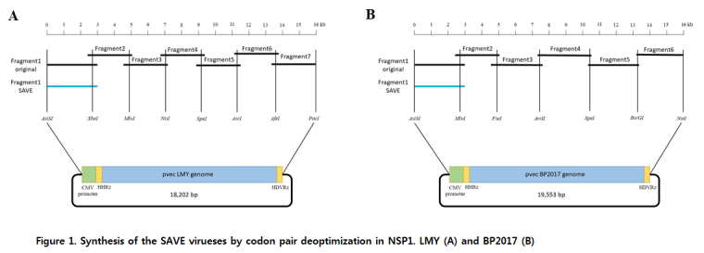
Recent Publications (minimum 5)
- Coleman JR (2008) Virus attenuation by genome-scale changes in codon pair bias. Science 320:1784-1787.
- Mueller S (2010) Live attenuated influenza virus vaccines by computer-aided rational design. Nat Biotechnol 28:723-726.
- Martrus G (2013) Changes in codon-pair bias of human immunodeficiency virus type 1 have profound effects on virus replication in cell culture. Retrovirology 2013; 10: 78.
- Ni YY (2014) Computer-aided codon-pair deoptimization of the major envelope GP5 gene attenuates porcine reproductive and respiratory syndrome virus. Virology Feb; 450-451.
5. Gao L (2015) HP-PRRSV is attenuated by de-optimization of codon pair bias in its RNA-dependent RNA polymerate nsp9 gene. Viroloy 485:135-144.

Photograph

Biography (150 word limit)
Dr Cha has his expertise in Animal virology and passion in developing vaccine and diagnostics against animal viral diseases to improve economy of livestock industry as well as welfare of pet animals. He has many experience in research about developing measures to minimize outbreak of animal diseases. Also, he has a big interest in combining high advanced technology on the research area.
Email: virusmania@korea.kr

Notes/Comments:

