Tracing the epidemic history of Hepatitis C virus genotype 1b in Tunisia and in the world, using a Bayesian Coalescent Approach.
KHEDHIRI Marwa, PhD Student, Pasteur Institute of Tunis, Tunisia
Dr GHEDIRA Kais, PhD, Pasteur Institute of Tunis, Tunisia
Dr CHOUIKHA Anissa, PhD, Pasteur Institute of Tunis, Tunisia
Dr TRIKI Henda, Professor, Pasteur Institute of Tunis, Tunisia

Abstract
Statement of the Problem: Hepatitis C virus (HCV) is one of leading causes of liver diseases. With the introduction of interferon-free direct acting antivirals and outstanding progresses in the prevention of HCV infection, the elimination of HCV seems more achievable today. Thus, it is important to understand its past population dynamics with time and its evolutionary and epidemic history. In Tunisia, HCV subtype 1b is the most prevalent representative around 70% of circulating genotypes. Here, we introduce a developed Bayesian Markov Chain Monte Carlo method for visualization of spatial and temporal spread of HCV-1b in Tunisia and in the world. Methodology & Theoretical Orientation: Our analyses included 371 Tunisian HCV-NS5B subtype 1b genome sequences obtained during the period 2012-2018 and 1265 HCV-NS5B-1b sequences retrieved from Genbank, checked with COMET and Genome detective tool for subtype identification and verification. These later were isolated from several countries between 1996 and 2018. Findings: The estimated time for the most recent common ancestor suggested that current HCV-1b strains emerged in Tunisia in 1923 [1904, 1942] and in the world in 1903 [1841,1930]. Conclusion & Significance: We suggest that the epidemiology of HCV-1b in Tunisia was mainly influenced by population movements between Maghrebian countries and between North and South Mediterranean countries.

Image
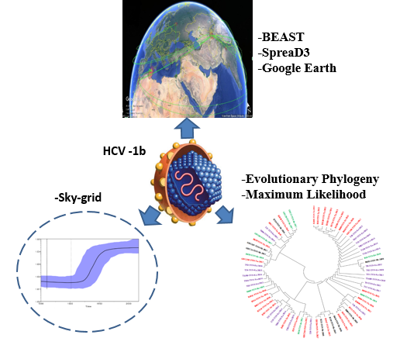

Photograph

Biography
- KHEDHIRI Marwa; PhD student in Microbiology, Faculty of Sciences of Tunis, Tunis El Manar University, Tunisia.
- Thesis: «Management of patients with chronic hepatitis C: study of the response to conventional combination therapy and prediction of no response to new antiviral drugs».Research project is currently led to the Pasteur Institute in Tunis, Tunisia in laboratory of Clinical Virology, under the direction of Hospitalo-university professor in Microbiology Dr. TRIKI Henda (Chief, Laboratory of Clinical Virology, Pasteur Institute of Tunis).

