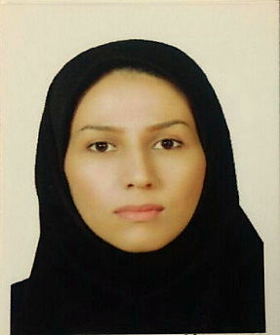

Title: Frequent pUL27 Variations in HIV-Infected Patients
Name:azam mirarab
Student Research Committee and b Infectious Diseases Research Centre, Golestan University of Medical Sciences, Gorgan, Iran
This study was conducted to evaluate mutations in genes UL27 HCMV clinical strains isolated from high-risk patients in Gorgan. DNA was extracted from 20 CMV-positive HIV (9/20) and congenitally infected (11/20) patients and used for UL27 polymerase chain reaction amplification. Sanger sequencing and multiple sequence alignment of products was performed
K90 was the most prevalent polymorphism in both HIV-positive and congenitally infected patients. Polymorphisms Q54, D123, and R107 (10%) were seen in more than one sample.
There were significantly more polymorphisms in the HIV positive samples (p = 0.038). HCMV pUL27 is highly variable in adult immunocompromised HIV-positive
Patients.

Biography:

azam mirarab has completed his MSc at the age of 30 years from golestan university of medical Sciences .she is a resercher in Department of Virology Central Laboratory. she has published 3 ISI papers in reputed journals of virology.and she is currently in the first stage of the PhD in Virology.

Presenting author details:
Full name: azam mirarab
Contact number: +989114847026
Linked In account: azam.mirarab@yahoo.com
Session name/ number:
Category: (Oral presentation/ Poster presentation): Poster presentation

