Diversity of BK Polyomavirus Genomes in correlation with BKPyV-associated diseases in Australian and Vietnamese Transplant Recipients

Dr Van Dinh Trang, Western Clinical School, Westmead Hospital, The University of Sydney, NSW 2006, Australia
Dr Rebecca Rockett, Centre for Infectious Diseases & Microbiology Laboratory Services, NSW Health Pathology-Institute of Clinical Pathology and Medical Research, Westmead NSW 2145, Australia
Prof Dominic E Dwyer, Western Clinical School, Westmead Hospital, The University of Sydney, NSW 2006, Australia

Abstract

BK polyomavirus (BK virus or BKPyV) is a circular double-stranded DNA virus with an approximately 5100 bp genome. BKPyV is opportunistic pathogen related to several human diseases under immunosuppressed status. It affects mostly renal and bone marrow transplant patients, and may cause BKPyV-associated nephropathy (BKVAN) occurring in 1-10% of renal transplant recipients. It is divided into four major genotypes (BKPyV I-IV). However, there are limitations of a 287-bp VP1 region to sub-classify genotype subgroups. The aim of this study was to detect the distribution of BKPyV genotypes and subgroups in Australian and Vietnamese transplant recipients (TRs), and to compare the improvement of phylogenetic analysis based on whole genome sequencing (WGS) rather than 287-bp VP1 region sequencing.

BKPyV DNA-positive blood and urine samples were analyzed from Australian and Vietnamese TRs. Primer-directed rolling circle amplification method was used to enable sufficient polyomavirus-specific WGS reads for accurate assessment of the BKPyV whole genome. Advances in next-generation sequencing (NGS) technologies is an effective approach to explore genetic diversity over the BKPyV complete genome. NGS was performed on a BKPyV DNA-enriched WGS directly from clinical samples.

Phylogenetic analysis of BKPyV based on WGS and VP1 region, four major genotypes I, II, III and IV were detected in Australia, whereas only genotypes I and IV were found in Vietnam.
Genotype I was classified into four subgroups I-a, I-b1, I-b2 and I-c in Australia, while subgroup I-b1 was detected in Vietnam. Within genotype IV, it was classified into IV-a2 and IV-c2 subgroups in Australian TRs, and three subgroups IV-a1, IV-a2 and IV-c1 in Vietnamese RTRs. However, the 287-bp VP1 region poorly differentiated subgroups in genotype IV. Particularly subgroups IV-c1 and IV-c2 compared to WGS phylogeny. Phylogenetic analysis based on the WGS is more accurate than the 287-bp VP1 region in classifying BKPyV genotypes/subgroups.

Photograph

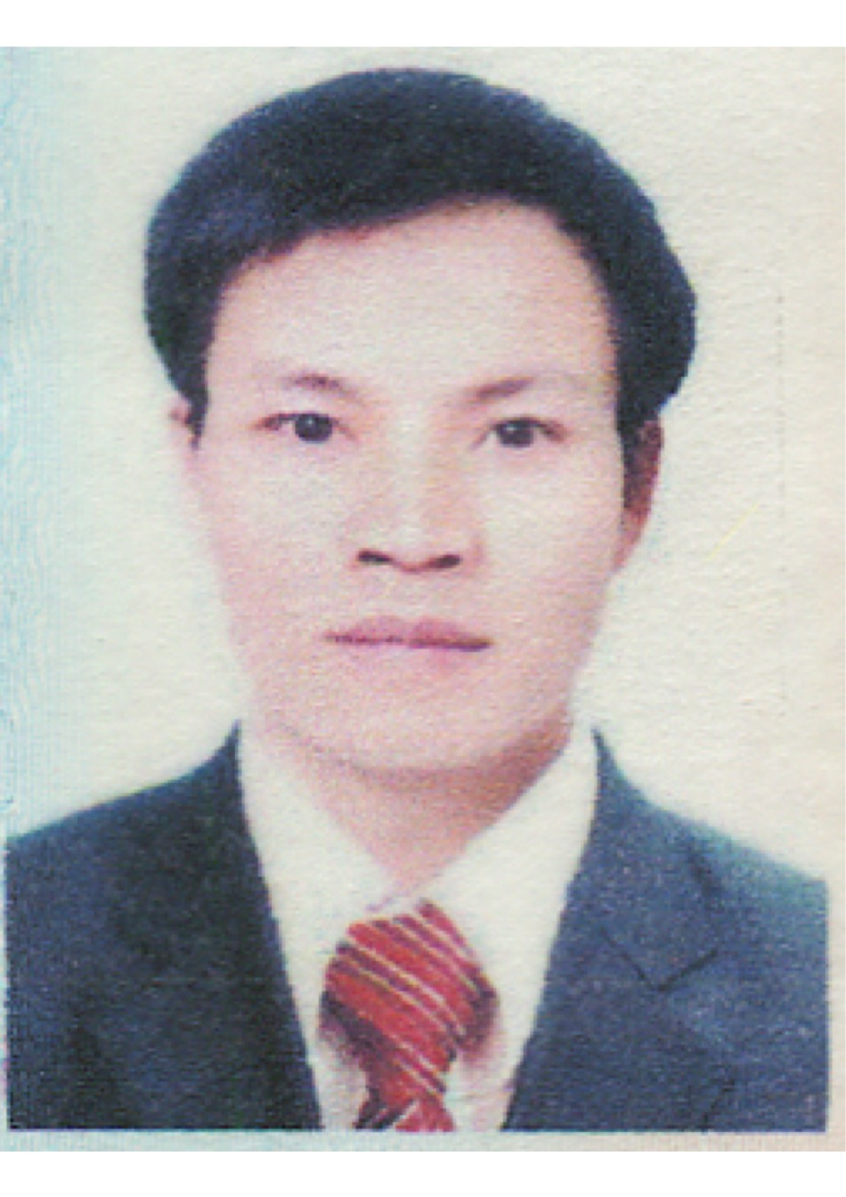
Biography
Dr Trang has his expertise in clinical medical microbiology. He has been working in a hospital in Hanoi for 13 years.
Since 2003, after the SARS outbreak, avian influenza H5N1 occurred in North Vietnam, he proposed a detailed plan to receive supports from experts from the Oxford University Clinical Research Unit (OUCRU. He gained experience and expanded co-operation with other reputable organizations around the world in research and training. Consequently, he has been studied in BK polyomavirus in the University of Sydney since 2015. He was author and co-author of some recent following papers.

1.Trang VD, Rockett R, Jeoffreys N, Trung NV, Hai An HP, Kok J, Dwyer DE. 2017. BK polyomavirus: a review of the virology, pathogenesis, clinical and laboratory features, and treatment. Future Virol.
2.Van TD, Dinh Q-D, Vu PD, Nguyen TV, Van Pham C, Dao TT, Phung CD, Hoang HTT, Tang NT, Do NT. 2014. Antibiotic susceptibility and molecular epidemiology of Acinetobacter calcoaceticus–baumannii complex strains isolated from a referral hospital in northern Vietnam. Journal of global antimicrobial resistance 2:318-321.
3. Le MT, Wertheim HF, Nguyen HD, Taylor W, Hoang PV, Vuong CD, Nguyen HL, Nguyen HH, Nguyen TQ, Nguyen TV. 2008. Influenza A H5N1 clade 2.3. 4 virus with a different antiviral susceptibility profile replaced clade 1 virus in humans in northern Vietnam. PLoS One 3:e3339.

Email:
dvan4312@uni.sydney.edu.au

Notes/Comments:

