Performance, Some Immune Parameters and Intestinal Microbial Flora Population of Ross 308 Broiler Chicks Fed by Fenugreek Essential Oil.
Omid Parvizi

Department of Animal Sciences, Islamic Azad University, Karaj Branch, Karaj, Iran.

Abstract

The aim of this study was to investigate the effect of using fenugreek essential oil on performance, some immune parameters and intestinal micro-flora on broiler chicks. A total of 240 one day Ross 308 broiler chicks were divided and assigned into 4 groups and 5 replicate of 16 birds each. Chicks were fed by basal diet as control and 3 levels (100, 200 and 250 ppm) of fenugreek essential oil respectively. During the experimental period feed intake, body weight gain and feed conversion ratio were calculated. After 30 and 38 days last, the blood samples were taken from wing vein to evaluate the sheep red blood cell (SRBC) and anti-body against Influenza and New castle disease vaccine (ND) respectively. For evaluation carcass traits 4 birds of the same weight in each group were slaughtered, separated and weighed. The obtained result showed that the highest feed intake related to the fenugreek essential oil and highest body weight was seen in the groups that the fed by fenugreek essential oil. Also there were significant differences between treatments about feed conversion ratio (p≤0.05). The SRBC, ND and Influenza titer as immune system parameters was for fenugreek essential oil respectively. The carcass evaluation mentioned that the highest carcass percentage was for fenugreek oil and there were significant differences between groups about intestine and gizzard percentage. The results showed that different levels of fenugreek oil used in experimental broilers had significant effects on intestinal microbial population flora. We may conclude that fenugreek essential oil at the present levels could have better body performance, some carcass parameters, and immune system in Ross 308 broiler chicks.

Image

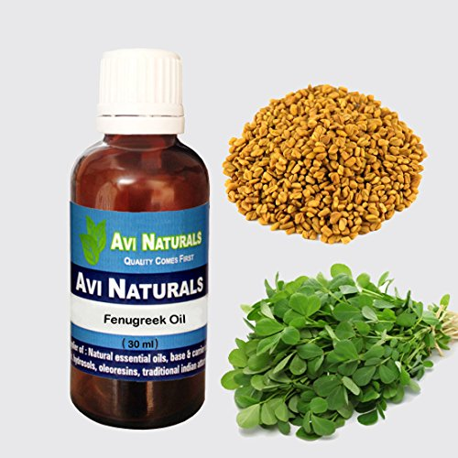

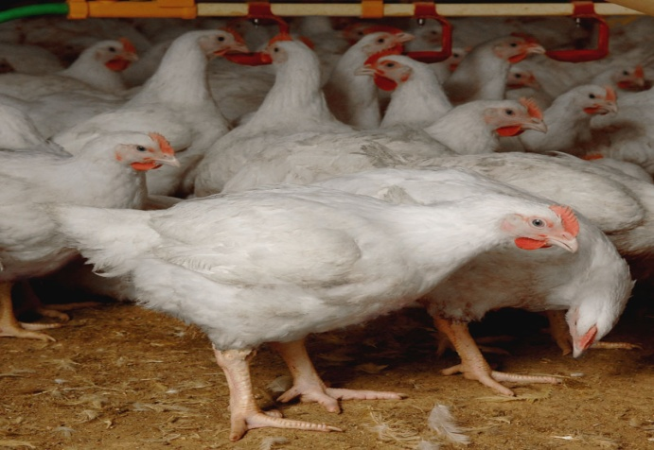


Biography
Omid Parvizi is a animal and poultry sciences (Master of sciences). He has graduated from Department of Animal Sciences, Islamic Azad University, Karaj Branch, Karaj, Iran. He works as an advisor in poultry farms and interested in researches in poultry feed additives and supplementations. He is also work as a commercial poultry industry agent in Iran.

Email: omidparvizi1353@gmail.com
Notes/Comments:
In the current study some of beneficial acts toward using fenugreek oil on performance, some immune parameters and intestinal microbial population on broiler chicks were demonstrated. We may conclude it will be possible that the higher concentration of fenugreek oil may produce better result in term of weight of studied parameters in broilers chicks. This improvement may be due to the biological functions to improve growth, digestibility and other activities that found in fenugreek. Although the beneﬁcial effects on health and growth are believed to be mediated by effects on gastrointestinal macrobiotic, the underlying mechanisms remain to be discovered. Also more research is needed on the other microbial and other biochemical parameters of fenugreek oil treated broilers and further studies are needed to more detail explanation.

