*Camel and Equine Science

Molecular detection of Trypanosoma brucei and some blood parameters of four naturally infected Nigerian Crossbred horses - a preliminary study

Onyinyechukwu Ada Agina^{*1,2}, John Ikechukwu Ihedioha¹, Tope Ebenezer Adeyeye¹, Paschal Umeakuana³, Wendy Gibson⁴, Sunday Idoko⁵
¹Department of Veterinary Pathology and Microbiology. Faculty of Veterinary Medicine. University of Nigeria, Nsukka.
²Jabatan Pathologi dan Mikrobiologi, Fakulti Perubatan Veteriner, Universiti Putra Malaysia
³Department of Veterinary Medicine. Faculty of Veterinary Medicine, University of Abuja, Nigeria
⁴School of Biological Sciences, University of Bristol, Bristol BS8 IUG, United Kingdom.
⁵Department of Veterinary Pathology. Faculty of Veterinary Medicine, University of Abuja, Nigeria
*Phone: +2347039010464; +601135201215 Email: onyinye.noel@unn.edu.ng
Abstract
Statement of the Problem: Trypanosome is one of the main causes of anaemia and are responsible for widespread morbidity and mortality particularly in exotic and cross breed of animals in the sub-tropical and tropical parts of the world. The purpose of this study is to detect Trypanosomes Nigerian crossbred horses slaughtered for meat at Obollo-Afor, Udenu Local Government Area, Enugu State Nigeria, by light microscopy and polymerase chain reaction (PCR). Blood was collected via the jugular outflow of 200 horses of varying ages and sex twice a week for a period of 20 weeks (July-November 2017). Conventional procedures were followed during the parasite identification in wet mount, leishman stained thin blood and buffy coat smears on glass slides, and PCR assay. Findings: The presence of a Trypanosoma species with an elongated, streamlined and tapered body was highly suggestive of T. brucei in thin blood smear. Conventional PCR assay utilized for the detection of Trypanosomes in trade Nigerian horses revealed an amplicon of 700 bp specific for ITS-1 region of ribosomal RNA of Trypanosome brucei. This was detected in 4 (2%) of 200 blood samples against the routine blood and buffy coat smear examination, which revealed T. brucei in 3 (1.5%) of blood samples. Trypanosoma brucei infected anaemic horses had normocytic hypochromic anaemia, high erythrocyte sedimentation rate (ESR) and normal leukocyte count. Trypanosoma brucei infected non-anaemic horses had normal erythrocytic parameters, normal ESR and leukocytosis. Conclusion and Significance: The prevalent Trypanosome species is T. brucei and its prevalence is low in Nigerian horses. Future studies on major histocompatibility complex class II gene (equine leukocyte antigen) in equine trypanosomosis would be conducted to determine if resistance to trypanosomosis is associated to the host ELA genes Recommendations to utilize nested PCR with bigger sample size will further confirm if the prevalence is low.
Keywords: Blood parameters; Buffy coat smear; Nigerian Horses; Prevalence; Trypanosoma
Image
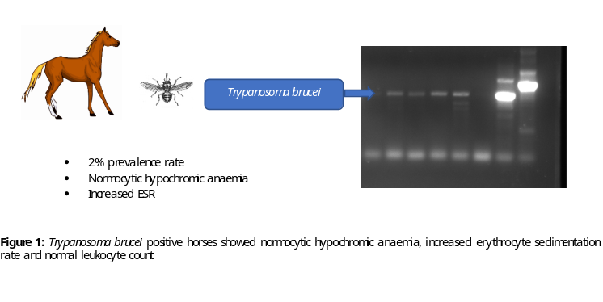
Recent Publications
- Adams ER, Malele, II, Msangi, AR , Gibson, WC (2006) Trypanosome identification in wild tsetse populations in Tanzania using generic primers to amplify the ribosomal RNA ITS-1 region. Acta Tropica 100:103-109.
- Agina OA, Ihedioha JI (2016) The haematological and serum biochemistry findings associated with natural trypanosome infection in Nigerian horses. Proceedings of the 41st Conference of Nigerian Society of Animal Production Ogun State, Nigeria pp 74-77.
- Auty H, Mundy A, Fyumagwa RD (2008) Health management of horses under high challenge from trypanosomes: a case study from Serengeti, Tanzania. Veterinary Parasitology 154:233–241
- Burger D, Dolivo G, Marti E (2015). Female major histocompatibility complex type affects male testosterone levels and sperm number in the horse (Equus Caballus). Proceedings of Biological Sciences 282:20150407.
- Ihedioha JI, Agina OA (2014) Haematological profile of Nigerian horses in Obollo Afor Enugu State. Journal of Veterinary and Applied Sciences 4(1):1-8.

Biography
Onyinyechukwu Agina has expertise in equine and bovine clinical pathology with focus on haemoparasites and major histocompatibility complex of large animals. She is a lecturer in department of Veterinary Pathology and Microbiology, Faculty of Veterinary Medicine, University of Nigeria Nsukka. She is currently a PhD scholar in the Universiti Putra Malaysia.
Email: onyinye.noel@unn.edu.ng

