The safety of biodegradable cat litter produced from mashed Leucaena (Leucaena leucocephala) stalk and bamboo residue soil: a case study
Wannita Krajarngjang, Environmental Science and Technology MSc, Department of Science, Faculty of Arts and Science, Kasetsart University, Nakorn Pathom, Thailand
Nuttikan Wichiensan, Biological Science BSc, Department of Science, Faculty of Arts and Science, Kasetsart University, Nakorn Pathom, Thailand
Chayakrit Sinthusingha, Physiology and Agriculture Biotechnology PhD, Department of Small Animal Clinical Practice, Faculty of Veterinary Medicine, Kasetsart University, Bangkok, Thailand
Patchanee Vichitbandha, Entomology PhD, Department of Science, Faculty of Arts and Science, Kasetsart University, Nakorn Pathom, Thailand

Abstract
The product safety is one of the important properties of any pet care products that need to evaluate before production in a commercial scale. Mashed Leucaena (Leucaena leucocephala) stalk (leu) and bamboo residue soil (soil) were recently reported as the potential main material of cat litters to produce alternatives for expensive imported biodegradable cat litters. Fungus contamination on products and responses of cats after contact “leu” cat litters and “soil” cat litters were evaluated compare to the commercial “pine” cat litters for safety in cat litter products. After treated with sterile procedure (15 min-autoclave and 5 min-air dry in 121°C), amount of fungus grown from “soil” cat litters significantly reduced from 1,419.32 cfu/g (pre-sterile condition) to 13.75 cfu/g (post-sterile condition) which post-value did also not differ from 10.83 cfu/g obtained from freshly unpacked “pine” cat litters. Cat litter samples were also randomly collected from cat trays (at day 3, 5 and 7) after regularly used by 6 cats and refilled (as needed). Fungus and yeast contamination in “leu” and “soil” cat litters after used were neither significantly differ from used “pine” cat litters nor from un-used cat litters (all types). Longer time of usage before clean the litter tray also not the major factor resulted in the variation of fungus contamination in each litter types. During experience using all three types of cat litters for 14 days each, number of cats (9 in total) showed the allergy symptoms during day 8 - day 14 were not significant different among types of cat litters they used. Both “leu” and “soil” cat litters could be safe to use as biodegradable cat litters. However, frequency of allergy symptoms and unique excretion behaviors of some cats which may result from other causes during the 14 day trials also be reported for future discussions.

Image
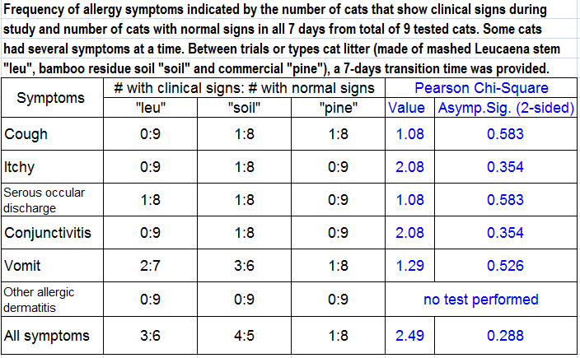

Recent Publications
- GuyNC, HopsonM, VanderstichelR (2014) Litterbox size preference in domestic cats (Felis catus). Journal of Veterinary Behavior 9:78-82.
- Hornfeldt S, Westfall ML (1996) Suspected bentonite toxicosis in a cat from ingestion of clay cat litter. Vet Hum Toxicol. 38(5): 365-366
- KimJ, DiaoJ, ShepherdMW Jr, SinghR, HeringaSD, GongC, JiangX (2012) Validating thermal inactivation of Salmonella spp. in fresh and aged chicken litter. Appl Environ Microbiol. 78(4):1302-1307.
- KrajarngjangW, VichitbandhaP (2018) Properties of cat litters produced from Leucaena stalk and Bamboo residue soil. Proceeding of the 15th KU-KPS National Conference, December 6-7, 2018. Kasetsart University Kamphaeng Saen Campus, Nakorn Pathom, Thailand. 1840-1847. (in Thai)
- WichiensanN, VichitbandhaP (2019) Effect of mashed Typha angustifolia leaf, rice husk ash, glycerol and guar gum ratios in cat litters from bamboo residue soil on hydration capacity and clumping ability of cat litters. Special problem research report for Bachelor of Science Program in Biological Sciences, Kasetsart University. (in Thai)
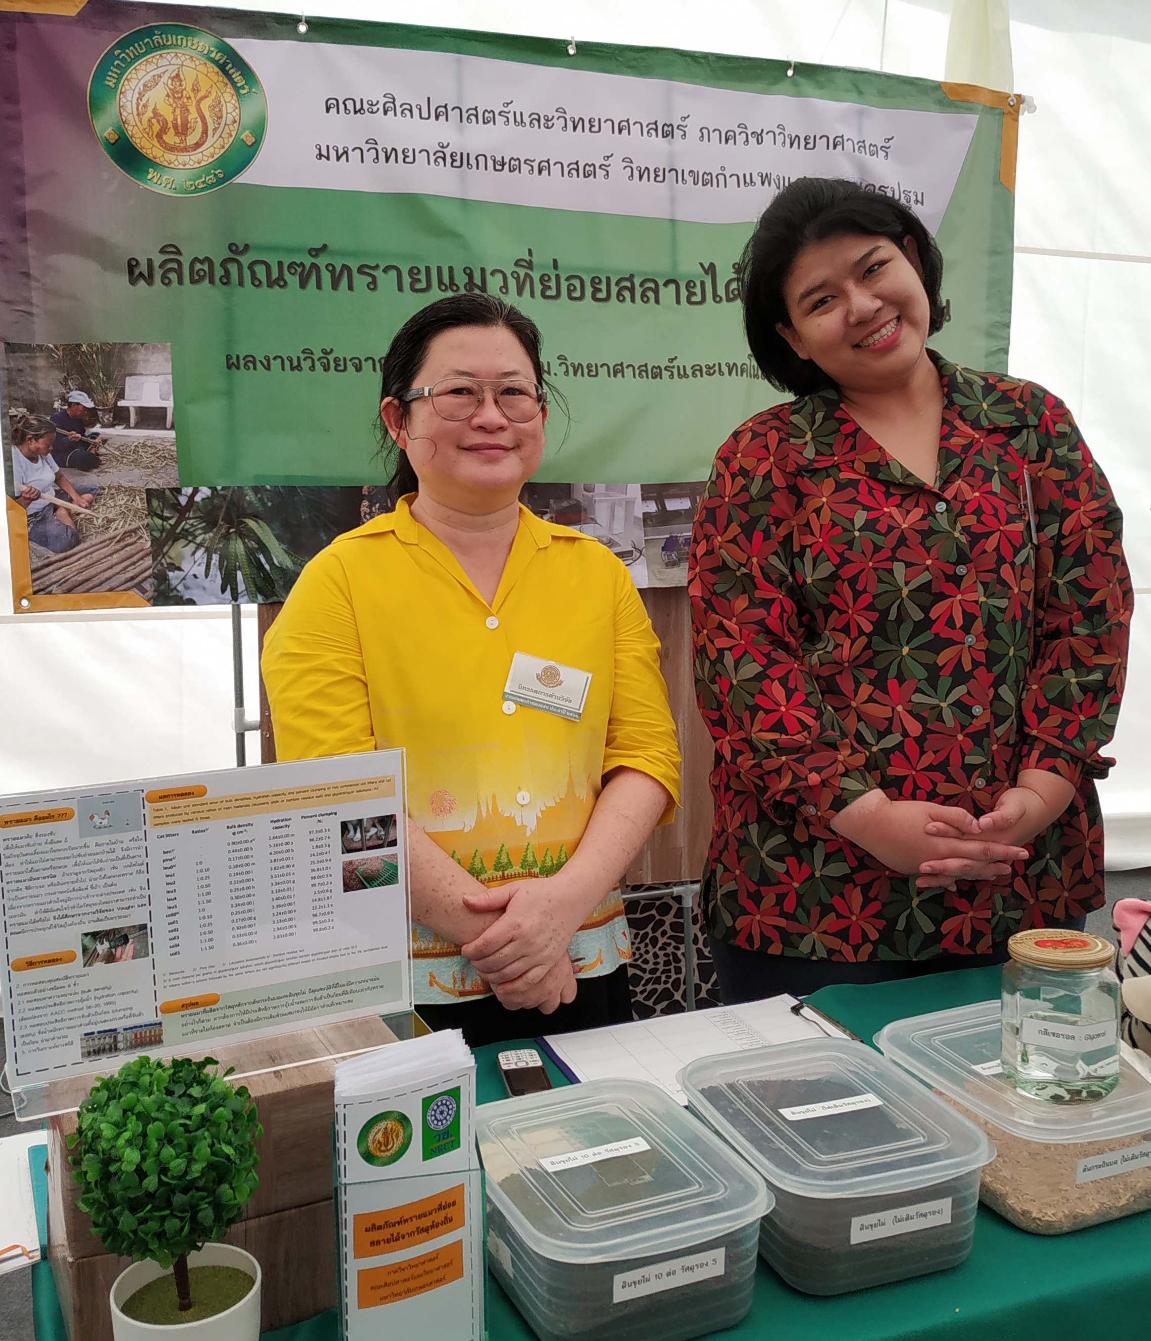


Biography
Dr.Patchanee Vichitbandha is a lecturer in Biology. She has her expertise in evaluation of biological control agents and natural products in the agricultural pest control. She also interested in biodiversity conservation and utilization. One interested task of her team is to utilize the agricultural products to increase their values in the market. Asso.Prof.Chayakrit Sinthusingha helps her in the clinical advises and research practices for evaluation for safety in cat litter products in this study.
Email: faaspnv@ku.ac.th
Notes/Comments:
Research trials were performed in a small animal clinic of Kasetsart University Veterinary Teaching Hospital, Kamphaeng Saen Campus, Faculty of Veterinary Medicine, Kasetsart University, Thailand. The financial supports were provided partly from several funding sources: 1) National Research Council of Thailand: NRCT(2018), 2) Student Development Fund, Faculty of Liberal Arts and Science, KU (2018) 3) Income Plan for Wannita Krajarngjang’s thesis, Master of Science Program in Environmental Science and Technology and 4) Income Plan for Nuttikan Wichiensan’s Special Problem Research, Bachelor of Science Program in Biological Sciences, Department of Science, Faculty of Liberal Arts and Science, KU (2018)

