Molecular and Morphological Investigations of the Effect of Thermal Manipulation during Embryogenesis on Thermo-tolerance and Muscle Structure in Broilers

Abdulhafez S.A Dalab, PhD, King Faisal University, KSA
Abdelhay M.A Rhamatalla, PhD, King Faisal University, KSA

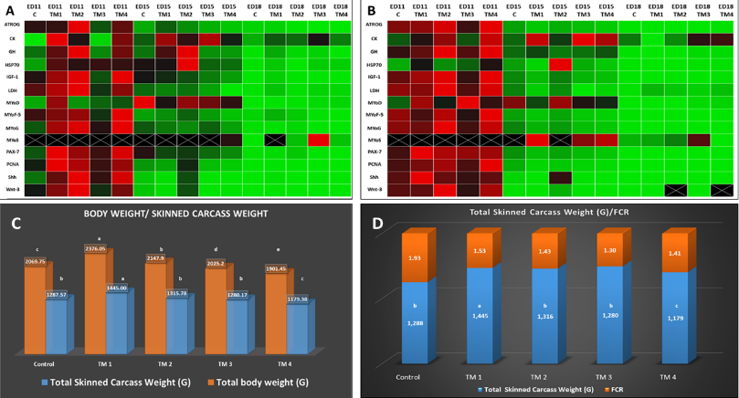
Abstract (300 word limit)
Statement of the Problem: Heat stress considered the main problem that facing small and medium size broiler farms that subsequently reduce the quality and quantity of broiler meat production. The aims of this study were to determine the optimum timing of thermal manipulation (TM) during embryogenesis that may result in improvement of body performance and thermotolerance acquisition parameters in pectoral and thigh muscles during embryogenesis and during subsequent thermal challenge (TC) at post-hatch day 35. Methodology & Theoretical Orientation: A total of 1440 fertile chicken eggs were divided randomly and equally into 5 treatments: control (no TM), TM1 (ED7-11), TM2 (ED11-15), TM3 (ED15-18) and TM4 (ED7-18) after hatching, all hatched chicks were randomly divided into two subgroups naïve (N) and thermally challenged (TC). Chick's response to TC were evaluated by determination of serum creatine kinas and lactate dehydrogenase and T3 at (0 h) and after 1, 3 and 6 h of TC in TM and naive chicks. Whereas gene expression was investigated and evaluated by using the semi-quantitative real time RT-PCR analyses. Morphological measurements were done by using Image processing and analysis imageJ 1.52a analyzer. Findings: Out of TM conditions that were investigated, TM1 was resulted in a significant improvement of hatchability rate (95.14%) and resulted in significant improvement of body performance parameters (feed conversion ratio, body and carcass weight, breast and thigh muscles weight) this improvement was associated with immediate and long-lasting effects of TM in the expression of IGF-1 and GH, MyoD, Myogenin, Pax7, and PCNA and significant improvement of thermotolerance acquisition parameters (lower body T^{b}, T3, CK, LDH, Hsp70 mRNA levels during thermal challenge. The sequences of hsp70 coding region 1 and 2 were deposited in GenBank under the accession numbers (MK852579) and (MK852580), respectively. Conclusion & Significance: TM during early embryogenesis improve muscle growth, body performance and thermotolerance acquisition in broiler. Recommendations are made for commercial broiler breeders to produce more enhanced broiler chickens..

Figure1. The effect of TM during embryogenesis on genes expression of muscle markers and thermotolerance acquisition in (A) pectoral and (B) thigh muscle. The data color indicates Up regulated-Red color, Down regulated-Green color and no change in Regulation -Black color. (C) and (D) post-hatch broiler chicks feed conversion ratio and related body and skinned carcass weights at day35 (n = 20).

Recent Publications (minimum 5)

- Al-Zghoul, MB, Al-Natour, MQ, Dalab, AS, Alturki, OI, Althnaian, T, Al-ramadan, SY, & Hannon, KM. (2016). Thermal Manipulation Mid-term Broiler Chicken Embryogenesis: Effect on Muscle Growth Factors and Muscle Marker Genes. Revista Brasileira de Ciência Avícola, 18(4), 607-618.
- Mohammad-Borhan Al-Zghoul , Sabry M. El-Bahr , Raida K. Al-Rukibat , Abd Elhafeed S. Dalab , Thnaian A. Althnaian1 and Saeed Y. Al-ramadan1 (2015) Biochemical and molecular investigation of thermal manipulation protocols during broiler embryogenesis and subsequent thermal challenge. BMC Veterinary Research. DOI 10.1186/s12917-015-0609-0.
- Mohammad-Borhan Al-Zghoul · Zuhair Bani Ismail · Abd Elhafeed S. Dalab · Abdulla Al-Ramadan · Thnaian A. Althnaian · Saeed Y. Al-ramadan · Abdelhadi M. Ali · Ibrahim F. Albokhadaim · Khalid Ahmed Al Busadah · Abdulhakeem Eljarah · Khaleel I. Jawasreh ·Kevin M. Hannon (2015). Thermal manipulation during broiler chicken embryogenesis: Effect on mRNA expressions of Hsp108, Hsp70, Hsp47 and Hsf-3 during subsequent post-hatch thermal challenge. Research in Veterinary Science 103, 211–217.
- Mohammad-Borhan Al-Zghoul , Zuhair Bani Ismail , Abdelhafeed S. Dalab , Abdulla Al-Ramadan , Thnaian A. Althnaian , Saeed Y. Al-ramadan , Abdelhadi M. Ali , Ibrahim F. Albokhadaim , Khalid Ahmed Al Busadah , AbdulhakeemEljarah ,Khaleel I. Jawasreh , Kevin M. Hannon. (2015). Hsp90, Hsp60 and HSF-1 genes expression in muscle, heart and brain of thermally manipulated broiler chicken.Research in Veterinary Science 99 , 105–111.
- Al-Zhgoul, M.-B., A.E.S. Dalab, M.M. Ababneh, K.I. Jawasreh, K.A.A. Busadah, and Z.B. Ismail. (2013). Thermal manipulation during chicken embryogenesis results in enhanced Hsp70 gene expression and the acquisition of thermotolerance. Research in Veterinary Science. 95, 502-507.

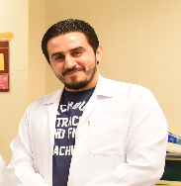
Biography (150 word limit)
Dr. Abdul Hafez S.A. Dalab, the PhD candidate and research assistant at the College of Veterinary Medicine, King Faisal University ( Molecular technology and cell biology), he mastered a lot of molecular techniques includes : DNA/RNA Extraction, PCR Amplification, Gel Electrophoresis, Restriction Digestion, DNA Sequencing, Genotyping, Regulation of Gene Expression and Gene Study, Real Time Polymerase Chain Reaction RT-PCR Technology, Droplet Polymerase Chain Reaction dd-PCR. She has built this model after years of experience in many grants and Bio-technology and Developmental biology researches.
Email: adalab@kfu.edu.sa

Notes/Comment

