F. A. Khan and A. Sahoo
ICAR-Central Sheep and Wool Research Institute, Avikanagar (Rajasthan), India
Abstract
Statement of the Problem: Gastrointestinal nematode infection is one of the main limiting factors for developing sheep production systems. Haemonchus contortus is a parasite of concern, because its infection may cause severe blood loss resulting in anaemia, anorexia, depression, loss of condition, and eventually death. Anthelmintic treatment has been the most common control method. However, there has been overuse and misuse of this approach in the last 4-5 decades, which has led to a worldwide increase in prevalence of anthelmintic resistance. This, together with the increasing market demand for green animal products, has led to the alternative methods of control. A promising option is the use of bioactive plants, considered as those that have been shown to affect a parasite population at various stages of their life cycle. The purpose of present study is to determine whether the inclusion of tanniferous dried khejri (Prosopis cineraria) leaves and/ or the increase of dietary protein concentration could reduce parasite establishment and improve resilience of lambs. Methodology: Feeding trials were conducted with 5-6 months old lambs. Lambs were drenched to control nematodes at the beginning of the experiment and were randomly allocated to six groups: Low protein (LP) + LP, high protein (HP) + HP, LP + LP and Khejri (K), LPK + LPK, HP + HPK and HPK + HPK. Lambs were fed with LP and HP concentrates either with or without tanniferous khejri leaves. At day 0 all groups were trickle infected with infective larvae. Faecal samples were collected for faecal egg count (FEC). Blood samples were collected for packed cell volume (PCV) and haemoglobin (Hb). Findings: In LP + LP group 5 Lambs required salvage treatment as PCV dropped down to 20% within 5 weeks of infection. 4 lambs each in group LP + LPK and LPK + LPK required the treatment. Bottle jaw condition was seen in 2 lambs in each group. On the other hand such conditions were never seen in any lamb in HP concentrate group. Inclusion of khejri had significant effect on FEC, PCV and Hb. HPK lambs had higher PCV and Hb values than the LPK lambs throughout the experiment. There was significant effect on average daily gains and it was due to lowest ADG (-0.29 g/day) in the group fed with LP diet throughout the trial. Highest ADG (75.2 g/day) was in the lambs fed with HPK diet throughout the experiment. Conclusion and significance: There was improvement in both resistance and resilience in lambs fed with combination of HP concentrate and khejri leaves.
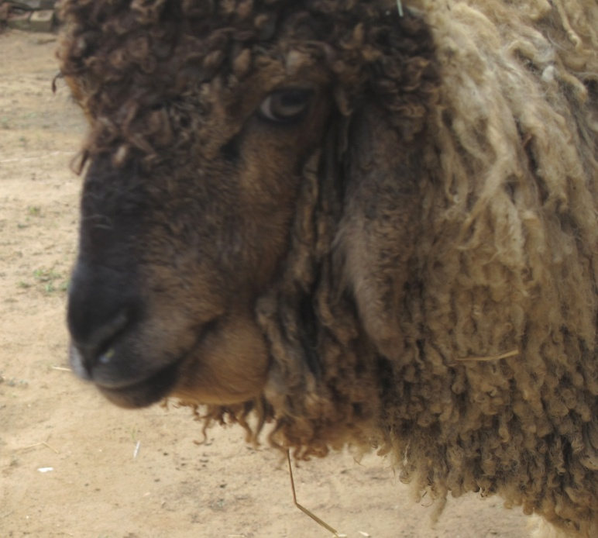
Figure 1. Bottle jaw condition in LP fed lamb

Figure 2. Packed cell volume of lambs of different dietary groups

Figure 3. Haemoglobin of lambs of different dietary groups

Recent Publications
- Butter NL, Dawson JM, Wakelin D, Buttery PJ (2000) Effect of dietary tannin and protein concentration on nematode infection (Trichostrongylus colubriformis) in lambs. Journal Agriculture Science 134: 89-99.
- Valderrabano J, Calvete C, Uriarte J (2010) Effect of feeding bioactive forages on infection and subsequent development of Haemonchus contortus in lamb faeces. Veterinary Parasitology 173: 89-94.
- Hoste H, Martinez-Ortiz-Montellano C, Manolaraki F, Brunet S, Ojeda-Robertos N, Fporquaux I, Torres-Acosta JFJ, Sandoval-Castro CA (2012) Direct and indirect effects of bioactive tannin-rich tropical and temperate legumes against nematode infections. Veterinary Parasitology 186: 18-27.
- Gujja S, Terrill TH, Mosjidis JA, Miller JE, Mechineni A, Kommuru DS, Shaik SA, Lamber BD, Cherry NM, Burke JM (2013) Effect of supplemental Sericea lespedeza leaf meal pellets on gastrointestinal nematode infection in grazing goats. Veterinary Parasitology 191: 51-58.
- Garcia-Hernandez C, Arece-Garcia J, Rojo-Rubio R, Mendoza Martinez GD, Albarran-Portillo B, Vazquez-Armijo JF, Avendano-Reyes L, Olmedo- Juarez A, Marie- Magdeleine C, Lopez-Leyva Y (2017) Nuraceutic effect of free condensed tannins of Lysiloma acapulcensis (Kunth) benth on parasitic infection and performance of Pelibuey sheep. Tropical Animal Health Production 49: 55-61.


F. A Khan has more than 25 years of research experience in the field of epidemiology and control of gastrointestinal nematodes of sheep. He has expertise in methods of control of H. contortus which may be alternative or adjunct to use of anthelmintics.

