CAMEL POX, EPIDEMYOLOGY, DIAGNOSIS AND CONTROL
DR. ABUBAKR M.I. KINGDOM OF BAHRAIN
abubakrmoha@hotmail.com
DR. ABDELRAHMAN A. O.
aabushook@gmail.com

Abstract

Camel pox is an economically important contagious skin disease of camelids caused by camel pox orthovirus ( 1, 2, 3, 6, 9, and 10).It is characterized by mild local skin infection and less common severe systemic infections. The disease is confined to camel-rearing belts particularly in developing countries and causes economic impact due to considerable loss in terms of morbidity, mortality, loss of weight and reduction in milk yield. Both inactivated and live-attenuated vaccines are available.However, live vaccines are preferred as they provide long-lasting immunity. Due to the close contact between camels and their human handlers in much of the world, it is believed that Camel pox is transmitted to humans via direct contact.( 4, 5, 7, and 8).

Clinical signs and symptoms
The incubation period was 3 to 15 days. The infection was generalized. Only adult camels over 3 years were infected. The morbidity rate was 80 % while the mortality rate was 5 %..The disease was characterized by skin lesions, swelling of the lymph nodes, rise in body temperature ( 40⁰ – 42⁰ C ), inability to eat and death. The skin lesions started as papules which developed into pustules. The lesions began on the head and neck (Fig. 1 and 2). The head was swollen, bloody froth was seen. Lesions eventually spread throughout the body being especially concentrated on the flank (Fig5),,fore limbs (Figs. 6 and 7) and hind limbs ( Figs. 8 and 9 ). Untreated animal recovered from the infection in 4 to 6 weeks.^{[6]}Untreated animal recovered from the infection in 4 to 6 weeks.

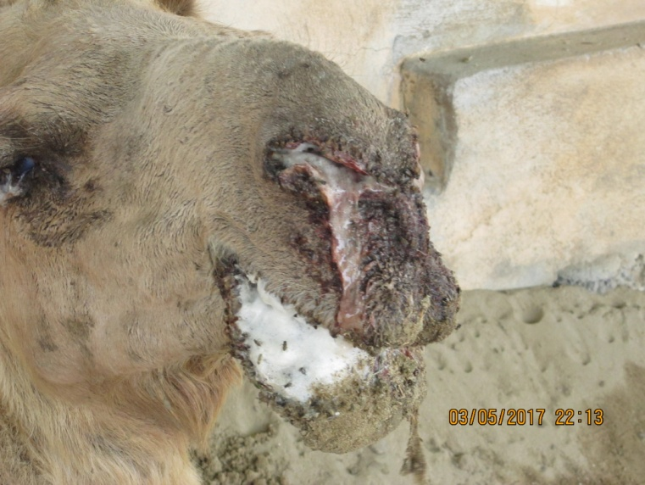
Fig. 1 : swelling of the head and bloody froth discharge.

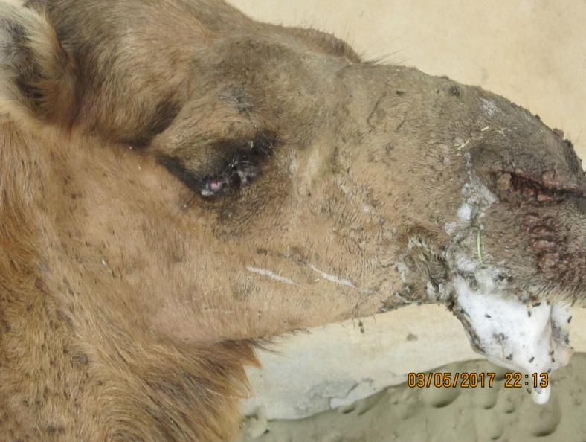
Fig. 2 :swelling of the head and frothy discharge

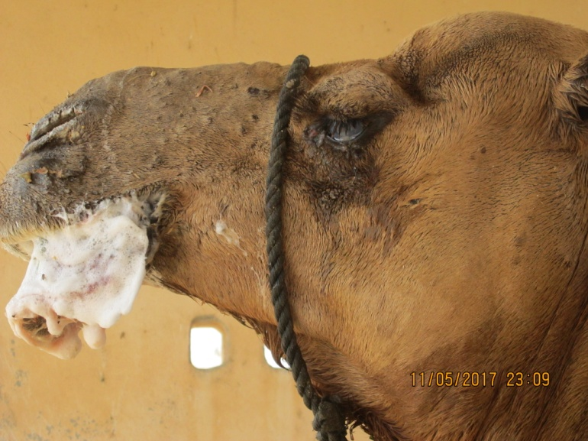
Fig. 3 : skin lesions and frothy discharge.

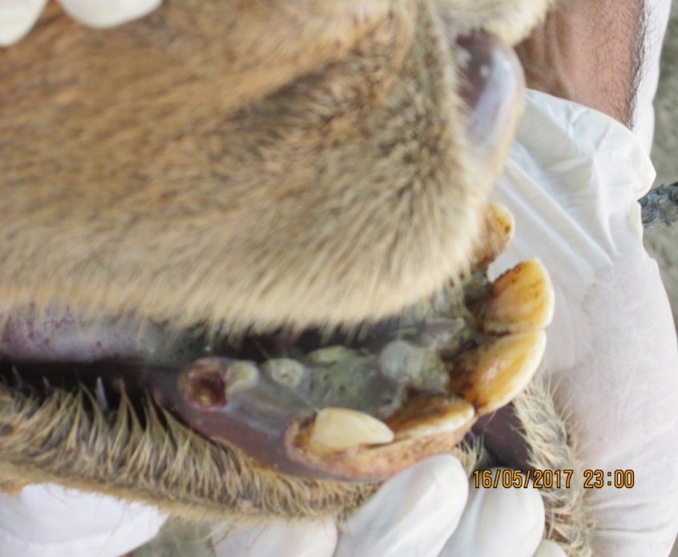

Fig. 4: sluffing of the mucosa.

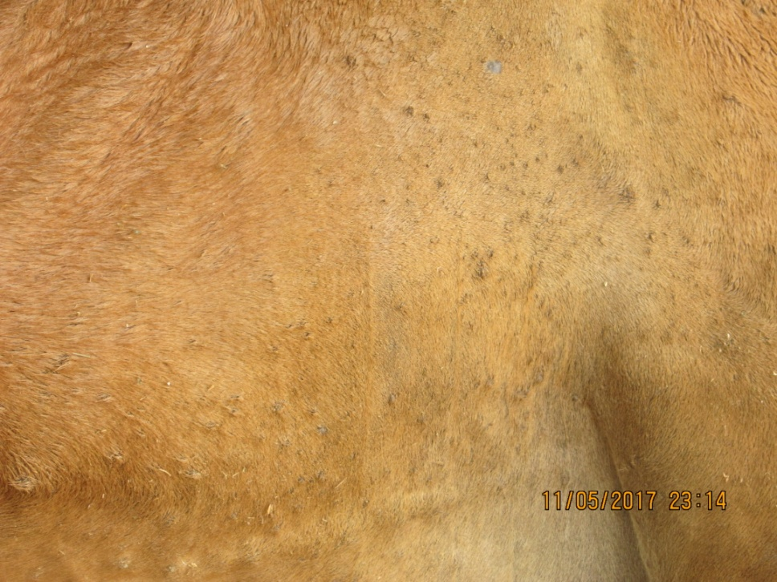

Fig. 5 : Body skin lesions

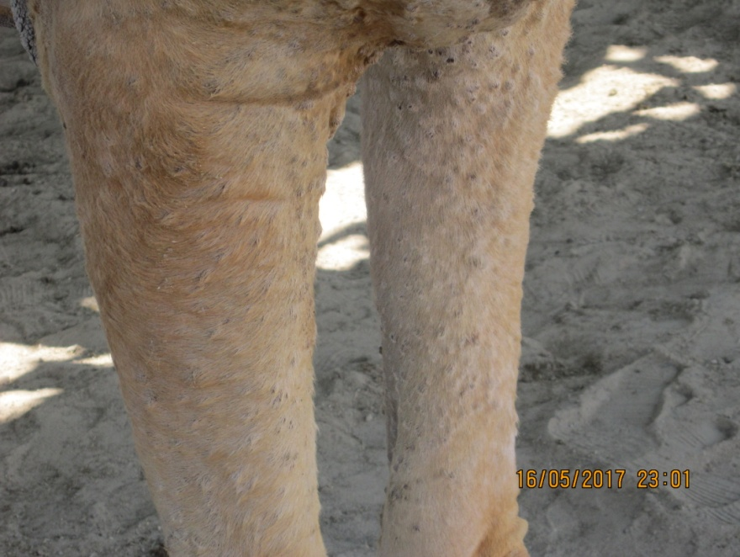
Fig. 6 : fore limb lesions.

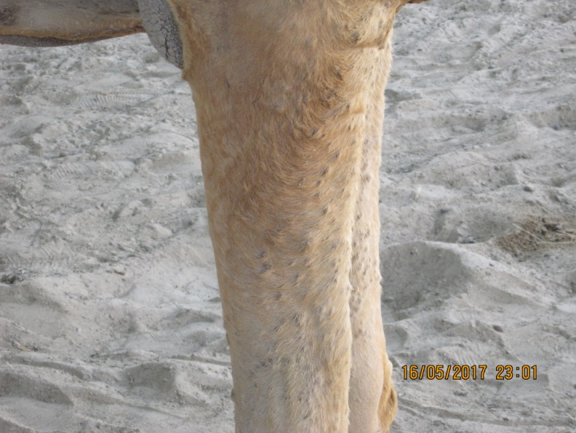
Fig. 7 : Fore limb lesions.

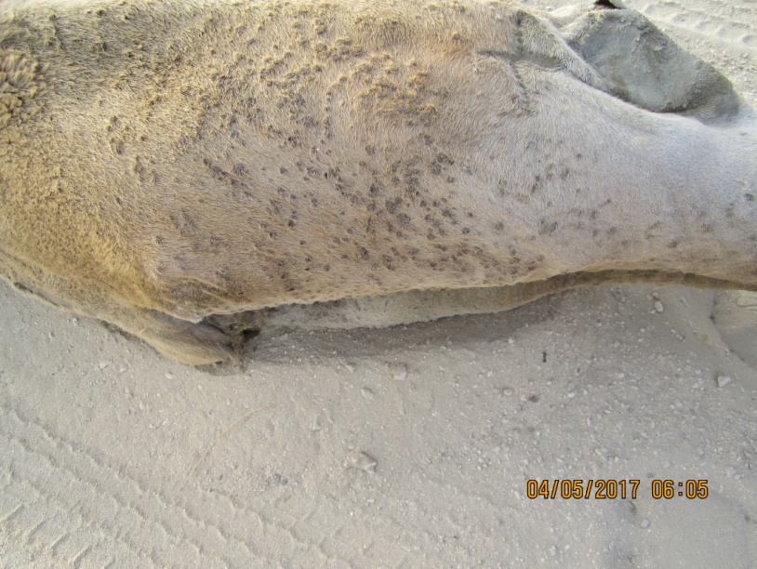

Fig.: 8 : Hind limb lesions.

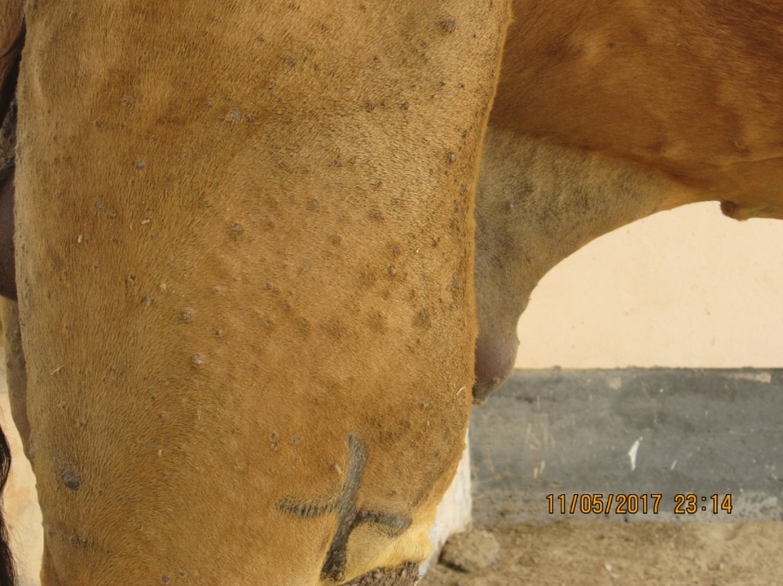
Fig. 9 : hind limb llesions.

Diagnosis and treatment
Diagnosis of the disease was based on the clinical symptoms.

Non-infected camels were treated with a single dose of 2ml.of a Saudi orthopox virus

live vaccine given intradermally. The inoculated camels showed no post- vaccination

reaction . The vaccine gives live immunity.

REFERANCES

1. Fenner, Frank J.; Gibbs, E. Paul J.; Murphy, Frederick A.; Rott, Rudolph; Studdert, Michael J.; White, David O. (1993). Veterinary Virology (2nd ed.). Academic Press, Inc.ISBN 0-12-253056-X.
2. Carter, G.R.; Wise, D.J. (2006). "Poxviridae". A Concise Review of Veterinary Virology. Retrieved 2006-06-10.
3. Gubser, Caroline; Smith, Geoffrey (2001). "The sequence of Camelpox virus shows it is most closely related to Variola virus, the cause of smallpox". Journal of General Virology. 83 (4): 855–872. PMID 11907336.doi:10.1099/0022-1317-83-4-855. Retrieved 30 March2012.
4.Jezek, Z; Kriz, B (1983). "Camelpox and its risk to the human population". Journal of Hygiene, Epidemiology, Microbiology, and Immunology. 27 (1): 29–42.PMID 6304186.
5. "Camelpox" (PDF). Terrestrial Animal Health Code. World Organization for Animal Health. Retrieved31 March 2012.
6. Wernery, U; Kaaden (1997). "Orthopox virus infections in dromedary camels in the United Arab Emirates (UAE) during winter season". Journal of Camel Practice and Research. 4 (1): 51–55.
7. Bera, BC (August 2011). "Zoonotic cases of camelpox infection in India". Journal of Veterinary Microbiology. 152(1-2): 29–38. PMID 21571451.doi:10.1016/j.vetmic.2011.04.010.
8. "Orthopoxvirus". Virus Zone. Swiss Institute of Bioinformatics.
9. Pfeffer, M (Jan 1998). "Fatal Form of Camelpox Virus Infection". The Veterinary Journal. 155 (1): 107–109.doi:10.1016/s1090-0233(98)80045-2.
10. Khalafalla, A (1998). "Epizootiology of Camel Pox, Camel Contagious Ecthyma and Camel Papillomatosis in the Sudan". Animal Production Under Arid Conditions. 2: 115–131.

