Comparing the effects on calf health after use of a commercially available Mycoplasma bovis vaccine in dairy herds in Scotland
Mr J Graeme Fowlie BVMS GPcert(EqP) MRCVS, Meadows Vet Centre, Oldmeldrum, Aberdeenshire, Scotland, UK

Abstract

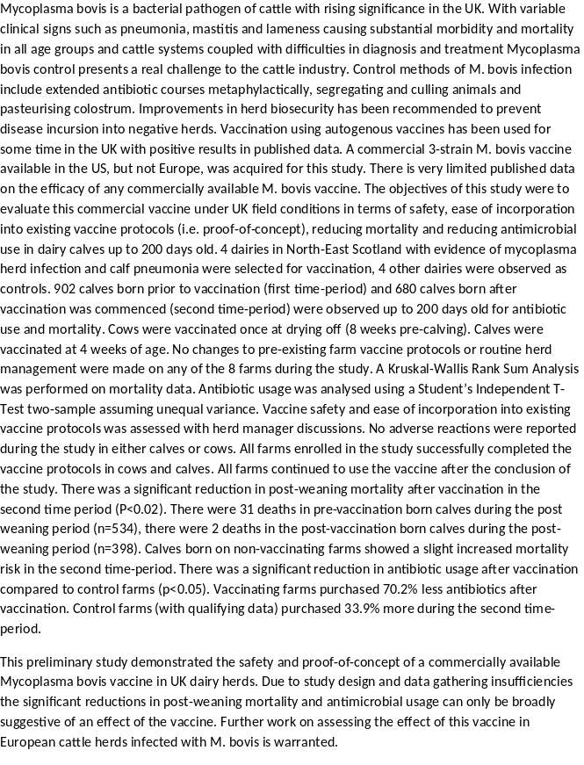
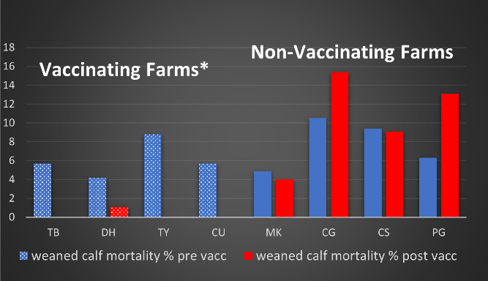
Recent Publications
- Animal & Plant Health Agency GB cattle quarterly report; Disease surveillance and emerging threats Volume 23:Q1 - January-March 2019 https://assets.publishing.service.gov.uk/government/uploads/system/uploads/attachment_data/file/806066/pub-survrep-c0119.pdf Accessed June 03 2020
- Burr P, (2018) Bovine respiratory disease what can we learn from current diagnostic tests? Proceedings of the British Cattle Veterinary Association, Leicestershire, UK 18-20 October 2018 26(2):156
- Lysnyansky I, Ayling RD 2016.Mycoplasma bovis: Mechanisms of Resistance and Trends in Antimicrobial Susceptibility. Front Microbiol. 2016;7:595. Published 2016 Apr 27.
- Calcutt MJ, Lysnyansky I, Sachse K, Fox LK, Nicholas RAJ, Ayling RD 2018. Gap analysis of Mycoplasma bovis disease, diagnosis and control: An aid to identify future development requirements. TransboundEmerg Dis. 2018;65 Suppl 1:91‐109.
5. Perez-Casal J, Prysliak T, Maina T, Suleman M, Jimbo S 2017. Status of the development of a vaccine against Mycoplasma bovis. Vaccine. 2017;35(22):2902‐2907. doi:10.1016/j.vaccine.2017.03.095

Photograph

 Biography
Graeme Fowlie is a director of Meadows Vets, a mixed practice based in Aberdeenshire, Scotland, with strong links to the local family farms of the area. Graeme has always had a keen interest in cattle pneumonia prevention since helping on the family farm before graduating from Glasgow Vet School. This is his first published study and was made possible with the assistance of his colleagues at Kernfarm, Netherlands who acquired the vaccine for it’s first use in Europe. In addition to cattle practice Graeme has a keen interest in equine work and small animal orthopaedics. Away from work Graeme enjoys rural life with his young family.
Email: prairie_kid@hotmail.com

