Bioactive Compounds in Animal Health:
Enhanced Immune Response mediated by Dietary Nucleotides
Dr Sergi Segarra PhD, R&D Bioiberica S.A.U., Spain

Abstract
Nucleotides are low molecular weight bioactive compounds which can naturally be found in all foods of animal and vegetable origin. Dietary nucleotides are considered immunomodulatory nutrients and their supply becomes conditionally essential when their demand increases and the body’s ability to produce them de novo is not enough, such as in situations like physiological stress, immunosuppression, infection, and certain disease states.
Several research studies report the positive effects of Nucleoforce®, a proprietary brand of nucleotide-rich yeast extract developed by Bioiberica S.A.U. (Palafolls, Spain), which is highly sustainable, and can be obtained through a fermentation process following a circular bioeconomy approach.
In dogs, the main clinical indication is leishmaniosis. In sick dogs, nucleotides with methylglucamine antimoniate achieved similar efficacy to the standard treatment without adverse effects; and, in clinically healthy Leishmania-infected dogs, they allowed a reduction in antibodies and a lower disease progression.
In livestock and aquaculture species, dietary nucleotides have been reported to provide health benefits mainly driven by a positive modulation of the immune response. More specifically, in a recent study in Pacific white shrimp, nucleotides improved performance, immune response and disease resistance against Vibrio harveyi. In another recent study in broiler chickens, Nucleoforce® maintained performance during periods of intestinal stress in combination with an ionophore. Moreover, the use of dietary nucleotides has also been proposed as a replacement for antibiotics/trace elements in piglets.
On the other hand, despite the damage that it has caused, COVID-19 might contribute to increasing awareness of the risks posed by zoonoses and lead to a greater commitment to One Health. Livestock and aquaculture production, as well an adequate management of diseases in companion animals, must keep promoting a more sustainable future following such collaborative approach. The incorporation of safe and effective solutions like dietary nucleotides could contribute to that purpose.
Image
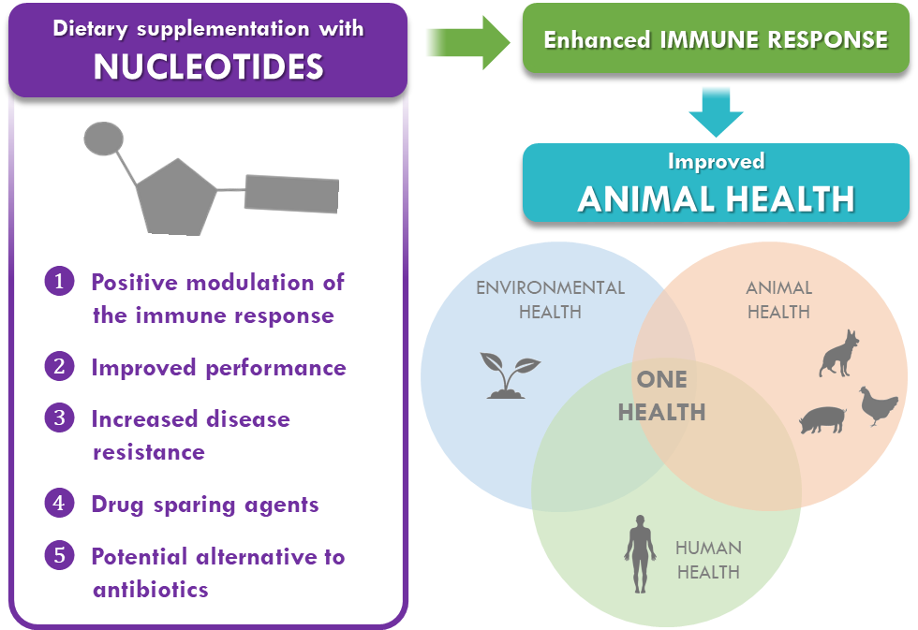

Recent Publications
1. Wu, Dayong, et al. "Nutritional modulation of immune function: analysis of evidence, mechanisms, and clinical relevance." Frontiers in immunology 9 (2019): 3160.
2. Segarra, Sergi. "Nutritional Modulation of the Immune Response Mediated by Nucleotides in Canine Leishmaniosis." Microorganisms 9.12 (2021): 2601.
3. Segarra, Sergi, et al. "Randomized, allopurinol-controlled trial of the effects of dietary nucleotides and active hexose correlated compound in the treatment of canine leishmaniosis." Veterinary parasitology 239 (2017): 50-56.
4. Segarra, Sergi, et al. "Prevention of disease progression in Leishmania infantum-infected dogs with dietary nucleotides and active hexose correlated compound." Parasites & vectors 11.1 (2018): 1-10.
5. Novriadi, Romi, et al. "Effects of dietary nucleotides supplementation on growth, total haemocyte count, lysozyme activity and survival upon challenge with Vibrio harveyi in pacific white shrimp, Litopenaeus vannamei." Aquaculture Reports 21 (2021): 100840.
6. Jones, Matthew, et al. " Evaluation of a nucleotide-rich yeast extract in a necrotic enteritis challenge model in broiler chickens.” International Poultry Scientific Forum, Atlanta, Georgia USA, January 24-26 2022.

Biography

Dr. Sergi Segarra obtained his Degree in Veterinary Medicine from the Autonomous University of Barcelona (UAB) in 2008. After working at different veterinary hospitals in Spain and the UK, in 2011 he completed an Internship in Small Animal Medicine and Surgery at the University of Bristol, UK. He also completed several externships at different institutions, including the University of Cambridge, the Animal Health Trust, the North Carolina State University, and the Long Island Veterinary Specialists Veterinary Hospital. In 2016, he obtained his PhD in Animal Medicine and Health from the UAB. He also holds a master’s degree in Applied Clinical Research in Health Sciences, a Postgraduate Diploma in Small Animal Practice, a Postgraduate Diploma in Veterinary Ophthalmology, a Postgraduate Diploma in Project Management and Innovation, and a Project Management Professional (PMP) Credential. He currently works as Research & Development Project Manager in Animal Health at Bioiberica S.A.U., in Barcelona.
Email: ssegarra@bioiberica.com

