APPLICATION OF ELISA IN EARLY DIAGNOSIS OF ECHINOCOCCUS SPP. IN PRIMATES
Nguyen Thi Nhien, Bui Khanh Linh¹
¹ Vietnam National University of Agriculture, Vietnam
Abstract
Macroscopic lesions (A) lung and (B) liver of langur (Pygathrix nemaeus) Contains Echinococcus spp.
Image

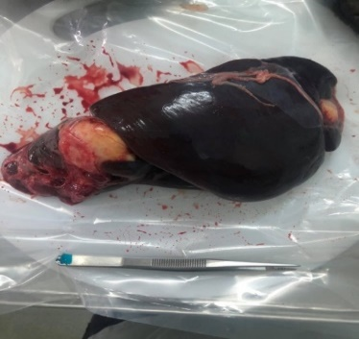
The Endangered Primate Rescue Center (EPRC), Ninh
Binh, Vietnam is one of the conservation centers for hunted primates, many of which are at risk of extinction. The primates rescued to that center were found to be infected with the larvae of a small tapeworm species Echinococcus spp. is one of the pathogens of great interest due to its ability to form water cysts that damage organs such as the liver, kidneys, lungs, even the heart and brain. Hydatid disease caused by Echinococcus spp. is noted in many
A
countries around the world and is a dangerous contagious disease. At the Center (EPRC), hydatid cyst disease is thought to be one of the main causes affecting the health of primates and even threatening their life. Therefore, ELISA is the first method applied
on primates at the Centre was been establishedOut of a total of 36 individuals tested for ELISA, there are 17 individuals with positive results, accounting for 47,2%. 9 individuals detected cysts in organs in the body were all positive for ELISA.

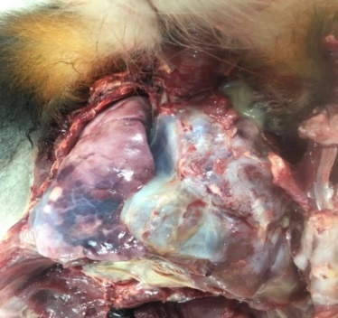
B

Recent Publications (minimum 5)

- Nhien Thi Nguyen, Manita Wittayarat, Zhao Namula, Yoko Sato, Quynh Anh Le, Qingyi Lin, Koki Takebayashi, Fuminori Tanihara, Maki Hirata, and Takeshige Otoi (2021). Chlorogenic acid and insulin–transferrin–selenium supplementation during in vitro maturation enhances the developmental competence of interspecies chimera blastocysts following cell injection. Journal of Applied Animal Research, 49(1), 486-491
- Tanihara, F., Hirata, M., Nguyen, T.N., Le A.Q., Hirano, T. and Otoi T. (2021). Generation of CD163-edited pig via electroporation of the CRISPR/Cas9 system into porcine in vitro-fertilized zygotes. Anim. Biotechnol., 32, 147-154
- Tanihara, F., Hirata, M., Nguyen, T.N., Sawamoto, O., Kikuchi, T. and Otoi T.* (2021). One-step generation of multiple gene-edited pigs by electroporation of the CRISPR/Cas9 system into zygotes to reduce xenoantigen biosynthesis. Int. J. Mol. Sci., 22 (5), 2249, 1-14
- Nhien Thi Nguyen, Maki Hirata, Fuminori Tanihara, Yoko Sato, Zhao Namula, Quynh Anh Le, Manita Wittayarat, Mokhamad Fahrudin and Takeshige Otoi (2020). In vitro development of zona pellucida-free porcine zygotes individually cultured after vitrification. Cryoletters, 41 (2): 86-91
- Fuminori Tanihara, Maki Hirata, Nhien Thi Nguyen, Quynh Anh Le, Takayuki Hirano, Takeshige Otoi (2020). Generation of viable PDX1 gene‐edited founder pigs as providers of nonmosaics. Molecular Reproduction and Development, 87 (4): 471-481

  Biography | As a faculty staff, lecturer, and scientist of the Vietnam National University of Agriculture (VNUA), I had involved in both teaching and research activities. My research interest focused on “infectious and parasitic diseases transmissible from animal to human, and development of the analysis methods and solutions for preventing diseases”. I also involved in creating new species such as genetically engineered pigs and using their advantages such as their similarity to human organs in size and function and ease of breeding in large quantity for suitable xenotransplantation of solid organs (kidney, liver, heart, lung, intestine, pancreas, etc). And I was also interested and involved in stem cell therapy for patients to treat cardiovascular and cancer diseases.
Email: ntnhien@vnua.edu.vn/ nhienvet@gmail.com

