Growth, Hematological and Histopathological responses to Gaur (Gyamopsis tetragonoloba) and Salinomycin sodium for ameliorating deleterious effects of coccidiosis in broiler chicken.

Omer Naseer, PhD, Department of Clinical Medicine, Cholistan University of Veterinary & Animal Sciences, Bahawalpur, Pakistan.

Abstract

Coccidiosis is among the major parasitic problems causing economic losses to the poultry industry. A study was conducted to determine the efficacy of guar (Gyamopsis tetragonoloba) and salinomycin sodium against coccidiosis in broiler chicken. One hundred and twenty broiler chicks were divided into four groups with each having 30 birds. Group A had salinomycin sodium supplementation; group B had Guar (Gyamopsis tetragonoloba) supplementation whereas groups C and D were positive and negative control respectively. Salinomycin and guar (Gyamopsis tetragonoloba) were administered as per medication protocols. 50,000 oocysts of Eimeria specie were induced orally to birds except negative control on day 21. Feces having oocysts were observed 7 days post-challenge and were counted by using McMaster technique along with weight gain and feed conversion ratio every week. At the same time blood profile of the birds was also monitored every week. It was concluded that salinomycin had the best results in terms of weight gain as compared to guar and feed conversion ratio was also less in group supplemented with guar (Gyamopsis tetragonoloba). On the other hand, guar showed reduction in oocysts per gram of feces and decreased bloody diarrhea along with mortality rate as its birds had a better blood profile than salinomycin.

Keywords: Poultry; infection; oocysts; hemoglobin; age; supplementation; blood profile

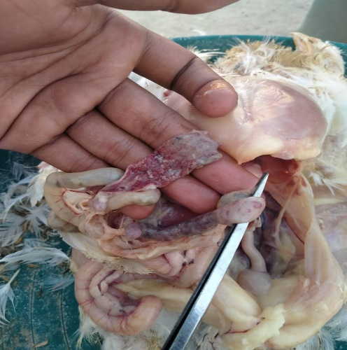
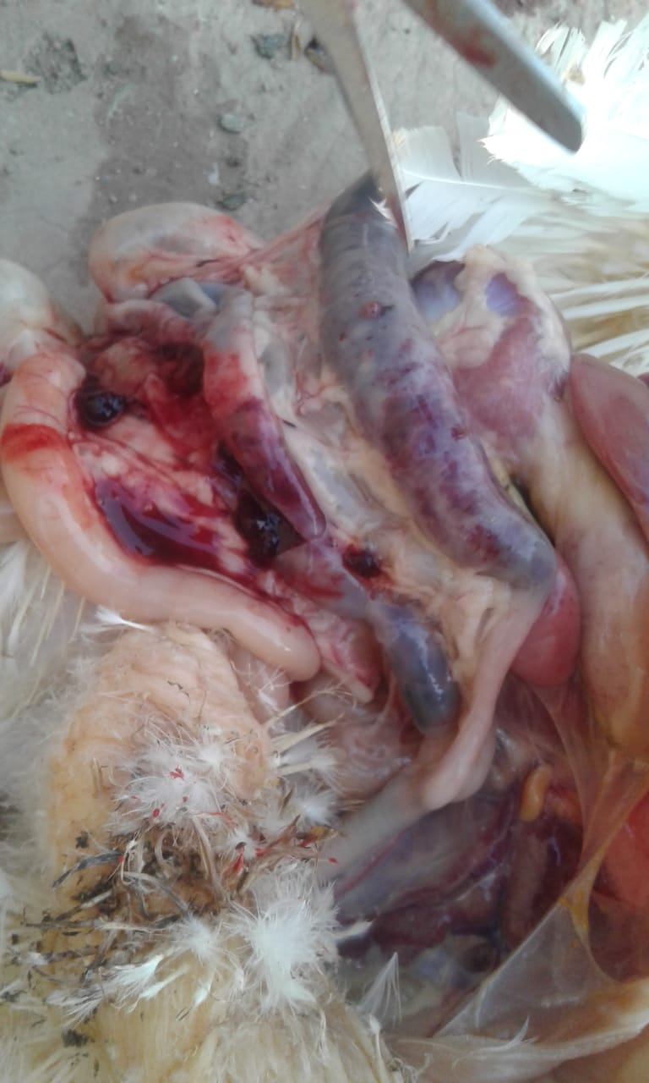
Clinical Signs of Coccidiosis in Broiler Chickens.

Recent Publications:

1. Omer Naseer , Matthew C. Jarvis , Max Ciarlet , Douglas G. Marthaler. 2017. Genotypic and epitope characteristics of group A porcine rotavirus strains circulating in Canada. Virology. Vol. 507: 53-63.
2. Omer NASEER, Jawaria Ali KHAN, Muhammad Sarwar KHAN, Muhammad Ovais OMER, Muhammad AVAIS, Muhammad Luqman SOHAIL, Muhammad Usman SALEEM and Muhammad SHAHID. 2018. Efficacy of ß-glucans and Manna oligosaccharides (Yeast Cell Wall) and HydratedSodium Calcium Aluminosilicate (HSCAS) in Preventing Aflatoxicosis in Bovine Calves. Indian Journal of Animal Research. Vol. 51, No. 3 , 1-6.
3. Omer NASEER, Jawaria Ali KHAN, Muhammad Sarwar KHAN, Muhammad Ovais OMER, Junaid NASEER, Muhmmad Luqman SOHAIL, Muhmmad Usman SALEEM, Waqas AHMAD, Abdullah Saghir AHMAD. 2018. Effect of dietary aflatoxins (AFB1) on hematological and biochemical indices of male buffaloes.. Indian Journal of Animal Research. Vol. 52, No. 5 , 718-723.
4. Omer Naseer, Muhammad Usman Saleem, Muhammad Luqman Sohail, Junaid Naseer, Jawaria Ali Khan, Muhammad Ovais Omer, Khalid Mahmood Anjum, Abdullah Saghir Ahmad, 2018. Effects of yeast based toxin binder supplementation on growth performance and intestinal microarchitecture in male buffalo calves (Bubalus bubalis) exposed to different concentrations of Aflatoxin B₁ Journal of the Hellenic Veterinary Medical Society. Vol. 69, No. 1, 853-862.
5. Omer Naseer, Jawaria Ali Khan, Muhammad Ovais Omer, Junaid Naseer, Muhammad Luqman Sohail, Muhammad Asif Munir, Muhammad Usman Saleem, Muhammad Imran, Muhammad Shahid. 2020. Exogenous Factors Affecting Growth of Aspergillus Species. Indian Journal of Animal Research. Vol. 54(8): 994-999.

Biography:


Dr. Omer Naseer is an Assistant Professor, Department of Clinical Medicine, Cholistan University of Veterinary and Animal Sciences, Bahawalpur, Pakistan and holds D.V.M., MPhil, Ph.D. (UVAS) degrees in Veterinary Clinical Medicine. He conducted significant part of his Ph.D. research at Veterinary Diagnostic Laboratory, University of Minnesota, USA and published peer-reviewed papers from his research.

Email: omernaseer@cuvas.edu.pk

