Ultrasonographic examination of the spinal cord and collection of cerebrospinal fluid from the Atlanto-occipital space in goat
Correspondence author: Muhammad Shahid
*Department of surgery, Cholistan University of veterinary and animals sciences’ Bahawalpur, Pakistan
Abstract
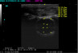
Ultrasonography, a non-invasive technique, is a real milestone and useful tool for the examination of Atlanto-occipital joint’s structural visualization. Collection of CSF is more accurate and easier under ultrasound-guided procedure. In this study, longitudinal and transverse views of AO joint was scanned and different structural dimensions were measured in healthy goats. In longitudinal plan, the distance between skin and arachnoidea ranges from 9.45 to 18.94 mm (mean ± SD, 14.91±2.55 mm). Height of subarachnoid space, dorsal and ventral to the spinal cord range from 2.44 to 9.64 mm (mean ± SD, 4.53±1.66 mm) and 2.68 to 7.17 mm (mean ± SD, 4.66±1.17mm), respectively. Diameter of the spinal cord varies from 2.2 to 8.27 mm (mean ± SD, 5.78 ± 2.03 mm) and height of the entire dural sac varies from 9.21 to 18.62 mm (mean ± SD, 4.82±2.64mm). Spinal cord can be seen only in longitudinal plan over a distance of 1.1 to 5.51 mm (mean ± SD, 3.22±1.00 mm). While, in transverse plan, the distance between the skin and arachnoidea range from 11.3-19.5 mm (mean ± SD, 15.72±2.03 mm). Height of the subarachnoid space dorsal and ventral to spinal cord ranges from 3.47-9.22 mm (mean ± SD, 6.40±1.65 mm) and 3.86-6.85 mm (mean ± SD, 5.13±0.78 mm), respectively. Diameter of the spinal cord varies from 2.36-7.56 mm (mean ± SD, 4.14±1.39 mm) and height of the entire dural sac varies from 13.29-22.3 mm (mean ± SD, 16.33±1.97 mm). These standard measurements will be a reference values in healthy goats.

Transverse view in the same goat with different anatomical structures measurement; (D1) distance between skin and arachnoidea 15.0 mm, (D2) depth of the subarachnoid space, which is dorsal to the spinal cord 5.61mm, (D3) spinal cord diameter 3.45 mm, (D4) depth of subarachnoid space, which is ventral to the spinal cord 4.74 mm, (D5) diameter of the entire dural space 14.9 mm
Publications list:
1: Larynx Trauma and Hyoid Bone Fracture after Bite Injury in Dog: Case Report. Manchi G, Brunnberg MM, Shahid M, Al Aiyan A, Brunnberg L, Stein S. Front Vet Sci. 2016 Aug 16; 3: 64. doi: 10.3389/fvets.2016.00064. e Collection 2016. (Impact factor 2.14)
2: Spontaneous pneumothorax in cats: two case reports and literature review. Manchi G, Jarolmasjed S, Brunnberg M, Shahid M, Rehbein S, Stein S, Gruber AD, Brunnberg L. Tierarztl Prax Ausg K Kleintiere Heimtiere 2017 Aug 10;45(4):273-279. doi: 10.15654/TPK-150466. Epub 2017 Aug 2. (Impact factor 0.264)
3: A case of a haematogenous spread osteomyelitis with development of a bone lytic lesion in a young Boxer mixed-breed dog. Pavel Slunsky, Mathias Brunnberg Leo, Shahid M, A. Haake, Prof, Dr. Brunnberg Leo. Wiener Tierärztliche Monatsschrift: WTM 104, 2017 (Impact factor 0.22)
4: Radial and ulnar fracture treatment with paraosseous clamp-cerclage stabilization technique in 17 toy breed dogs. George Manchi, Mathias M Brunnberg, Shahid M, Ahmad Al Aiyan, Eric Chow, Leo Brunnberg and Silke Stein. Veterinary Record Open 2017; 4: e000194. Doi: 10. 1136 (Impact factor 1.23)
5: Repair of a Tibiotarsal Fracture in a Pomeranian Goose (Anser anser) With a Locking Plate. Slunsky P, Weiß J, Haake A, Shahid M, Brunnberg L, Müller K. J Avian Med Surg. 2018 Mar; 32(1):50-56. doi: 10.1647/2016-242. (Impact factor 0.27)
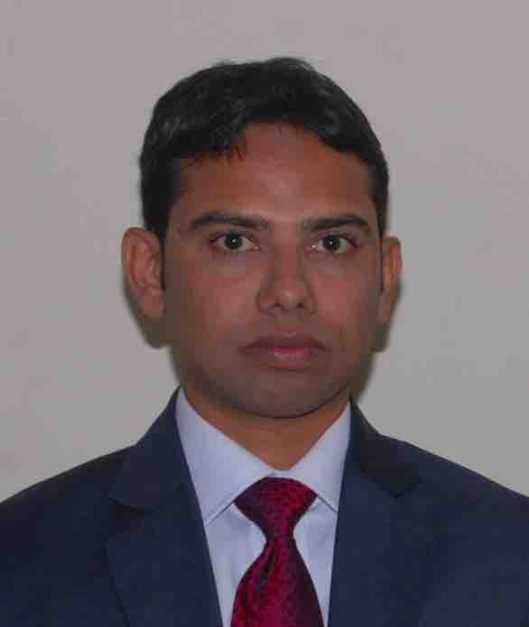
Bibliography:
I am working as an assistant professor in surgery department at Cholistan University of veterinary and animal sciences Bahawalpur, Pakistan. I have won German Academic Exchange Service (DAAD) scholarship in 2013. My PhD research topic was “proteomic analysis to identify small protein molecules that affect specific biological pathways and to identify disease biomarkers in dog’s synovial fluid osteoarthritis”. I did my PhD at clinic for small pets, department of small animal medicine and surgery, Freie Universität Berlin, Germany. I have an internship experience of 1 year and 6 months at Freie Universität pet center. Also, I worked as a veterinary doctor for the duration of 1 year and 1 month at a German hospital. I have complete command in the fields of ICU, Surgery, anatomy and Internal medicine. My handling of CT technique, endoscopy, Fluoroscopy, ultrasound examination and radiology techniques are excellent.
Email: mshahid@cuvas.edu.pk

