Aloe Vera and Pyoderma in Dogs with Special Reference to Biochemical alterations
Hany Y. Hassan, Ahmed Bayomi, Ahmed Kamr, Amanallah El-Bahrawy, Ahmed Elsify, Ali Abdelazeim and Hadeer Khaled
Department of Animal Medicine and Infectious Diseases; Veterinary Hygiene, and Veterinary Pathology, Faculty of Veterinary Medicine, University of Sadat City, Sadat City; Egypt.

Abstract (300 word limit)
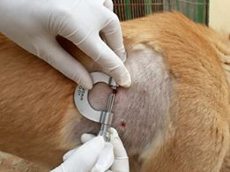
This study was aimed to investigate the efficacy of aloe vera gel ointment 20% and 40% as a new topical therapy against treatment of staphylococcal pyoderma with a special reference to altered clinical and biochemical biomarkers associated with experimental pyoderma in dogs. Twenty dogs were inoculated intradermal with 105 CFU Staphylococcus aureus and divided into four groups (group1: control positive without treatment, treated group2: 20% aloe vera ointment, treated group3: 40% aloe vera ointment and treated group4: gentamycin ointment). At zero day of the experimental local therapy, the lesion was hyperemic, painful, hotness and bulged with bus secretion, ended with completed healing at 14 days post treatment (dpt). A significant increase in the concentrations of malondialdehyde, ceruloplasmin, serum amyloid A, haptoglobin, interleukins (IL-1, IL-6, IL-10) and tumor necrosis factor (TNF-α) in infected dogs at zero day, group 1 at 3rd dpt, 7th dpt, 10th dpt and 14th dpt and group 2, 3 and group 4 at 3rd dpt and 7th dpt when compared to their concentrations in the control ones (P <0.05), while there is no statically changes for acute phase proteins and cytokines concentrations at 14th dpt at group 2, group 3 and group 4 when compared to control ones (P > 0.05), except for haptoglobin and TNF-α that were statistically higher in group 4 than control dogs at 14th dpt (P <0.05). On the other hand, there is a significant decrease in the concentrations of total antioxidant capacity and catalase in control dogs than group 2 at 3rd dpt, 7th dpt, 10th dpt and 14th dpt, and at 3rd dpt among group 3, and 7th dpt in group 4.

Fig. 1: Using a caliber for detection of size of hyperemic, painful and bulged pyoderma in dog.

Image
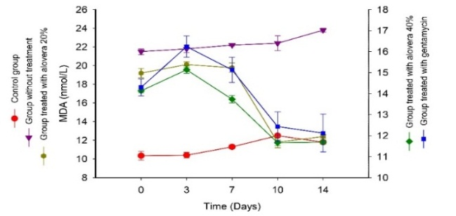

Fig. 2: Effect of Aloe Vera Ointment 20%, 40% and gentamycin treatment on oxidative stress at different times of pyoderma treatment 3dpt, 7dpt, 10dpt and 14dpt.

Recent Publications (minimum 5)
- Beigh AS, Beigh AH, Soodan SJ, Soodan SA, Nazki S, and Khan MA (2014) Oxidative stress, hematobiochemical parameters, trace elements xidative stress, hematobiochemical parameters, trace elements and vitamins in dogs with zinc responsive dermatosis. Veterinarski Arhiv 84 (6), 591-600, 2014.
- Beigh SA, Soodan JS, Singh R, Khan AM, Dar MA (2014a) Evaluation of trace elements, oxidant/antioxidative status, vitamin C and β-carotene in dogs with dermatophytosis. Mycoses, 57 (2014), pp. 358-365.
- Kapun AP, Salobir J, Levart A, Kotnik T, Svete AN (2012) Oxidative stress markers in canine atopic dermatitis. Research in Veterinary Science 92 (2012) 469–470.
- Manzillo VF, Nocera FP, De Martino L, Gizzarelli M, Oliva G (2016) A Successful Vancomycin Treatment of Multidrug-Resistant MRSA-Associated Canine Pyoderma. Journal of Dermatologic Research and Therapy. vol- 1 Issue 2 Pg. no.- 13.
- Ulutas B, Ural K, Ulutas PA (2011) Phase Response with Special Reference to C-Reactive Protein in Dogs Acute Phase Response with Special Reference to C-Reactive Protein in Dogs with Generalized Demodicosis with Generalized Demodicosis. ta Scientiae Veterinariae. 39(3): 980. Acta Scientiae Veterinariae, 2011. 39(3): 980.

Photograph

 Biography (150 word limit)
Dr. hany has capability in evaluation and desire in improving the veterinary education and research. He also is an expertise in a quality assurance in higher education and in the student assessment methods. He is a PI to interested developmental projects in his university. He has a vision after years of experience in research, evaluation, teaching and administration both in veterinary hospitals and education institutions. In the same time he is PIs for different scientific projects beside that he is in the editorial board of various veterinary research journals. The research vision based on back to the nature, so he is interested in alternative veterinary medicine, especially herbal medicine. From his educational point of view, he encourages and implements teaching and learning through peers. He also participates in organizing many educational and service veterinary medical convoys.

Email: hanyhassan1959@gmail.comsted
Notes/Comments:

