Comparison of different herbal (goji berry, green tea , diospyros kaki) extracts in the treatment of the experimentaly induced dry eye in mice: preliminary report
Alper BASA, Fırat Unıversity Turkey
Ibrahim CANPOLAT, Fırat Unıversity Turkey
Kadrı KULUALP, Dokuz Eylül Unıversity,Turkey
Abdullah ASLAN, Fırat Unıversity Turkey
Sema Cakır, Fırat Unıversity Turkey

Abstract
Dry eye syndrome (DES) is a multifactorial disease of the ocular surface and tear characterized by tear film instability, vision therapy and symptoms, along with damage to the ocular surface. Herbal extracts are used in the treatment of many inflammatory diseases due to their wide spectrum of action. The aim of this study is to compare the therapeutic effects of extracts from diospyros kaki, green tea and goji berry leaves on the experimentally formed dry eye model. The study material consisted of 28 (n = 28) 8 week old healthy BALB / C female mice produced within the Experimental Research Unit of Fırat University. Subjects were randomly divided into 4 groups, 7 in each group. Groups; Control group (Cont-G), goji berry group (GBG), green tea group (GTG) and Diospyros kaki group (DKG). 5 µl of Benzalkonium Chloride was applied topically to the subjects' right eyes twice daily for 14 days. Extracts, which gave their names to the groups for 15 days from the 15th to the 30th day, were instilled in the right eyes at a dose of 5 µl in order to determine the therapeutic effect. Balance saline solution was performed to the right and left eyes of the subjects in the control group. Endodontic absorbent paper point test, corneal staining test and tear break-up time tests were performed to measure the eye damage and the therapeutic effect of the extracts on the days of 0.15, 20, 25 and 30 of the study. Test data were noted. The differences in the tear volume, tear film BUT, and fluorescein staining scores between the groups were evaluated by using a one-way analysis of variance (ANOVA) test with Tukey’s post hoc analysis. A value P < 0.05 was considered statistically significant.

Image
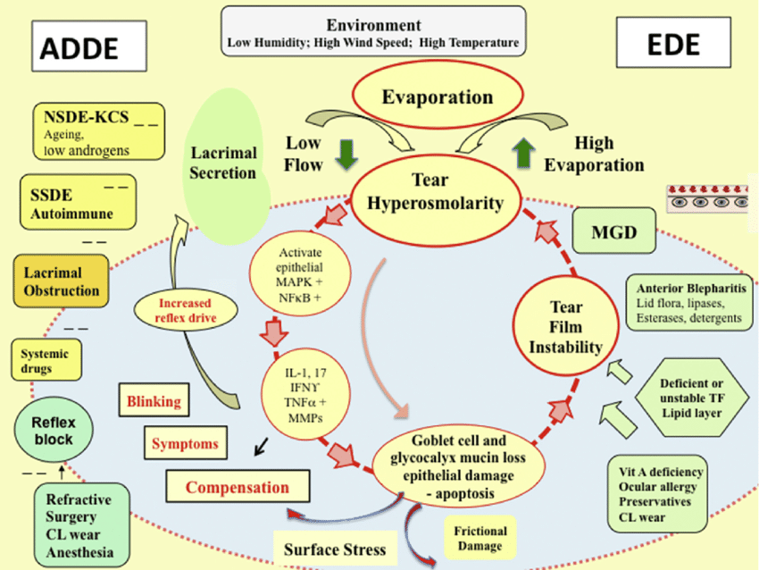

Dry Eye Mechanisim
Recent Publications
- Bei W, Zang L, Guo J, Peng W, Xu A, Good DA, Hu Y, Wu W, Hu D, Zhu X, Wei M, Li C (2009) Neuroprotective effects of a standardized flavonoid extract from diospyros kaki leaves. Journal of Ethnopharmacology 126:134-42.
- Chien KJ, Horng CT, Huang YS, Hsieh YH, Wang CJ, Yang JS, Lu CC, Chen FA (2018) Effects of lycium barbarum (goji berry) on dry eye disease in rats. Molecular Medical Report 17(1):809-818.
- Li Z, Choi JH, Oh HJ, Park SH, Lee JB, Yoon KC (2014) Effects of eye drops containing a mixture of omega-3 essential fatty acids and hyaluronic acid on the ocular surface in desiccating stress-induced murine dry eye Current Eye Research 39(9):871-878.
- Nejabat M, Reza SA, Zadmehr M, Yasemi M, Sobhani Z (2017) Efficacy of green tea extract for treatment of dry eye and meibomian gland dysfunction; a double-blind randomized controlled clinical trial study. Journal of Clinical Diagnosis Research 11(2):05-08.
- Xiao X, He H, Lin Z, Luo P, He H, Zhou T, Zhou Y, Liu Z (2012 ) Therapeutic effects of epidermal growth factor on benzalkonium chloride-induced dry eye in a mouse model. Invest Ophthalmology Vision Science 20;53(1):191-197.

Photograph



Biography
My name is Alper. I did a master's degree in surgery at Selcuk University in 2012 . My specialty is hip dysplasia in puppies. I worked small and large animal farms in 2013-2015. In 2016, I started my doctorate studies at Fırat University. I attended trainings and conferences on wound healing and eye dryness. I especially like to take part in new research oriented projects. I have a young and dynamic structure.

Email: alper_basa32@hotmail.com

Notes/Comments:

