Disinfecting effect of chlorine dioxide (ClO₂) on duck eggs originated from a duck breeding farm; determination of the total CFU count on the egg surface
PIA HARTWIG; ORSOLYA PALÓCZ; DR. GYÖRGY CSIKÓ, PhD, habil

Department of Pharmacology and Toxicology, University of Veterinary Medicine, Budapest, Hungary

Abstract:
Occurrence of disease outbreaks that can be attributed to the food industry due to bacterial or other pathogen contamination has been well known since centuries. Disinfection with efficient but at the same time least harmful compounds is a subject of major importance throughout the whole food production process for food- and animal-safety aspects. Since poultry meat is a major food source for humans, it is highly important to reduce the germ count on the surface of eggshells, in order to prevent the risk of spreading pathogens; e.g. Salmonella spp. and Campylobacter spp.
The usage of biocides as disinfectants has been widespread since many decades. The hyper-pure chlorine dioxide (ClO₂) solution at low concentration is an “Ideal Biocide” based on its good performance towards microorganisms, and due to the fact that it does not harm humans or animals and is environmentally friendly.
The goal of study was to examine the disinfecting effect of ClO₂ on the surface of duck eggs and to achieve a significant decrease of the total germ count on the egg´s surface.
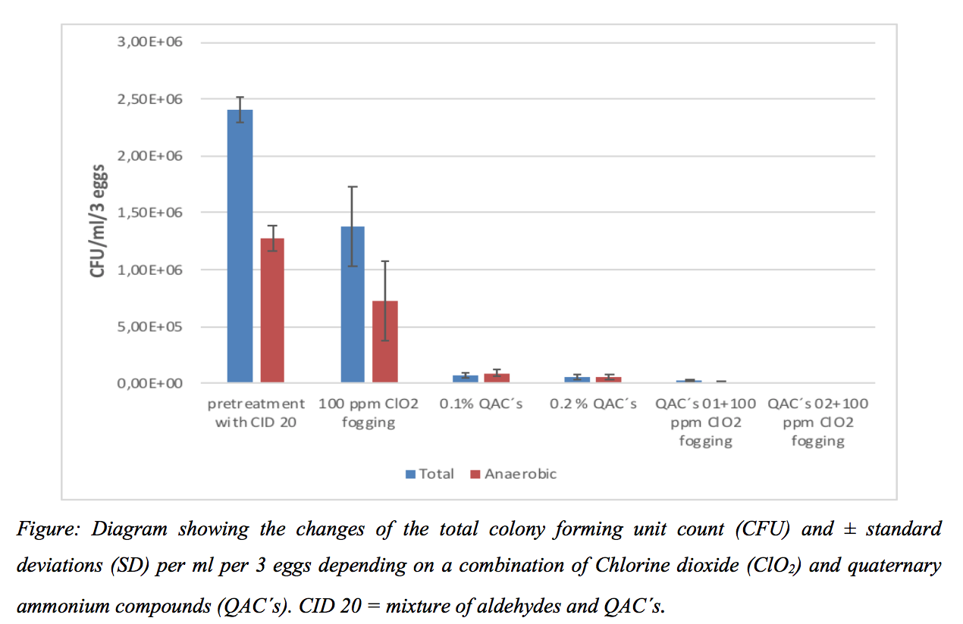
Three experiments on duck eggs have been carried out, using a combination of different ClO₂ and quaternary ammonium compound (QAC´s) concentrations. For the first experiment, the effect of ClO₂ was almost the same for all concentrations (30, 100 and 300 ppm) that have been tested. In the next experiment we combined ClO₂ with a QAC disinfectant. The highest decrease in total germ count (10⁻⁵) occurred with QAC treatment in combination with ClO₂ fogging. During the third measurement, QAC concentration was reduced. The highest germ count reduction was achieved by the combination of 0.2% QAC spraying and 100 ppm ClO₂ fogging.
Overall, ClO₂ alone cannot remove all microorganisms, but in combination with a formaldehyde-free disinfectant, the effectiveness of ClO₂ is increased and also spores can be destroyed.

