Characterisation of fungi isolated form porcine microbiota and examination of their synergism with probiotic bacteria

Hafner, Nathalie; Dr. Csikó, György, PhD, habil; Palócz, Orsolya

Department of Pharmacology and Toxicology, University of Veterinary Medicine, Budapest, Hungary

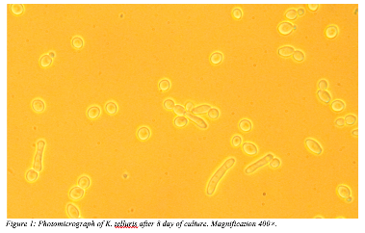
Our aim was to find out more about the beneficial fungal species, Kazachstania (Arxiozyma) telluris, which occurs naturally in the healthy porcine intestine, to promote its growth and to find out with which probiotic bacteria it will form the best beneficial synergistic action.
We isolated and selectively cultured different fungi species from swine faeces of different origin. DNA was isolated from the selected fungi isolates, and the species of the isolated K. telluris fungus was determined via PCR. We tested different isolates of the fungus together with probiotic bacteria which are commonly used in the swine industry. In our experiments, we used Bacillus subtilis and Lactobacillus plantarum. We determined their growth rate and correlated it with the turbidity of their 24 h culture. The effect of the spent culture supernatant of the fungi and probiotic mixture on the viability of porcine intestinal cells (IPEC-J2 cell line) was measured with neutral red uptake test.
Among the collected faecal samples, the K. telluris could be found only in young Mangalica pigs (5×10² CFU/g). The viability of IPEC-J2 cells was not altered after the treatment with 5% of K. telluris spent culture supernatant (SCS). The simultaneous treatment of the monolayer jejunal cell cultures with the 5% fungal SCS with 5% supernatant of either B. subtilis or L. plantarum has not reduced the viability of the cells.
Based on our examinations, K. telluris can be detected in the normal gut microbiota of young extensively kept domestic swine. In the case of older and intensively-farmed pigs, we could not obtain the K. telluris fungus. We would like to further evaluate the presence of K. telluris in the microbiota of wild boar intestines. In addition, we will investigate the synergistic effect of K. telluris with the beneficial enteric bacteria of pigs in vitro and in vivo.

