Effect of oophoresalpingohysterectomy on serum antioxidant enzymes in dogs

Manzano P Linaloe, M. Sc. UNAM, Mexico.
Caballero C Sara, PhD, UNAM, Mexico.
Guarner L Veronica, PhD, Instituto Nacional de Cardiología “Ignacio Chávez, Mexico. Díaz D Eulises, Instituto Nacional de Ciencias Medicas y Nutrición “Salvador Zubirán, Mexico.
Moreno G Adrian, MVZ, UNAM, Mexico
Pérez-T Israel, PhD, Instituto Nacional de Cardiología “Ignacio Chávez, Mexico

Statement of the Problem: Oxidative stress (EO) is the consequence of a deficiency of natural protective substances against free radicals (RL) and/or excessive exposure to them or to their generating agents. There are few studies on the evaluation of oxidant-antioxidant status after oophoresalpingohysterectomy (OSH) in dogs. Estrogens have antioxidant properties per se due to their structural characteristics; moreover, they have influence and interact with antioxidant enzymes and adipose tissue. Here we determined the effect of OSH on antioxidant enzymes in serum and also quantified morphological changes in subcutaneous adipocytes. 12 female dogs between 1 and 5 years of age, classified as body condition 3 according to weight and body fat percentage (%GC) were studied. Lateral OSH was performed and subcutaneous adipose tissue was taken to determine morphological changes and cell number under basal conditions and sixth month after OSH. Concentrations of cholesterol, triglycerides, glucose, insulin, HOMA index, 17β-estradiol(17β-E2), extracellular superoxide dismutase(SOD-ec), peroxidases, glutathione peroxidase(GPx), glutathione-S-transferase(GST), glutathione reductase (GR), glutathione (GSH), lipid peroxidation (LPO), capacity antioxidant total(TAC), vitamin C and nitrates/nitrites ratio(NO3-/NO2-) were determined in serum in basal conditions and one and six months after the surgery. The activity of the enzymes SOD-ec, peroxidases, GSH, GPx and GST showed significant differences (p≤0.05), LPO was increased and vitamin c decreased (p=0.03) after OSH. The concentration of estradiol(17β-E2) showed a tendency to decrease six months after OSH. An increase in the %GC and hypertrophy of the subcutaneous adipose tissue was observed after OSH from the first month and was further accentuated at six months (p=0.001). The results suggest that the decrease of 17β-E2, as a consequence of OSH, alters the activity of antioxidant enzymes in serum which, in turn, increase LPO and decrease the TAC. These changes were associated with an increase in body weight and hypertrophy of subcutaneous adipose tissue.

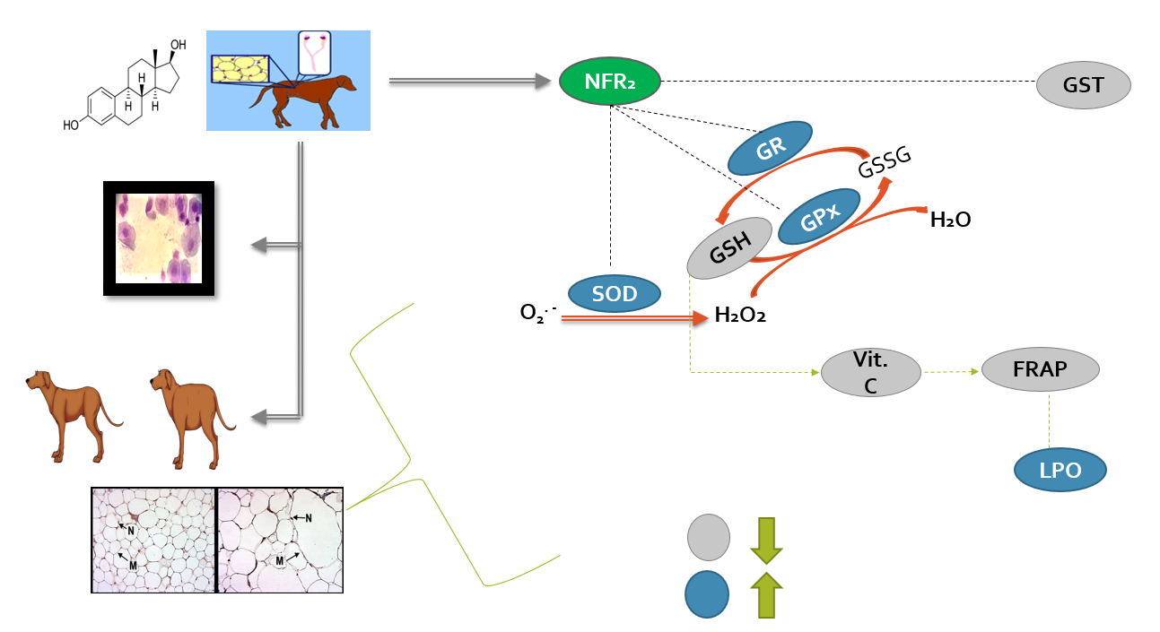
Figure 1: Effect of oophoresalpingohysterectomy on serum antioxidant enzymes and adipose tissue in dogs.

Recent Publications
- Pérez-T, Guarner-L, Rubio-R. (2017) Reductive Stress in Inflammation-Associated Diseases and the Pro-Oxidant Effect of Antioxidant Agents. International Journal of Molecular Science 18: E2098
- Ferreira A, Silva W, Souza M, et al. (2015) Comparação entre as abordagens lateral direita e mediana ventral em cadelas submetidas à ovariossalpingo-histerectomia. Arquivo Brasileiro de Medicina Veterinária e Zootecnia 67: 984-992.
- Soto M, Zuñiga A, Guarner-L, et al. (2016) Infusion of hibiscus sabdariffa L. modulates oxidative stress in patients with Marfan syndrome. Mediators of Inflammation 2016:8625203.
- Zúñiga A, Pérez-T, V. Guarner-L, et al. (2017) Glutathione system participation in thoracic aneurysms from patients with Marfan syndrome. Vasa 46:177-186.
- Pérez-T, V. Guarner-L, Zúñiga A, et al. (2016). Effect of Cross-Sex Hormonal Replacement on Antioxidant Enzymes in Rat Retroperitoneal Fat Adipocytes. Oxidative medicine and cellular longevity 2016:1527873.

